EmailManager.py

Introduction
The program aims to zip the .eml-files in
Emails.zip
and put its parameters (date, sender, receiver, subject, ...) in the SQLite file:
Emails.db
Thus emails can be found by using apps like SQLite Studio and simple SQL-statements i.e. :

SELECT *
FROM emails
WHERE [from] LIKE ‘%Ferdi%’
ORDER BY date

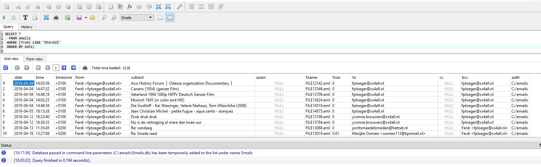
The outcome of such a search can be printed, saved in a spreadsheet or it allows to find and open the searched .eml-files in the .zip-file that EmailManager maintains.
General
Emails are normally kept on the server of the ISP (Internet Service Provider) as long as the ISP-allowed disk space is not full or the emails are deleted by one or another policy of the owner, the ISP or someone else.
A safer way is to keep the emails on a local disk and make backups of it. This can be done by saving the emails to disk. Doing this results in .eml-files with the 'subject' of the email as the filename. These emails keep all the information it has including attachments. The locally saved emails can be viewed with the default email program, can be forwarded or can be answered on, just as if the email was on the server of the ISP.
It is not easy to do searches in the thus saved emails with tools of the operating system because info like date, sender, recipient, cc's and bcc's are hidden within the email. That is why EmailManager changes the filenames in simple filenames (FILE1.eml, FILE2.eml, ...).
Making backups of thousands of emails is error-prone, that is why EmailManager stores all these emails in a zip-file.

Using the program
Suppose the emails are stored in a dedicated folder. This folder can be made the default folder for EmailManager to open and to work in.
When EmailManager starts it first tries to read the file
C:/EmailManager/EmailManager.json
In this file, it finds the path of the default folder and the number of restarts of the program which is needed for safe renaming the email files.
If C:/EmailManager/EmailManager.json doesn't exist EmailManager will create one and will set the default folder as 'C:/' and Number of Restarts as zero. If it does not exist EmailManager also will create a new LogFile EmailManager.log.
Most of the defaults can be managed from within the running EmailManager
EmailManager runs from a PythonScripts folder and needs the script archive_emails.py and the EmailManagerHelp-folder. There should be a Windows-path to the PythonScripts folder.
In Windows10 EmailManager starts from the Anaconda-Powershell or by running EmailManager.py from within Spyder with the command:
EmailManager.py

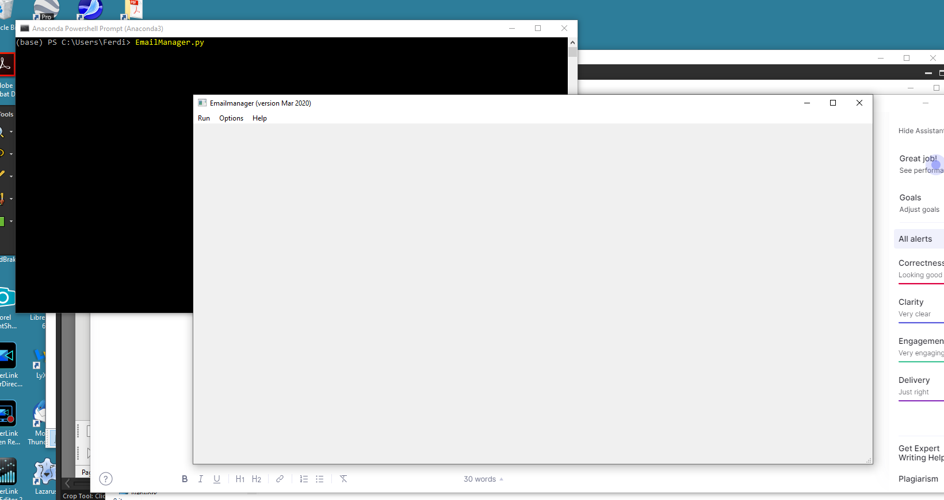
From then EmailManager will show as a Windows application. Be aware that the Anaconda-Powershell or Spyder should not be closed during working with EmailManager.
To archive, the emails use the file option 'actions | archive emails'. This will EmailManager do its tasks: renaming all the .eml-files in the current folder AND its subfolders (!!!!) and transferring them to the zip file Emails.zip. The parameters (date, from, to, subject, size, ...) of the emails are written to the database file Emails.db.
Both Emails.zip and Emails.db can be opened from the Windows environment or EmailManager.py itself.
EmailManager maintains a file localEmailManager.json in the default folder containing the number of the last file written into Emails.zip (and Emails.db). Once new emails are written into the default folder EmailManager will continue numbering these emails where it stopped after the last run: so was the last processed .eml-file FILE100.eml EmailManager will name the new and next .eml-files as FILE101.eml, FILE102.em, ... This EmailManager.json should be left untouched in the folder to allow flawlessly running of EmailManager.

Although EmailManager default opens the default folder it allows to work in other folders, just by moving to that folder when performing an action. Be aware that using the options to open the database or zip file EmailManager will open the files stored in the default folder. In the case these files are NOT in the default folder you should use the general ‘Open File’ option.
How to make a selection of email-files
Suppose you need to collect all the emails between you and Amazon.com of the last year. These emails can be found in SQLite Studio. The best way to start with is open Emails.db from within the running EmailManager. This ensures you are using the right emails.db in the default folder.
To collect all the desired emails use the SQL statements:
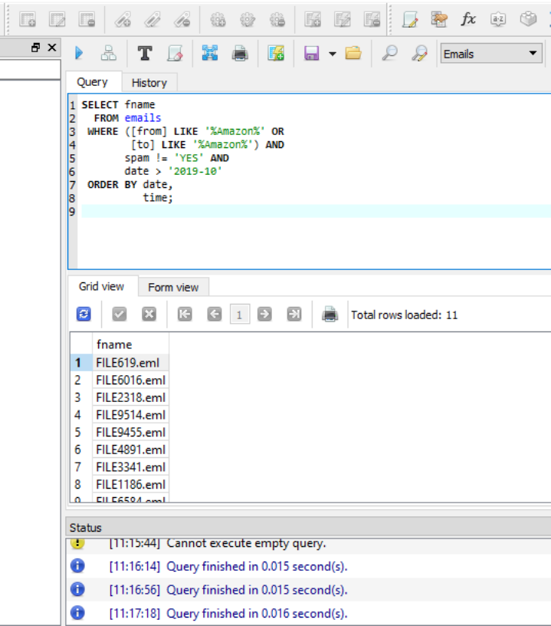

In this example 11 records were found.
A remark about brackets put around the column-names ‘from’ and ‘to’: this prevents the SQL-interpreter to see ‘from’ or ‘to’ as a reserved word and generates a syntax-error.

Now select the 'fname'-column and copy the content to a text file that you can name for instance 'Amazon.txt'. You can use Windows Notepad for that. This 'Amazon.txt'-file then looks like:

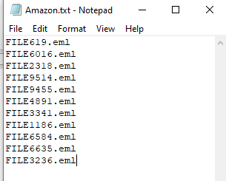

Now save this file (anywhere) for instance in your Download-folder.

Now use the option ‘Select emails’ from EmailManager:

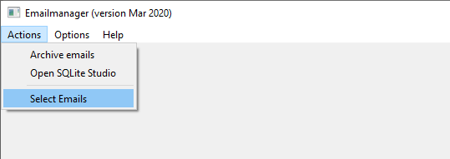

This will open an Open-File dialog in the default folder, that is the folder in which your emails are stored. Regardless of this default folder you can travel to the downloads folder and choose the file ‘Amazon.txt’

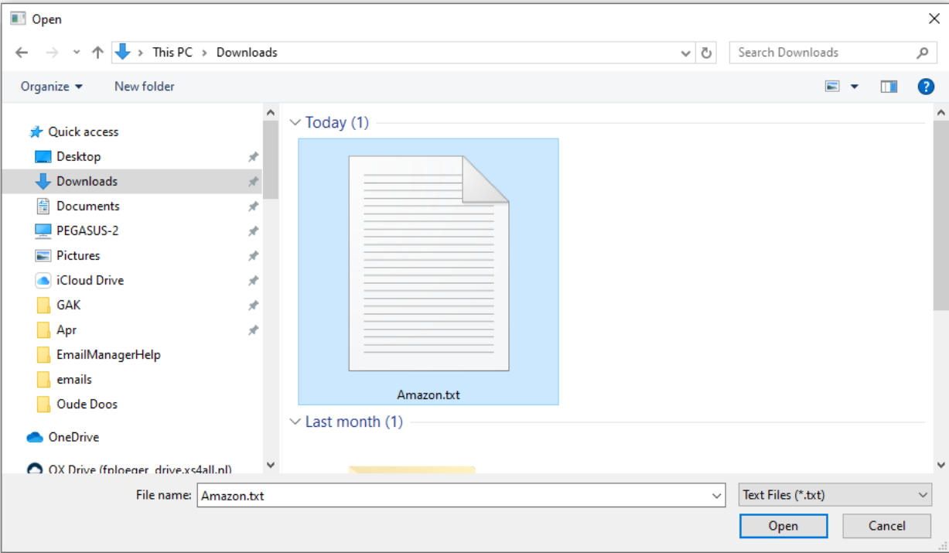

EmailManager than will create a folder Amazon in the same downloads folder with the emails you selected with the SQL-statements as above, however these files are now renamed FILE0001.eml (was FILE619.eml), FILE0002.eml (was FILE6016.eml), ..., FILE0011.eml (was FILE3236.eml).

So now you have the 11 emails in the order of Date and Time as found in SQLite Studio.

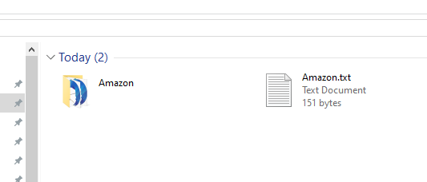

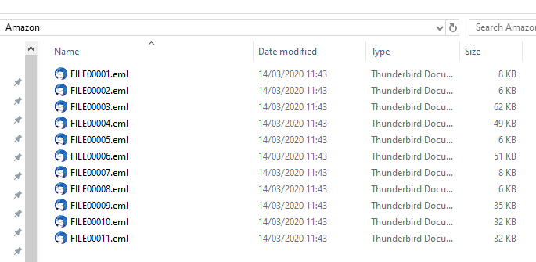

These files will open with your default emailprogram and are identical to the emails - including attachments - as when you received them.

