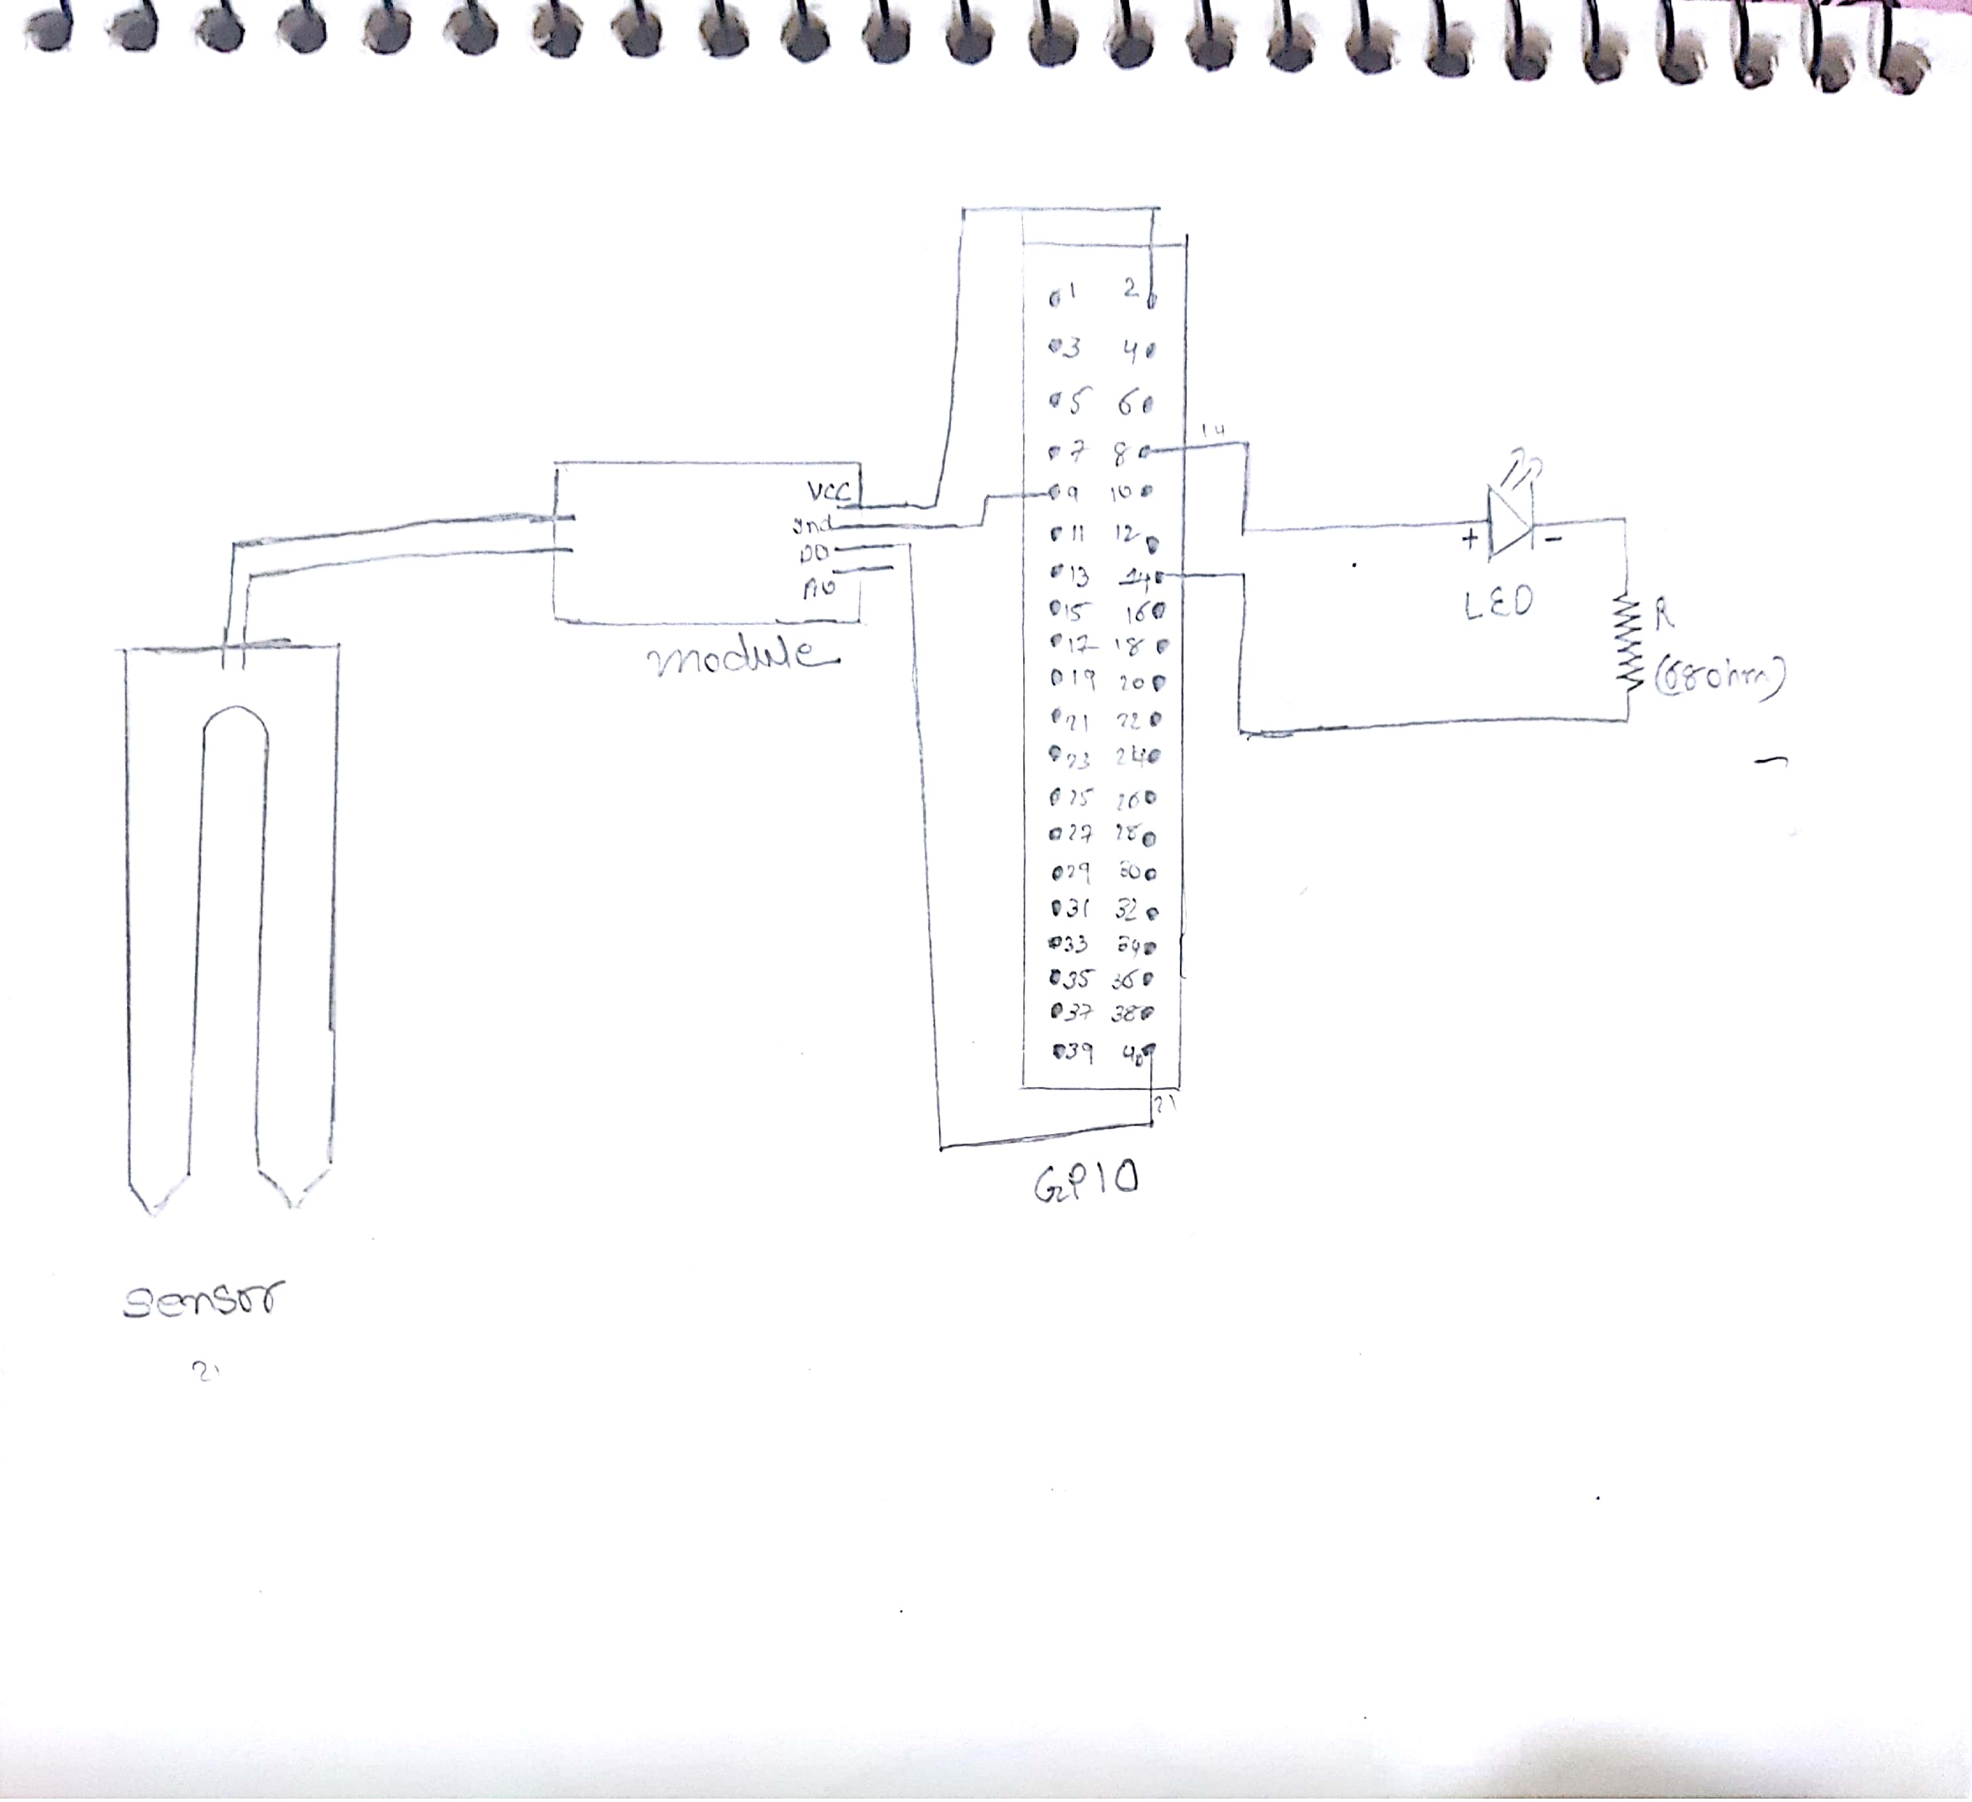

Here in image the connection is shown connect as same

Here I used

1 x Breadboard

1 x 68 Ohm resistor

1 x Through Hole (simple LED)

1 x moisture sensor and module