1. [SELECT](https://localhost/phpmyadmin/url.php?url=https://dev.mysql.com/doc/refman/8.0/en/select.html" \t "mysql_doc) \* FROM `obat` JOIN pabrik on obat.id\_pabrik = pabrik.id ORDER BY pabrik ASC;

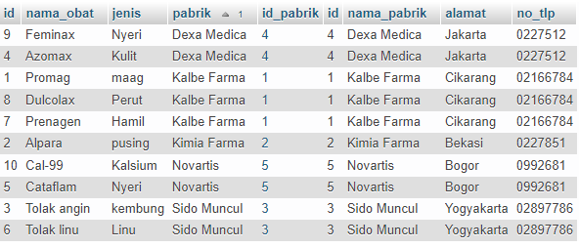

1. [SELECT](https://localhost/phpmyadmin/url.php?url=https://dev.mysql.com/doc/refman/8.0/en/select.html) \* FROM `obat` [LEFT](https://localhost/phpmyadmin/url.php?url=https://dev.mysql.com/doc/refman/8.0/en/string-functions.html#function_left) JOIN pabrik on obat.id\_pabrik = pabrik.id ORDER BY pabrik ASC;

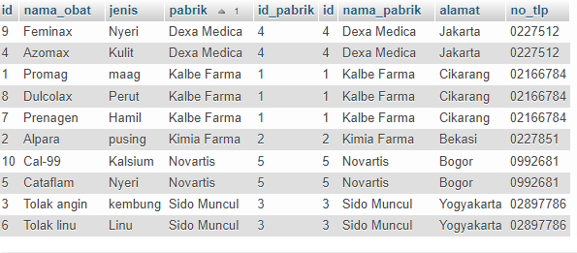

1. [SELECT](https://localhost/phpmyadmin/url.php?url=https://dev.mysql.com/doc/refman/8.0/en/select.html) \* FROM `pabrik` JOIN detail\_pabrik on detail\_pabrik.id\_pabrik = pabrik.id ORDER BY pabrik.id ASC;

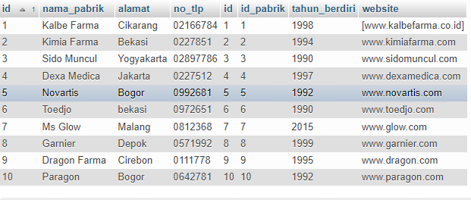

1. [SELECT](https://localhost/phpmyadmin/url.php?url=https://dev.mysql.com/doc/refman/8.0/en/select.html) \* FROM `pabrik` [RIGHT](https://localhost/phpmyadmin/url.php?url=https://dev.mysql.com/doc/refman/8.0/en/string-functions.html#function_right) JOIN detail\_pabrik on detail\_pabrik.id\_pabrik = pabrik.id ORDER BY pabrik.id ASC;

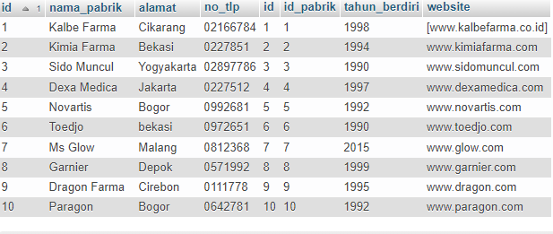

1. [SELECT](https://localhost/phpmyadmin/url.php?url=https://dev.mysql.com/doc/refman/8.0/en/select.html) pabrik.id, nama\_pabrik FROM `pabrik` [LEFT](https://localhost/phpmyadmin/url.php?url=https://dev.mysql.com/doc/refman/8.0/en/string-functions.html#function_left) JOIN detail\_pabrik  on detail\_pabrik.id\_pabrik = pabrik.id ORDER BY pabrik.id ASC;

