1. [SELECT](https://localhost/phpmyadmin/url.php?url=https://dev.mysql.com/doc/refman/8.0/en/select.html" \t "mysql_doc) \* FROM `obat` JOIN pabrik ON obat.id\_pabrik = pabrik.id JOIN detail\_pabrik ON obat.id\_pabrik = pabrik.id;

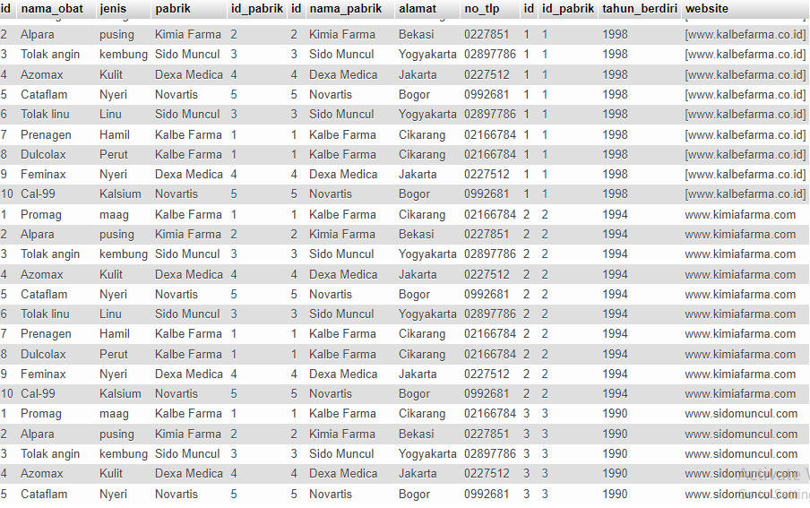

1. [SELECT](https://localhost/phpmyadmin/url.php?url=https://dev.mysql.com/doc/refman/8.0/en/select.html) obat.id\_pabrik, jenis, nama\_obat, pabrik FROM `obat` [RIGHT](https://localhost/phpmyadmin/url.php?url=https://dev.mysql.com/doc/refman/8.0/en/string-functions.html#function_right) JOIN pabrik ON obat.id\_pabrik = pabrik.id JOIN detail\_pabrik ON obat.id\_pabrik = pabrik.id;

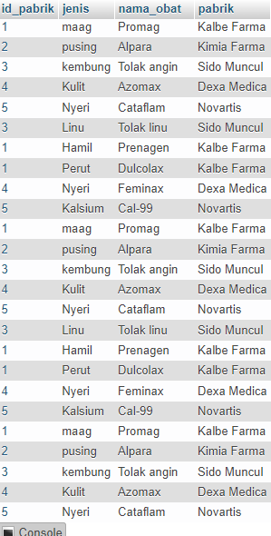

1. [SELECT](https://localhost/phpmyadmin/url.php?url=https://dev.mysql.com/doc/refman/8.0/en/select.html) obat.id\_pabrik, jenis, nama\_obat, pabrik FROM `obat` [RIGHT](https://localhost/phpmyadmin/url.php?url=https://dev.mysql.com/doc/refman/8.0/en/string-functions.html#function_right) JOIN detail\_transaksi ON obat.id = detail\_transaksi.id\_obat JOIN transaksi ON detail\_transaksi.id\_transaksi = transaksi.id;

