1. [SELECT](https://localhost/phpmyadmin/url.php?url=https://dev.mysql.com/doc/refman/8.0/en/select.html" \t "mysql_doc) \* FROM obat order by pabrik DESC;

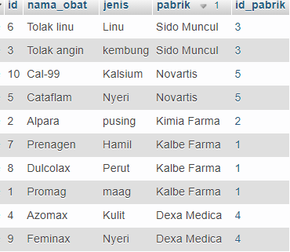

1. [SELECT](https://localhost/phpmyadmin/url.php?url=https://dev.mysql.com/doc/refman/8.0/en/select.html)\* FROM obat ORDER BY pabrik ASC;

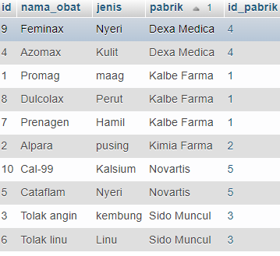

1. [SELECT](https://localhost/phpmyadmin/url.php?url=https://dev.mysql.com/doc/refman/8.0/en/select.html)\* FROM obat WHERE nama\_obat [LIKE](https://localhost/phpmyadmin/url.php?url=https://dev.mysql.com/doc/refman/8.0/en/string-comparison-functions.html#operator_like) '%pa%';



1. [SELECT](https://localhost/phpmyadmin/url.php?url=https://dev.mysql.com/doc/refman/8.0/en/select.html) id\_pabrik, [SUM](https://localhost/phpmyadmin/url.php?url=https://dev.mysql.com/doc/refman/8.0/en/group-by-functions.html#function_sum)(pabrik) as total FROM obat ORDER BY id\_pabrik;



1. [SELECT](https://localhost/phpmyadmin/url.php?url=https://dev.mysql.com/doc/refman/8.0/en/select.html) \* FROM obat WHERE nama\_obat [LIKE](https://localhost/phpmyadmin/url.php?url=https://dev.mysql.com/doc/refman/8.0/en/string-comparison-functions.html#operator_like) '%ag%';

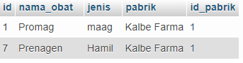

1. [SELECT](https://localhost/phpmyadmin/url.php?url=https://dev.mysql.com/doc/refman/8.0/en/select.html) [SUM](https://localhost/phpmyadmin/url.php?url=https://dev.mysql.com/doc/refman/8.0/en/group-by-functions.html#function_sum)(id\_obat) AS "total" FROM detail\_transaksi;



1. [SELECT](https://localhost/phpmyadmin/url.php?url=https://dev.mysql.com/doc/refman/8.0/en/select.html) [SUM](https://localhost/phpmyadmin/url.php?url=https://dev.mysql.com/doc/refman/8.0/en/group-by-functions.html#function_sum)(id\_pabrik) AS "Total Pabrik" FROM detail\_pabrik ORDER by id\_pabrik;



1. [SELECT](https://localhost/phpmyadmin/url.php?url=https://dev.mysql.com/doc/refman/8.0/en/select.html) \* FROM pembeli WHERE nama [LIKE](https://localhost/phpmyadmin/url.php?url=https://dev.mysql.com/doc/refman/8.0/en/string-comparison-functions.html#operator_like) '%in%';



1. [SELECT](https://localhost/phpmyadmin/url.php?url=https://dev.mysql.com/doc/refman/8.0/en/select.html) \* FROM detail\_transaksi WHERE harga [LIKE](https://localhost/phpmyadmin/url.php?url=https://dev.mysql.com/doc/refman/8.0/en/string-comparison-functions.html#operator_like) '%40000%';



1. [SELECT](https://localhost/phpmyadmin/url.php?url=https://dev.mysql.com/doc/refman/8.0/en/select.html) \* FROM detail\_transaksi ORDER BY harga ASC;

