[SELECT](https://localhost/phpmyadmin/url.php?url=https://dev.mysql.com/doc/refman/8.0/en/select.html" \t "mysql_doc) \* FROM obat;

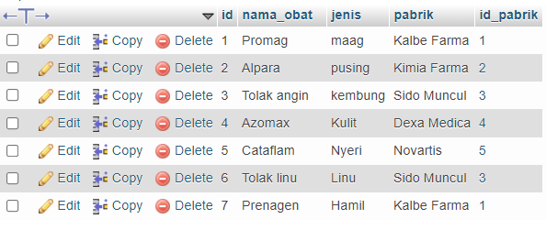

[SELECT](https://localhost/phpmyadmin/url.php?url=https://dev.mysql.com/doc/refman/8.0/en/select.html) \* FROM `obat` WHERE pabrik = 'Sido Muncul';

