Lab 1: Wave files and the pack function

*2.Write a Python script using the wav module to read and print basic information about your wav file. See the* *demo file read_wavefile_02.py. Verify that the provided information matches the intended properties of the wave file. For your 16-bit wav file, what is the value of width returned by getsampwidth()? Submit your recorded wav file,* *Python code, and* *written comments.*

**Recorded wav file:** jjs16.wav , jjs8.wav , jjs32.wave

**Python code:** myvoice.py

import wave

wf=wave.open('jjs16.wav')

a = wf.getnchannels()

print "number of channels is: ", a

b = wf.getframerate()

print "frame rate (number of frames per second) is: ",b

c = wf.getnframes()

print "total number of frames (length of signal) is", c

d = wf.getsampwidth()

print "number of bytes per frame is :", d

**written comments:**

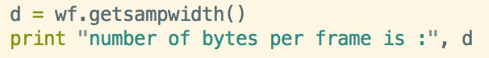



The value of width returned by getsampwidth() is 2, one byte is equal to 8-bit, so 16-bit is equal to two bytes.

I used the same record of my voice and save it as unsigned 8-bit PCM and signed 16-bit PCM, signed 32-bit PCM and all the wave’s frequency is 16000Hz. Since I used mono, so the channel is 1. The frame rate is equal to the frequency 16000 I have choosed. And the total number of frame changed due to the length of my sound wave. The number of bytes per frame changes due to the bit I choose to save. When I opened jjs16.wav, it came on 2. When I opened jjs8.wav, it came on 1. When I opened jjs32.wav, it came on 4.