9. Modify the Matlab demo program filter_cat.m to use different filters.

(d)  A Butterworth band-stop filter (instead of a band-pass filter).

Make plots showing the filters and input/output signals, as in the demo file. Comment on your observations.

%% filter_cat.m

%

% Band-pass filter demo

%% Load speech signal

clear

close all

[x, Fs] = audioread('cat01.wav');

Fs

soundsc(x, Fs)

%% Plot waveform

N = length(x);

t = (1:N)/Fs;

figure(1)

clf

plot(t, x)

xlabel('Time (sec)')

title('Speech signal')

xlim([0.2 0.6])

%% Fourier transform

% Use the FFT

% Use power of 2 for FFT speed

Nfft = 2^ceil(log2(N))

X = fft(x, Nfft); % X will be of length Nfft

X = fftshift(X);

fn = (-Nfft/2:Nfft/2-1)/Nfft; % fn : normalized frequency

f = Fs * fn; % f : frequency in Hz

figure(1)

clf

plot(f, abs(X))

xlabel('Frequency (Hz)')

title('Spectrum')

xlim([0 4000])

%% Make a filter

% Lets make a band-pass Butterworth filter

% Band-egdes (Hz)

%f1 = 700;

%f2 = 1500;

f1 = 300;

f2 = 2000;

% b, a : difference equation coefficients for Butterworth filter

% [b, a] = butter(2, [f1, f2]*2/Fs);

% [b, a] = cheby2(2,50,[f1, f2]*2/Fs); % why the figure more thin

[b, a] = butter(2, [f1, f2]*2/Fs, 'stop');

%% Frequency response

% Use 'freqz' to calculate the frequency response of the filter

[H, om] = freqz(b, a);

f_freqz = om*Fs/(2*pi);

plot(f_freqz, abs(H))

% plot(f_freqz, abs(H), [f1 f1], [0 1], 'r', [f2 f2], [0 1], 'r')

title('Frequency response of filter')

xlabel('Frequency (Hz)')

%% Pole-zero diagram

zplane(b, a)

%% Run the filter

% Run the signal x through the difference equation

y = filter(b, a, x); % y : output of filter

figure(1)

clf

plot(t, y)

xlabel('Time (sec)')

title('Filtered speech signal')

xlim([0.2 0.6])

%%

% Save output signal to wave file

Nbits = 16; % bits per sample

audiowrite('cat01_bpf.wav', y, Fs, 'BitsPerSample', 16)

%%

% Plot the input and output signal

% (vertical offset of 'y' to make the signal more clear)

figure(1)

clf

plot(t, x, t, y - 0.3)

legend('Input signal', 'Output signal')

xlabel('Time (sec)')

axis tight

xlim([0.25 0.5])

orient landscape

print -dpdf filter_cat_signals

%%

xlim([0.35 0.4])

%%

% List to the output signal

soundsc(y, Fs)

%% Frequency-domain plots

Y = fft(y, Nfft);

Y = fftshift(Y);

figure(2)

clf

subplot(3, 1, 1)

plot(f, abs(X))

xlabel('Frequency (Hz)')

title('Spectrum of input signal')

xlim([0 4000])

subplot(3, 1, 2)

plot(f_freqz, abs(H) )

xlabel('Frequency (Hz)')

title('Frequency response of filter')

xlim([0 4000])

subplot(3, 1, 3)

plot(f, abs(Y))% , f, abs(X))

xlabel('Frequency (Hz)')

title('Spectrum of output signal')

xlim([0 4000])

orient tall

print -dpdf filter_cat_freq

%% Exercises

%

% Use a higher-order Butterworth filter. Compare.

%

% Use a Chebyshev filter instead of a Butterworth filter (cheby1 or cheby2

% in Matlab).

%

% Use an Elliptic filter instead of a Butterworth filter (ellip in Matlab)

%

% (For later) Implement the filter in real-time in PyAudio

% on the same wavefile. Read the wavefile into Python,

% implement a difference equation, and play the output signal

% as you calculate it.

**Figure 1 : Frequency**

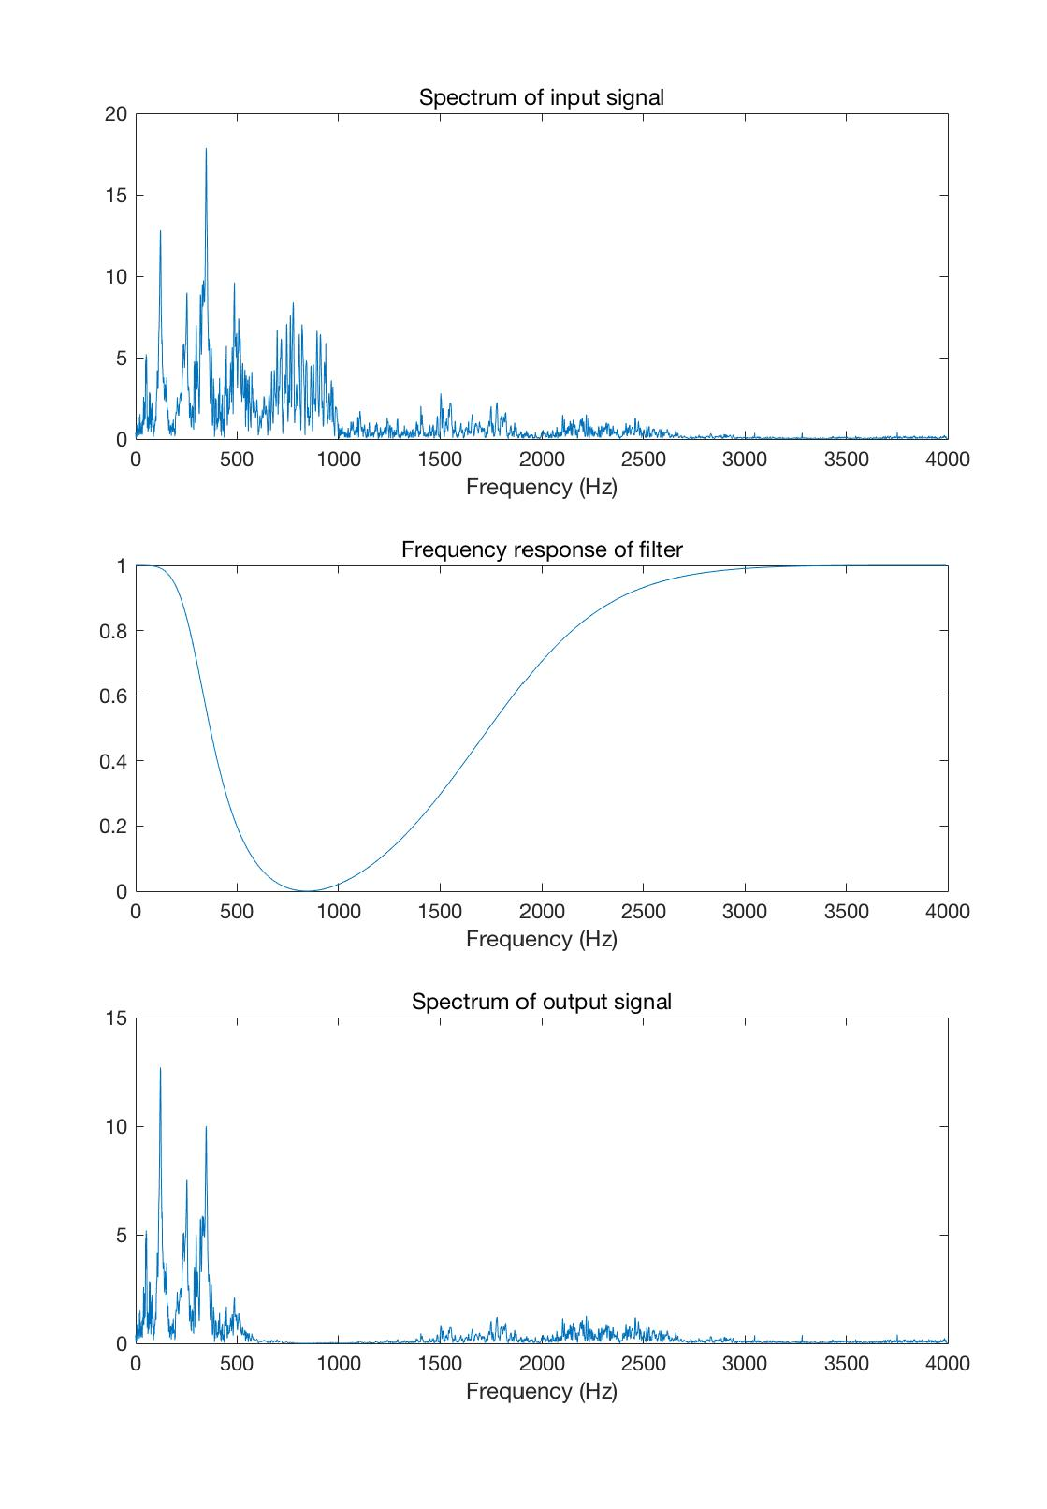

**Figure 2: Input and output signal**

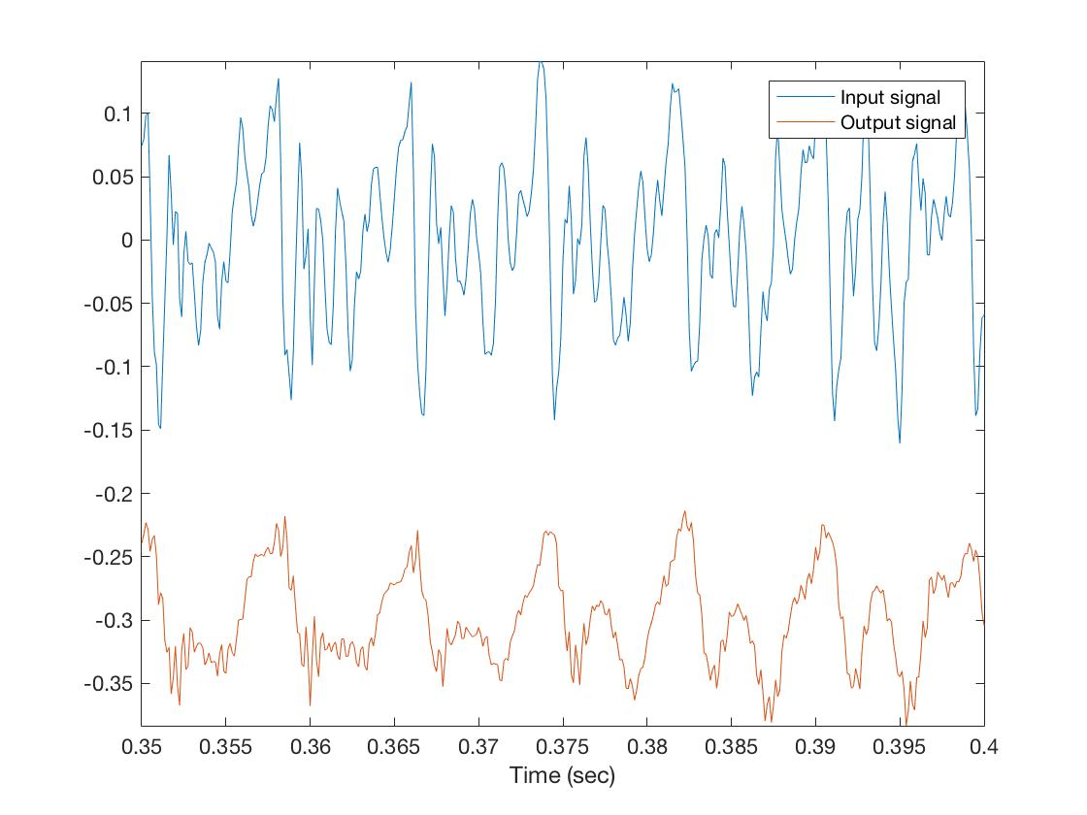

**Comment:**

I change the rank of frequency from 700-1500 to 300-2000, since it could show a clearer figure.

From figure 1 I can see that frequency from 300-2000 has been almost removed through filter, when compare input and output figure of frequency. (Actually it is removed from 500 to 1500 since frequency response is in decrease at 300-500 and increase at 1500-2000, thus the filter may not work well in these rank. )

In figure 2 , it shows that output signal is shorter when compare with input signal, because the signal at frequency in 300-2000 has been cut off through the band-stop filter.

Also, I change wavwrite to audiowrite when save output signal to wav file and save it as 16 bits.