17_3:

**Real-time complex AM:**

From the Matlab demo I found that complex AM requires to design a complex filter for the input signal. To see the function of this filter, I plot the fft of input signal (x) and filtered signal (r). The picture shows below:

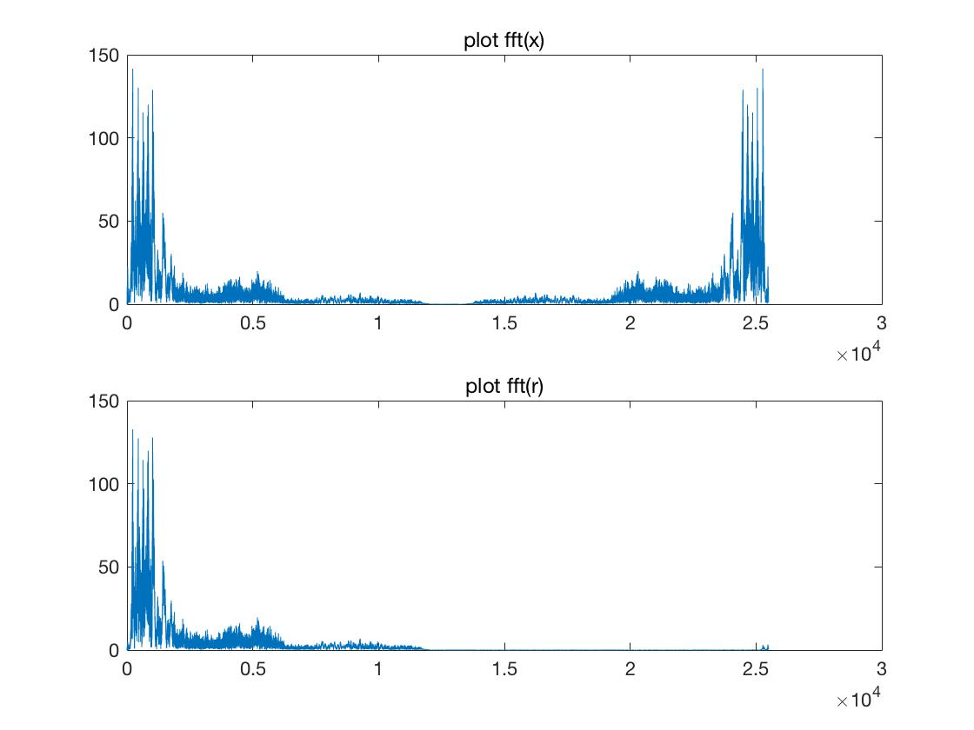

The filter has moved off half of the input signal on the spectrum. Then make AM on the filtered signal (g), it means multiply ewj, at last it preserves the real part of the signal (y), making the output signal conjugative symmetry.

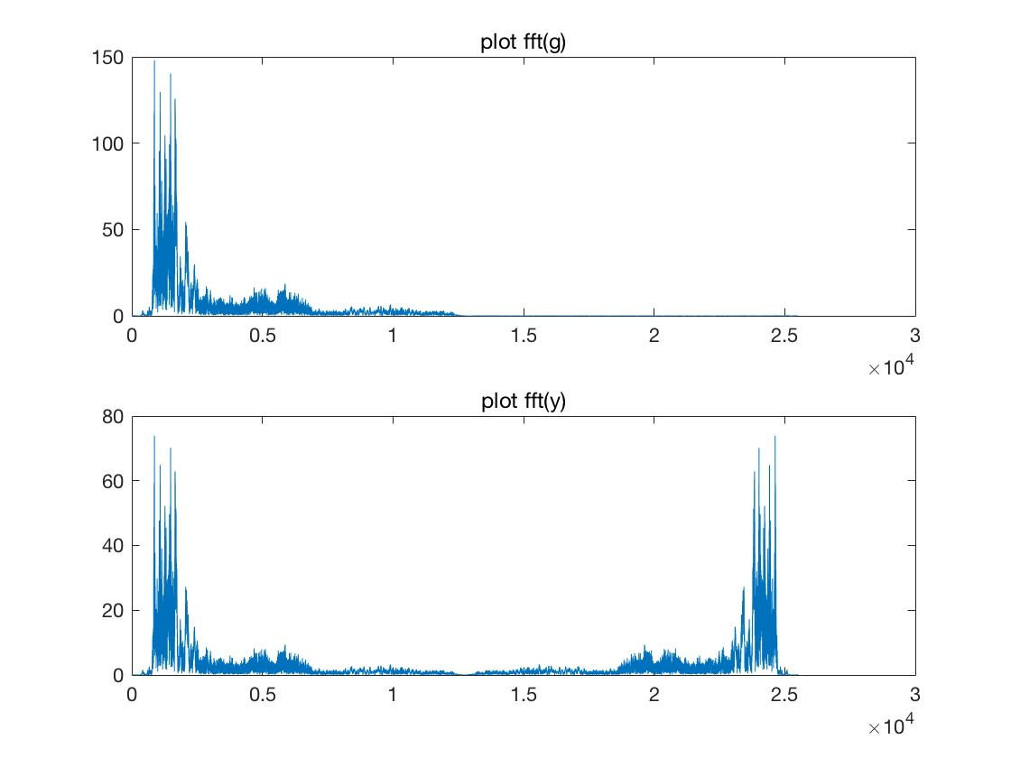

This method moves off the overlap of real AM. The spectrum of the output signal is a shift of the input signal.

In the python code I get the fft spectrum as following:

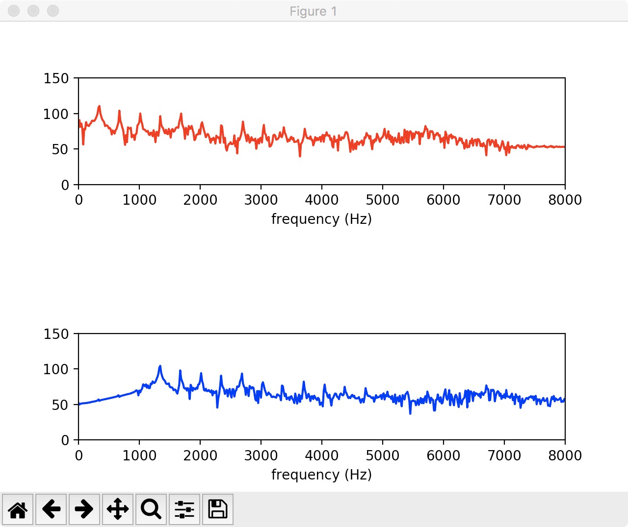

**Real-time real AM:**

Comparing with the earlier exercise 14, the program is an real AM

cosθ = ½(ejθ +e-jθ)

So H(ejw) = ½ H(ej(w-θ))+ ½H(ej(w+θ)),

