1.

|  |  |  |
| --- | --- | --- |
|  | Discovery time | Finishing time |
| A | 1 | 16 |
| B | 17 | 18 |
| C | 11 | 14 |
| D | 4 | 9 |
| E | 19 | 20 |
| F | 3 | 10 |
| G | 6 | 7 |
| H | 2 | 15 |
| I | 5 | 8 |
| M | 12 | 13 |

There are five strongly connected components:{E},{B},{A},{H,M,C},{F,G,I,D}

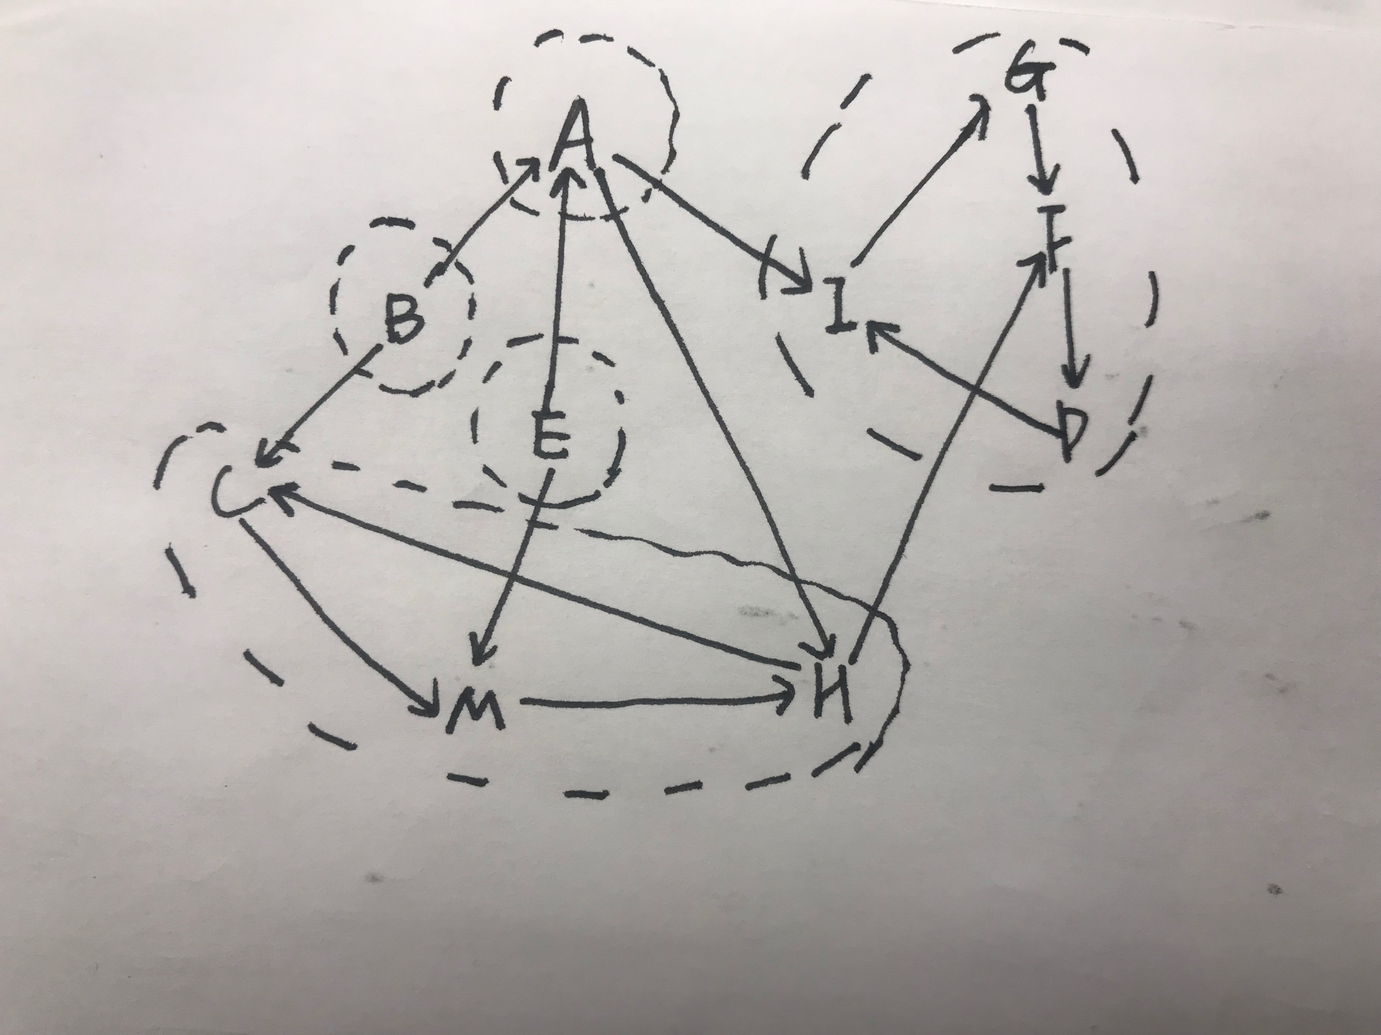

2.The edges which are added into A (c,f),(g,h),(a,c),(b,d),(e,d),(f,h),(e,f),(g,i).

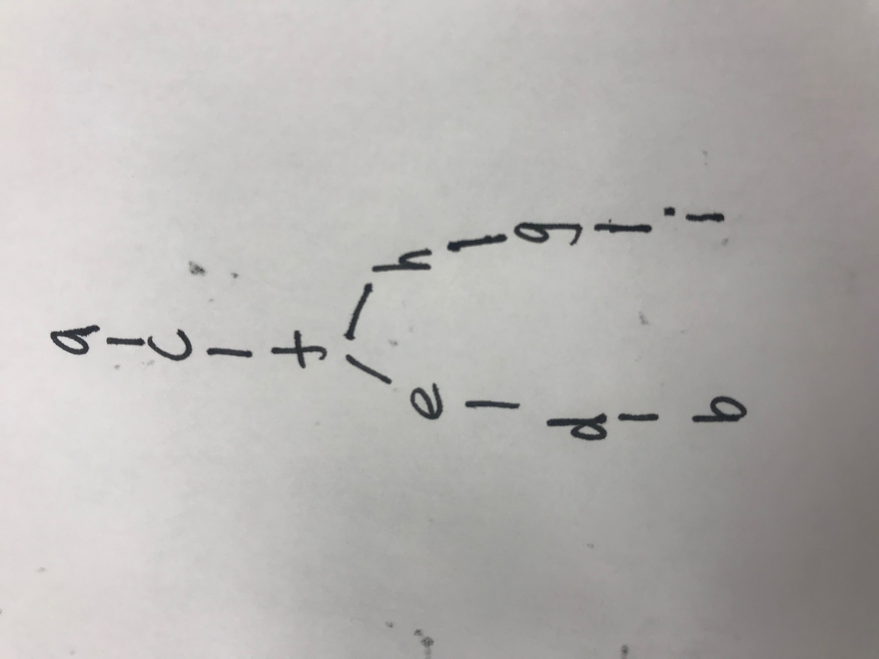

3.

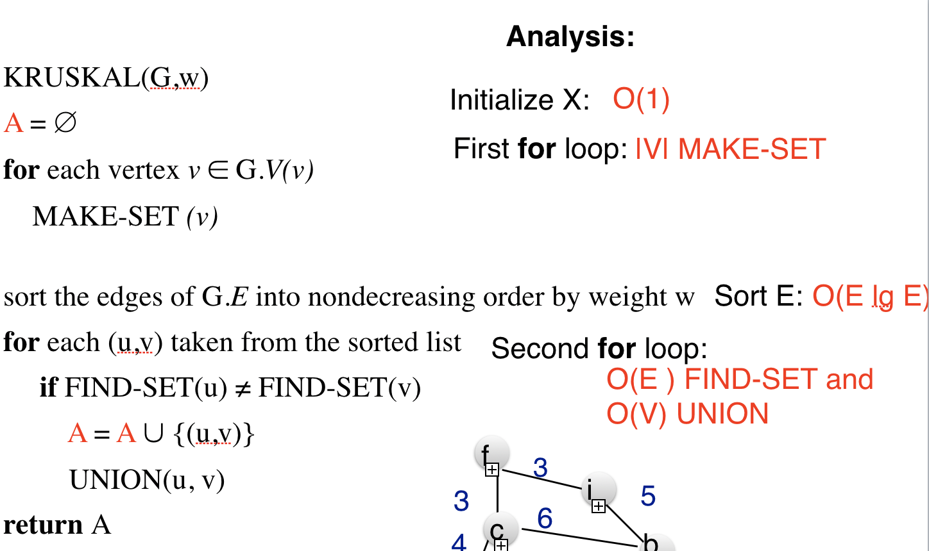

Because the running time of MAKE_SET is O(log|V|), FIND_SET is O(log|V|), UNION is O(log|V|),

first for loop:O(|V|log|V|)

sort E: O(|E|log|E|)

second for loop: O(E log|V|)+O(|V|log|V|)

Therefore, the running time of the algorithm is O(|V|log|V|+|E|log|E|)

4.The simpler algorithm does not always produce correct results.

Consider a counter-example like:

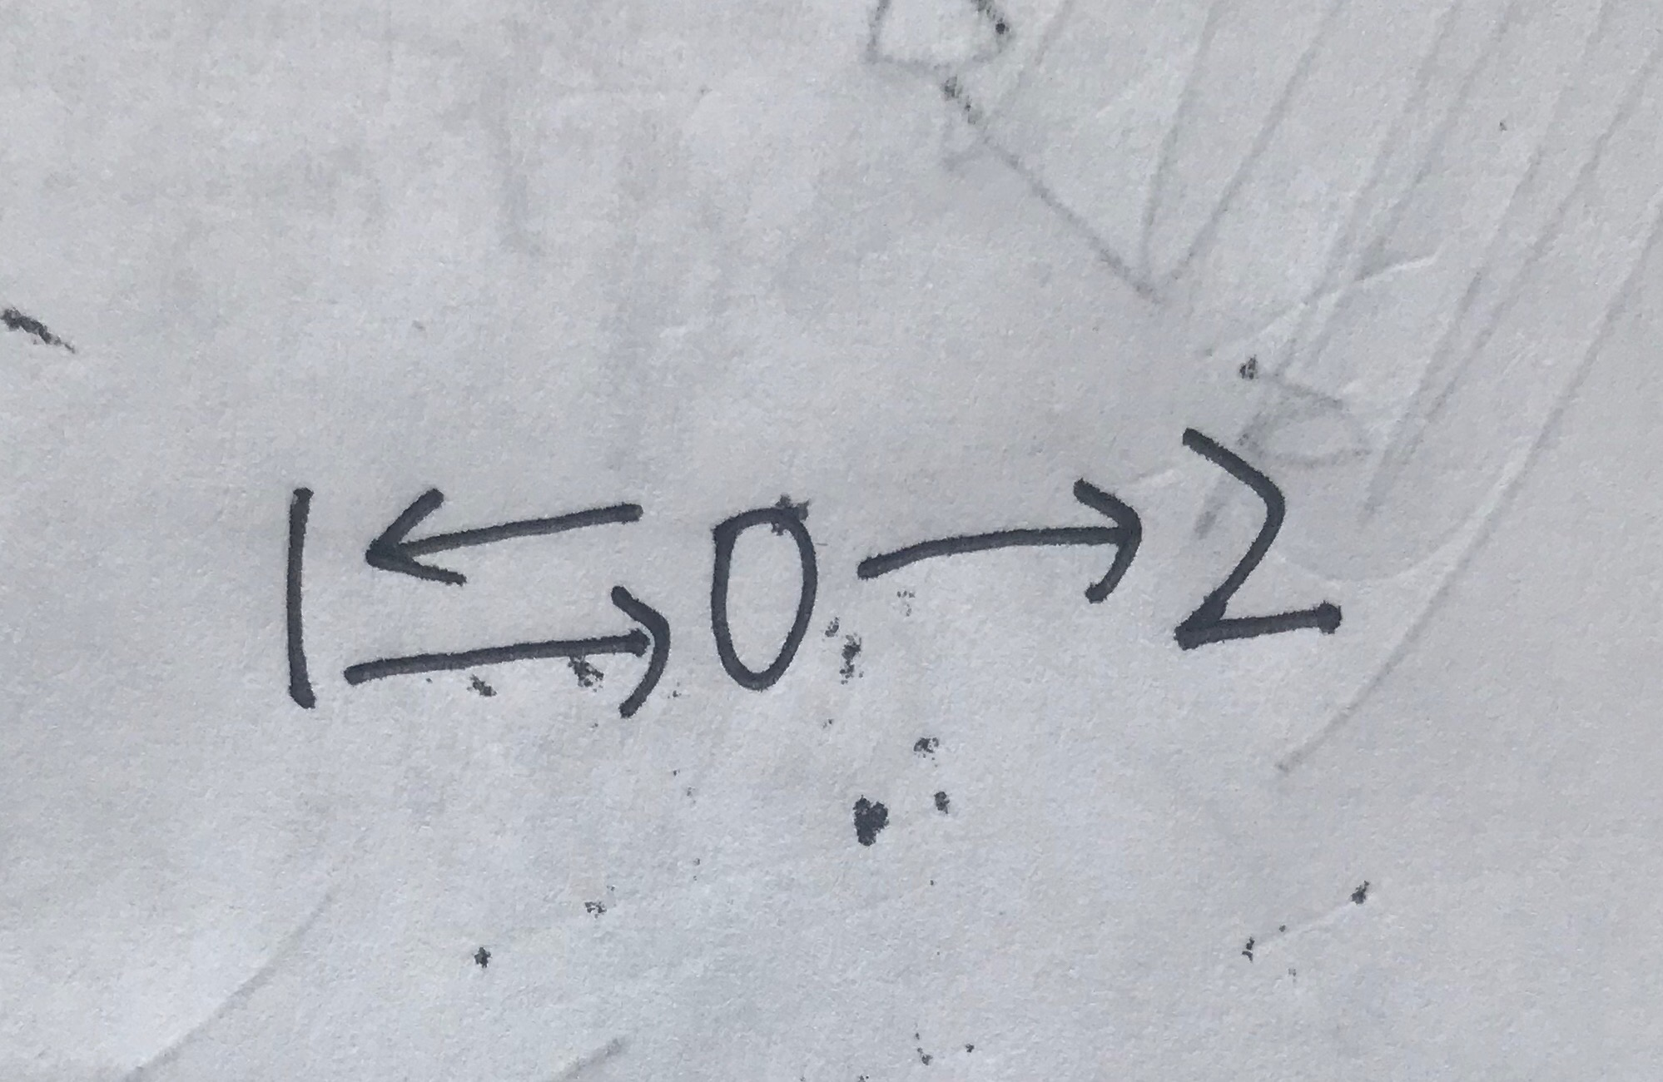

The first DFS beginning with 0 will result in the following finishing time order:1,2,0, the second execution of DFS will show all vertices are in the same strongly connected component because 1 is reachable to both 0 and 2, however, this graph definitely has two strongly connect component which are {0,1},{2}. So the simpler algorithm is wrong.

5.For each ship, according to the distance between it and the safe polities for it, we make a min_heap, whose running time is O(n), and the we take the minimum from the heap in O(1).