Problem 1

(a)

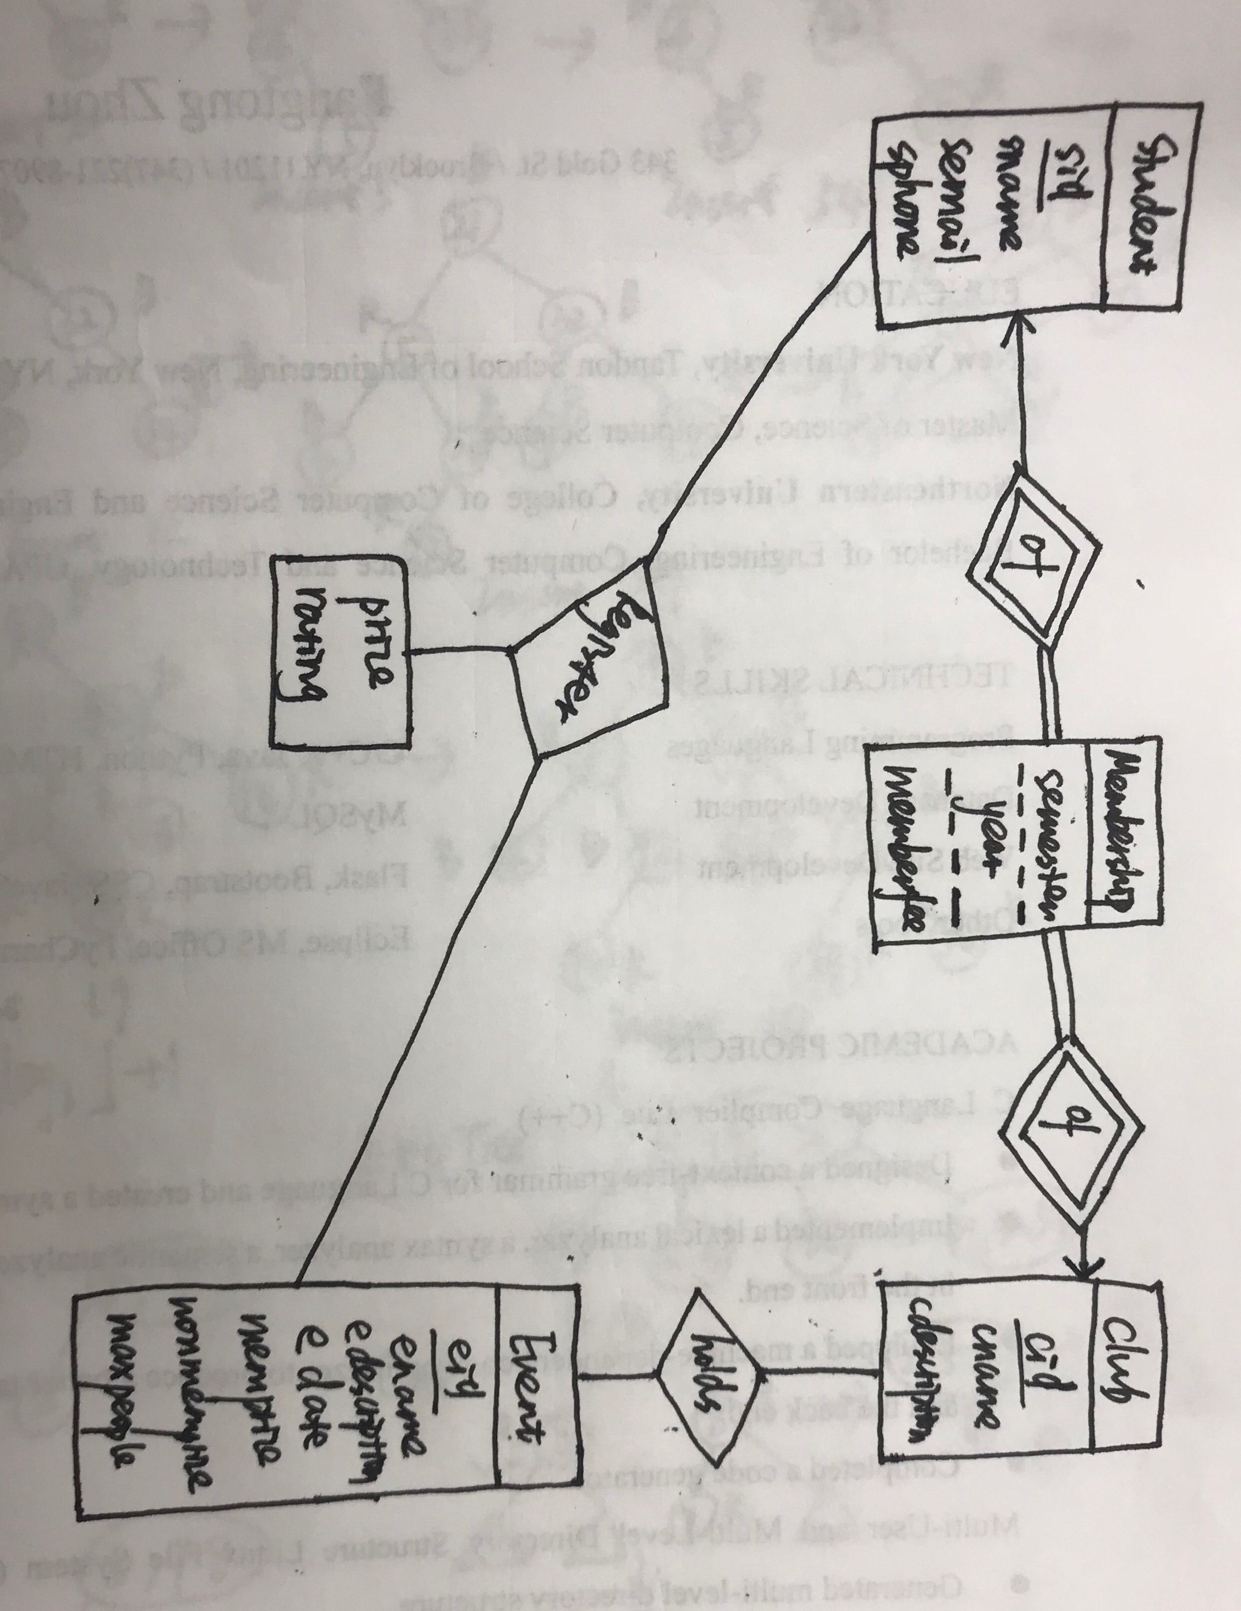

Membership is a weak entity.

(b)(sid,cid) is a foreign key in Membership table.

(eid,cid) is a foreign key in HoldsEvent table.

(eid, sid) is a foreign key in Register table.

(c) I would delete HoldsEvent table, and insert an attribute of cid into Event table.

(d)I assume nonmember price is the same for the same event. Then I would delete the attribute of memprice from Event table, and add it into HoldsEvent table.

(f)

(i) select S.sid, count(R.eid),sum(price)

from Student S left outer join Register R on S.sid=R.sid, Event E

where E.edate between '2018-09-04 00:00:00' and '2018-12-21 00:00:00'

and E.eid=R.eid

group by sid;

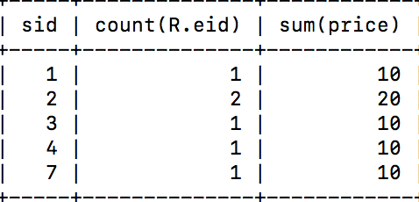

(ii) select E.eid, E.ename

from Event E,(select eid,count(*) as n

from HoldsEvent

group by eid) Num

where E.eid = Num.eid and Num.n >=all(select count(*) as p

from HoldsEvent

group by eid);

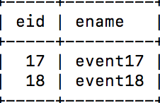

(iii) select T.id

from (select distinct R.sid as id

from Register R natural join HoldsEvent H, Club C,Membership M

where C.cid= H.cid and C.cname="chess club" and M.sid!=R.sid and M.cid=C.cid and M.semester="Fall" and M.year=2017

) as T, Register R natural join Event E,HoldsEvent H,Club C

where R.sid=T.id and R.eid=H.eid and H.cid=C.cid and month(edate)>8 and year(edate)=2017

group by T.id

having sum(R.price)>(select distinct memberfee

from Membership M natural join Club C

where c.cname="chess club");

result:

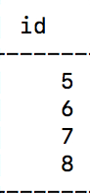

(iv) select sid

from Membership M

where (M.semester="Fall" and M.year=2015) or M.year>2015

group by sid,cid

having count(*)>=7

I have inserted some values to table Membership

insert into Membership values(8,1,'spring',2015,10),

(8,1,'Fall',2015,10)

(8,1,'spring',2016,10),

(8,1,'spring',2017,10),

(8,1,'Fall',2016,10);

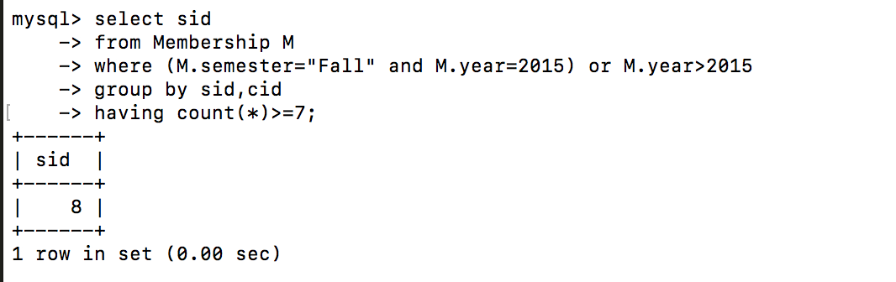

(v) select cname

from Club C, HoldsEvent H

where C.cid=H.cid and H.eid = all(select eid

from Register

group by eid

having avg(rating)>4);

result:

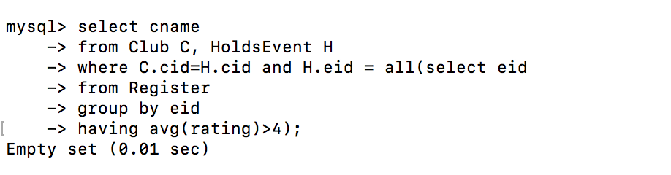

(vi) select C1.cname, C2.cname

from HoldsEvent H1 join HoldsEvent H2 on H1.eid=H2.eid, Club C1,Club C2

where C1.cid=H1.cid and C2.cid=H2.cid and H1.cid>H2.cid

group by H1.cid, H2.cid

having count(*)>=5

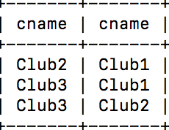

(vii) select distinct S.sname

from Register R natural join Student S,Membership M,(select H1.eid as id

from HoldsEvent H1, HoldsEvent H2, Club C1, Club C2

where H1.eid=H2.eid and H1.cid=C1.cid and C1.cname ="chinese student association" and H2.cid=C2.cid and C2.cname="Japanese student association") as T

where R.eid=T.id and S.sid not in (select sid

from Membership M natural join Club C

where C.cname ="chinese student association" or C.cname="Japanese student association");

I have inserted a record into table Holdsevent: insert into HoldsEvent(eid,cid) values(1,5)

result:

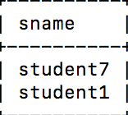

(g)

(iii)

(iv)

(v)

(vi)

(vii)

(h)

(i) insert into Membership

select R.sid,H.cid,"Fall",2018,0

from Register R natural join HoldsEvent H,Event E

where month(edate)>8 and year(edate)=2018 and E.eid= R.eid and (R.sid,H.cid) not in(select sid,cid from Membership where semester="Fall" and year=2018)

group by R.sid,H.cid

having count(*)>5

(ii) delete from Student

where sid not in (select sid from Membership) or sid not in(select sid from Register);

(iii)insert into Event(ename, edescription, edate, memprice,nonmemprice,maxpeople) values("Halloween Party","Fun",'2018-10-10',10,20,50);

insert into HoldsEvent values(20,15);

insert into HoldsEvent values(20,1);

Problem 2

(a) create view SC as

select S.sid,S.sname,C.cid, C.cname

from Student S left outer join Membership M on S.sid=M.sid,Club C

where M.semester="Fall" and M.year=2018 and C.cid=M.cid;

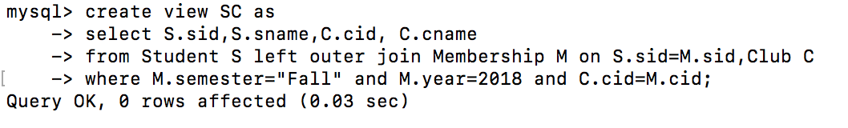

(i) select count(*)

from SC

where sname="John Myers";

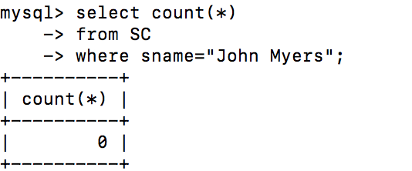

(ii) create view S_num as

select sid, sname,count(*)

from SC natural join Register R,HoldsEvent H natural join Event E

where month(edate)>8 and year(edate)=2018 and SC.cid=H.cid

group by sid,sname,SC.cid

(iii) select *

from S_num

where sname="student8";

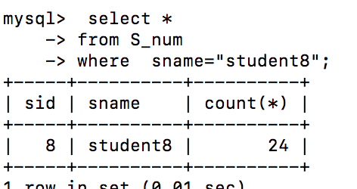

(iv)drop view SC;

drop view S_num;

(b) create trigger delete after update

on Membership for each row

referencing new row as nrow

when(nrow.sid in (select M.sid

from Membership M outer left join Register R on S.sid=R.sid,Event E

where year(edata)>=2016 and E.eid=R.eid

group by M.sid

having count(*)=0))

begin

delete * from Membership where sid=nrow.sid

end;

(c) ccreate trigger increase after insert

on Register for each row

referencing new row as rnow

when((select count(R.sid) from Register R where R.eid=nrow.eid)>=(select 0.8*maxpeople from Event E where E.eid =nrow.eid))

begin

update Event set nonmemprice=1.5*nonmemprice where eid=nrow.eid;

end;

Problem3

(a)

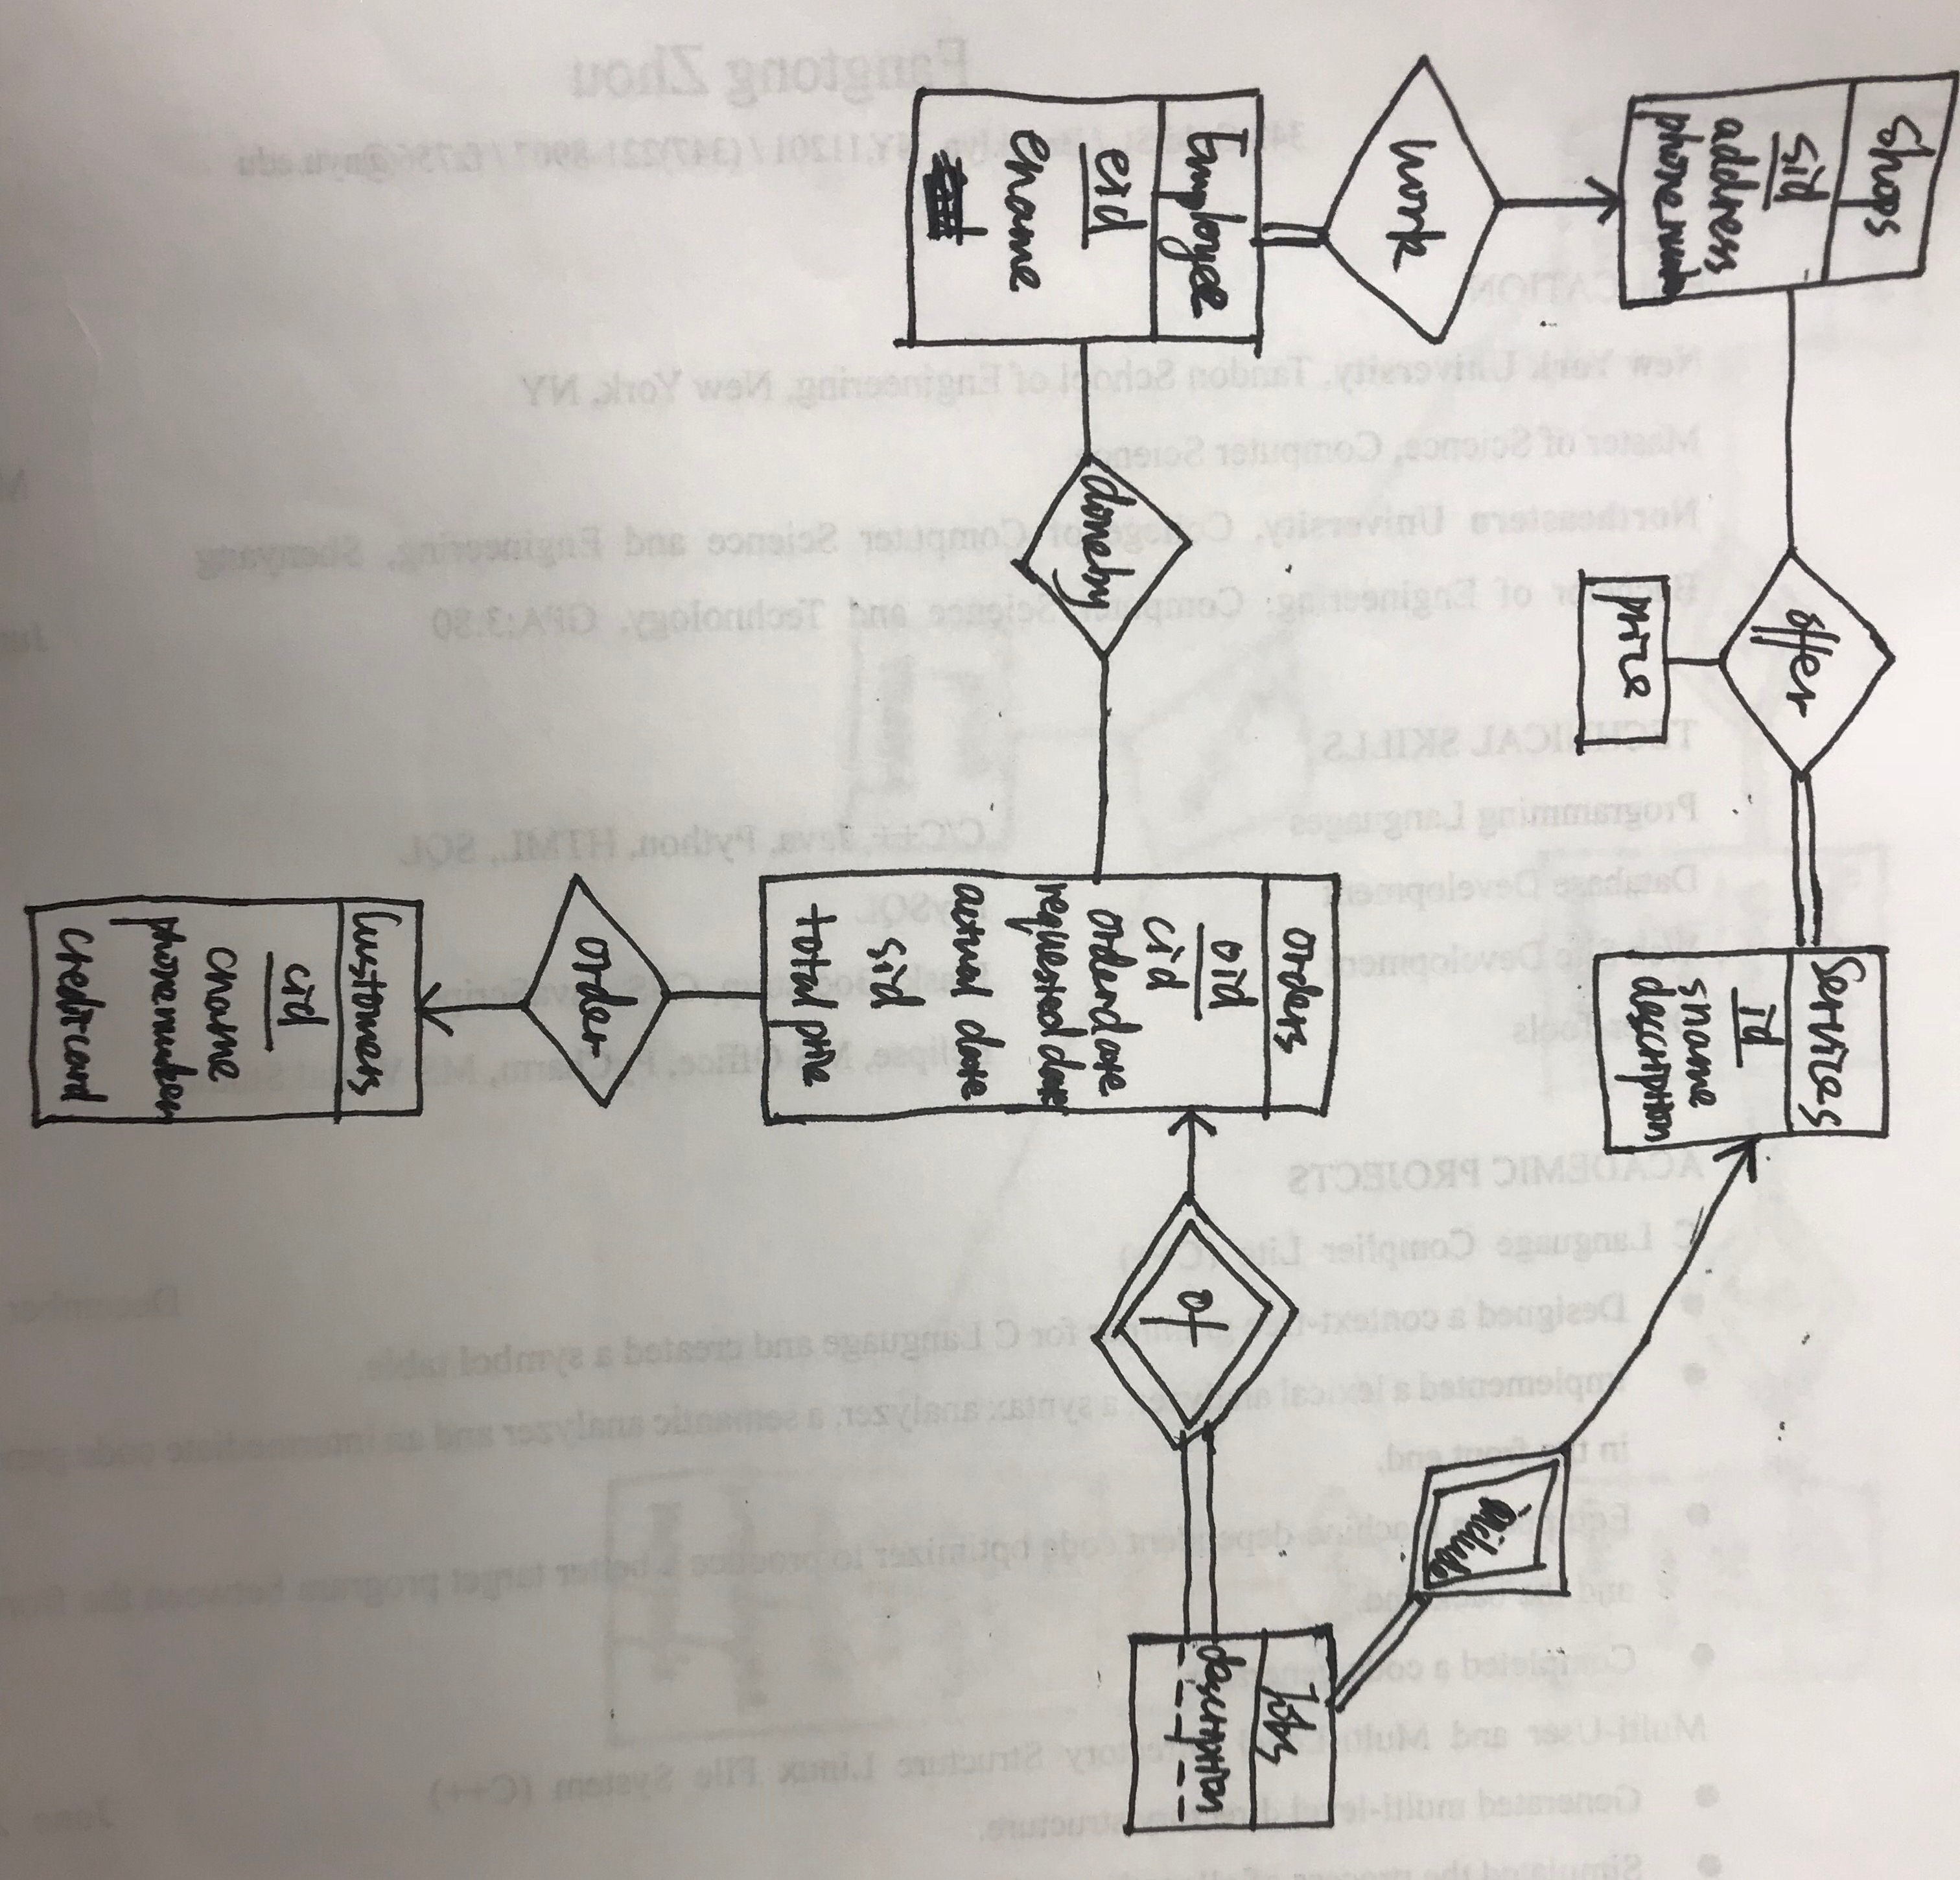

I assume that in one order there may be some jobs which are the same kind of service, so I can use description in jobs table to tell them.

And Jobs is a weak entity.

(b)Shops (sid, address, phone number)

Services (id, sname, description)

Offer (sid, id, per price)

Employees (eid, ename, sid)

Customers (cid, cname, phone number, credit card)

Orders (oid, cid, orderdate, requested date, actual completion date, sid, total price)

Jobs (oid, id ,decription, amount)

Doneby(oid,eid)

(c)

(i) select count(oid), sum(total_price)

from Customers natural join Orders

where cname="Jhon Myers" and year(order_date)=2017;

(ii) select count(sid)

from (select sid

from offer

group by sid

having count(id) =(select count(id) from Services)) as T;

(iii) select E.eid, delay.num/count(D.oid)

from Employees E left outer join Doneby D on E.eid=D.eid,(select E.eid, count(O.oid) as num

from Orders O, Employees E left outer join Doneby D on E.eid=D.eid

where O.oid= D.oid and to_days(O.actual_completed_date)-to_days(O.requested_date)>1

group by E.eid) as delay

where E.eid =delay.eid

group by eid

(iv) select cid, cname

from Customers C natural join Orders O,Jobs J , Services S

where O.oid=J.oid and S.sname="color copying" and J.id=S.id and C.cid in (select cid

from Customers C natural join Orders O,Jobs J,Services S

where O.oid=J.oid and S.sname="shipping" and J.id=S.id);

(d)Sample data:

insert into Shops(address, phone_number) values("343 Gold","1234567890"),

("Avalon Fort Greene","1234567890"),

("Avalon Dobro","1234567890"),

("The Eagle","1234567890"),

("Hoyt and Horn","1234567890");

insert into Services(sname,decription)values("color copying","decription"),

("shipping","decription"),

("printing","decription"),

("blinding","decription"),

("scanning","decription");

insert into offer values(1,1,2),

(1,2,2),

(1,3,2),

(1,4,5),

(1,5,1);

insert into Employees(ename,sid) values("Evelyn",1),

("Emily",2),

("Alice",3),

("Ying",4),

("Bao",5);

insert into Customers(cname,phone_number,credit_card)values("Jhon Myers","1234567890","1234567890"),

("Evelyn","1234567890","1234567890"),

("Happy","1234567890","1234567890"),

("Ying","1234567890","1234567890"),

("Boston","1234567890","1234567890");

insert into Orders(cid,order_date,requested_date,actual_completed_date,sid,total_price) values(1,'2017-10-10','2017-11-11','2017-11-23',1,100),

(2,'2017-01-23','2017-03-03','2017-03-03',2,23),

(3,'2018-01-01','2018-02-01','2018-02-01',3,200),

(2,'2018-07-01','2018-09-02','2018-09-09',3,30),

(4,'2017-08-08','2017-09-09','2018-11-11',4,200);

insert into Jobs values(1,1,10,10),

(1,2,10,10),

(2,1,10,10),

(2,2,19,20),

(3,1,34,100);

insert into Doneby values(1,1),

(1,2),

(1,3),

(2,3),

(3,4),

(4,5);

(i)

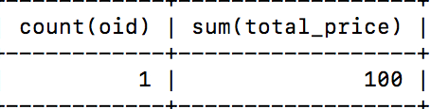

(ii)

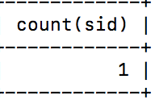

(iii)

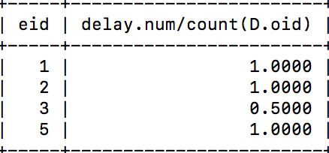

(iv)

