**PROJECT ON**

New Project Ltd Database Management



**Executing the Solution**



: Eke Ferdinand & Habib Hassan

: August 26, 2018

Name of Developer

Date of Submission

Name of the Coordinator : Mr. Imoh

: August 5, 2018

: August 26, 2018

Start Date End Date

**TimeCard Database Management System**

**(Project Title)**



**CERTIFICATE**

This is to certify that this report titled *New Project ltd Database Management System* embodies the original work done by **Eke Ferdinand & Habib Hassan**in partial fulfillment of their course requirement at NIIT.

Coordinator:

*Mr. Imoh*

**ACKNOWLEDGEMENT**

We would love to thank Mr. Imoh and other faculty members for each and every suggestion given to us in driving this project to the finish.

**System Summary:** New Project Ltd. is a leading company in the United States that provides staff on contract for various software project assignments. The company has offices in Texas, Washington, and New York.

The company is known for providing qualified and skilled staff that can fulfill the project requirements efficiently. New Project employs professionals from various fields to match the requirement of its clients.

**SYSTEM ANALYSIS**

**DATABASE DESIGN**

**Database Name**: *ProcessIT*

**Number of Schemas**: *4*

**Schema Names**:

## Payment

* + 1. *ProjectDetails*
    2. *CustomerDetails*
    3. *HumanResources*

**Number of tables**: *9*

**Table Names**:

1. *CustomerDetails.Clients*
2. *HumanResources.Employees*
3. *ProjectDetails.Projects*
4. *Payment.PaymentMethod*
5. *Payment.Payments*
6. *ProjectDetails.WorkCodes*
7. *ProjectDetails.ExpenseDetails*
8. *ProjectDetails.TimeCards*
9. *ProjectDetails.TimeCardExpenses*

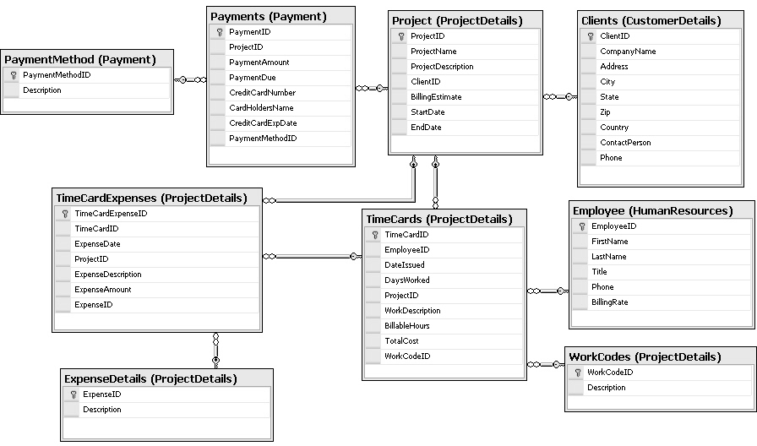

**SCHEMATIC DIAGRAM OF THE DATABASE**

**E-R DIAGRAM OF THE DATABASE**

for

for

For

Payment

Clients

Project

Payment Method

has

for

TimeCards

Employee

has

for

TimeCard Expenses

WorkCodes

for

for

ExpenseDetails

Relationship

Entities

Attributes => properly explained in the following Entity/Table Structure

**TABLE DESIGN**

|  |  |  |  |
| --- | --- | --- | --- |
| ***Field Name*** | ***Data type*** | ***Width*** | ***Description*** |
| *CustomerID* | *int* |  | *Customer number* |
| *CompanyName* | *varchar* | *30* | *Company name* |
| *Address* | *varchar* | *50* | *Customer address* |
| *City* | *varchar* | *20* | *Customer city* |
| *State* | *varchar* | *200* | *Customer state* |
| *Zip* | *int* |  | *Zip code* |
| *Country* | *char* | *30* | *Customer Country* |
| *ContactPerson* | *varchar* | *30* | *Contact Person* |
| *Phone* | *varchar* | *30* | *Phone number* |

CustomerDetails.Clients

|  |  |  |  |
| --- | --- | --- | --- |
| ***Field Name*** | ***Data type*** | ***Width*** | ***Description*** |
| *EmployeeID* | *int* |  | *Employee number* |
| *FirstName* | *varchar* | *30* | *Employee first name* |
| *LastName* | *varchar* | *30* | *Employee last name* |
| *Title* | *char* | *10* | *Employee designation* |
| *Phone* | *varchar* | *30* | *Phone number* |
| *BillingRate* | *int* |  | *Billing rate* |
|  |  |  |  |

HumanResources.Employees

|  |  |  |  |
| --- | --- | --- | --- |
| ***Field Name*** | ***Data type*** | ***Width*** | ***Description*** |
| *ProjectID* | *int* |  | *Project number* |
| *ProjectName* | *varchar* | *30* | *Project name* |
| *ProjectDescription* | *varchar* | *100* | *Project Description* |
| *ClientID* | *int* |  | *Client number* |
| *BillingEstimate* | *money* |  | *Billing Estimate* |
| *StartDate* | *date* |  | *Project start date* |
| *EndDate* | *date* |  | *Project end date* |

ProjectDetails.Projects

|  |  |  |  |
| --- | --- | --- | --- |
| ***Field Name*** | ***Data type*** | ***Width*** | ***Description*** |
| *PaymentMethodID* | *int* |  | *Payment mrethod* |
| *Description* | *varchar* | *30* | *Payment Descriptio* |

Payment.PaymentMethod

|  |  |  |  |
| --- | --- | --- | --- |
| ***Field Name*** | ***Data type*** | ***Width*** | ***Description*** |
| *PaymentID* | *int* |  | *Payment number* |
| *ProjectID* | *int* |  | *Project number* |
| *PaymentMethodID* | *int* |  | *Payment Method* |
| *PaymentAmount* | *int* |  | *Payment amount* |
| *PaymentDue* | *int* |  | *Payment Due* |
| *PaymentDate* | *date* |  | *Date of Payment* |
| *CreditCardNumber* | *Varchar* | 30 | *Credit Card number* |
| *CardHoldersName* | *Varchar* | 30 | *Card holders’ name* |
| *CreditCardExpDate* | *date* |  | *Card Expiry Date* |

Payment.Payments

|  |  |  |  |
| --- | --- | --- | --- |
| ***Field Name*** | ***Data type*** | ***Width*** | ***Description*** |
| *WorkCodeID* | *int* |  | *Work code number* |
| *Description* | *varchar* | *50* | *Work description* |

ProjectDetails.WorkCodes

|  |  |  |  |
| --- | --- | --- | --- |
| ***Field Name*** | ***Data type*** | ***Width*** | ***Description*** |
| *ExpenseID* | *int* |  | *Expense number* |
| *Description* | *varchar* | *100* | *Expense Description* |

ProjectDetails.ExpenseDetails

|  |  |  |  |
| --- | --- | --- | --- |
| ***Field Name*** | ***Data type*** | ***Width*** | ***Description*** |
| *TimeCardID* | *int* |  | *Time Card number* |
| *EmployeeID* | *int* |  | *Employee number* |
| *WorkCodeID* | *int* |  | *Work Code number* |
| *ProjectID* | *int* |  | *Project number* |
| *DateIssued* | *datet* |  | *Date issued* |
| *DaysWorked* | *int* |  | *Days worked* |
| *WorkDescription* | *Varchar* | 100 | *Work Description* |
| *BillableHours* | *int* |  | *Billable Hours* |
| *TotalCost* | *int* |  | *Total Cost* |

ProjectDetails.TimeCards

|  |  |  |  |
| --- | --- | --- | --- |
| ***Field Name*** | ***Data type*** | ***Width*** | ***Description*** |
| *TimeCardExpenseID* | *int* |  | *Time Card Expense number* |
| *TimeCardID* | *int* |  | *Time Card number* |
| *ProjectID* | *int* |  | *Project number* |
| *ExpenseID* | *int* |  | *Expense number* |
| *ExpenseDate* | *date* |  | *Expense date* |
| *ExpenseAmount* | *money* |  | *Expense Amount* |
| *ExpenseDescription* | *varchar* |  | *Expense Description* |

ProjectDetails.TimeCardExpenses

**VALIDATIONS PERFORMED**

|  |  |
| --- | --- |
| ***Validation Required*** | ***Method(s) Used For Validation*** |
| *ClientID should be auto generated & must be unique.* | *Identity, Primary key constraint* |
| *CompanyName, ContactPerson, Address, City, State, Zip, Country and Phone should be mandatory.* | *NOT NULL clause in the CREATE TABLE statement* |
| *Phone should be entered in the format ‘[0-9][0-9]-[0-9] [0-9][0-9]-[0-9]*  *[0-9][0-9][0-9]-[0-9][0-9] [0-9]-[0-9]*  *[0-9] [0-9]’* | *CHECK constraint* |

|  |  |
| --- | --- |
| ***Validation Required*** | ***Method(s) Used For Validation*** |
| *EmployeeID should be auto generated.* | *Identity, Primary key constraint* |
| *Title must have any one of the following values:*  *Trainee, Team Member, Team Leader, Project Manager, or Senior Project Manager.* | *CHECK constraint* |
|  | *CHECK constraint* |
| *BillingRate should be greater than 0.* |  |
| *FirstName and Phone should not be left blank.* | *NOT NULL clause in the CREATE TABLE statement* |
| *Phone must be in the format:*  *„[0-9][0-9]-[0-9] [0-9][0-9]-[0-9][0-9][0-9][0-9]-[0-9][0-9] [0-9]-[0-9] [0-9]*  *[0-9]‟*  *Example: 11-111-1111-111-111* | *CHECK constraint* |

|  |  |
| --- | --- |
| ***Validation Required*** | ***Method(s) Used For Validation*** |
| *ProjectID should be auto generated.* | *Identity, Primary key constraint* |
| *ProjectName, StartDate, and EndDate should not be left blank.* | *NOT NULL clause in the CREATE TABLE statement* |
| *BillingEstimate should be greater than 1000 USD.* | *CHECK constraint* |
| *EndDate should be greater than the StartDate.* | *CHECK constraint* |
| *ClientID is a foreign key from the Clients table* | *FOREIGN KEY clause in the CREATE TABLE statement* |

|  |  |
| --- | --- |
| ***Validation Required*** | ***Method(s) Used For Validation*** |
| *PaymentMethodID should be auto generated.* | *Identity, Primary key constraint* |
| *Description should not be blank* | *NOT NULL clause in the CREATE TABLE statement* |

|  |  |
| --- | --- |
| ***Validation Required*** | ***Method(s) Used For Validation*** |
| PaymentID should be auto generated. | *Identity, Primary key constraint* |
| PaymentAmount should be greater than 0. | *CHECK constraint* |
| PaymentDate should be greater than the end date of the project. | *CHECK constraint* |
| If a credit card is not used for payments, CreditCardNumber, CardHoldersName, and CreditCardExpDate should be made NULL. | *TRIGGER* |
| If a credit card is used, the CreditCardExpDate value should be greater than the payment date. | *CHECK constraint* |
| ProjectID is a foreign key from the Project table. | *FOREIGN KEY clause in the CREATE TABLE statement* |
| PaymentDue can allow NULL but should not be greater than PaymentAmount | *NULL & CHECK constraint* |

|  |  |
| --- | --- |
| ***Validation Required*** | ***Method(s) Used For Validation*** |
| WorkCodeID should be auto generated | *Identity, Primary key constraint* |
| *Description should not be blank* | *NOT NULL clause in the CREATE TABLE statement* |

|  |  |
| --- | --- |
| ***Validation Required*** | ***Method(s) Used For Validation*** |
| ExpenseID should be auto generated. | *Identity, Primary key constraint* |
| *Description should not be blank* | *NOT NULL clause in the CREATE TABLE statement* |

|  |  |
| --- | --- |
| ***Validation Required*** | ***Method(s) Used For Validation*** |
| *TimeCardID should be auto generated* | *Identity, Primary key constraint* |
| *EmployeeID is a foreign key from the Employee table.* | *FOREIGN KEY clause in the CREATE TABLE statement* |
| *DateIssued should be greater than the current date and the project start date* | *CHECK constraint* |
| *DaysWorked should be greater than 0.* | *CHECK constraint* |
| *ProjectID is a foreign key from the Projects table.* | *FOREIGN KEY clause in the CREATE TABLE statement* |
| *Billable hours should be greater than 0* | *FOREIGN KEY clause in the CREATE TABLE statement* |
| *TotalCost should be automatically calculated by using the following formula: TotalCost=Billable Hours * BillingRate.* | *TRIGGER* |
| *WorkCodeID is a foreign key from the WorkCodes table* | *FOREIGN KEY clause in the CREATE TABLE statement* |

|  |  |
| --- | --- |
| ***Validation Required*** | ***Method(s) Used For Validation*** |
| *TimeCardExpenseID should be auto generated* | *Identity, Primary key constraint* |
| *TimeCardID is a foreign key from the TimeCards table.* | *FOREIGN KEY clause in the CREATE TABLE statement* |
| *ExpenseDate should be less than the project end date* | *CHECK constraint* |
| *ExpenseAmount should be greater than 0.* | *CHECK constraint* |
| *ExpenseDate should not allow NULL.* | *NOT NULL clause* |
| *ProjectID is a foreign key from the Projects table.* | *FOREIGN KEY clause in the CREATE TABLE statement* |
| *ExpenseID is a foreign key from the ExpenseDetails table.* | *FOREIGN KEY clause in the CREATE TABLE statement* |

*Details of the Generated Report(s)*

**REPORTS OUTLINE**

|  |  |  |  |
| --- | --- | --- | --- |
| ***Report Name*** | ***Report Type*** | ***Description*** | ***Tables/Queries Used*** |
| *Project and Employee Details report* | *Query Output* | *This report displays the ProjectDetails,*  *EmployeeDetails for a given employee & project id.* | *ProjectDetails,*  *EmployeeDetails* |

**CONFIGURATION**

|  |  |  |
| --- | --- | --- |
| **Hardware: HP** *PC compatible with Core-i5 processor, 8-GB RAM, and 640GB of Hard disk*  **Operating System:** *Microsoft Windows Windows 10 with Service Pack 2* | | |
| **Software:** *Microsoft SQL Server 2014 Standard Edition* | | |
| **PROJECT FILE DETAILS** | | |
| **S.No** | **File Name** | **Remarks** |
| *1* | *TimeCard.mdf TimeCard_Log.ldf* | *SQL Server database that contains tables, procedures, triggers, constraints, and queries.* |