Algorithms
Lab 2 Solution
Gang Ferdinand Dinga

Question 1. Comparing Algorithms. Problem: Find the THIRD largest in an array.

Algorithm 1 : Idea – Use three loops one after another. First loop will find Max. Second loop will find Second Max, Third loop will find third max. Note that it is possible First max == second Max == Third Max as in 7, 20, 18, 4, 20, 19, 20, 3. and your program should return 20 in this case.
Solution:
Algorithm ALG1(arr[0..n-1])
Input array of integers
Output the third largest element in the array .
if n == 0 then error
max <-0
for i <- 0 to n-1 do
if arr[i] > max then
max <- arr[i]
for i <- 0 to n-1 do
if arr[i] > second and arr[i] <= max then
second <- arr[i]
third <- 0
for i <- 0 to n-1 do
if arr[i] > third and arr[i] <= second then
third <- arr[i]
return third
Time complexity O(3n) = O(n);

Algorithm ALG2(arr[0..n-1])
Input array of integers
Output the third largest element in the array .

if n = 0 then error
max <- arr[0]
preMax <-arr[0]
prePreMax <-arr[0]
for i <- 0 to n-1 do
x <- arr[i]
if x >= max:
third <- second
second <- max
max <-x
else if x >= second:
third <- second
second <- x
else if x > third:
third <- x
return third

Time complexity: single loop O(n)

Algorithm 3 — Ordered dictionary / sort-based approach
Two variants:
(a) Insert all elements into an ordered dictionary (or multiset) that keeps elements sorted; then pick largest key (or top 3 values).
(b) Simpler: sort the array descending and pick the first element (index 0) as the largest – but to follow the “third largest” semantics with duplicates you can just return element at index 0 after sorting descending and allow duplicates — or scan sorted list to find the third distinct value depending on exact requirement.
Time complexity:
- Building ordered dict (balanced BST or multiset): O(n log n) (insert each element O(log n)).
- Sorting approach: O(n log n).

Empirical comparison (expected)
- ALG2 ≈ fastest (single linear pass, smallest constant).
- ALG1 ≈ linear but ≈ 3× work of ALG2 but larger constant.
- ALG3 (ordered dict / sort) ≈ O(n log n) so it will grow noticeably slower for large n (worse asymptotic).
So asymptotic ordering by running time for large n: ALG2 <= ALG1 (both O(n)) << ALG3 (O(n log n)).

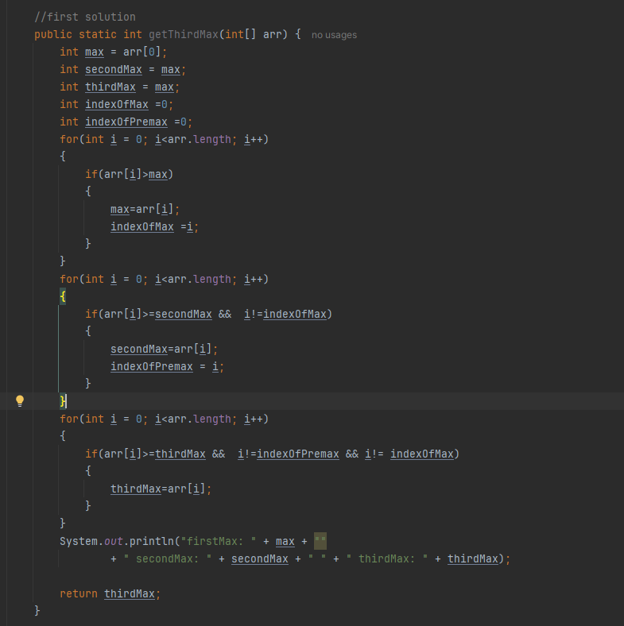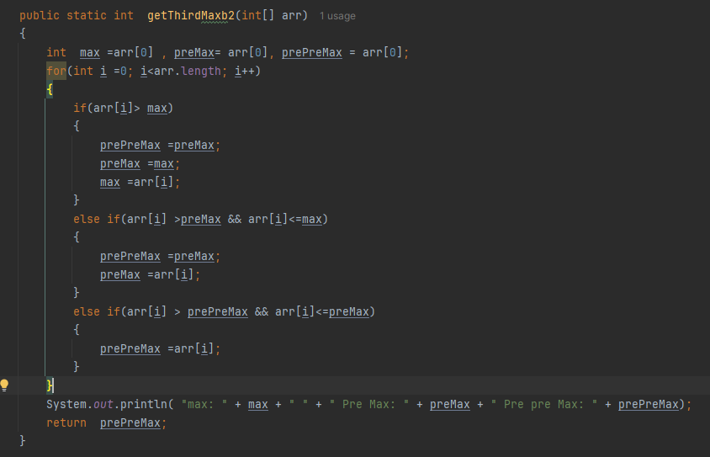

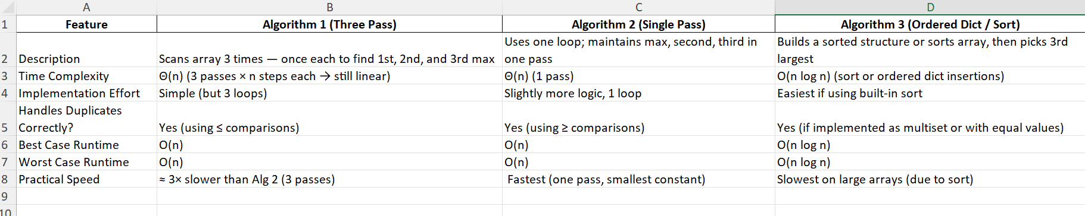
Question2:
10, 1, n3, n1/3, log(log n), n2, n1/2, logn , log nn, nk (k > 3), n1/k (k > 3), nlogn, ln n, 2n, 3n, nn, n1/2 logn, n1/3 logn, n!.
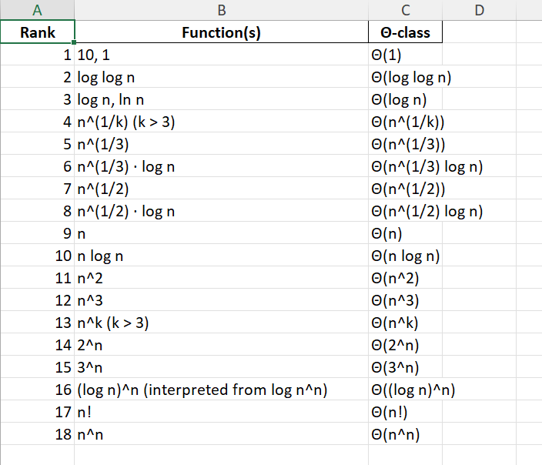
Justification:
- Constants (1,10) don’t grow with n → smallest.
- log log n ≪ log n.
- Any log n is smaller than any positive fractional power n^{ε} (so log n << n^{1/k} for any k).
- Among polynomial-root families, larger denominator k → smaller exponent; so n^{1/k} (k>3) < n^{1/3} < n^{1/2} < n < n^2 < n^3 < n^k (k>3).
- Multiplying by slowly-growing log n increases a function slightly but does not jump it past the next polynomial power when exponents differ enough (hence n^{1/3} << n^{1/3} log n << n^{1/2}).
- Exponentials with fixed base c^n outrun any polynomial as n grows (2^n, 3^n, …).
- (\log n)^n = e^{n \ln\ln n} eventually outruns c^n for fixed c, but it is still far smaller than n! ≈ (n/e)^n (Stirling: exponent ~ n ln n) and much smaller than n^n = e^{n ln n}. So ordering for large n is 2^n << 3^n << (\log n)^n << n! << n^n.

