Mortgage Pricing Exception — Detailed Sequence Diagrams
  - Blue Harvest Agentic SDLC Engineering Assignment | UML / PlantUML-style interaction design
This document is dedicated to sequence diagrams and their interpretation. It represents an implementation proposal, not evidence of completed implementation or execution.

Diagram index
- 1. Create pricing exception request
- 2. Review and approve or decline
- 3. Submit a new immutable revision
- 4. Retrieve approved discount for mortgage application

System participants
- Relationship Manager — submits exception requests and revised terms.
- Authorized Reviewer — inspects and decides the current pending revision.
- ASP.NET Core API — handles HTTP requests, authentication context and responses.
- Pricing Exception Service — enforces business invariants and transaction boundaries.
- EF Core / SQLite — persists requests, revisions, decisions, histories and idempotency records.
- Mortgage Application Service — downstream consumer of currently approved discounts.

Notation
Solid arrows represent calls; dashed arrows represent replies. Activation bars indicate a participating component. “alt / else” bands show mutually exclusive outcomes. All actor identities should be derived from authenticated context, not trusted directly from request payloads.

1. Create pricing exception request
Idempotency validation and all creation writes belong to one atomic operation. A replay is not a new request.
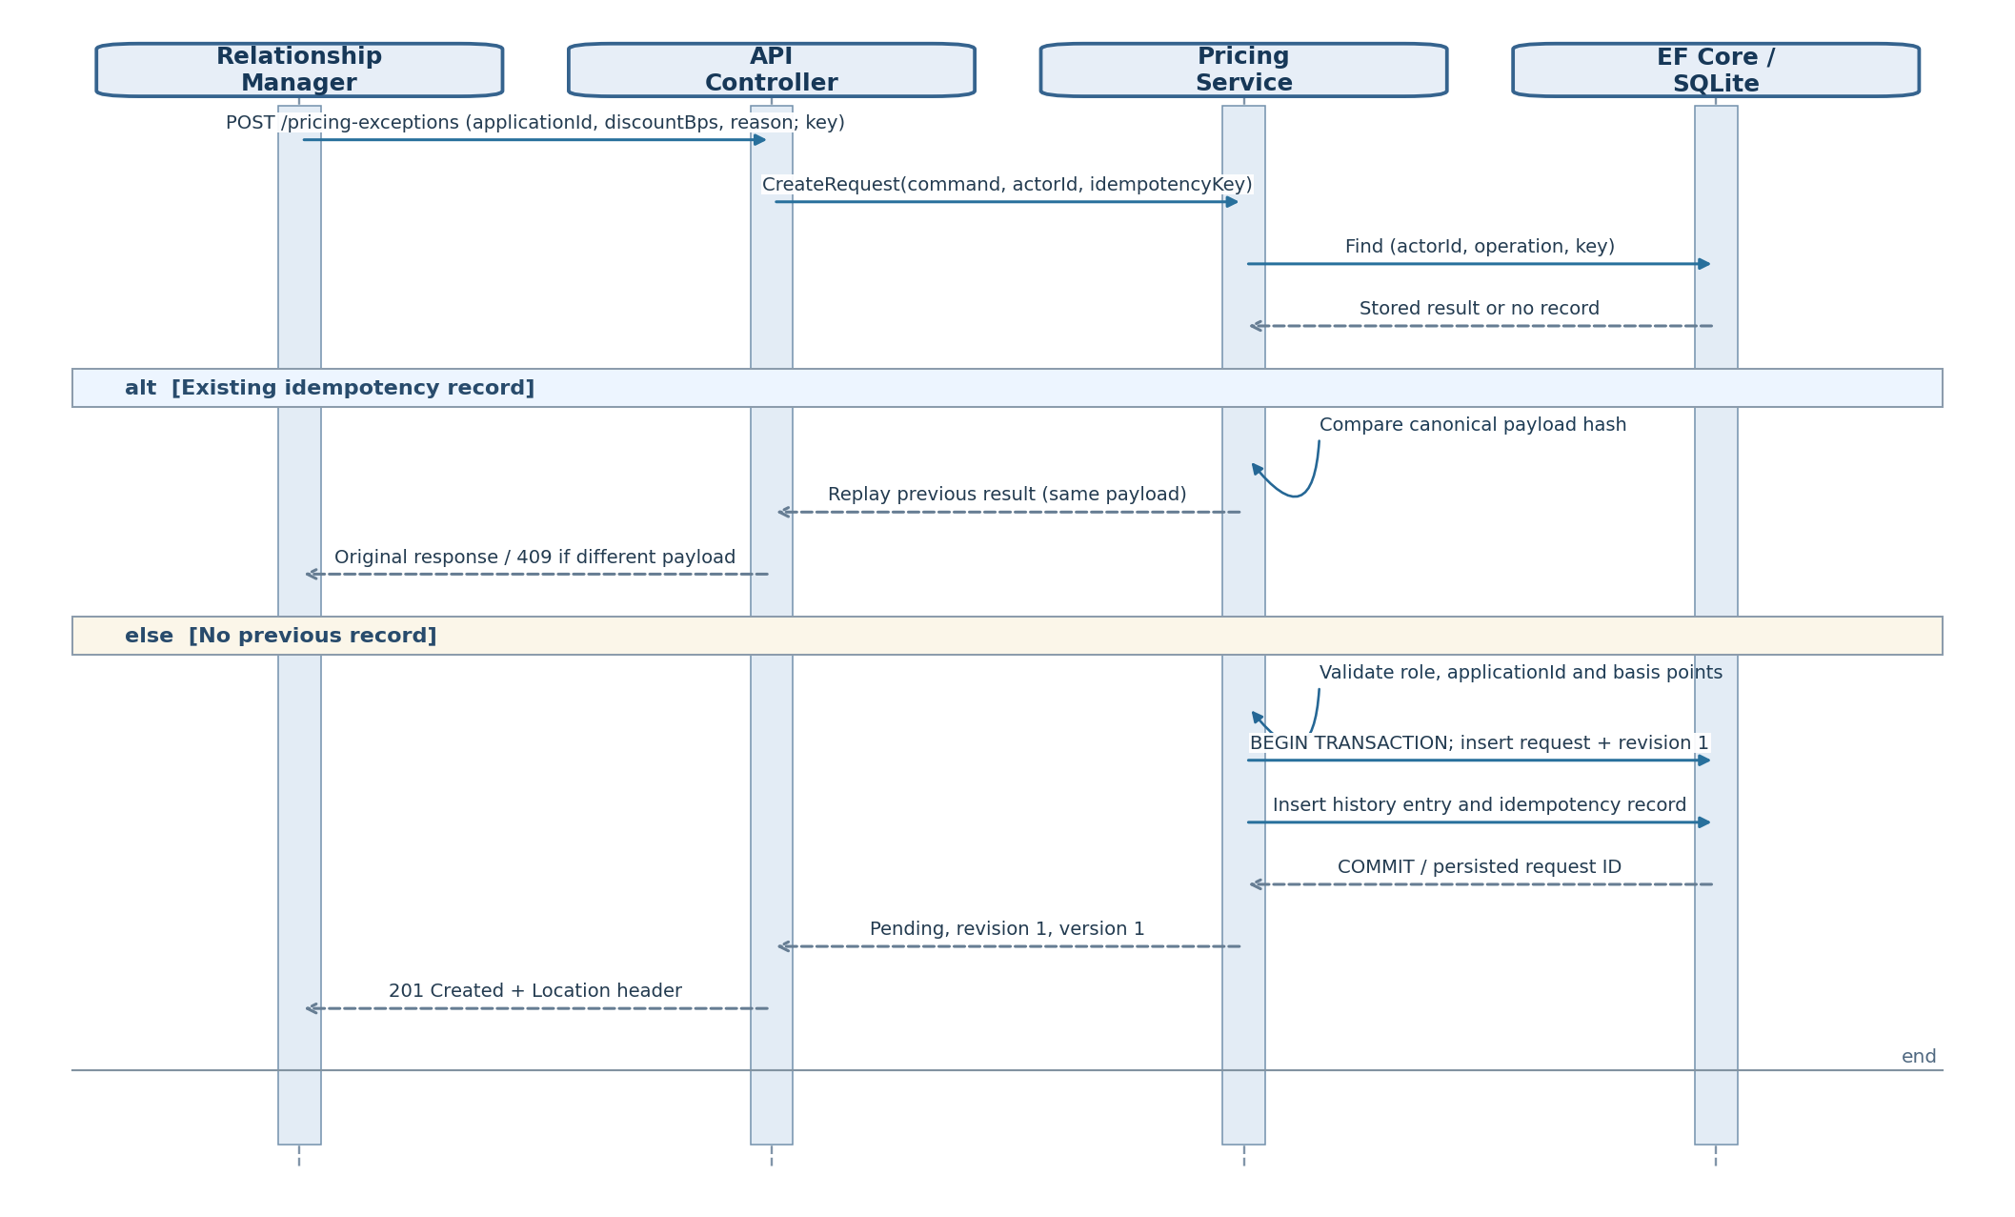
Figure 1. PlantUML-style UML sequence — create pricing exception request.
Success path: persist request, initial immutable revision, first history event, and idempotency entry together. Retries return the original outcome; payload mismatch produces a conflict.

2. Review and approve or decline
A decision is tied to the exact immutable revision. The application must not accept two competing decisions.
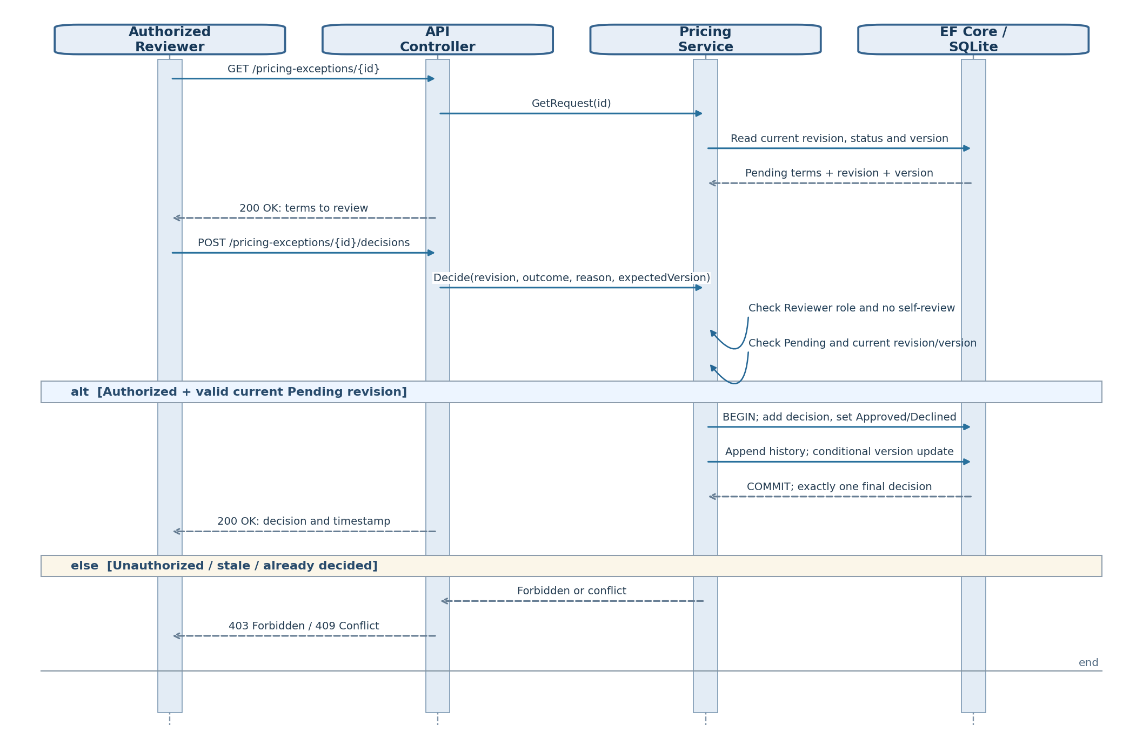
Figure 2. PlantUML-style UML sequence — review and approve or decline.
Decision rules: the reviewer must be authorized; self-review is rejected by proposed policy; decision is final for the addressed revision; a stale version or repeated decision is rejected.

3. Submit a new immutable revision
New terms are never edited into an existing revision. A pending newer revision makes any earlier approval historical, not current.
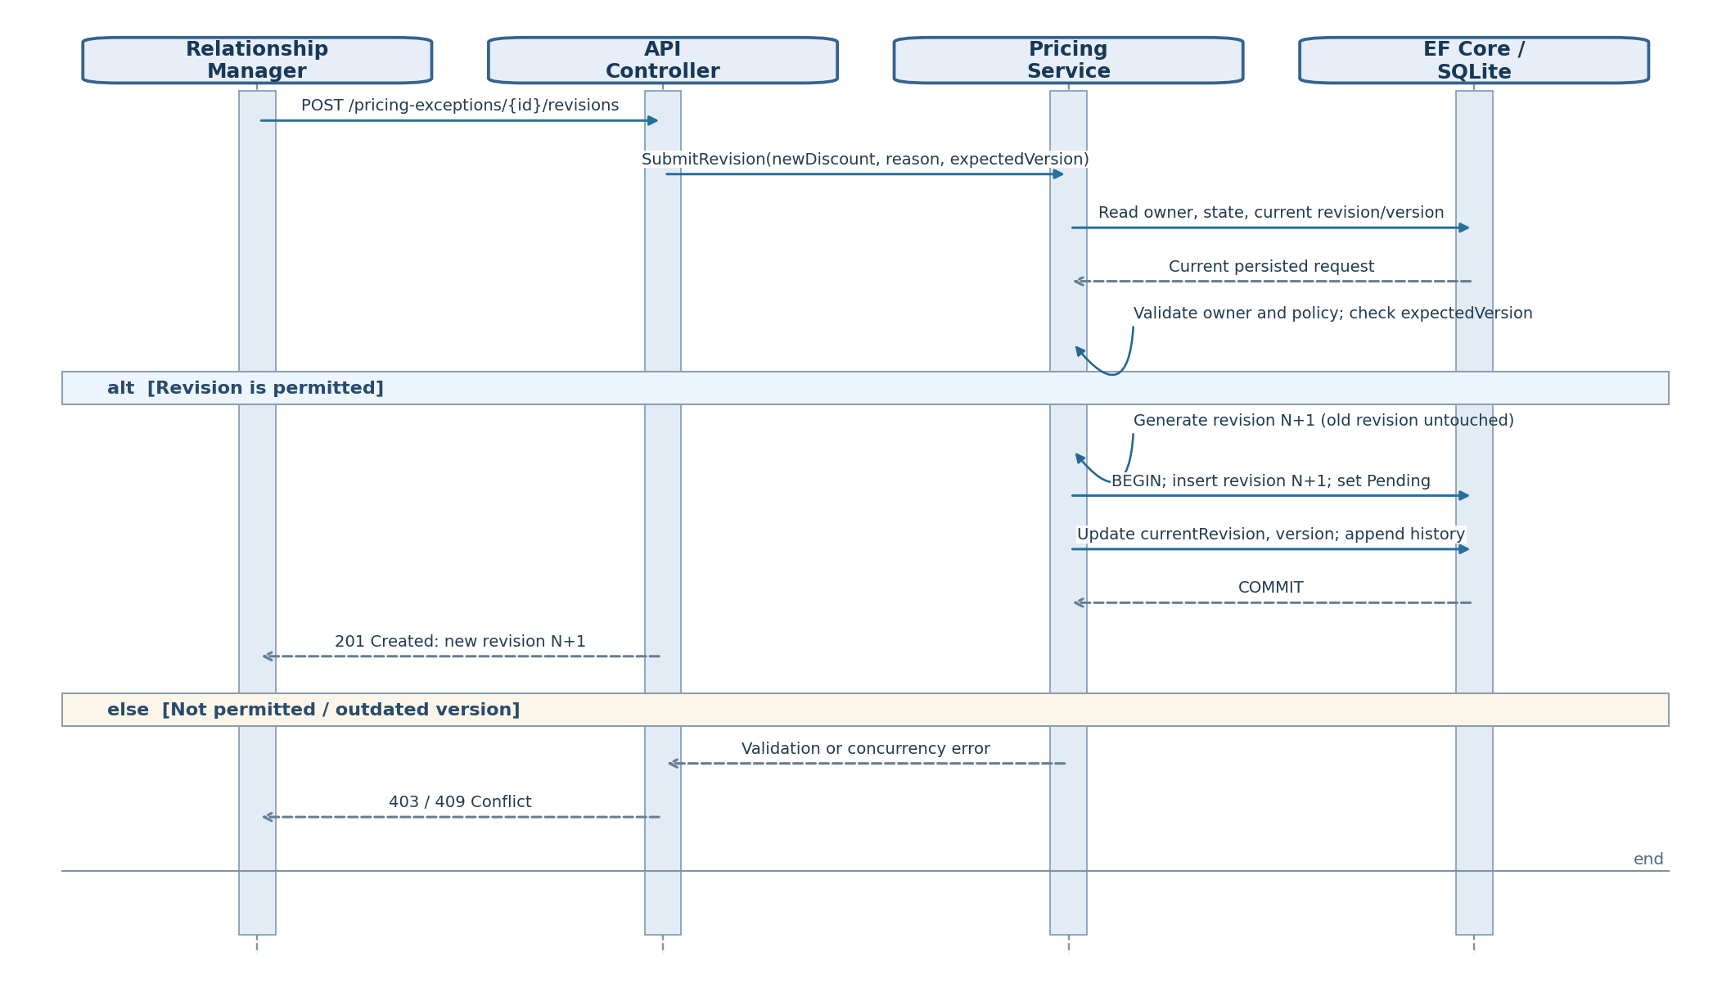
Figure 3. PlantUML-style UML sequence — submit a new immutable revision.
Revision rules: preserve old submitted terms and decisions, create revision N+1, and move overall status to Pending. Whether post-approval revisions are allowed must be confirmed with stakeholders.

4. Retrieve approved discount for mortgage application
Only the currently approved revision may be exposed. The downstream service uses the API and never queries the pricing database directly.
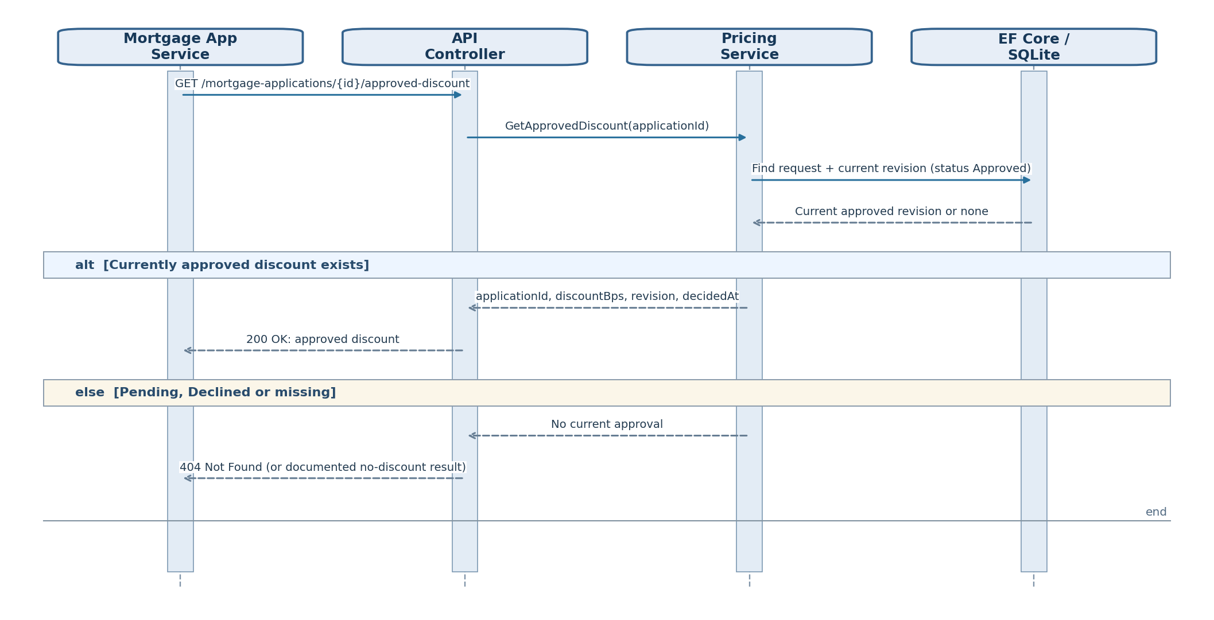
Figure 4. PlantUML-style UML sequence — retrieve approved discount for mortgage application.
Integration boundary: the mortgage application service reads through the pricing API, not its database. “No current approval” is represented as 404 for this proposed contract.

5. Cross-cutting rules and requirements
Rule | Description
Immutable terms | Changes create a new RequestRevision, rather than editing approved/reviewed data.
Review traceability | ReviewDecision identifies reviewer, outcome, revision and decision time.
Audit history | HistoryEntry records meaningful state transitions with actor and time; retained append-only.
Retry safety | Idempotency key is scoped to actor and operation, with a stored payload hash and response.
Concurrency | Expected version must match current version for a state-changing operation.
Transactional consistency | Creation and review writes should complete atomically; partial history or decision records are not acceptable.
Downstream contract | Return a discount only when the current revision is Approved.
Assumptions | Discount caps, revision after approval, and unique application policy require business confirmation.
API routes and status codes are illustrative, designed to make the workflow concrete. Exact routing and response conventions may be adjusted as long as required semantics are preserved.

6. PlantUML source for the diagrams
The following text is editable PlantUML notation. It can be copied into a PlantUML editor to regenerate standard UML sequence diagrams.

PlantUML source 1: Create pricing exception request
@startuml
skinparam sequenceMessageAlign center
actor "Relationship Manager" as RM
boundary "ASP.NET Core API" as API
control "PricingExceptionService" as SVC
database "SQLite / EF Core" as DB
RM -> API : POST /pricing-exceptions\nIdempotency-Key, applicationId, discountBps, reason
API -> SVC : CreateRequest(command, actorId, key)
SVC -> DB : Lookup(actorId, operation, key)
DB --> SVC : Existing record or none
alt Existing key
SVC -> SVC : Compare payload hashes
alt Same payload
SVC --> API : Stored response
API --> RM : Original response (replayed)
else Different payload
API --> RM : 409 Conflict
end
else New key
SVC -> SVC : Validate input and authorizations
SVC -> DB : BEGIN; insert Request, Revision 1, History, Idempotency
DB --> SVC : COMMIT
SVC --> API : RequestId, Pending, revision 1
API --> RM : 201 Created
end
@enduml

PlantUML source 2: Review and approve or decline
@startuml
actor Reviewer as REV
boundary API
control "PricingExceptionService" as SVC
database DB
REV -> API : GET /pricing-exceptions/{id}
API -> SVC : GetRequest(id)
SVC -> DB : Read current revision and version
DB --> SVC : Pending terms
API --> REV : 200 OK + terms
REV -> API : POST /pricing-exceptions/{id}/decisions
API -> SVC : Decide(revision, outcome, reason, expectedVersion)
SVC -> SVC : Verify Reviewer role, no self-review, Pending, version
alt Allowed
SVC -> DB : BEGIN; insert ReviewDecision, update status/version, append History
DB --> SVC : COMMIT
API --> REV : 200 OK + decision
else Forbidden or conflict
API --> REV : 403 Forbidden / 409 Conflict
end
@enduml

PlantUML source 3: Submit a new immutable revision
@startuml
actor "Relationship Manager" as RM
boundary API
control "PricingExceptionService" as SVC
database DB
RM -> API : POST /pricing-exceptions/{id}/revisions
API -> SVC : SubmitRevision(newTerms, expectedVersion)
SVC -> DB : Load owner, status, current revision, version
DB --> SVC : Current request
SVC -> SVC : Check policy, ownership, version
alt Revision allowed
SVC -> DB : BEGIN; insert immutable revision N+1
SVC -> DB : Set current revision N+1 and Pending; append History
DB --> SVC : COMMIT
API --> RM : 201 Created + revision N+1
else Invalid or stale
API --> RM : 403 / 409 Conflict
end
@enduml

PlantUML source 4: Retrieve approved discount for mortgage application
@startuml
actor "Mortgage Application Service" as MAS
boundary "ASP.NET Core API" as API
control "PricingExceptionService" as SVC
database "SQLite / EF Core" as DB
MAS -> API : GET /mortgage-applications/{id}/approved-discount
API -> SVC : GetApprovedDiscount(applicationId)
SVC -> DB : Read only current Approved revision
DB --> SVC : Approved discount or none
alt Current revision Approved
SVC --> API : discountBps, revision, decidedAt
API --> MAS : 200 OK + approved discount
else No current approval
API --> MAS : 404 Not Found
end
@enduml

