Entity relationship diagram and data dictionary
Generated from the repository code. Method names reflect the current controllers, service interfaces and private helpers. Entity relationships are unchanged by the naming refactor.
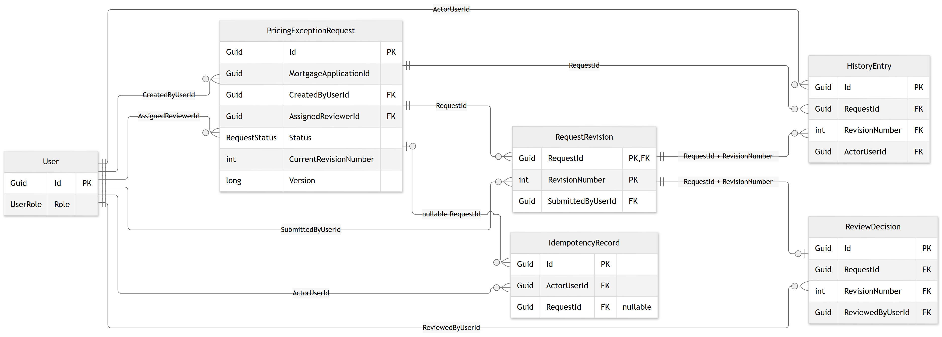
PK = primary key; FK = foreign key. Crow-foot relationships describe physical constraints, not additional service-only rules. For a zoomable full-field diagram, open diagrams/entity-relationships-full.svg.

Relationships, constraints and important boundaries
- The six entities shown are the current persisted model, not the original proposal. PostgreSQL table names are plural DbSet names. MortgageApplicationId is an external reference: no local MortgageApplication table or foreign key exists.
- RequestRevision uses composite primary key (RequestId, RevisionNumber). ReviewDecision has its own Id primary key and a unique foreign-key pair (RequestId, RevisionNumber), giving a revision zero or one decision. HistoryEntry references both its request and its composite revision.
- IdempotencyRecord.RequestId is nullable in the model and migration, although the workflow currently fills it. CurrentRevisionNumber is a service-managed pointer: there is no composite foreign key from PricingExceptionRequest to its current revision.
- Version is an EF concurrency token; it is not a database-generated row version. One request per application and actor/scope/key retry uniqueness are checked by services: the current migration does not create unique indexes for either rule.
- Submitted revisions, decisions, history and completed retry records are protected from edits/deletion through DbContext SaveChanges guards. The PostgreSQL migration defines cascade deletes for required FKs, and an optional retry-record FK without cascade; these are not database append-only triggers. Direct SQL can bypass application guards.
- RequesterName, AssignedReviewerName and ReviewerName are stored name snapshots. Changing a current user profile does not rewrite historical attribution. Enums are stored as PostgreSQL integers; API JSON uses enum names.
- The service sets ResponseStatusCode and ResponseJson on retry records, but does not populate nullable Location. The controller derives HTTP status and Location on each response. HistoryEntry.Details is nullable and the workflow does not currently set it.

User — Users
Property | C# type | PostgreSQL storage | Key / nullability
Id | Guid | uuid | PK, required
DisplayName | string | text | required
Role | UserRole | integer enum | required

PricingExceptionRequest — PricingExceptionRequests
Property | C# type | PostgreSQL storage | Key / nullability
Id | Guid | uuid | PK, required
MortgageApplicationId | Guid | uuid | required
CreatedByUserId | Guid | uuid | FK, required
RequesterName | string | varchar(200) | required
AssignedReviewerId | Guid | uuid | FK, required
AssignedReviewerName | string | varchar(200) | required
Status | RequestStatus | integer enum | required
CurrentRevisionNumber | int | integer | required
Version | long | bigint | required
CreatedAtUtc | DateTimeOffset | timestamp with time zone | required
UpdatedAtUtc | DateTimeOffset | timestamp with time zone | required

RequestRevision — RequestRevisions
Property | C# type | PostgreSQL storage | Key / nullability
RequestId | Guid | uuid | PK, FK, required
RevisionNumber | int | integer | PK, required
DiscountBasisPoints | int | integer | required
Reason | string | text | required
SubmittedByUserId | Guid | uuid | FK, required
SubmittedAtUtc | DateTimeOffset | timestamp with time zone | required

ReviewDecision — ReviewDecisions
Property | C# type | PostgreSQL storage | Key / nullability
Id | Guid | uuid | PK, required
RequestId | Guid | uuid | FK, required
RevisionNumber | int | integer | FK, required
Outcome | DecisionOutcome | integer enum | required
ReviewReason | string? | text | nullable
ReviewedByUserId | Guid | uuid | FK, required
ReviewerName | string | text | required
DecidedAtUtc | DateTimeOffset | timestamp with time zone | required

HistoryEntry — HistoryEntries
Property | C# type | PostgreSQL storage | Key / nullability
Id | Guid | uuid | PK, required
RequestId | Guid | uuid | FK, required
RevisionNumber | int | integer | FK, required
Sequence | long | bigint | required
Action | string | text | required
ActorUserId | Guid | uuid | FK, required
Details | string? | text | nullable
OccurredAtUtc | DateTimeOffset | timestamp with time zone | required

IdempotencyRecord — IdempotencyRecords
Property | C# type | PostgreSQL storage | Key / nullability
Id | Guid | uuid | PK, required
ActorUserId | Guid | uuid | FK, required
OperationScope | string | text | required
Key | string | text | required
PayloadHash | string | text | required
ResponseStatusCode | int | integer | required
ResponseJson | string | text | required
Location | string? | text | nullable
RequestId | Guid? | uuid | FK, nullable
Sources: src/PricingExceptions.API/Models/Entities/*.cs; Models/Enums/*.cs; Data/PricingExceptionsDbContext.cs; Data/Migrations/*InitialPostgreSql.cs and model snapshot.

