Mortgage Pricing Exception
  - Entity Class Diagram & Relationships
BLUE HARVEST | AGENTIC SDLC ENGINEERING ASSIGNMENT | 3 NOVEMBER 2026
Proposed domain and persistence model. This document intentionally contains no source code.

Improved entity class diagram
The model comprises six entities. Solid connections represent persisted relationships; the mortgage application remains an external system referenced by its identifier.
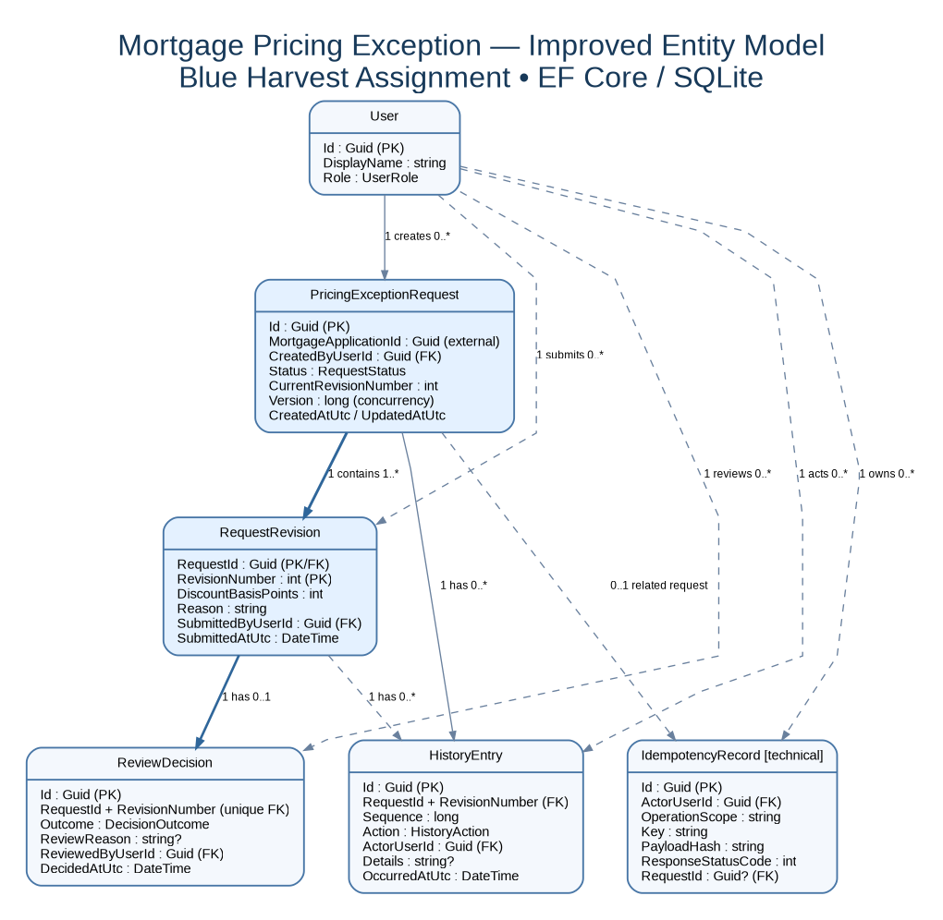

Entity responsibilities
Entity | Responsibility
User | Represents an internal actor who creates, revises, or reviews a pricing exception.
PricingExceptionRequest | Owns the overall exception, external mortgage application reference, current revision, and status.
RequestRevision | Stores a numbered, immutable snapshot of the proposed discount and supporting reason.
ReviewDecision | Records an authorized approval or decline against one specific revision.
HistoryEntry | Preserves a chronological, append-only audit record of request activity.
IdempotencyRecord | Associates a caller and operation key with a processed request to support safe retries.

Entity relationships and cardinalities
Relationship | Cardinality | Meaning
User → PricingExceptionRequest | 1 : 0..* | A user may create multiple requests; each request has one creator.
PricingExceptionRequest → RequestRevision | 1 : 1..* | A request begins with revision 1 and retains all later revisions.
RequestRevision → ReviewDecision | 1 : 0..1 | A revision may be pending or have one final decision.
PricingExceptionRequest → HistoryEntry | 1 : 1..* | Each request accumulates audit entries from creation onward.
RequestRevision → HistoryEntry | 1 : 0..* | History entries may identify the revision to which an action relates.
User → RequestRevision | 1 : 0..* | The submitting user is recorded for each revision.
User → ReviewDecision | 1 : 0..* | A reviewer may make many decisions, each with one reviewer.
User → HistoryEntry | 1 : 0..* | Every recorded human action identifies its actor.
User → IdempotencyRecord | 1 : 0..* | A caller may own multiple operation retry records.

Key design rules
- A submitted revision freezes its discount (basis points) and reason; new terms create a new revision.
- Only an authorized reviewer may approve or decline, and self-review is prohibited in the proposed policy.
- Each decision is attached to the exact revision reviewed; past decisions are never overwritten.
- Only the current revision, when approved, is eligible for downstream approved-discount retrieval.
- A new revision changes the active request status to Pending; older approved decisions remain in history.
- A repeated operation with the same caller/key and payload replays the original result; a different payload is a conflict.
- MortgageApplicationId refers to the existing mortgage application service; it is not a locally owned mortgage entity.
Scope note: Revision behavior, approval restrictions, and some uniqueness policies are proposed design choices to confirm with stakeholders. The assignment calls for controlled approvals, traceable history, approved-discount retrieval, and retry safety.

