**PITCH AND ROLL WEBSITE**

Having started out on a goal to design an engaging website that captures the essence of a unique business in the broad digital environment, where creativity meets technical ability. A concept was realized through a careful design and development process, resulting in an appealing online destination. We conceptualized a visually attractive website that leaves a lasting impression with a great eye for aesthetics and usability. A website that makes visitors embark on a virtual adventure that resonates with their senses through intelligent layout and straightforward navigation. Throughout the development phase, accessibility and responsiveness were top priorities. The website was created to easily adapt to several screen sizes and devices, offering a great user experience whether accessed via desktop computer, laptop, tablet, or smartphone. Below are screenshots of some examples of JavaScript included in the html code:

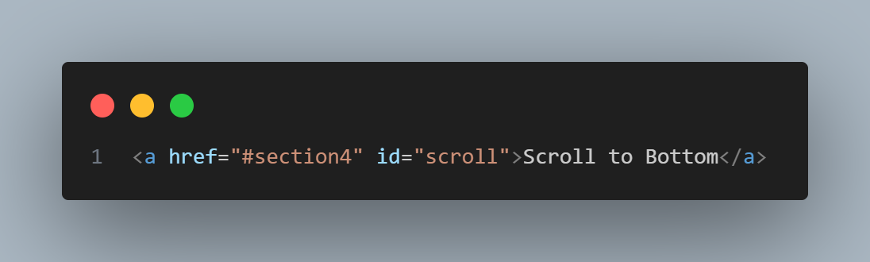

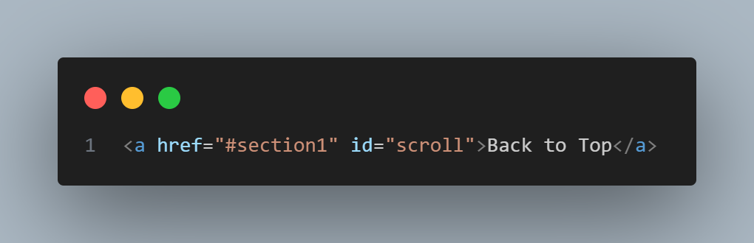

The Html elements above have provided for the ability of the page to adopt smooth scrolling with some animation using anchor links. JavaScript and some CSS transitioning properties. Thereby, allowing the pages on this website to scroll smoothly from top to bottom and vice versa.

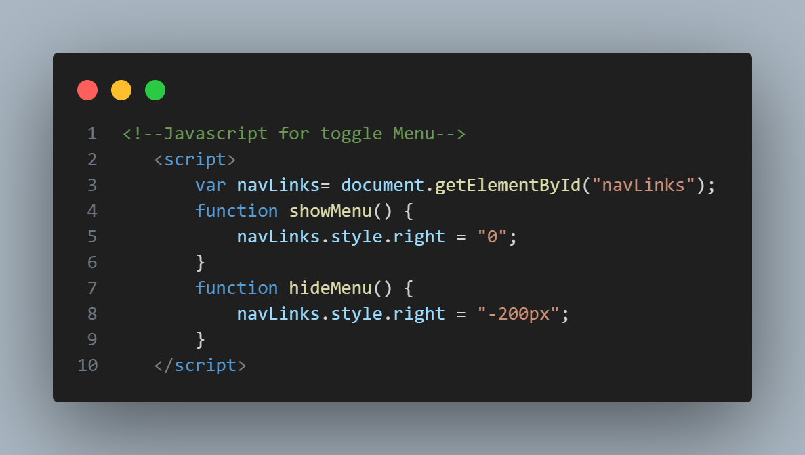

While the above code shows how JavaScript has been utilized to toggle the menu or the header and its visibility or responsiveness to different screens.

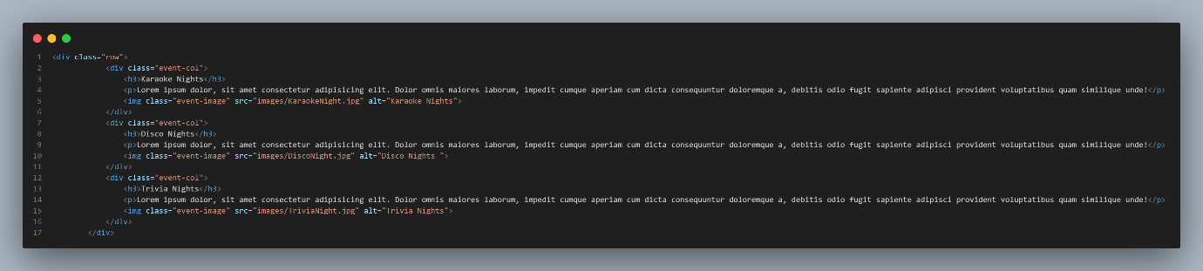

In this example, the div has been manipulated so as to display a picture of the desired column when a mouse over event occurs.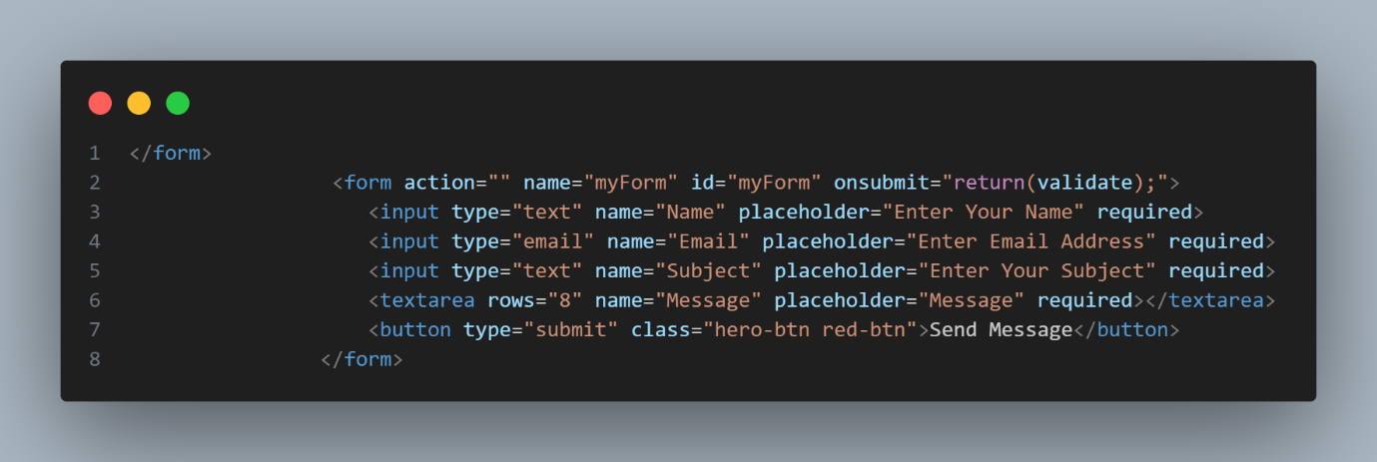

A JavaScript function “validate” has been used to validate a form within the html and handle any real time errors that may arise when filling the form, this function also alerts the user of any errors and when the form has been submitted successfully or not.