1. Introduction
   1. It is important for a model to have the ability to distinguish and tell apart images from one another. With car classification, it is also important! With that, the reason that car-make classification MLM (Machine Learning Model) is important for drone based on this is because on one benefit, it can help with traffic security of detecting a make of a car and finding a driver violating road rules.
   2. Adding onto how this has real world relevance is that it can also detect cars in an accident quickly and in a far distance to also quickly determine which car make the car is (with emblem being wreck in the front, or back of car, and car info not readily available to see on the driver's side due to said accident.).
   3. The Car Makes assigned for this Group Project assignment are **Ford, Toyota, and Honda**.
2. Data Collection
   1. Across each car make class, we have gathered **100 Training Images. We have scrapped these images on the web (Using Google and Bing).** The file format for these images are **PNG and JPG,** which are the file formats that we already planned to use. When gathering these images, we then save them onto a main folder structure. This folder structure consists of **val, train, and test.** Each of these folders has **Ford, Toyota, and Honda**, where they have their respective images based on that.
   2. With validation and test images, before explaining the images, we have to first discuss how we obtained the validation images. Our first attempt at obtaining the validation images was in our university parking lot at Fraizer Hall. Our second attempt was at the Freshman parking lot. With our first attempt, we went lot by lot that had at least one or more of the cars makes that we must capture into ONE photo. We did this at least 20 times. When going to the last image, we did not have enough battery power for the drone (the flight time was about 20 minutes). On the second attempt, we went to the freshman parking lot. In this attempt, we seemed to find more of the makes we were looking for compared to the first attempt. In this, there were many photos of the makes that we are looking for that had multiple makes (like the Ford, Toyota, and Honda in one photo, where we also took at least 20 images more in total). In both attempts, the weather was a clear, sunny day, where the lighting in the second attempt was better than the first due to the first having way more trees, causing shadows to be on the cars. In both attempts, many photos have cars being shot at a –30-degree angle (camera pointing downwards to the front and rear of the car). However, in the second attempt, in some of the photos, we capture photos of the cars at an angle close to 0 degrees (centered) front and back. Our challenges when it came to doing this operation were more intense in the first attempt, where we had trees to worry about, more shadows, and battery life to be mindful of as well. In both our first attempt and second, our team communication where we all participated in flying and tracking the drone was very great.
   3. 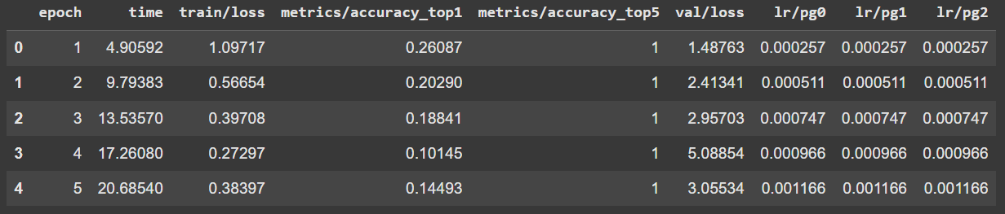
      1. With the First image, it shows the train data, metrics/accuracy_top1, time (seconds), val/loss, lr/pg0, lr/pg1, lr/pg2. With time, processing each of the images was relatively quick. With train/loss, the highest was 1.097.
   4. Sample Images:
      1. 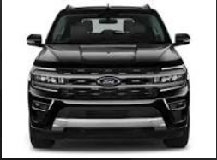
      2. 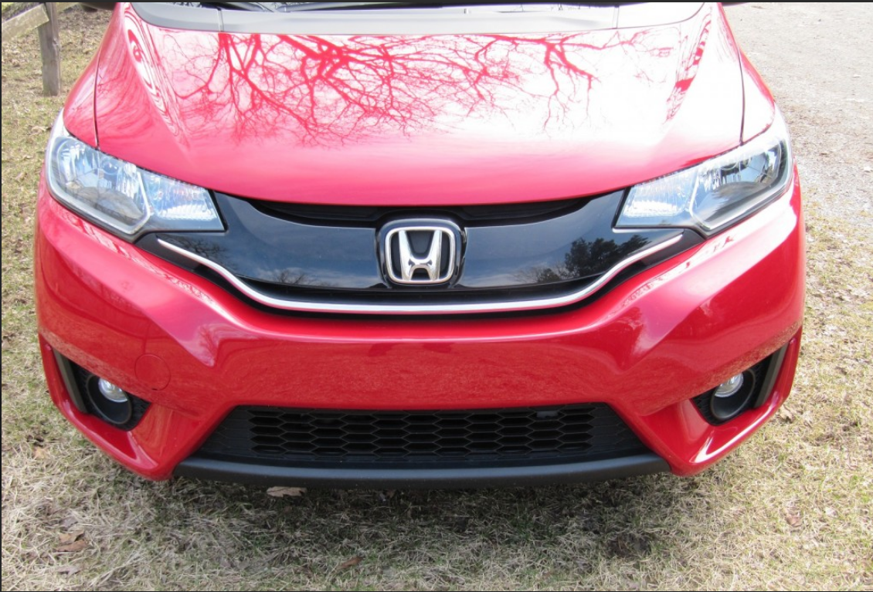
      3. 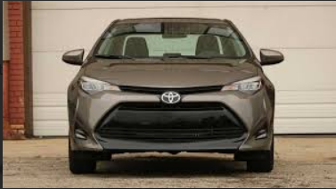
3. Dataset Organization
   1. Our Folder Structure:
      1. 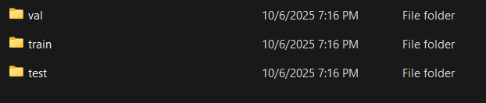
      2. Val: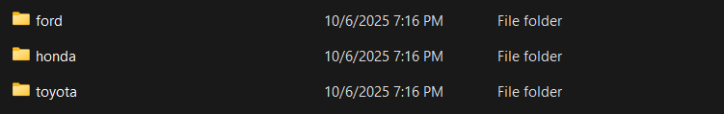
      3. Train: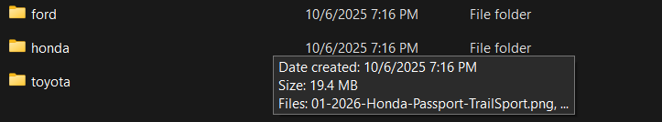
      4. Test: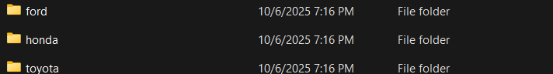
   2. Confirm Totals
      1. We have 300 Images of training, 69 validation images, and 8 test images (for the front and rear of the car).
      2. How did we attempt to avoid duplicates? With the train, we make sure that each image is different from one another (i.e. angles, lighting, model, etc). With validation, we make sure that each cropped image is different from one another like with the train, but with the front and back of the cars.
   3. Model Training
      1. The YOLOv11 model variant that we have used is yolo11n-cls.pt.
      2. Epoch
         1. With our epoch, we first set it to 35, but when checking accuracy score, it was in the high 20%. We then tried to put it at 30 epoch, to see if it would change anything, but it did, and the accuracy score was worse (low 20%). We then tried to adjust the epoch to 48 to see if the accuracy would increase, and it did at 30%.
      3. Image Size
         1. The images were scaled at 224 x 224 (looking at that based on the sample/test images results).
         2. The batch size that we are sure of is just default.
      4. Training process
         1. Firstly, the thing that went smoothly was the epoch operation, in which our model was trained in; the time duration was about 7 minutes. The issue that we faced first off was trying to access our directory via shared files. We tried to do this but instead download the directory from our Shared Google Drive, zip it up, and reupload it into another folder in one of our own drives (Ferdinand).
   4. Results & interpretation
      1. Validation results:
         1. With our accuracy, like mentioned above, it is 30%.
         2. With loss curve trends, there were some spikes early on, but then stabilized later.
      2. Test set performance:
         1. Our overall accuracy across the images was about 90-100 percent.
      3. Confusion matrix:
         1. With our confusion matrix, it seems that our model did not perform great with the predictions of Hondas or Fords. However, compared to the others, it performed the best when predicting Toyotas.
         2. 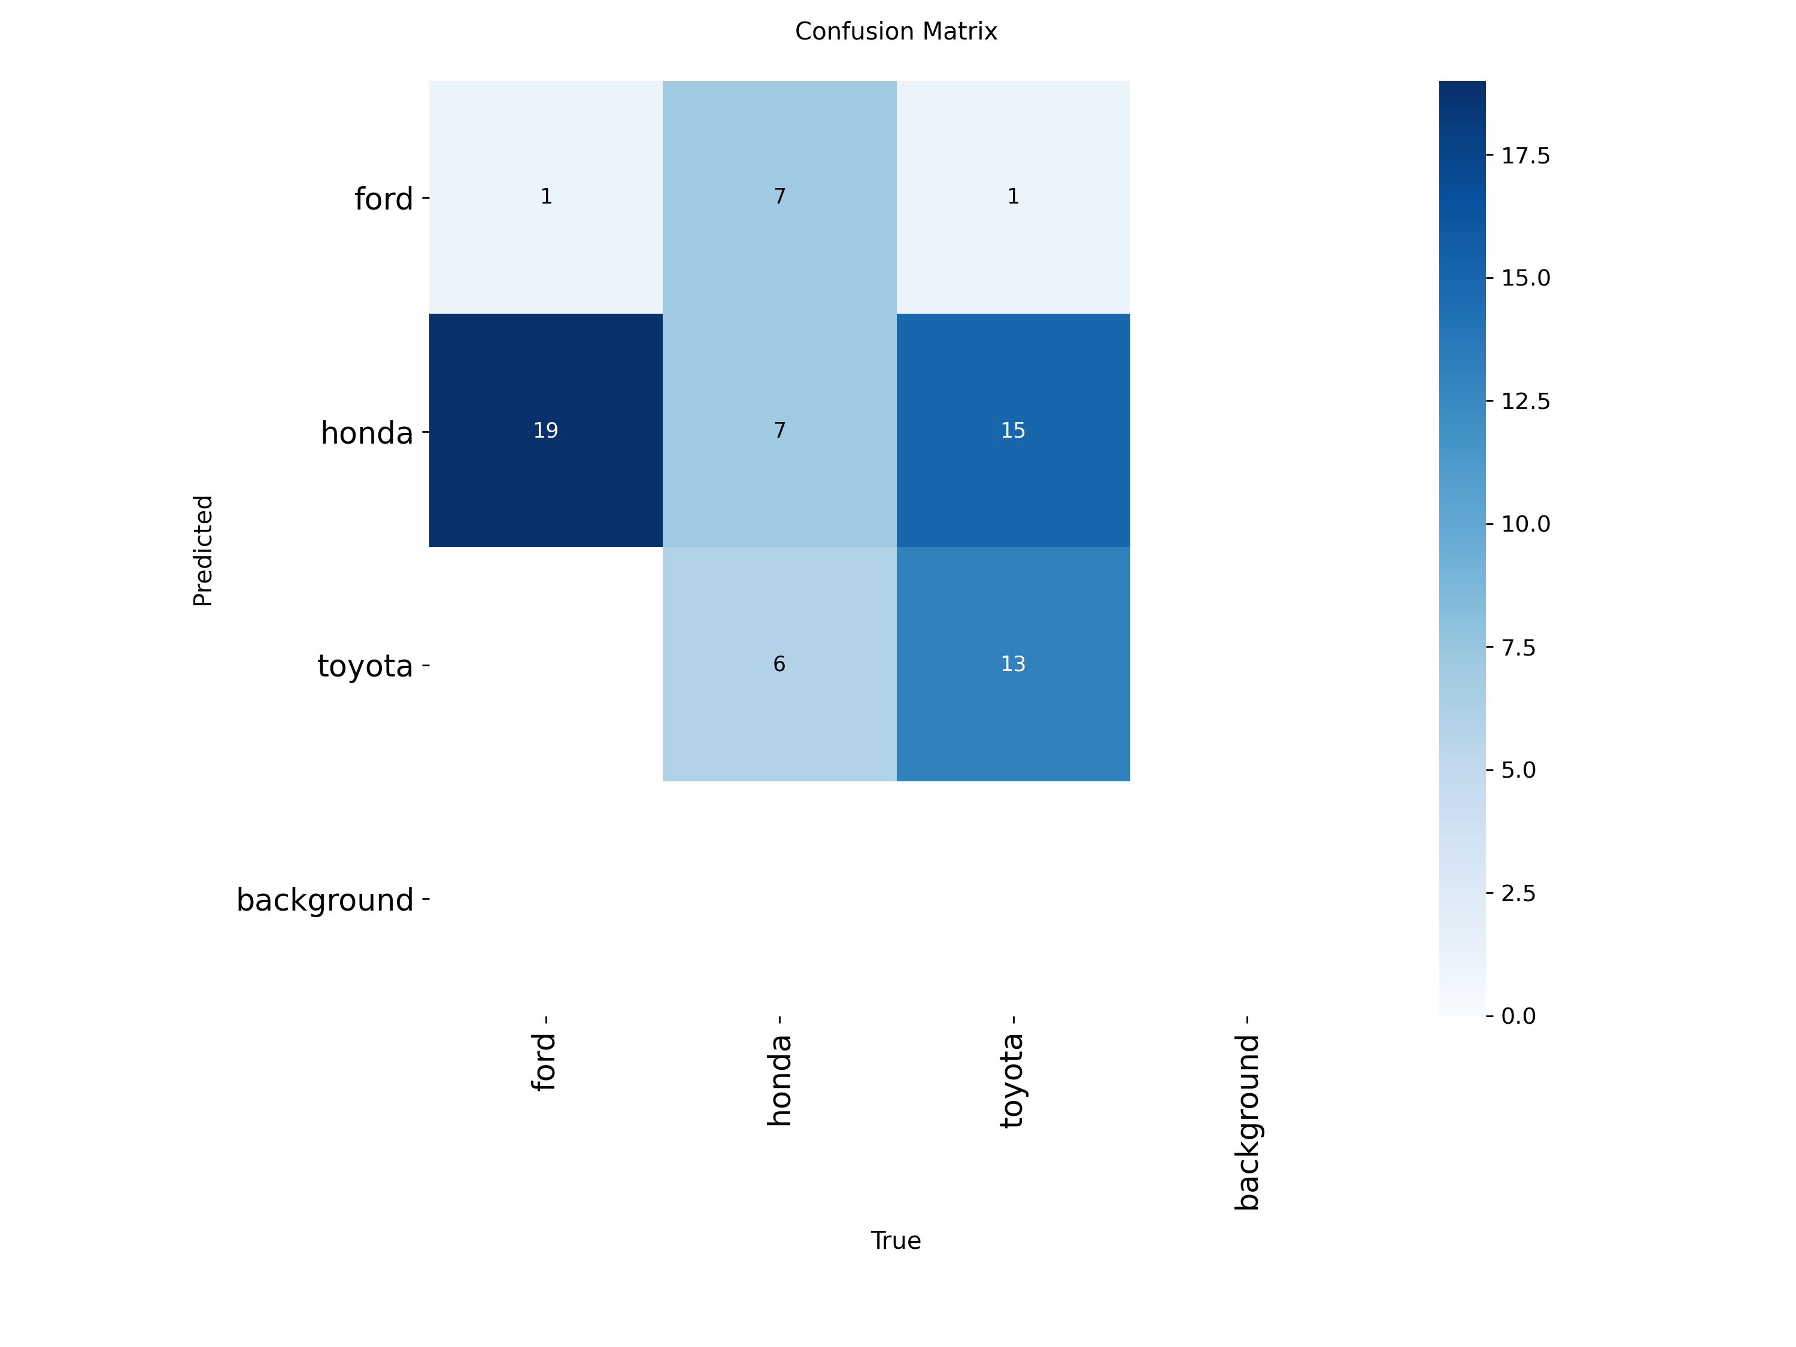
         3. We think that the cause of the misclassification/accuracy was that it could have to do with the image resolution (where some images are blurry in the test), how we did not have cars bundled into one validation image to where our model could have a better time classifying the car, vehicle types (Truck, SUV, Sedan, etc), lighting, and how we did not really have enough images for the rear of the vehicles in our train dataset.
   5. Reflection
      1. What we think would improve the performance of the model would be accounting for the things above (like having more clearer images, more rear images, have consistent lighting in both train and valid) while also having a high epoch level, like with 48 percent to further solidify its classification accuracy.
      2. What I think we have learned about drone data collection and classification is that with drone data collection, it is a lengthy process where detail and consistency is accounted for, like with accounting lighting, camera angles, front and rear images for the cars, while also having team coordination and communication of the drone operation. With classification, it made us conscious of how we can change attributes of our model (like with epoch size) to make it more accurate with classification. Overall, it is a complex process requiring paying attention to details, being coordinated and communicating as a team, and making sure you give thought into how the Machine Learning Model can be improved when giving it data and classifying it.
      3. This skill can be applied to more general stuff in object classification like with road signs of tree species, and more.