Table of Contents

AI Gateway & AI Governance for Cloudera AI (CAI) On-Prem
Audience: Solution architects positioning Cloudera AI for an on-prem customer who has purchased CAI instances and needs an AI gateway and AI governance story.
Guiding principle: Keep the customer inside CAI. Every plane below is hosted on Cloudera AI primitives — no external gateway, no third-party SaaS, no data leaving the cluster.
Status: Field guidance based on current CAI capabilities (mid-2026). Reassess as CAI Inference Service Application serving reaches on-prem GA.

1. The Current Picture
# | Capability | State on-prem | Notes
1 | CAI Inference Service | ✅ GA | Production-grade model serving via NVIDIA NIM + Triton on KServe. Exposes the OpenAI API for generative models and Open Inference Protocol for predictive models. Has built-in monitoring and metrics, and integrates with Cloudera AI Registry (Atlas-backed). (CAI Inference Overview)
2 | CAI Workbench Applications | ✅ GA | Flexible long-running web apps, but the entry point must be a Python script on CDSW_APP_PORT / CDSW_READONLY_PORT. App engines do not autoscale/scale-to-zero like inference endpoints. (Analytical Applications)
3 | CAI Inference Service Applications | ☁️ Cloud only | Custom Docker images, MCP clients/servers, autoscaling, scale-to-zero — not yet on-prem. (CAII Application Serving)
4 | AI Gateway & AI Governance | ❌ No out-of-box component | CAI does not yet ship a dedicated AI gateway or centralised AI governance plane — we assemble both on CAI.
Agent Studio (and RAG / Fine-Tuning / Synthetic Data Studios) run inside the CAI Workbench as AI Studios (Technical Preview). (AI Studios Overview, Provisioning Workbenches)

2. What "AI Gateway" and "AI Governance" Mean Here

AI Gateway (the traffic plane)
A reverse proxy between applications/agents and model endpoints:
- Unified OpenAI-compatible API across many models
- Routing, load balancing, fallback, retries
- Rate limiting and quota enforcement per team/key
- API key / token issuance and rotation
- Semantic + exact-match response caching
- Cost and token accounting
- Request/response logging and tracing

AI Governance (the control plane)
Policy, safety, and auditability over what flows through the gateway:
- Input safety — prompt-injection / jailbreak / data-exfiltration defence
- Output safety — content moderation, PII/secret redaction
- Prompt & completion audit trail for compliance
- Model lineage, versioning, and access control
- Drift / quality monitoring
Key insight: CAI already gives you the two hardest pieces — a production model-serving plane with metrics (Inference Service) and a lineage/registry backbone (AI Registry + Atlas). The missing gateway proxy and central guardrail are added on top, entirely within CAI. This document presents two deployment tiers: a common approach that any partner can stand up today using CAI Workbench Applications, and an advanced approach built on ray-serve-cai (a Cloudera Professional Services capability, currently in progress).

3. Recommended On-Prem Architecture — A Progressive Path (All on CAI)
Both tiers solve the same three planes — Plane A: AI Gateway, Plane B: Central Guardrail, Plane C: Audit & Lineage — and both keep everything inside CAI. They differ only in how the gateway and guardrail are hosted:
Tier | Hosting substrate | Availability | Best for
Common (baseline) | Stand-alone CAI Workbench Applications (Python entry on CDSW_APP_PORT) | Available today — any partner/SI can build it | Getting to a working, fully-on-CAI gateway + governance quickly
Advanced | ray-serve-cai microservices (Ray Serve on CML Applications) | Cloudera Professional Services — in progress | Production scale, autoscaling, multi-model routing, shared central services
Recommendation for partners: start with the common approach to deliver value immediately. Graduate to the advanced ray-serve-cai tier when the customer needs production-grade scaling, higher throughput, or a shared central gateway/guardrail across many workflows — engage Cloudera Professional Services for that stage.

3.1 Common Approach (Available Now) — Stand-alone CAI Workbench Applications
Host the gateway and the guardrail as two independent CAI Workbench Applications, each a single Python entry script served on CDSW_APP_PORT. (Analytical Applications) Both call the CAI Inference Service models over the OpenAI API. Nothing leaves CAI.
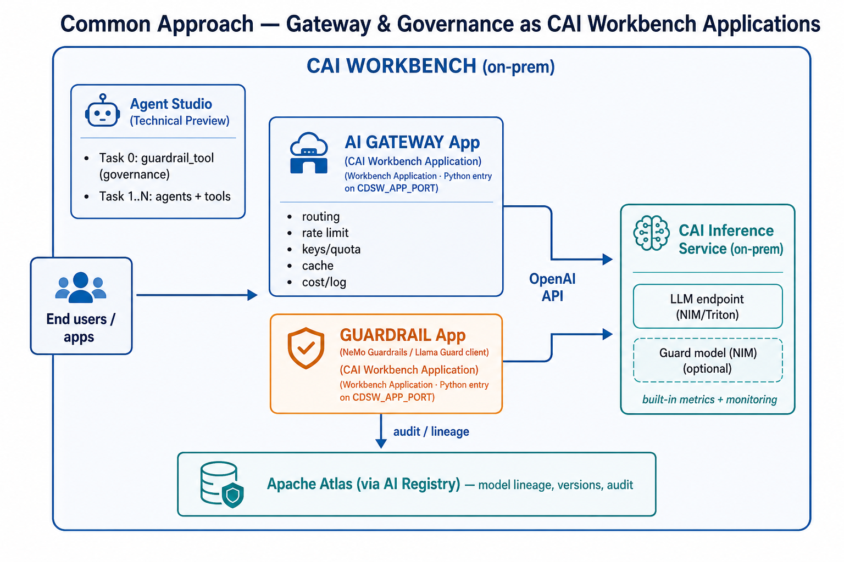
AI Gateway Application: run a lightweight OpenAI-compatible proxy (e.g. a LiteLLM proxy, or a small FastAPI app) as the Workbench Application's Python entry point. It provides routing, per-key rate limiting/quota, response caching, and cost/token logging in front of the CAI Inference endpoints.
Guardrail Application: run a guardrail server (e.g. NeMo Guardrails, or a thin service that calls a Llama Guard 3 model hosted on CAI Inference) as a second Workbench Application. Agent Studio's guardrail_tool points its Layer 2 api mode at this application's endpoint.
Strengths | Trade-offs
Available today on any on-prem CAI; no Professional Services dependency | Each app is a single Python entry — limited horizontal scaling
Simple to build, version, and hand over to an SI | App engines do not autoscale / scale-to-zero like inference endpoints
Fully inside CAI; uses CAI auth and networking | Gateway and guardrail are separate apps to operate individually

3.2 Advanced Approach (Cloudera Professional Services — In Progress) — ray-serve-cai Microservices
For production scale, host the gateway and guardrail as Ray Serve microservices via ray-serve-cai, which launches a Ray cluster using CML Applications as nodes (1 head + N workers) entirely within the CAI Workbench. These microservices speak the OpenAI API to the CAI Inference Service.
ray-serve-cai is a Cloudera internal Professional Services capability, currently in progress. Engage the Cloudera PS team to deploy this tier. It supersedes the common approach for customers who need throughput, autoscaling, and shared central services.
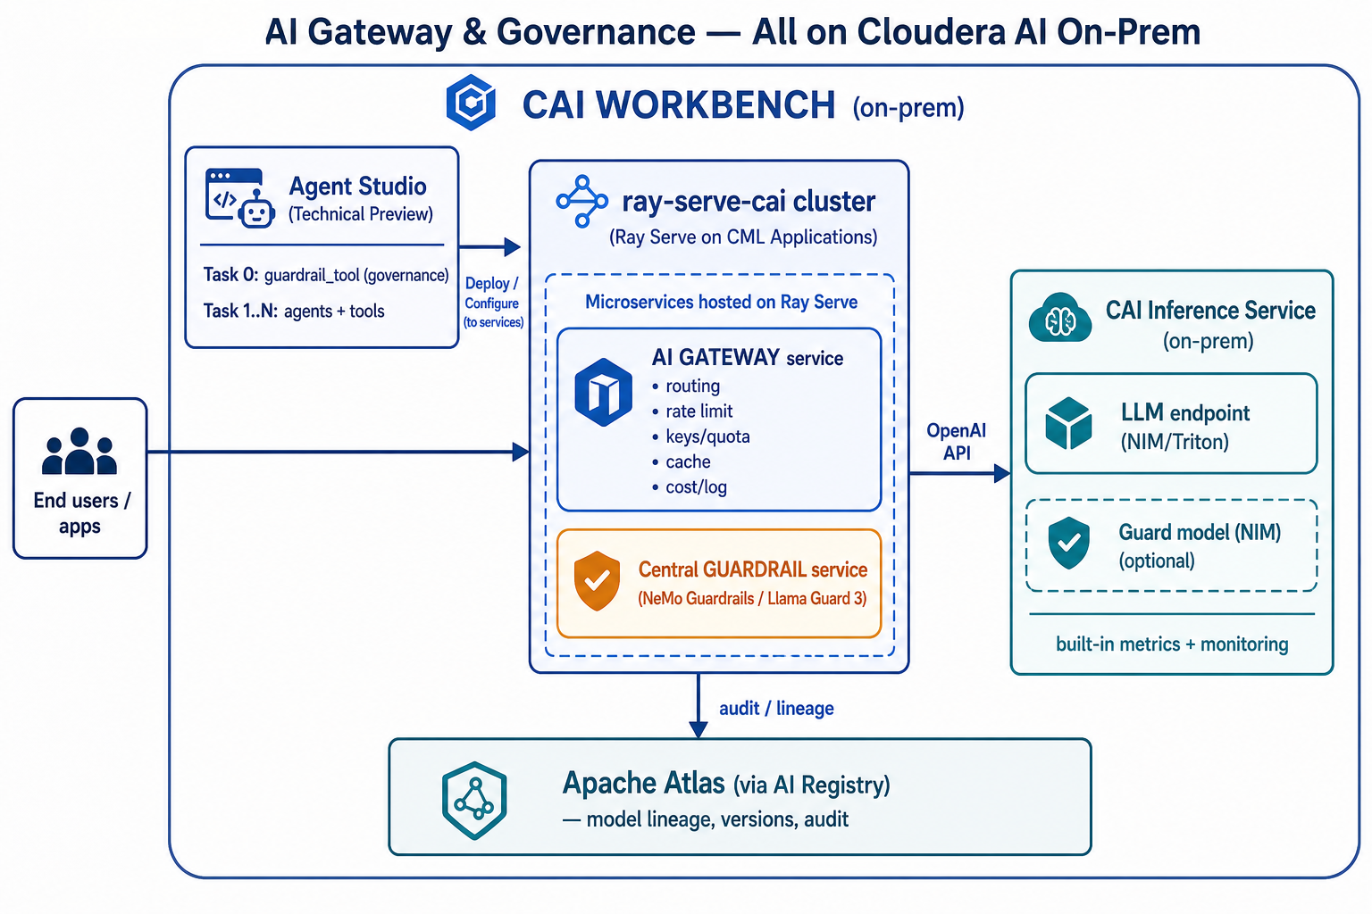
What ray-serve-cai adds over the common approach:
- Launches a Ray cluster on CAI using CML Applications as nodes (head with no GPU + GPU workers). (ray-serve-cai README)
- Autoscaling across worker nodes instead of a single Python entry per app.
- OpenAI-compatible serving surface — gateway and guard models are drop-in for any OpenAI client.
- Plugin engine architecture (vLLM stable; SGLang/custom planned) to host guard models or small auxiliary models directly on the cluster.
- One shared cluster hosts both the gateway and the central guardrail microservices, so policy and routing are centralised across all workflows.
Division of labour (advanced tier):
Layer | Hosts | Runs on
CAI Inference Service | Production LLMs (+ optional guard model via NIM) | KServe / NIM / Triton
ray-serve-cai cluster | AI Gateway microservice, Central Guardrail microservice, small auxiliary models | Ray Serve on CML Applications
Agent Studio | Workflows, agents, guardrail_tool (Task 0) | CAI Workbench
Atlas / AI Registry | Lineage, versions, audit | CAI governance integration

4. The Three Planes (apply to both tiers)

Plane A — AI Gateway
Responsibility | Common (Workbench App) | Advanced (ray-serve-cai)
Unified OpenAI API | Single proxy app exposes /v1 | Ray Serve deployment exposes /v1
Routing / fallback | Proxy routes by model name to CAI Inference endpoints | Gateway deployment routes across CAI Inference + Ray-hosted models
Rate limit / quota / keys | In the proxy app (per-key budgets) | In the gateway deployment, cluster-wide
Caching | In-app cache | Ray Serve shared cache deployment
Cost / logging | App emits per-request records | Gateway emits records; Ray dashboard + metrics

Plane B — Central Guardrail + the guardrail_tool
The central guardrail server can be NeMo Guardrails or a Llama Guard 3 model — hosted as a Workbench Application (common) or a Ray Serve microservice (advanced). Either way, the heavy guard-model inference can also sit on the CAI Inference Service (NIM), with the guardrail server orchestrating rail logic in front of it.
This project's guardrail_tool (studio-data/tool_templates/guardrail_tool/) is one of the tools that connects to the central guardrail server / CAI Inference services. It runs as Task 0 in Agent Studio workflows and enforces input safety before prompts reach downstream agents:
Layer | Mechanism | Where it runs on CAI
1 — Regex / heuristics | Prompt-injection, jailbreak, SQL-DDL, schema-fishing | In-process (stdlib), < 1 ms
2 — ML classifier | api mode → central guardrail server (Llama Guard 3 / NeMo Guardrails) | Workbench App or Ray Serve microservice or CAII endpoint
3 — Domain policy | Table allowlists, sensitive-column (PII/credentials/financial) blocking | In-process, < 5 ms
Point Layer 2 at the central guardrail endpoint (same config in both tiers — only the URL changes):
{
"mode": "api",
"domain": "text_to_sql",
"classifier_endpoint": "https://<guardrail-app-or-ray-endpoint>/v1",
"classifier_api_key": "<cdp-jwt>",
"api_type": "openai_compatible",
"classifier_threshold": 0.85
}
This gives defence in depth: cheap local regex/policy in the tool, plus a centralised model-based rail on CAI for the hard cases. Multiple tools and applications share the one guardrail server, so policy is consistent and centrally updatable.

Plane C — Audit & Lineage (identical in both tiers)
- Model lineage / versioning / access control: CAI Registry + Apache Atlas (enable Governance at workbench provisioning). (CAI Inference Overview)
- Prompt / completion audit trail: captured at the gateway (Plane A) and written to the customer's on-prem log store.
- Workflow-level audit: Agent Studio persists every task input/output, including each guardrail_tool verdict (ALLOW/BLOCK + threat categories + layer).

5. Recommended Solution by Time Horizon
Horizon | AI Gateway | AI Governance
Now — common approach | Gateway as a stand-alone CAI Workbench Application (OpenAI-compatible proxy) fronting CAI Inference endpoints | Guardrail Workbench Application (NeMo Guardrails / Llama Guard 3) + guardrail_tool as Task 0 + Atlas/AI Registry lineage
Pilot / quick demo | Single proxy Workbench Application | guardrail_tool in mode: local (Prompt-Guard-86M, no extra endpoint)
Advanced — ray-serve-cai (Cloudera PS, in progress) | Gateway as a Ray Serve microservice with autoscaling and multi-model routing | Central guardrail microservice on the same Ray cluster, shared across all workflows
Future (CAII App serving on-prem GA) | Migrate gateway + guardrail to CAI Inference Service Applications (custom Docker, scale-to-zero, MCP-native) | Same governance planes; co-locate guard models and policies in the CAII application

6. Why This Is the Best Available Answer
- The customer stays in CAI. Gateway, guardrail, models, and lineage all run on Cloudera AI — no external gateway, no data egress, ideal for regulated on-prem buyers.
- Progressive adoption. Partners deliver value immediately with the common Workbench-Application approach, then graduate to the advanced ray-serve-cai tier (Cloudera Professional Services) when scale demands it — with no rewrite, since both speak the OpenAI API.
- Reuses CAI's strongest assets. Inference Service gives production serving + metrics; AI Registry gives Atlas lineage. We add only the two missing planes — both on CAI.
- Centralised, consistent governance. One guardrail server serves every workflow and app; the guardrail_tool adds in-workflow defence in depth and shares the same central policy endpoint.
- Forward-compatible. Because everything speaks the OpenAI API, Workbench Applications, Ray Serve microservices, and the future on-prem CAII Application deployment are all drop-in swappable.
- Governance is already in this repo. The guardrail_tool is built, documented, and slots into Agent Studio as Task 0 with local or central-server api modes.

7. References
- Cloudera AI Inference service Overview
- Provisioning Cloudera AI Workbenches
- AI Studios Overview (Technical Preview)
- Analytical Applications (Workbench)
- Serving Applications on Cloudera AI Inference service (Technical Preview)
- Microservice hosting layer: ray-serve-cai (/Users/zhongqishuai/Projects/cldr_projects/ray-serve-cai)
- Project governance tool: studio-data/tool_templates/guardrail_tool/ (see its README.md)

