Customer Demo Planning and Delivery Blueprint

Intelligent AML Investigation and Continuous Learning Platform
  - Agentic AML Investigation + Human Review + Governed ModelOps
Audience  Bank financial crime compliance, investigation operations, data science, and IT teams | Demo Scope  Synthetic data; suspicious activity investigation; human review; model retraining and seamless upgrades
Recommended Timeline  12-15 minute customer demo; four-week MVP delivery | Document Version  v1.0 | 2026-08-28

Recommendation: Position the demo as an Intelligent AML Alert Investigation Platform, centered on a suspected mule account that rapidly funnels, splits, and transfers funds overseas. Traditional rules and ML detect risk; agents investigate across data sources and organize evidence; bank employees make the final decision; and a second dashboard closes the loop through label feedback, retraining, validation, approval, staged deployment, and rollback.

1. Why This Scenario
This scenario is better suited to a customer demonstration than generic fraud detection because it is not merely a model-score display. It is an explainable, actionable, and auditable business workflow spanning real-time transaction intake, risk detection, agent-led investigation, human disposition, and continuous model improvement. MAS AML/CFT requirements for banks cover suspicious transaction monitoring and reporting, while its transaction-monitoring guidance emphasizes assessing activity against customer background and expected behavior rather than viewing a transaction amount in isolation. [1][2]
Candidate Scenario | Demo Clarity | Need for Agents | Dashboard Potential | Learning Loop | Recommendation
Payment Fraud Classification | High | Medium | High | Medium | Good for a single-model demo, but the investigation workflow is limited
Real-time Scam Intervention | Very High | High | High | Medium | Requires credible simulation of victim behavior and real-time intervention
AML Suspicious Activity Investigation | Very High | Very High | Very High | Very High | Recommended: evidence, networks, human review, and MLOps fit naturally
Periodic KYC Review | Medium | High | Medium | Medium | Clear workflow, but less real-time and visually compelling

Industry direction also supports this choice. The Wolfsberg Group defines effective monitoring for suspicious activity more broadly than traditional transaction monitoring, recommending that institutions combine customer attributes, customer behavior, and transactions, while treating transition validation, the balance between model risk and financial-crime risk, and explainability as core pillars. [3][4]

2. Business Scenario Definition

2.1 Scenario in One Sentence
The bank scores incoming transactions in real time. When the combined pattern of rapid multi-account funneling, short-window splitting, cross-border transfer, and KYC mismatch emerges, the system automatically creates an investigation case. Multiple agents call internal bank data and analytical tools to collect evidence and explain risk, enabling an AML investigator to close the case, request more information, or escalate it into a suspicious transaction report (STR) draft.

2.2 Demo Case: Project Nightfall
Case Summary: Nova Trading Pte. Ltd. is a small local electronics wholesaler whose account was opened 45 days ago and whose declared monthly turnover is approximately SGD 280,000. Within 24 hours, the account receives 46 transfers totaling SGD 1.26 million from 37 personal accounts. Of those funds, 92% is split and sent within two hours to three new overseas beneficiaries. Eight related accounts share device fingerprints or beneficiaries.

- Trigger Signals: A sharp increase in transaction frequency and value, rapid movement of funds, split transfers, new cross-border beneficiaries, activity inconsistent with declared KYC turnover, and device or beneficiary network links.
- Model Output: Risk score: 0.93. Primary reason codes: rapid_fund_movement, many_to_one_funneling, kyc_turnover_mismatch, and shared_device_network.
- Agent Output: Evidence inventory, fund-flow graph, transaction timeline, mapping to risk indicators, missing-information list, recommended disposition, and a source-cited STR narrative draft.
- Human Decision: The investigator selects Suspicious, False Positive, or Need More Information and provides reason codes and notes. Any material action affecting a customer, account, or regulatory report requires human approval.

3. Input and Output Contracts

3.1 Input Data
Data Domain | Key Fields / Content | Role in Investigation | Demo Source
Transaction Stream | transaction_id, time, amount, currency, direction, channel, counterparty, country | Real-time triggering and fund-flow reconstruction | Synthetic transaction generator + streaming replay
Customer / KYC | Industry, occupation, risk rating, expected turnover, region, account age, beneficial owners | Assess whether activity matches the customer profile | Synthetic customer master data
Accounts and Devices | Account status, balance, login devices, IPs, beneficiaries, linked accounts | Identify shared infrastructure and account networks | Synthetic account and device relationships
Historical Alerts / Cases | Triggered rules, investigation outcomes, reason codes, notes, STR escalation status | Model training, context, and feedback loop | Synthetic labels + live demo annotation
Lists and External Intelligence | Sanctions / PEP, adverse media, high-risk countries, internal watchlists | Additional screening and background evidence | Fixed snapshot or stub API
Policies and Procedures | Bank AML policy, investigation SOPs, red-flag indicators, escalation criteria | Constrain agent outputs and disposition recommendations | Approved RAG document set

3.2 Output Objects
- Investigator Output: Real-time risk events, customer summary, transaction timeline, network graph, evidence citations, information gaps, disposition recommendation, and STR narrative draft for review by authorized personnel.
- Feedback Label: Final disposition, reason codes, comments, operator, timestamp, and evidence version, feeding the training-data and model-governance process.
- Model Release Record: Data, code, and model versions; metrics; approvals; traffic allocation; and rollback point for data teams, MRM, and audit.

4. End-to-End Solution Architecture
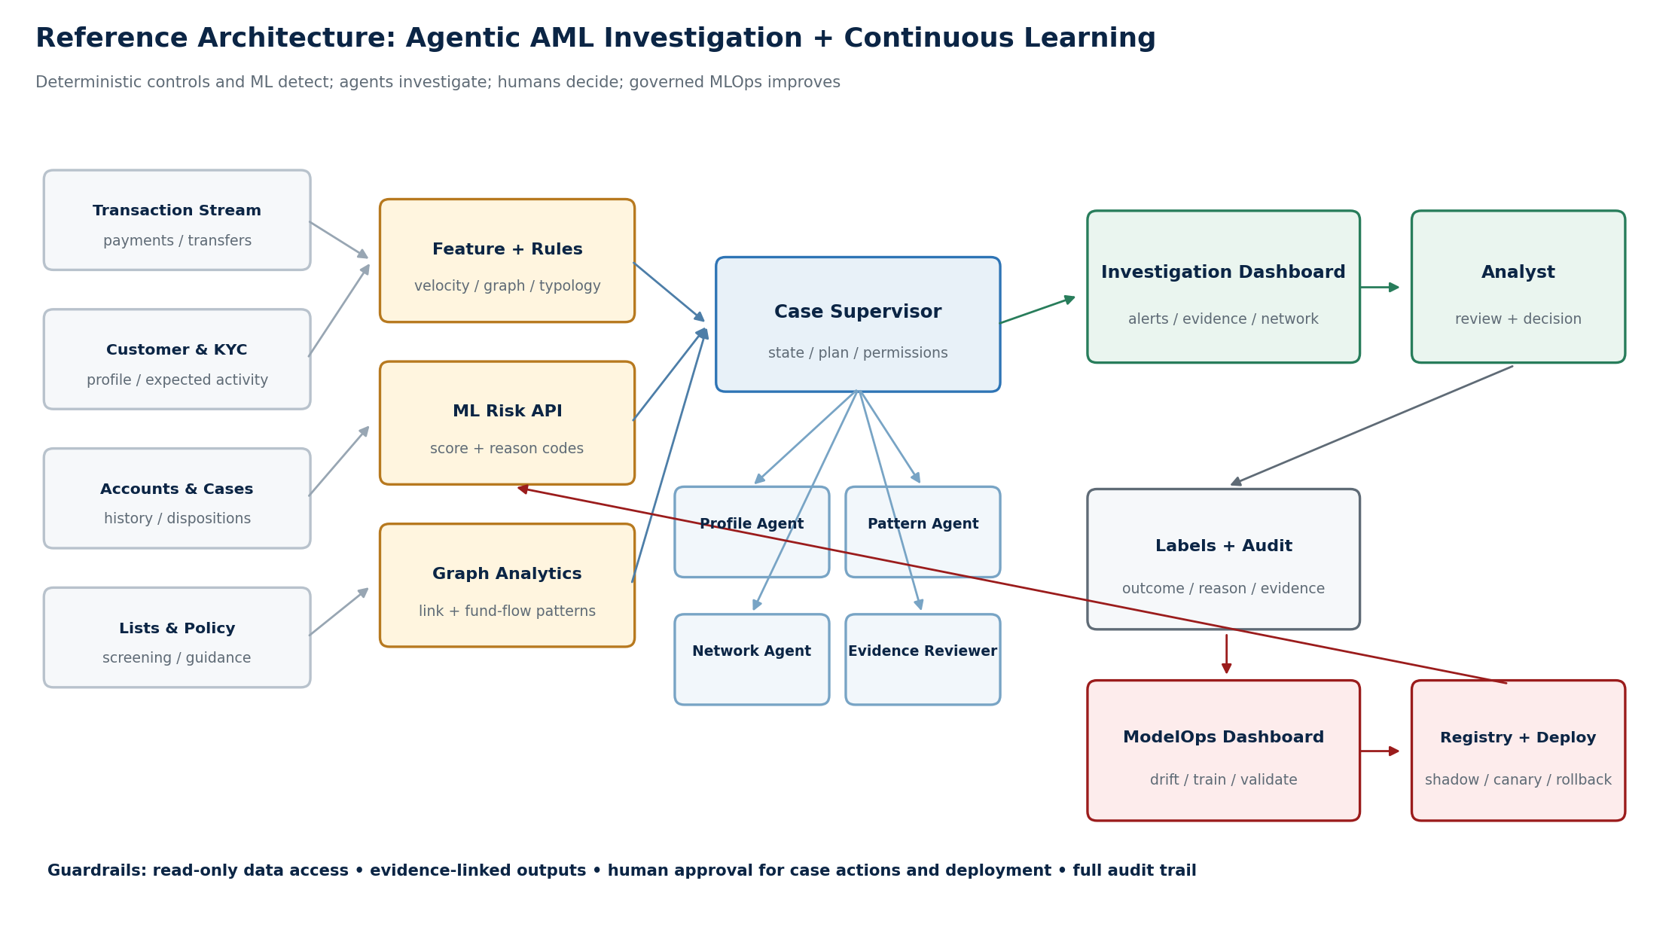
Figure 1. Recommended architecture: deterministic detection + multi-agent investigation + human decision + governed continuous learning

4.1 Core Design Principles
- Clear Separation of Duties: Rules and traditional ML provide repeatable detection and ranking. LLMs and agents do not replace the risk model; they investigate, retrieve, explain, and draft.
- Evidence First: Every factual claim must come from a tool result. The interface displays the evidence_id, query time, and data version, and prohibits unsupported facts generated only by the language model.
- State Machine First: Use deterministic states - ALERT_CREATED to COLLECTING to ANALYZING to REVIEWED to HUMAN_DECISION - rather than unconstrained conversation.
- Tiered Permissions: Read operations may run automatically. Writing to cases, initiating retraining, deploying models, and submitting STRs require different levels of approval.
- Replaceable Models: Expose the risk model through a stable API. The agent tool depends only on the contract, not on a specific algorithm or model version.

5. Multi-Agent and Tool Design

5.1 Recommended Agent Topology
Component | Responsibility | Key Tools | Permitted Output
Case Supervisor | Create the plan, dispatch work in parallel, maintain state, reconcile conflicts | Case MCP, task-state store | Task graph, state transitions, final synthesis
Customer Profile Agent | Review KYC, expected activity, historical risk, and relationships | Customer/Account MCP, Document RAG | Profile deviations, evidence citations, missing information
Transaction Pattern Agent | Analyze value, velocity, periodicity, channels, and rule hits | Transaction MCP, ML Risk API, Feature API | Anomalous patterns, reason codes, timeline
Network Investigation Agent | Compute account, device, beneficiary, and fund-flow relationships | Graph Analytics Tool | Subgraph, key nodes, paths, and statistics
Screening & Policy Agent | Screen lists and adverse media, then map findings to internal policy | Screening Tool, Policy RAG | Match results, policy clauses, escalation conditions
Evidence Reviewer | Cross-check facts, consistency, provenance, and uncertainty | Read-only Evidence Store | Pass / reject, gap list, confidence
Narrative Composer | Draft the case summary and STR narrative from verified evidence | Verified Evidence Store | Citation-based narrative; no final decision

Implementation Recommendation: The MVP does not require seven separate LLM services. Start with one Supervisor and four role-based workers. Evidence Reviewer and Narrative Composer can be two controlled stages of the same worker. The model-scoring service is a deterministic tool, not an agent.

5.2 MCP and Tool Boundaries
Tool / MCP Server | Example Interfaces | Permissions and Constraints
Bank Data MCP | get_customer, get_accounts, query_transactions | Read-only in production by default; row-level access; field masking; audited queries
Graph Tool | build_fund_flow, find_shared_entities, rank_nodes | Constrain by case_id and time window; return a reproducible graph version
Risk Model Tool | score_transaction, explain_score | Return explicit timeout/failure states; record model_version
Case MCP | create_case, append_evidence, propose_disposition | Writes require case scope; final disposition requires human confirmation
MLOps Control MCP | launch_training, compare_models, request_promotion | Agents may initiate or recommend; validation, approval, and production promotion cannot bypass gates
Policy RAG | retrieve_policy, map_red_flags | Use approved documents only; return passage and version; no conclusion without a source

6. Dual-Dashboard Design
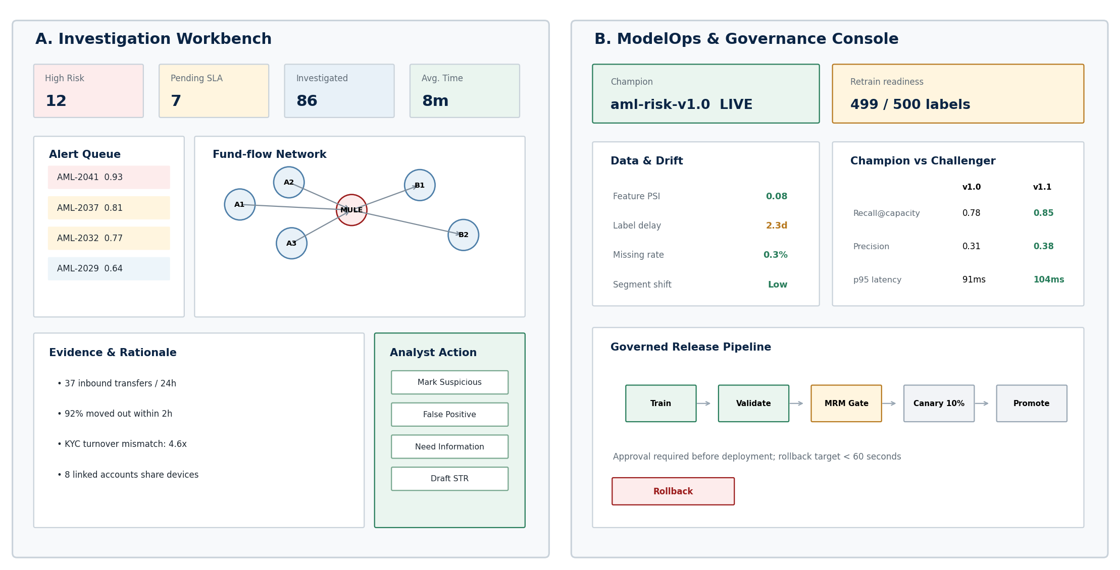
Figure 2. Dual-dashboard information architecture: Investigation Workbench and ModelOps Governance Console

6.1 Dashboard A: AML Investigation Workbench
The audience is frontline AML investigators, team leads, and compliance managers. The interface must answer four questions: What needs attention now? Why? Where is the evidence? What should happen next?
- Real-time Alert Queue: Filter by risk, SLA, amount, customer segment, country, and model version. New transactions update through SSE or WebSocket.
- Case Workbench: Display customer and KYC summaries, account relationships, transaction timeline, fund-flow network, historical cases, and screening results side by side.
- Model and Rule Explanation: Show risk score, top features, reason codes, and underlying values. Do not present an LLM-generated explanation as the model explanation.
- Agent Progress: Show tools called, evidence obtained, conflicts found, failed retries, and outstanding items. Support pause and resume.
- Human Actions: Suspicious, False Positive, Need More Information, Assign, Escalate, and Generate STR Draft. Require reason codes before submission.
- Audit Panel: Record who did what, when, and against which data, model, and policy versions.

6.2 Dashboard B: ModelOps & Governance Console
The audience is data science, model risk management (MRM), data engineering, platform operations, and compliance model owners. This is not merely a training button; it shows how new labels create a data version, how a challenger is validated, and who approved release.
- Labels and Data Quality: New disposition count, label latency, class distribution, segment coverage, duplicate or conflicting labels, and training cutoff.
- Data and Concept Drift: PSI and distribution changes, missingness, channel and country shifts, score drift, and delayed business labels.
- Retraining Triggers: Label-volume threshold, schedule, performance degradation, or manual trigger. The agent explains the trigger and starts a run.
- Champion/Challenger: Compare recall@capacity, precision, PR-AUC, calibration, segment performance, alert volume, and latency on the same holdout set.
- Approval and Release: Training complete to technical validation to AML SME/MRM approval to shadow to 10% canary to promotion, with one-click rollback retained.
- Lineage and Audit: Link data_version, feature_version, code_commit, model_version, prompt or agent version, and approval records end to end.

7. Traditional ML Model Design
Use LightGBM or XGBoost for the first risk model: both train quickly, provide clear feature importance, and are easy to deploy on CPUs, making them suitable for a live customer demonstration. The model output is a risk-ranking signal and does not directly determine customer treatment.
Feature Family | Examples | Corresponding Risk Signal
Velocity | Inbound count over 1h/24h, value growth, account-balance turnover speed | Short-window anomalous activity
Flow | Percentage transferred out 15/60/120 minutes after receipt; in/out ratio | Rapid pass-through of funds
Counterparty | New-beneficiary ratio, country risk, counterparty concentration | New cross-border route
Structuring | Splitting near thresholds, consecutive small amounts, repeated value patterns | Structuring intended to evade monitoring
KYC mismatch | Actual transaction volume versus declared turnover; deviation from industry baseline | Activity inconsistent with customer background
Network | Shared devices or beneficiaries, suspicious two-hop neighbors, node centrality | Organized or mule-account network
History | Historical alerts, investigation outcomes, reactivation after dormancy | Recurring risk and sudden behavioral change

7.1 Scoring API Contract
Recommended Response: transaction_id, customer_id, risk_score, risk_band, reason_codes[], top_features[], model_version, feature_timestamp, scored_at, and decision_threshold_version. Every agent summary must retain the model_version and evidence timestamp.

7.2 Why Use Two-Stage Detection
- Event-Level Scoring: Score every new transaction quickly to produce a rankable risk event.
- Case-Level Aggregation: Combine related risk events across the customer, account, time-window, and relationship-network levels before deciding whether to create an investigation alert.
- Agent Investigation: Run the more expensive multi-agent workflow only for high-value alerts, avoiding an LLM call for every normal transaction.

8. Closed Loop from Human Feedback to Model Upgrade
- Label: The investigator submits a disposition, reason codes, and notes. The system freezes the corresponding data and evidence versions.
- Curate: The data pipeline deduplicates records, checks conflicts, and creates training_dataset_vN. Inconclusive cases are not treated as positive or negative labels by default.
- Trigger: The agent may recommend retraining when any trigger is met: 500 newly adjudicated cases, PSI above 0.20, a relative decline of more than 10% in a key metric, or the monthly schedule.
- Train: MLOps runs feature construction, temporal splitting, model training, calibration, offline testing, and explainability reporting.
- Validate: Automated gates eliminate unqualified candidates. AML SMEs and MRM review coverage, segment performance, alert quality, and limitations.
- Deploy: Run the new model in shadow mode, followed by a 10% canary. Increase traffic gradually after health checks pass. The API remains stable, and Dashboard A switches seamlessly to the new version.
- Rollback: Automatically stop traffic expansion if error rate, p95 latency, feature missingness, or score distribution becomes abnormal. Revert to the previous champion when authorized.
Demo Technique: Pre-set the label count to 499/500. When the investigator completes the final label in Dashboard A, Dashboard B immediately shows 'retrain ready.' Use precomputed results or an accelerated job so training completes in 30-60 seconds for a smooth demonstration. State clearly that this is demo acceleration, not a representation of production retraining time.

9. Synthetic Data Design

9.1 Data Scale
Mode | Customers | Accounts | Transactions | Adjudicated Cases | Real-time Replay
Development Mode | 2,000 | 3,000 | 100,000 | 500 | 1-3 tx/s
Customer Demo Mode | 20,000 | 30,000 | 1-2 million | 3,000-5,000 | 5-20 tx/s (accelerated time)

9.2 Required Behavior Types
- Normal salary, bill, credit-card repayment, merchant-settlement, SME supply-chain payment, and seasonal patterns.
- Mule / funnel account: rapid transfer out after many-to-one inbound payments.
- Structuring: split transactions near thresholds across channels or accounts.
- Circular flow: funds circulate among linked accounts before returning to the original network.
- Dormant-to-active: a dormant account suddenly shows high-frequency cross-border activity.
- Network linkage: shared devices, IPs, phone numbers, beneficiaries, or beneficial owners.
- Hard negatives: merchant promotions, property transactions, or group treasury activity that appear suspicious but have valid explanations, preventing the model from learning overly simplistic rules.

9.3 Leakage Prevention and Labels
- Temporal Split: Create train, validation, and test sets by event time; never randomly shuffle future transactions into training.
- Network Split: Related accounts from the same synthetic criminal network must not appear in both training and test sets.
- Label Levels: Retain three levels - transaction signal, alert disposition, and case outcome - so that a rule hit is not treated directly as a true-crime label.
- Label Status: Suspicious, False Positive, or Inconclusive, with reason_code, confidence, and adjudicator.
- Privacy Statement: All names, accounts, devices, and external news are synthetic. The interface is clearly marked DEMO / SYNTHETIC DATA.

10. Evaluation and Acceptance Plan

10.1 Detection Model
Dimension | Primary Metrics | Suggested Demo Thresholds (Configurable)
Detection Capability | PR-AUC, Recall@review capacity, typology coverage | Recall@Top 2% >= 0.80; all injected typologies covered
Alert Quality | Precision, False-positive rate, alerts/day | Precision@Top 2% >= 0.35; alert volume remains within capacity
Calibration | Brier score, ECE, risk-band reliability | ECE <= 0.05; monotonic high-risk bands
Stability | PSI, missingness, segment performance | Key-feature PSI < 0.20; no unexplained discontinuities
Performance | p50/p95 latency, error rate, throughput | p95 < 150 ms; error rate < 0.1%

10.2 Agent Investigation
Dimension | Test Method | Acceptance Target
Factual Correctness | Compare each atomic fact in the generated summary with the corresponding tool result | 100% factual support; zero unsourced facts
Evidence Coverage | Check whether every risk conclusion cites an evidence_id | 100% citation coverage for key conclusions
Investigation Completeness | Score against the golden-case checklist | >= 95% completion of required investigation steps
Tool Reliability | Fault injection: timeout, empty result, insufficient permissions | No guessing; explicit failure; safe retry or fallback
Disposition Appropriateness | AML SME blind review of recommendations | >= 90% agreement with the golden outcome; final decision remains human
Efficiency | Time from alert to review-ready case pack | p95 < 30 seconds (demo environment)

10.3 Business and ModelOps
- Average investigation handling time, throughput per investigator, SLA breach rate, reopen rate, and supervisor override rate.
- Time from label cutoff to a testable challenger, reproducible training rate, gate pass rate, release failure rate, and rollback time.
- New-alert visibility in Dashboard A < 2 seconds; no scoring API interruption during model switch; rollback target < 60 seconds.
- These figures are demo acceptance targets, not regulatory thresholds, and must not be used directly as production risk appetite.

11. Security, Regulatory, and Governance Boundaries
FATF notes that new technologies and collaborative analytics can improve AML/CFT effectiveness, identify more complex patterns, and reduce false positives, while stressing compliance with privacy and data-protection frameworks. [5] In Singapore, STRO is the financial intelligence unit that receives and analyzes STRs, and SONAR is the channel through which businesses submit them. [6][7] The demo should therefore show generation of an STR draft, not autonomous agent submission to the regulator.
Action | May the Agent Act Automatically? | Required Controls
Read data within case scope | Yes | Least privilege, field masking, query audit, timeout and row limits
Generate investigation plan, summary, or STR draft | Yes | Verified evidence only; display uncertainty and provenance
Write evidence or recommendations | Limited | Case scope; idempotency key; pre- and post-write audit
Close a case or mark it Suspicious | Not Independently | Investigator confirmation; dual approval for high-risk cases where required
Freeze an account, reject a transaction, or contact a customer | Outside Demo Automation Scope | Handled through existing bank controls and authorization workflows
Initiate retraining | May recommend and start a controlled job | Fixed data version; resource and approval policy limits
Promote a production model | Not Independently | Independent validation, MRM, and model-owner approval; staged rollout and rollback
Submit an STR | No | Authorized personnel review and submit through the existing regulatory-reporting process

Governance Basis: In its 2026 work on safeguards for AI agents in finance, MAS emphasized verifying and recording an agent's proposed actions before execution. This aligns with the tiered permissions, approval gates, and action ledger in this design. [8]

- Version models, prompts, tool schemas, and policy documents; retain the versions used in each case record.
- Keep sensitive data within the controlled environment; prioritize private deployment or approved model endpoints in production.
- Prompt-injection defense: treat external text as untrusted data and never allow it to alter system permissions or invoke unauthorized tools.
- Use an allow-list for all tools, validate parameters against schemas, and protect write operations with idempotency keys, dry runs, and approval tokens.
- Continuously red-team hallucination, privilege escalation, data leakage, tool loops, malicious documents, model or tool outages, and incorrect rollback.

12. 12-15 Minute Customer Demo Script
Time | Screen / Action | Key Message
0:00-1:00 | Opening: show the two user groups and closed-loop architecture | This is not a standalone chatbot; it is a complete AML, AI, and MLOps closed loop
1:00-2:30 | Dashboard A: normal transaction flow continues | Rules and ML perform low-cost real-time scoring first; the system does not call an LLM for every transaction
2:30-4:00 | Inject Project Nightfall suspicious transactions; a high-risk alert appears | Explain the risk score, reason codes, model version, and live SLA
4:00-7:30 | Open the case and run the agents; KYC, timeline, network, and screening evidence appear progressively | Every conclusion is traceable to a tool result; parallel investigation reduces handling time
7:30-9:00 | Evidence Reviewer identifies supporting evidence and gaps; generate an STR draft | The LLM organizes information but does not replace final human judgment
9:00-10:00 | The investigator marks the case Suspicious and selects reason codes | Human feedback supports the case workflow and creates high-quality training labels
10:00-12:30 | Switch to Dashboard B; the label count moves from 499 to 500; start retraining and compare the challenger | Show data versions, metrics, explanations, approval gates, and audit records
12:30-14:00 | Approve the canary; shift traffic gradually; Dashboard A displays the new model_version | Stable API, seamless upgrade, and one-click rollback
14:00-15:00 | Summary and customer discussion | Discuss how the customer's current transaction monitoring, case management, model governance, and deployment processes map to the design

12.1 Live Demo Resilience
- Use local fixed snapshots for all data, external lists, and adverse media; do not depend on venue internet access.
- Support live agent execution and prepare a deterministic replay. If the live run fails, switch seamlessly to recorded steps.
- The retraining demo may run a real pipeline, but precompute artifacts and metrics to keep live waiting time under 60 seconds.
- Prepare a reset script to restore alerts, label count, model versions, and traffic allocation; run a smoke test before every demonstration.
- Clearly mark all screens Synthetic Data / Demo. Do not show a real bank logo, real customers, or real sanctions-list matches.

13. Implementation Scope and Delivery Plan

13.1 MVP and Enhancements
Tier | Required Deliverables | Out of Scope for Now
MVP | Two AML typologies; ML risk API; 1+4 agents; dual dashboards; human labeling; governed retraining and canary; audit logs | Live regulatory submission, real customer data, automated account actions
Enhanced | More typologies; interactive fund-flow graph; policy RAG; batch cases; fault injection; explanation reports | Interbank data sharing; formal cross-jurisdiction validation
Production Follow-up | Integrate with existing transaction-monitoring and case systems; SSO/RBAC; MRM; disaster recovery; capacity; data residency; operating SOPs | Automated disposition before customer governance approval

13.2 Four-Week Implementation Plan
Week | Focus | Primary Tasks | Exit Criteria
Week 1 | Story and Data | Lock the typologies; complete the schema, synthetic data, normal and suspicious behavior replay, and low-fidelity UI | Nightfall case is reproducible; data-quality checks pass
Week 2 | Models and Agents | Train v1; deploy scoring API; implement MCP; complete Supervisor and workers; create golden case | Generate a traceable case pack end to end; offline metrics meet target
Week 3 | Dual Dashboards and MLOps | Real-time alerts; case workbench; labeling; retraining pipeline; registry; canary and rollback | One label can trigger the complete governed model-upgrade story
Week 4 | Integration and Hardening | Evaluation set, permissions, audit, graceful degradation, replay, reset, customer script, and rehearsals | Five consecutive successful demos; no critical P0/P1 defects

13.3 Recommended Roles
Role | Responsibility | Suggested Allocation
AML SME / Product Owner | Define typologies, golden cases, disposition criteria, and demo narrative | 0.3-0.5 FTE
Data Engineer | Synthetic data, streaming replay, data tables, features, and quality | 0.5-1.0 FTE
ML Engineer | Models, evaluation, APIs, registry, retraining, and release | 1.0 FTE
Agent Engineer | Supervisor, MCP, permissions, evidence, and agent evaluation | 1.0 FTE
Frontend Engineer | Dual dashboards, real-time updates, network graph, and interactions | 1.0 FTE
Platform/SRE | Deployment, identity, logging, observability, reset, and replay | 0.3-0.5 FTE

If one or two people must deliver quickly, implement external screening, STR formatting, and actual training duration as replaceable stubs or replays. Concentrate engineering effort on end-to-end business-flow completeness and an explainable user experience.

14. Key Risks and Mitigations
Risk | Manifestation | Mitigation
Scenario Too Broad | Attempting to cover scams, AML, sanctions, and credit risk at once | Lock one Nightfall case; keep other typologies in the backlog
Model Becomes Decorative | No clear relationship between the risk score and the agent conclusion | The model provides explainable signals only; the agent explicitly cites and may challenge them
Synthetic Data Too Simple | Rules or models appear nearly 100% accurate | Add hard negatives, seasonality, label noise, and network-isolation tests
Agent Hallucination | Generating customers, transactions, or policies that do not exist | Evidence allow-list, atomic fact checks, Evidence Reviewer, and no output without a source
Unauthorized Automation | Agent directly closes a case, deploys a model, or submits an STR | Permission matrix, approval token, dry run, and action ledger
Live Latency or Failure | Model training or tool calls time out | Warm-up, caching, replay, precomputed artifacts, and clear degraded states
Technology Without Business Value | The customer cannot see what is saved or improved | Anchor the story in investigation time, queue capacity, evidence quality, auditability, and release cycle

15. Definition of Done
- Starting from a clean reset, complete the demonstration within 15 minutes without manual backend intervention.
- A new transaction appears in Dashboard A within two seconds with risk_score, reason_codes, and model_version.
- Every key fact in the Nightfall case links back to the original tool result or evidence record.
- After investigator labeling, feedback enters a new dataset_version without overwriting historical evidence.
- Dashboard B displays the complete retraining, metric comparison, approval, canary, promotion, and rollback lifecycle.
- The scoring API remains available during the model-version switch, and Dashboard A shows that the new version is active.
- Permissions, audit, failure fallback, Synthetic Data labeling, and regulatory boundaries are visible in the UI.
- Pass at least five consecutive end-to-end rehearsals and prepare a deterministic replay as live-demo insurance.

16. Eight Decisions to Confirm Before Kickoff
- Is the target customer primarily a retail bank, corporate bank, or payment institution? This determines the Nightfall customer profile and transaction types.
- Is the demo positioned for Singapore? If yes, align the interface and policy RAG with MAS and STRO terminology; otherwise remain jurisdiction-neutral.
- Does the customer care more about AML operating efficiency or the platform's Agent, MCP, and MLOps capabilities? This determines the narrative emphasis.
- Which components can be reused: streaming platform, lakehouse, model serving, agent framework, model registry, or case UI?
- Should retraining run live, or use a hybrid of a real pipeline and precomputed results?
- Which roles complete ModelOps approvals, and should the demo show dual approval?
- Are external network calls allowed? The recommended default is no, using local intelligence snapshots.
- What defines demo success: business resonance, architecture validation, PoC initiation, or product capability showcase?

Appendix A: Recommended Core Tables
Table | Primary Key | Key Relationships / Purpose
customers | customer_id | KYC, risk rating, expected activity, industry, and beneficial owners
accounts | account_id | Linked customer_id; status, opening date, balance
transactions | transaction_id | from/to account, amount, currency, channel, event_time
devices | device_id | Account, login-session, and IP relationships used for network features
alerts | alert_id | Triggering event, rule hits, score, model_version
cases | case_id | One or more alerts; status, assignee, SLA, disposition
evidence | evidence_id | case, tool, query, payload hash, data_version, timestamp
annotations | annotation_id | case, label, reason_code, comment, adjudicator
model_runs | run_id | Dataset, feature, code, and model versions and metrics
deployments | deployment_id | environment, traffic, approval, rollback model

Appendix B: Verified Design References
[1] MAS Notice 626 - Prevention of Money Laundering and Countering the Financing of Terrorism (Banks)
[2] MAS - Guidance for Effective AML/CFT Transaction Monitoring Controls
[3] Wolfsberg Group - Effective Monitoring for Suspicious Activity, Part I (2024)
[4] Wolfsberg Group - Effective Monitoring for Suspicious Activity, Part II: Transitioning to Innovation (2025)
[5] FATF - Digital Transformation of AML/CFT
[6] Singapore Police Force - Suspicious Transaction Reporting Office
[7] Singapore Police Force - SONAR
[8] MAS - Safeguards for AI Agents in Finance (2026)
[9] MAS - Artificial Intelligence Model Risk Management (2024)
Note: This document is a product and technical plan for a customer demo. It does not constitute legal, regulatory, model-risk, or suspicious-transaction-reporting advice. Production implementation must be reviewed by the bank's compliance, model risk, information security, and legal functions.

