**Abstract**

This study analyzes global data on sustainable energy from 2000 to 2020, offering a comprehensive assessment of key energy indicators including electricity access, renewable energy capacity, carbon emissions, energy intensity, financial flows, and economic growth across countries. The analysis tracks global progress toward Sustainable Development Goal 7 (SDG 7) – ensuring universal access to affordable, reliable, sustainable, and modern energy for all. By comparing trends between developed and developing nations, the research highlights disparities in electricity access, renewable energy adoption, and carbon emissions reduction. It examines how financial flows to developing countries have supported clean energy transitions, with a focus on renewable energy share, energy efficiency, and decarbonization efforts. The findings provide valuable insights into the relationship between energy consumption, economic growth, and sustainability, emphasizing challenges such as high initial costs, technological limitations, and regulatory barriers. Ultimately, this study underscores the importance of global collaboration in accelerating the energy transition and achieving a low-carbon, inclusive, and sustainable energy future.

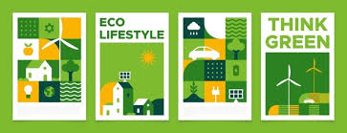

**Understanding of Sustainable Energy**

The concept of sustainable energy is based on the principles of sustainability, which aim to meet the needs of the present without compromising the ability of future generations to meet their own needs. Sustainable energy systems are designed to ensure that the energy used today does not compromise the availability of energy for future generations.

Sustainable energy is a critical component of a sustainable future, as it plays a key role in reducing greenhouse gas emissions, mitigating climate change, and protecting the environment. By transitioning to sustainable energy sources and practices, we can reduce our dependence on non-renewable energy sources, promote energy independence, and create a more sustainable and equitable world

Global Sustainable Energy

**The Future**

**In Our Hand**

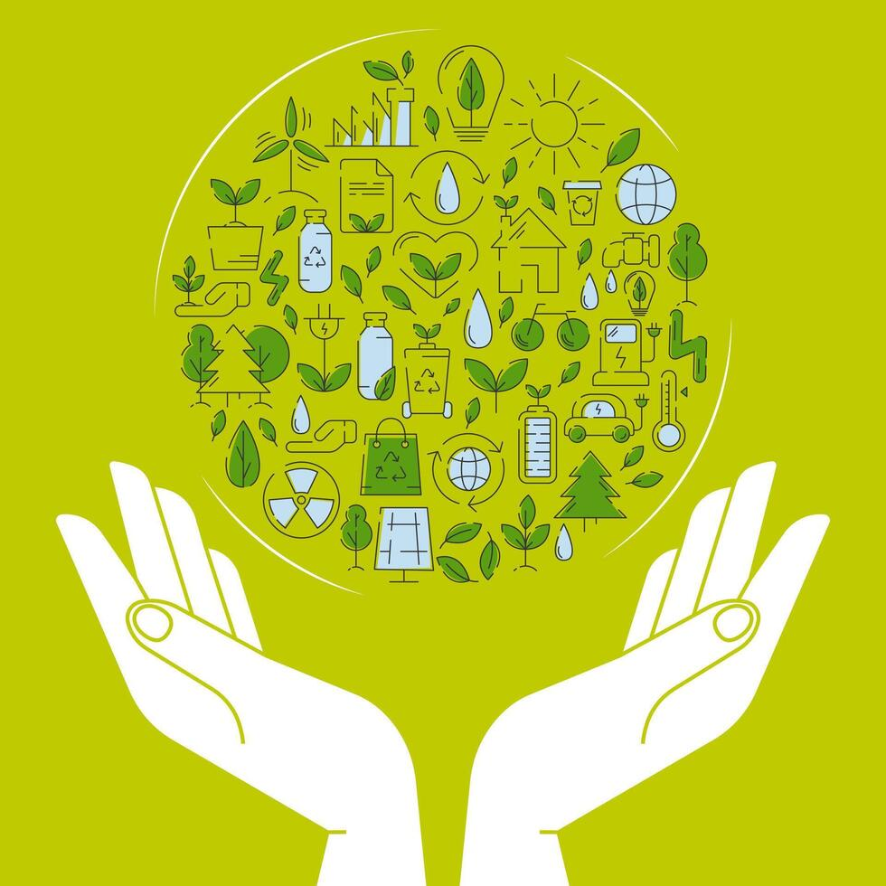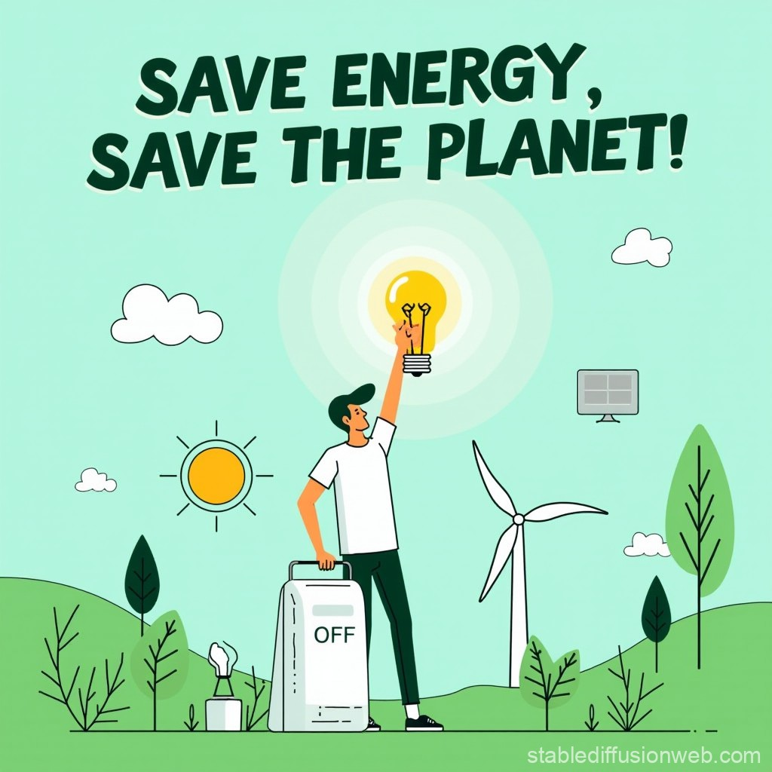

**Results**

**1. Electricity Access Trends :** In 2000, sub-Saharan Africa had the lowest electricity access rates, with some countries below 20%. By 2020, global electricity access reached approximately 90%, with South Asia and sub-Saharan Africa making substantial progress due to rural electrification programs and off-grid solutions

**2. Renewable Energy Share in Total Energy Consumption:** Countries like Germany, Sweden, and Brazil have led the transition, with renewables accounting for over 40% of their final energy consumption. In contrast, fossil fuel-dependent nations, such as those in the Middle East, have slower transitions.

**3. Carbon Emissions Trends:** Global carbon emissions have fluctuated due to economic growth, energy policies, and industrial activity. High-emission countries like China, the United States, and India have seen growing emissions despite increased renewable adoption..

**4. Energy Intensity and Efficiency:** Energy intensity, measured as energy use per unit of GDP, has declined globally, indicating improved energy efficiency. Developed nations have achieved significant reductions due to energy-saving technologies and stringent policies.

**5. Financial Flows into Sustainable Energy:** Investment in clean energy projects has increased, particularly in developing countries. Financial flows to Africa and Asia have grown, with international donors and private investors supporting solar, wind, and hydro projects.

**6. Economic Growth and Energy Consumption Trends:** The relationship between GDP growth and energy consumption varies across regions. In industrialized economies, economic growth has become less dependent on fossil fuel consumption due to energy efficiency measures and a shift to services-oriented economies.

**7. Progress Toward Sustainable Development Goal 7 (SDG 7):** Many countries have made significant progress in achieving SDG 7, particularly in improving electricity access and renewable energy adoption.

**8. Developed vs. Developing Countries in Energy Transition:** Developed nations have largely transitioned towards cleaner energy sources, with robust policy frameworks and technological advancements. Developing countries, while making progress, face infrastructure, financial, and policy-related barriers.

**9. Off-Grid and Mini-Grid Renewable Solutions:** Countries like Kenya, Bangladesh, and India have pioneered innovative business models for off-grid energy, enabling rural communities to benefit from sustainable electricity without relying on traditional grid expansion. These solutions are vital for accelerating universal energy access.

**10. Government Policies and Their Impact on Energy Transition**

Government policies, including subsidies, tax incentives, and regulatory frameworks, have significantly influenced the pace of energy transition. Nations with strong policy support, such as Germany's Energiewende and China's renewable energy subsidies, have witnessed rapid adoption of clean energy. Conversely, countries with fossil fuel subsidies have faced slower transitions.

### ****Challenges****

#### **High Initial Costs**

* **Renewable Energy Infrastructure**
* **Financial Barriers for Developing Nations**

#### **Technological Limitations**

* **Intermittency of Renewable Energy**
* **Limited Grid Flexibility**

#### **Regulatory Barriers**

* **Inconsistent Energy Policies**
* **Subsidies for Fossil Fuels**

#### **Infrastructure Limitations**

* **Weak Transmission Networks**
* **Limited Electrification in Rural Areas**
* **Challenges in Integrating Mini-Grids**

#### **Lack of Public Awareness**

* **Energy Efficiency Knowledge Gaps**
* **Misconceptions About Renewable Energy**
* **Education and Advocacy Deficits**

.

**Conclusion**

This report on The global data on sustainable energy from 2000 to 2020 provides invaluable insights into the complex interplay of electricity access, renewable energy adoption, carbon emissions, energy intensity, financial flows, and economic growth across nations. However, challenges such as high initial costs, technological limitations, regulatory barriers, infrastructure shortcomings, and public awareness gaps continue to hinder the full realization of a sustainable energy future. While developed nations have largely transitioned to cleaner energy sources, developing countries face ongoing struggles due to financial and infrastructure constraints. Moreover, the growing demand for energy in emerging economies, coupled with the persistence of fossil fuel subsidies and outdated energy infrastructure, complicates efforts to achieve the goals set by Sustainable Development Goal 7. Addressing these challenges is essential for fostering a low-carbon, equitable energy future and ensuring that sustainable energy becomes a reality for all.

### ****Impacts on Sustainable Energy Indicators****

**Electricity Access:** Limited infrastructure and high costs slow progress in achieving universal energy access.

**Renewable Energy Share:** Fossil fuel subsidies and grid limitations hinder the growth of renewables in the energy mix.

**Carbon Emissions:** Continued reliance on fossil fuels results in high emissions, delaying climate goals.

**Energy Intensity:** Developing nations struggle to improve energy efficiency due to outdated industrial processes.

**Financial Flows:** Insufficient funding in low-income nations creates disparities in energy transitions.

**Economic Growth:** Dependence on fossil fuels can lead to economic volatility, particularly in oil-exporting countries.