Санкт-Петербургский Национальный Исследовательский Университет ИТМО

Факультет программной инженерии и компьютерной техники

Курсовая работа

По дискретной математике  
часть 2

Вариант 18

Выполнила:

Богданова Мария Михайловна

P3118

Преподаватель:

Поляков Владимир Иванович

г. Санкт-Петербург

2023

Построить комбинационную схему, реализующую функцию C = A − 1 при t = 0 (A = a1a2a3a4 и C = c1c2c3c4), C = A − B при t = 1. (A = a2a3a4, B = ba1, C = c1c2c3c4) При переносе, e = 1.

|  |  |  |  |  |  |  |  |  |  |  |
| --- | --- | --- | --- | --- | --- | --- | --- | --- | --- | --- |
| t | b | A1 | A2 | A3 | A4 | e | C1 | C2 | C3 | C4 |
| 0 | 0 | 0 | 0 | 0 | 0 | 1 | 1 | 1 | 1 | 1 |
| 0 | 0 | 0 | 0 | 0 | 1 | 0 | 0 | 0 | 0 | 0 |
| 0 | 0 | 0 | 0 | 1 | 0 | 0 | 0 | 0 | 0 | 1 |
| 0 | 0 | 0 | 0 | 1 | 1 | 0 | 0 | 0 | 1 | 0 |
| 0 | 0 | 0 | 1 | 0 | 0 | 0 | 0 | 0 | 1 | 1 |
| 0 | 0 | 0 | 1 | 0 | 1 | 0 | 0 | 1 | 0 | 0 |
| 0 | 0 | 0 | 1 | 1 | 0 | 0 | 0 | 1 | 0 | 1 |
| 0 | 0 | 0 | 1 | 1 | 1 | 0 | 0 | 1 | 1 | 0 |
| 0 | 0 | 1 | 0 | 0 | 0 | 0 | 0 | 1 | 1 | 1 |
| 0 | 0 | 1 | 0 | 0 | 1 | 0 | 1 | 0 | 0 | 0 |
| 0 | 0 | 1 | 0 | 1 | 0 | 0 | 1 | 0 | 0 | 1 |
| 0 | 0 | 1 | 0 | 1 | 1 | 0 | 1 | 0 | 1 | 0 |
| 0 | 0 | 1 | 1 | 0 | 0 | 0 | 1 | 0 | 1 | 1 |
| 0 | 0 | 1 | 1 | 0 | 1 | 0 | 1 | 1 | 0 | 0 |
| 0 | 0 | 1 | 1 | 1 | 0 | 0 | 1 | 1 | 0 | 1 |
| 0 | 0 | 1 | 1 | 1 | 1 | 0 | 1 | 1 | 1 | 0 |
| 0 | 1 | 0 | 0 | 0 | 0 | d | d | d | d | d |
| 0 | 1 | 0 | 0 | 0 | 1 | d | d | d | d | d |
| 0 | 1 | 0 | 0 | 1 | 0 | d | d | d | d | d |
| 0 | 1 | 0 | 0 | 1 | 1 | d | d | d | d | d |
| 0 | 1 | 0 | 1 | 0 | 0 | d | d | d | d | d |
| 0 | 1 | 0 | 1 | 0 | 1 | d | d | d | d | d |
| 0 | 1 | 0 | 1 | 1 | 0 | d | d | d | d | d |
| 0 | 1 | 0 | 1 | 1 | 1 | d | d | d | d | d |
| 0 | 1 | 1 | 0 | 0 | 0 | d | d | d | d | d |
| 0 | 1 | 1 | 0 | 0 | 1 | d | d | d | d | d |
| 0 | 1 | 1 | 0 | 1 | 0 | d | d | d | d | d |
| 0 | 1 | 1 | 0 | 1 | 1 | d | d | d | d | d |
| 0 | 1 | 1 | 1 | 0 | 0 | d | d | d | d | d |
| 0 | 1 | 1 | 1 | 0 | 1 | d | d | d | d | d |
| 0 | 1 | 1 | 1 | 1 | 0 | d | d | d | d | d |
| 0 | 1 | 1 | 1 | 1 | 1 | d | d | d | d | d |

|  |  |  |  |  |  |  |  |  |  |  |
| --- | --- | --- | --- | --- | --- | --- | --- | --- | --- | --- |
| 1 | 0 | 0 | 0 | 0 | 0 | 0 | 0 | 0 | 0 | 0 |
| 1 | 0 | 0 | 0 | 0 | 1 | 0 | 0 | 0 | 0 | 1 |
| 1 | 0 | 0 | 0 | 1 | 0 | 0 | 0 | 0 | 1 | 0 |
| 1 | 0 | 0 | 0 | 1 | 1 | 0 | 0 | 0 | 1 | 1 |
| 1 | 0 | 0 | 1 | 0 | 0 | 0 | 0 | 1 | 0 | 0 |
| 1 | 0 | 0 | 1 | 0 | 1 | 0 | 0 | 1 | 0 | 1 |
| 1 | 0 | 0 | 1 | 1 | 0 | 0 | 0 | 1 | 1 | 0 |
| 1 | 0 | 0 | 1 | 1 | 1 | 0 | 0 | 1 | 1 | 1 |
| 1 | 0 | 1 | 0 | 0 | 0 | 1 | 1 | 1 | 1 | 1 |
| 1 | 0 | 1 | 0 | 0 | 1 | 0 | 0 | 0 | 0 | 0 |
| 1 | 0 | 1 | 0 | 1 | 0 | 0 | 0 | 0 | 0 | 1 |
| 1 | 0 | 1 | 0 | 1 | 1 | 0 | 0 | 0 | 1 | 0 |
| 1 | 0 | 1 | 1 | 0 | 0 | 0 | 0 | 0 | 1 | 1 |
| 1 | 0 | 1 | 1 | 0 | 1 | 0 | 0 | 1 | 0 | 0 |
| 1 | 0 | 1 | 1 | 1 | 0 | 0 | 0 | 1 | 0 | 1 |
| 1 | 0 | 1 | 1 | 1 | 1 | 0 | 0 | 1 | 1 | 0 |
| 1 | 1 | 0 | 0 | 0 | 0 | 1 | 1 | 1 | 1 | 0 |
| 1 | 1 | 0 | 0 | 0 | 1 | 1 | 1 | 1 | 1 | 1 |
| 1 | 1 | 0 | 0 | 1 | 0 | 0 | 0 | 0 | 0 | 0 |
| 1 | 1 | 0 | 0 | 1 | 1 | 0 | 0 | 0 | 0 | 1 |
| 1 | 1 | 0 | 1 | 0 | 0 | 0 | 0 | 0 | 1 | 0 |
| 1 | 1 | 0 | 1 | 0 | 1 | 0 | 0 | 0 | 1 | 1 |
| 1 | 1 | 0 | 1 | 1 | 0 | 0 | 0 | 1 | 0 | 0 |
| 1 | 1 | 0 | 1 | 1 | 1 | 0 | 0 | 1 | 0 | 1 |
| 1 | 1 | 1 | 0 | 0 | 0 | 1 | 1 | 1 | 0 | 1 |
| 1 | 1 | 1 | 0 | 0 | 1 | 1 | 1 | 1 | 1 | 0 |
| 1 | 1 | 1 | 0 | 1 | 0 | 1 | 1 | 1 | 1 | 1 |
| 1 | 1 | 1 | 0 | 1 | 1 | 0 | 0 | 0 | 0 | 0 |
| 1 | 1 | 1 | 1 | 0 | 0 | 0 | 0 | 0 | 0 | 1 |
| 1 | 1 | 1 | 1 | 0 | 1 | 0 | 0 | 0 | 1 | 0 |
| 1 | 1 | 1 | 1 | 1 | 0 | 0 | 0 | 0 | 1 | 1 |
| 1 | 1 | 1 | 1 | 1 | 1 | 0 | 0 | 1 | 0 | 0 |

Минимизация на картах Карно:

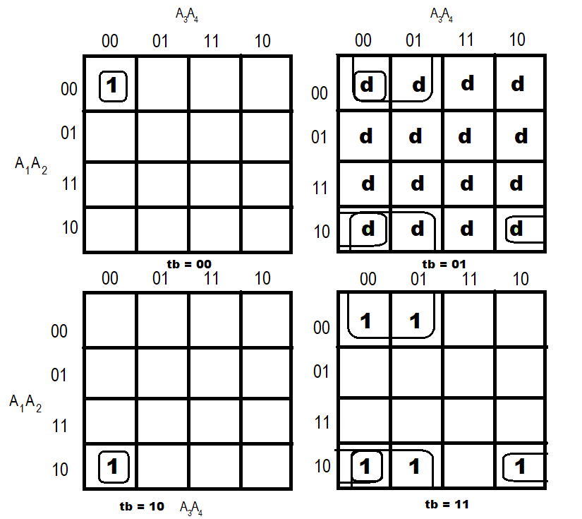

e = ¬a2 ¬a3 b V a1 ¬a2 ¬a4 b V a1 ¬a2 ¬a3 ¬a4 t V ¬a1 ¬a2¬ a3 ¬a4 ¬t (Sq = 21)

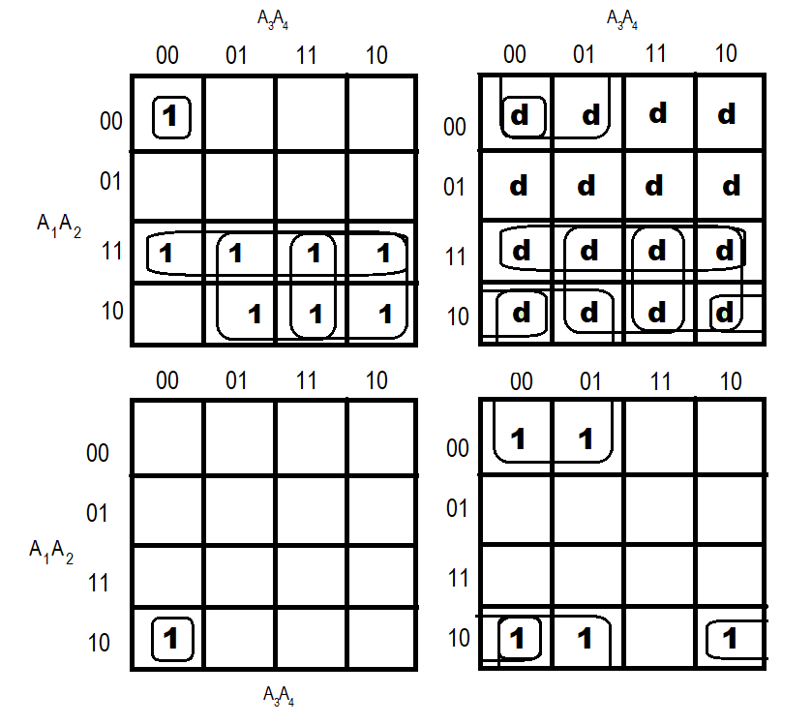

c1 = ¬a2 ¬a3 b V a1 a2 ¬t V a1 a3 ¬t V a1 a4 ¬t V a1 ¬a2 ¬a4 b V a1¬a2¬a3¬a4 t V¬a1¬a2¬a3 ¬a4 t (SQ = 33)

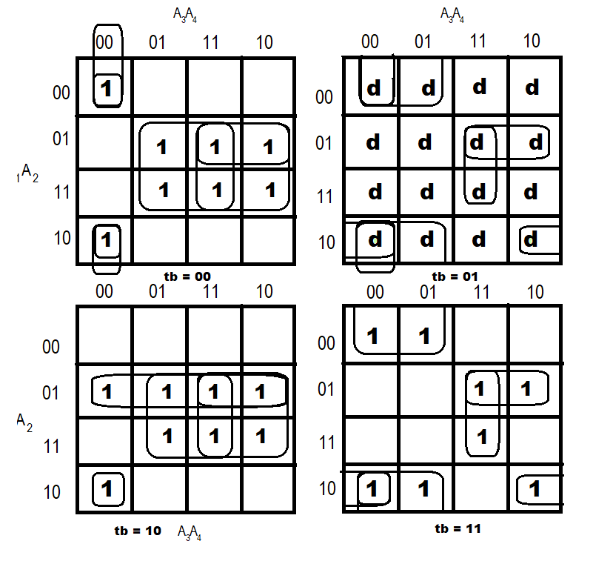

c2 = a2a3a4 ∨ ¬a2¬a3 b ∨ ¬a1a2a3 ∨ a2a3 ¬b ∨ a2a4¬b ∨ a1¬a2 ¬a3 ¬a4 ∨ a1 ¬a2 ¬a4 b ∨ ¬a1a2 ¬b t ∨ ¬a2 ¬a3¬ a4 ¬t (SQ = 40)

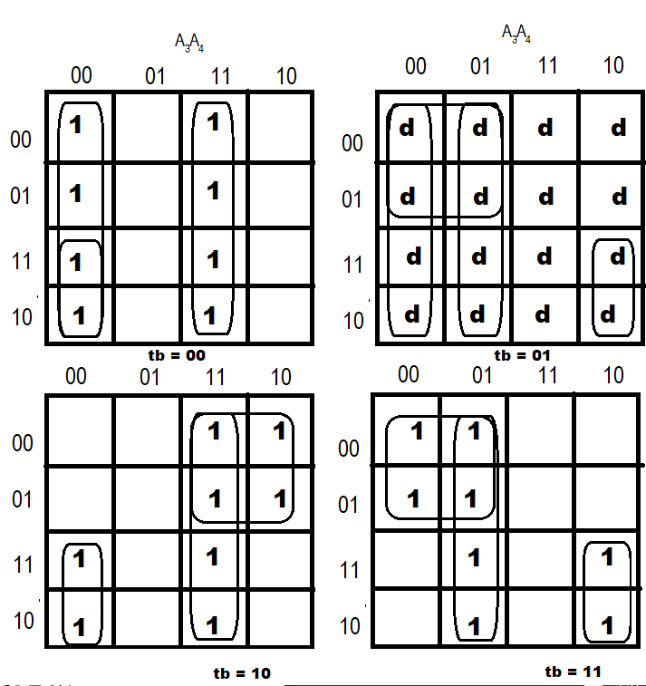

c3 = ¬a1¬a3 b ∨¬a3 a4 b ∨ a3 a4¬b ∨¬a3¬a4¬t ∨ a1 a3¬a4 b ∨¬a1 a3¬b t ∨ a1¬a3¬a4¬b (SQ = 31)

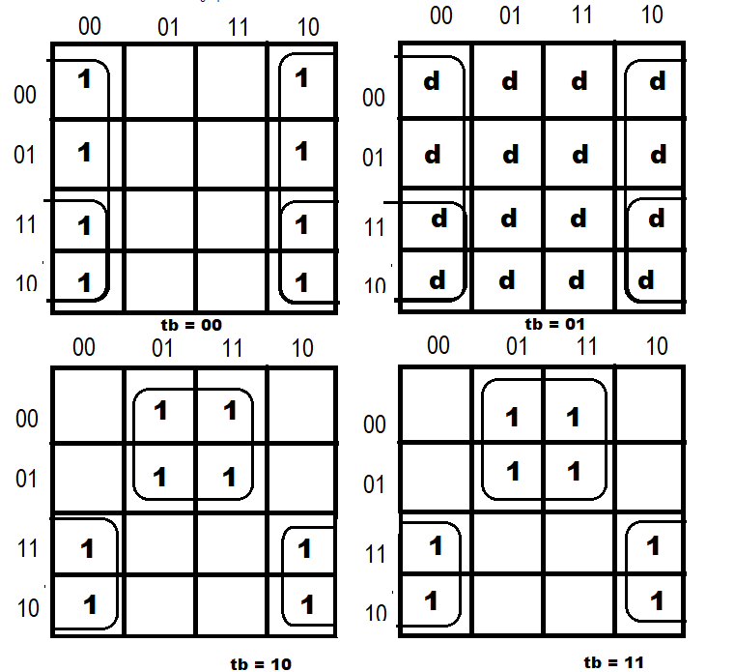

c4 = a1 ¬a4 ∨ ¬a4¬t ∨¬a1 a4 t (SQ = 10)

Преобразование системы:

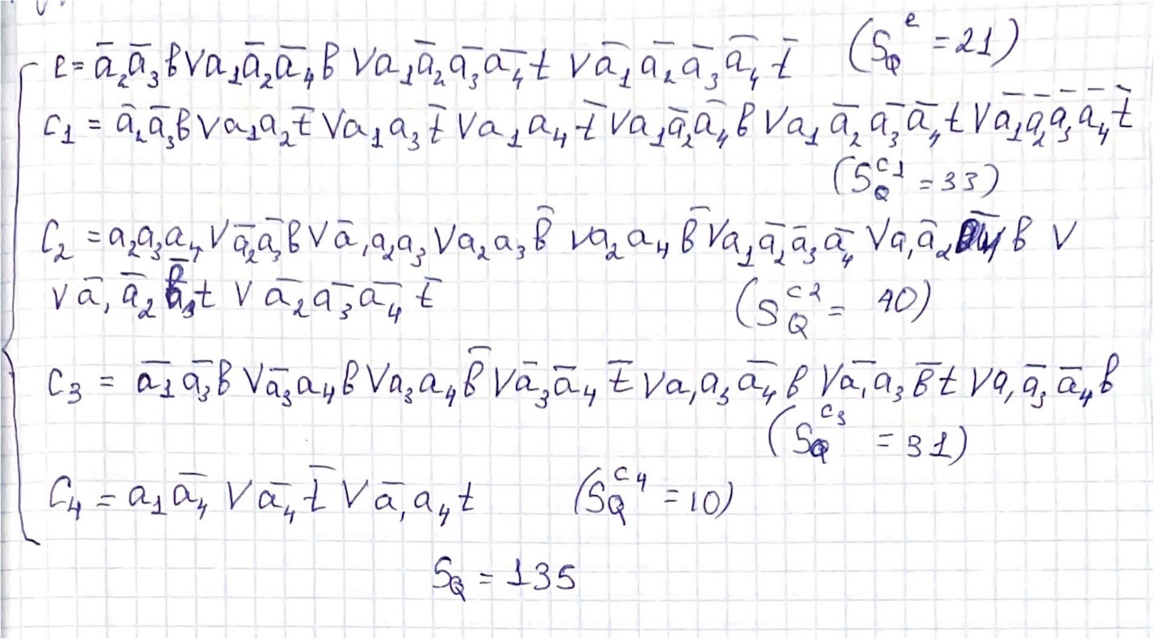

Совместная декомпозиция системы:

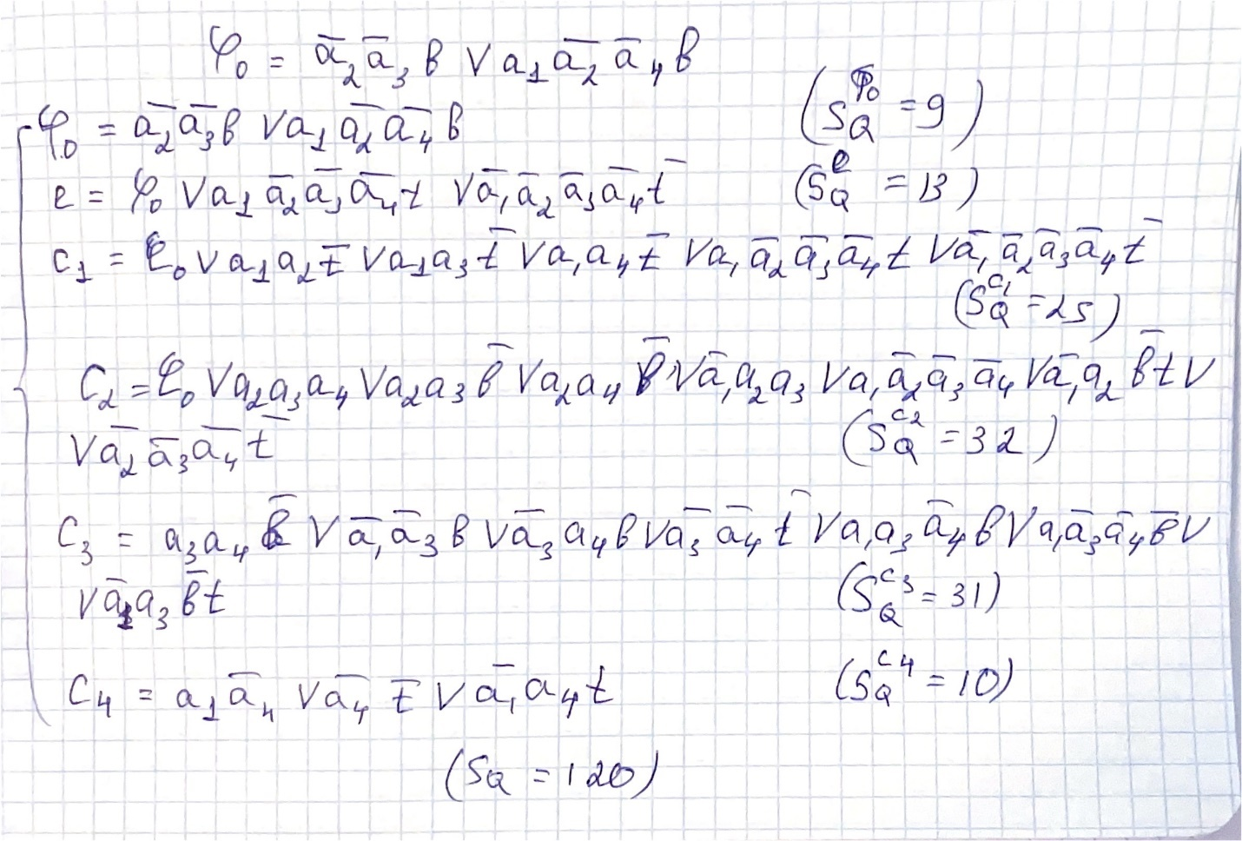

Раздельная факторизация системы:

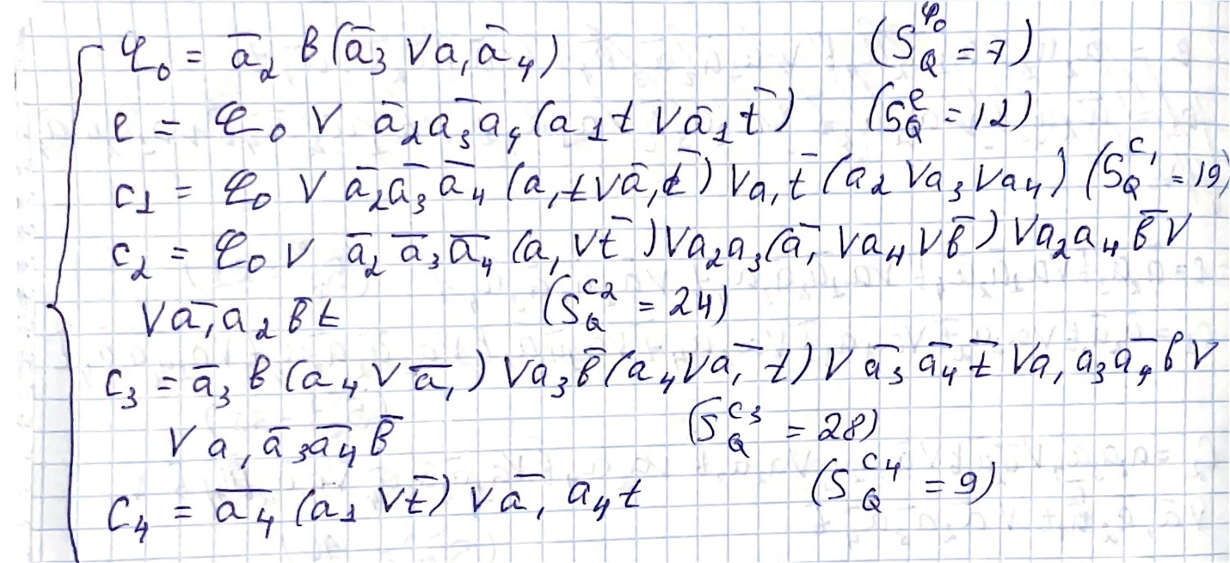

(SQ = 99)

Совместная декомпозиция:

Раздельная факторизация:

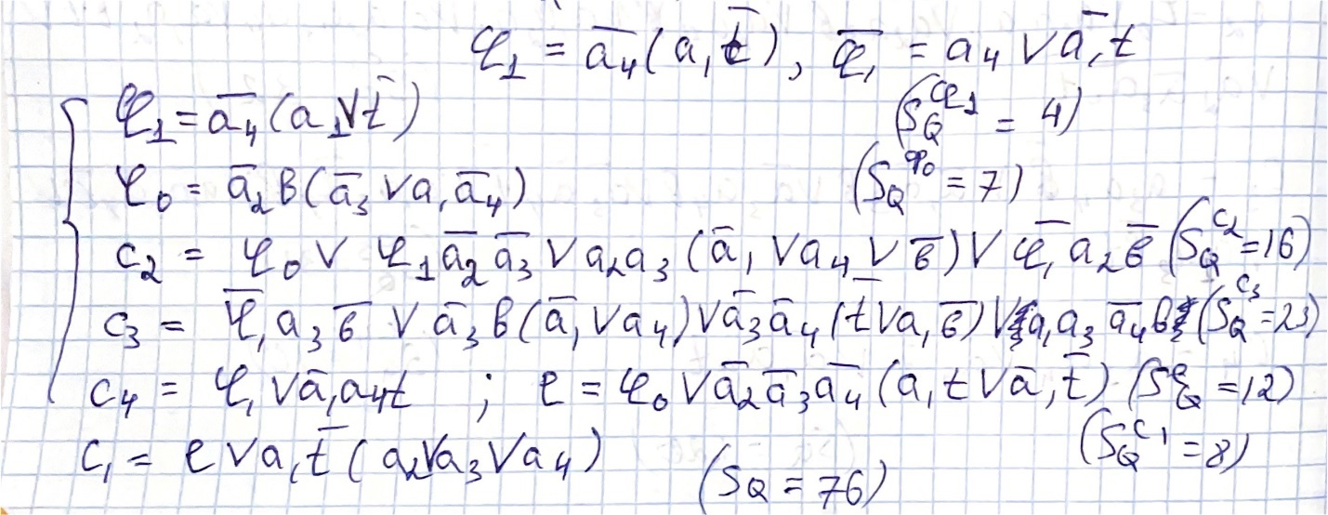

Совместная декомпозиция:

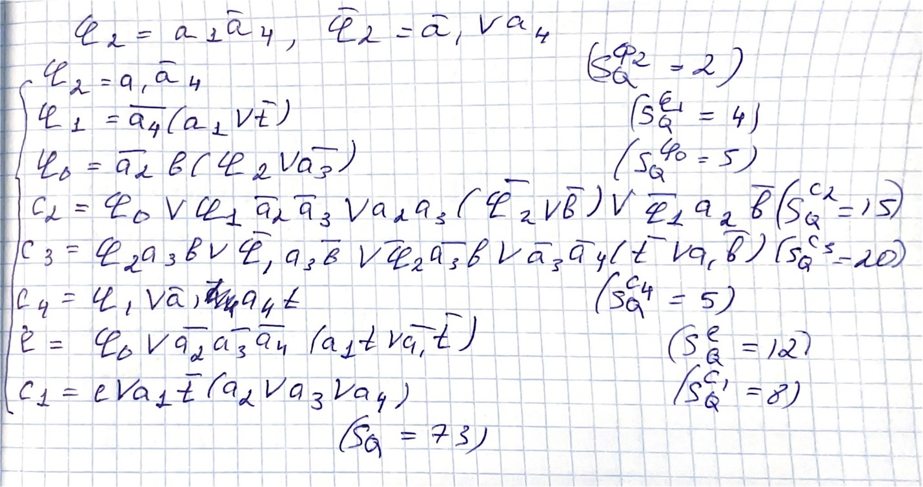

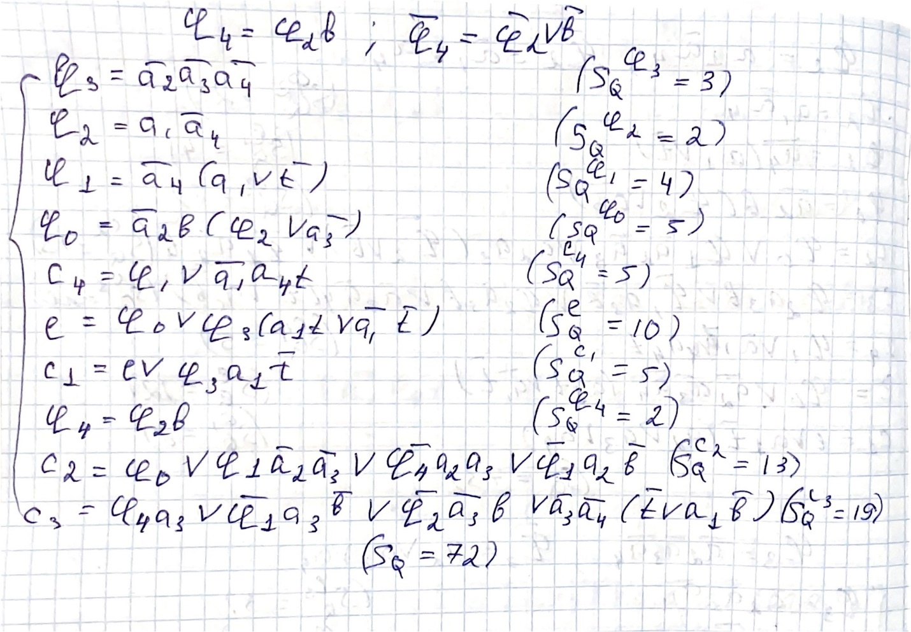

Раздельная факторизация:

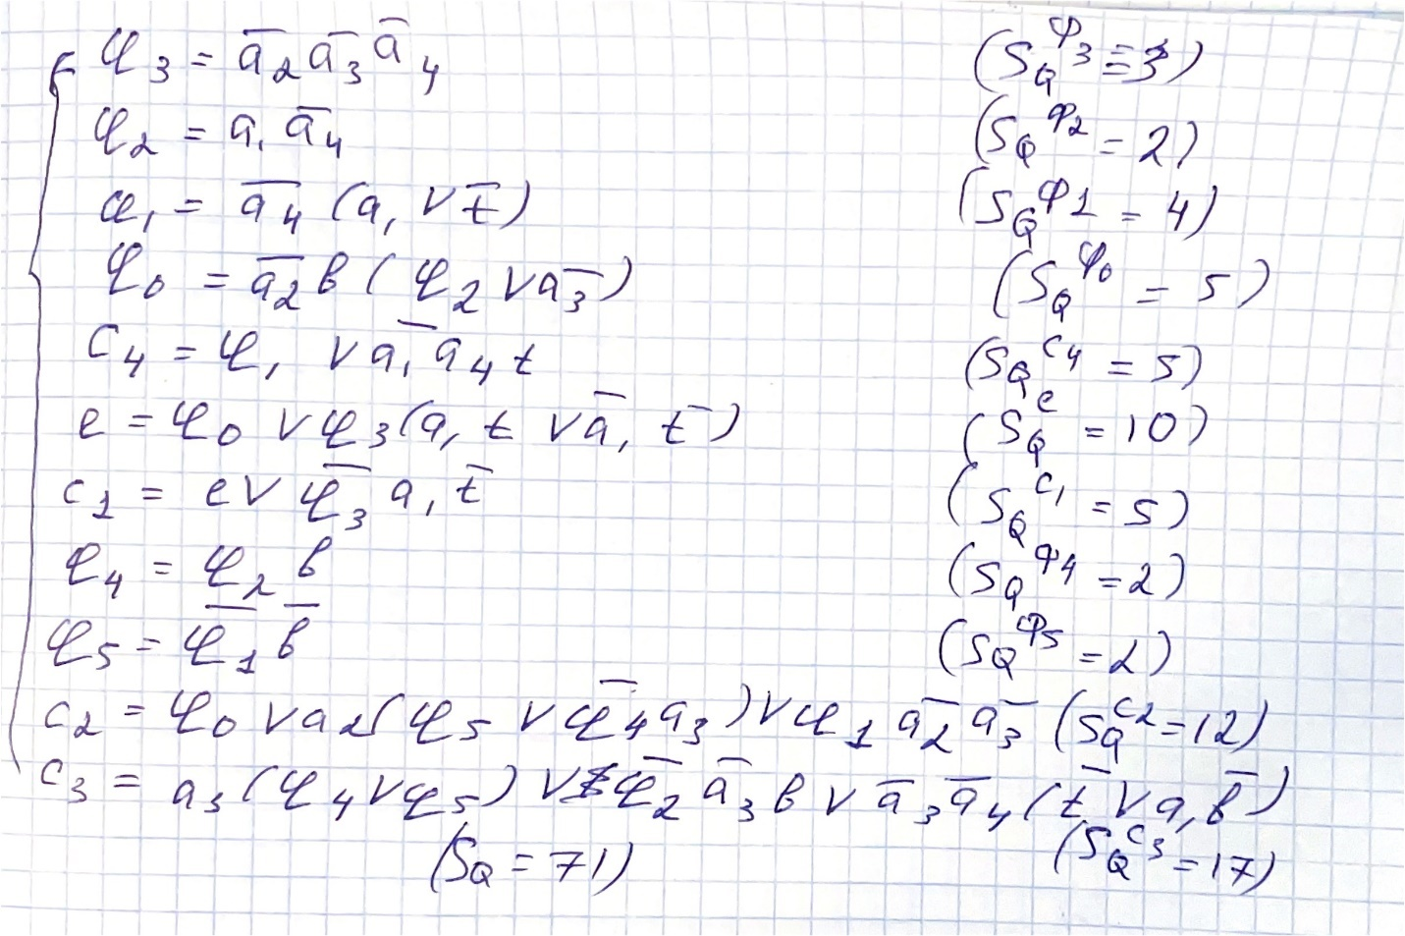

Синтез комбинационной схемы в булевом базисе:

Набор аргументов: a1 = 1, a2 = 1, a3 = 0, a4 = 0, b = 1, t = 1

Выходы схемы из таблицы истинности: e = 0, c1 = 0, c2 = 0, c3 = 0, c4 = 1

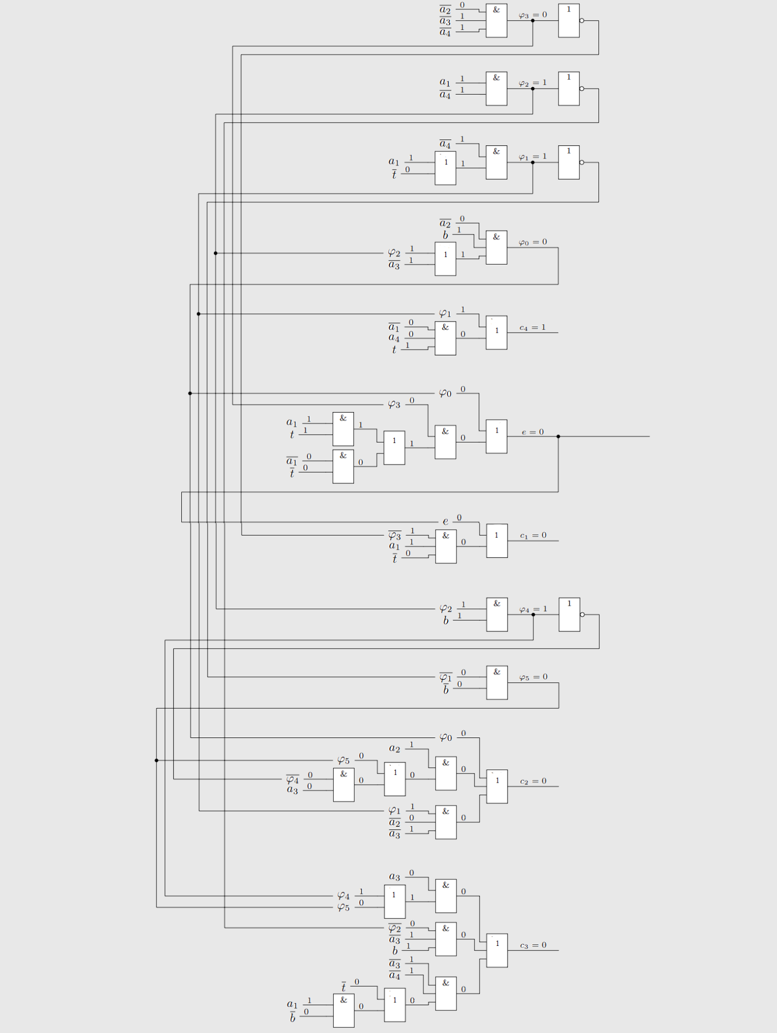

SQ = 71; t = 7