Multi-cytokine HRECs Markdown
Fergus McLellan
2024-11-25

Introduction
This R Markdown outlines the steps undertaken to perform differential expression and pathway analysis for the investigation of cytokine and DMFU-incuded signalling in HRECs. # Setup Work Space
To begin, I load tidyverse and run some code to clear my environment and set my desired information printing parameters
#rm(list = ls(all.names = TRUE)) unhash to clear environment
#gc() unhash to clear cache
options(max.print = .Machine$integer.max, scipen = 999, stringsAsFactors = F, dplyr.summarise.inform = F) #sets integer limit to max
library(tidyverse) #contains multiple packages for general tidiness
library(magrittr) #package adding useful functions for pipe operator
library(dtplyr) #package adding useful functions for pipe operator
library(textshaping)
set.seed(12345)
next, I set my and input/output paths
in_path <- "raw_data/" #set input path from working directory
out_path = "significant_data/" # set output path from working directory

Differential Expression Analysis
The following section will describe the steps undertaken for initial differential expression analysis, with the goal of producing: 1. Normalised counts 2. Principal component analysis 3. Significantly differentially expressed gene lists
This markdown will use analysis in Part 2 as an example, however the same techniques were applied for Part 1 with names swapped to match experimental groups used (Control DMFu VEGF VEGFDMFu).
This data was then exported as .CSV files and used in morpheus to generate count heatmaps (Figure 1B) and biovenn for venn diagram generation.

DESeq2
Differential expression analysis using DESEQ2
There are 3 objects required for DESeq to run properly:
- A Counts matrix, with one 1 set of labels (Ensembl ID in this case) as the row name
- A Design factor with 1 level per treatment, and repetitions = n
- A colData data frame containing a column reflecting the design

Data and Metadata

Counts Matrix
Counts <-read.delim(paste0(in_path,"raw_counts.csv"), header = TRUE, row.names = 1, sep = ",")
Counts <- as.matrix(Counts[,1:48])
head(Counts)
## Control_1 Control_2 Control_3 Control_4 Control_5 Control_6
## ENSG00000223972 0 0 0 0 0 0
## ENSG00000227232 100 90 110 99 134 112
## ENSG00000278267 18 12 16 22 24 10
## ENSG00000243485 0 0 0 0 0 0
## ENSG00000237613 0 0 0 0 0 0
## ENSG00000268020 0 0 0 0 0 0
## TGFb1_1 TGFb1_2 TGFb1_3 TGFb1_4 TGFb1_5 TGFb1_6 TGFb2_1 TGFb2_2
## ENSG00000223972 0 0 0 0 0 0 0 0
## ENSG00000227232 76 110 137 92 136 92 88 108
## ENSG00000278267 26 19 27 30 12 22 16 18
## ENSG00000243485 0 0 0 0 0 0 0 0
## ENSG00000237613 0 0 0 0 0 0 0 0
## ENSG00000268020 0 0 0 0 0 0 0 0
## TGFb2_3 TGFb2_4 TGFb2_5 TGFb2_6 TNFa_1 TNFa_2 TNFa_3 TNFa_4
## ENSG00000223972 0 0 0 0 0 0 0 0
## ENSG00000227232 92 126 128 102 97 85 135 103
## ENSG00000278267 14 21 35 13 14 14 22 13
## ENSG00000243485 0 0 0 0 0 0 0 0
## ENSG00000237613 0 0 0 0 0 0 0 0
## ENSG00000268020 0 0 0 0 0 0 0 0
## TNFa_5 TNFa_6 Thrombin_1 Thrombin_2 Thrombin_3 Thrombin_4
## ENSG00000223972 0 0 0 0 0 0
## ENSG00000227232 106 115 106 116 89 60
## ENSG00000278267 13 11 12 18 24 19
## ENSG00000243485 0 0 0 0 0 0
## ENSG00000237613 0 0 0 0 0 0
## ENSG00000268020 0 0 0 0 0 0
## Thrombin_5 Thrombin_6 IL.6_1 IL.6_2 IL.6_3 IL.6_4 IL.6_5 IL.6_6
## ENSG00000223972 0 1 0 0 0 0 0 0
## ENSG00000227232 93 93 68 127 105 72 107 80
## ENSG00000278267 14 14 16 24 9 22 17 21
## ENSG00000243485 0 0 0 0 0 0 0 0
## ENSG00000237613 0 0 0 0 0 0 0 0
## ENSG00000268020 0 0 0 0 0 0 0 0
## VEGF_1 VEGF_2 VEGF_3 VEGF_4 VEGF_5 VEGF_6 All_1 All_2 All_3
## ENSG00000223972 0 0 0 0 1 0 0 0 0
## ENSG00000227232 103 70 75 89 100 108 98 80 113
## ENSG00000278267 5 15 21 22 15 11 21 23 11
## ENSG00000243485 0 0 0 0 0 0 0 0 0
## ENSG00000237613 0 0 0 0 0 0 0 0 0
## ENSG00000268020 0 0 0 0 0 0 0 0 0
## All_4 All_5 All_6
## ENSG00000223972 0 0 0
## ENSG00000227232 112 72 91
## ENSG00000278267 24 16 23
## ENSG00000243485 0 0 0
## ENSG00000237613 0 0 0
## ENSG00000268020 0 0 0

Meta Data
So as to keep the global environment neat, a custom function was written to generate meta data based on the investigation being performed.
#Possible comparison types: all_groups, fibro, inflam, angio, single *IF SINGLE MUST ALSO IDENTIFY TREATMENT*
metadatapicker <- function(comparisontype, treatment = NULL){
if(comparisontype == "important"){
condition <- factor(c(rep("Control", 6), rep("TGFb2", 6), rep("TNFa", 6), rep("Thrombin", 6), rep("ALL", 6)))
coldata <- data.frame(condition)
coldata$condition <- relevel(coldata$condition, ref = "Control")
# All Condition ---------------------------------------------------------
}else if (comparisontype == "all"){
condition <- factor(c(rep("Control", 6), rep("TGFb1", 6), rep("TGFb2", 6), rep("TNFa", 6), rep("Thrombin", 6) , rep("IL6", 6), rep("VEGF", 6), rep("ALL", 6)))
coldata <- data.frame(condition)
coldata$condition <- relevel(coldata$condition, ref = "Control")
# Fibro Condition ---------------------------------------------------------
}else if (comparisontype == "fibro"){
condition <- factor(c(rep("Control", 6), rep("TGFb1", 6), rep("TGFb2", 6), rep("TNFa", 6), rep("Thrombin", 6)))
coldata <- data.frame(condition)
coldata$condition <- relevel(coldata$condition, ref = "Control")
# Inflam Condition --------------------------------------------------------
}else if (comparisontype == "inflam"){
condition <- factor(c(rep("Control", 6), rep("TGFb1", 6), rep("TNFa", 6), rep("Thrombin", 6) , rep("IL6", 6)))
coldata <- data.frame(condition)
coldata$condition <- relevel(coldata$condition, ref = "Control")
# Angio Condition ---------------------------------------------------------
}else if (comparisontype == "angio"){
condition <- factor(c(rep("Control", 6), rep("TGFb2", 6), rep("Thrombin", 6) ,rep("VEGF", 6)))
coldata <- data.frame(condition)
coldata$condition <- relevel(coldata$condition, ref = "Control")
# Individuals only (no cocktail) ---------------------------------------------------------
}else if (comparisontype == "individuals"){
condition <- factor(c(rep("Control", 6), rep("TGFb1", 6), rep("TGFb2", 6), rep("TNFa", 6), rep("Thrombin", 6) , rep("IL6", 6), rep("VEGF", 6)))
coldata <- data.frame(condition)
coldata$condition <- relevel(coldata$condition, ref = "Control")
# Single Comparison Condition ---------------------------------------------
}else if (comparisontype == "single"){
if(!is.null(treatment)){
condition <- factor(c(rep("Control", 6), rep(treatment, 6)))
coldata <- data.frame(condition)
coldata$condition <- relevel(coldata$condition, ref = "Control")
}else{
print("Please select a treatment for your single comparison. Returning only Control group in data frame")
}
}else{
print("Invalid selection. Please choose from the list of possible comparisons.")
return(NULL)
}
return(list("condition" = condition, "coldata" = coldata,"name"= paste0(comparisontype,"_",treatment)))
}
Use function to set meta data. Allows: - all - individuals - important - fibro - inflam - angio - single*
*single comparisons requires selection of the treatment of interest
Assign a list for the meta data objects and split this list to give a condition factor and coldata data frame object
metadata <- metadatapicker(comparisontype = "all",
treatment =
) %>%
list2env(.GlobalEnv)

Condition Factor
levels(condition)
## [1] "ALL" "Control" "IL6" "TGFb1" "TGFb2" "Thrombin" "TNFa"
## [8] "VEGF"

colData Data frame
unique(coldata)
## condition
## 1 Control
## 7 TGFb1
## 13 TGFb2
## 19 TNFa
## 25 Thrombin
## 31 IL6
## 37 VEGF
## 43 ALL

Data Cleaning
Next, it is good practice to clean the data, removing any NA values, or unusable counts. For this I have used the WGCNA package goodSamplesGenes function.
library(WGCNA, quietly = TRUE) #Weighted Gene Co-expression Analysis package containing GoodSamplesGenes check
ddsCounts <- Counts #create duplicate of Counts before manipulating counts
gsg <- goodSamplesGenes(t(ddsCounts))
## Flagging genes and samples with too many missing values...
## ..step 1
## ..step 2
summary(gsg)
## Length Class Mode
## goodGenes 57500 -none- logical
## goodSamples 48 -none- logical
## allOK 1 -none- logical
gsg$allOK #false in all ok indicates NA Values/iterative 0 values
## [1] FALSE
table(gsg$goodGenes) # individual gene check (iterative check for repeated 0 values)?
##
## FALSE TRUE
## 18955 38545
table(gsg$goodSamples) #sample check
##
## TRUE
## 48
ddsCounts <- ddsCounts[gsg$goodGenes == TRUE, gsg$goodSamples == TRUE] #omit bad genes

Run DESeq2
DESeq2 was utilised to perform repeated wald tests to identify significantly differentially expressed genes. Several output objects were generated for future use:
- DESeq object
- Normalised counts data frame
- Averaged normalised counts data frame
- Variance stabilised counts data frame
dds <- DESeqDataSetFromMatrix(countData = ddsCounts, colData = coldata, design= ~condition)
dds <- DESeq(dds)
res <- results(dds) #results object example
## [1] "38545 genes examined, example results object:"
## log2 fold change (MLE): condition VEGF vs Control
## Wald test p-value: condition VEGF vs Control
## DataFrame with 6 rows and 6 columns
## baseMean log2FoldChange lfcSE stat pvalue
## <numeric> <numeric> <numeric> <numeric> <numeric>
## ENSG00000223972 0.0444196 0.370065 5.889216 0.0628377 0.94989571
## ENSG00000227232 98.8416405 -0.355984 0.122943 -2.8955075 0.00378546
## ENSG00000278267 17.8343074 -0.282354 0.294598 -0.9584400 0.33784093
## ENSG00000238009 0.1769574 -1.072555 3.354243 -0.3197608 0.74914968
## ENSG00000233750 0.5498715 -0.651585 1.742873 -0.3738567 0.70851090
## ENSG00000268903 4.8581692 -0.266914 0.498427 -0.5355127 0.59229540
## padj
## <numeric>
## ENSG00000223972 NA
## ENSG00000227232 0.0283983
## ENSG00000278267 0.6009277
## ENSG00000238009 NA
## ENSG00000233750 NA
## ENSG00000268903 NA
Normalised counts can be exported as .csv for use in web tools, or as an RDS using:
#saveRDS(dds, file= paste0(in_path,name,"dds.RDS")) #unhash to save RDS
Generating an average, normalised counts data frame and variance stabilised transformation data frame
avg_ncounts <- sapply(seq(1, ncol(normcounts), 6), function(j) rowMeans(normcounts[,j+(0:(5))])) %>% #sequences along columns and averages every 6 columns
as.data.frame()%>% #represents the result as a data frame
set_colnames(levels(condition)) #sets the column names to match the levels of condition
vsdata <- vst(dds, blind= FALSE) #variance stablising transformation for PCA
vscounts <- assay(vsdata) #variance stabilised counts

Principal Component Analysis

Load Necessary Packages
library(RColorBrewer) #color palettes
library(ggplot2) #plotting package
library(ggrepel) #text and point repel
library(svglite) #save SVGs

Plot PCA in ggplot
Generate PCA using ggplot2 plotPCA
#mycols <- c('#9d9da1','#89489b','#3eb548','#4097AB') #colours for DMFu analysis
mycols <- c("#666666","#A6761D","#E6AB02", "#66A61E", "#1B9E77","#E7298A", "#D95F02", "#7570B3") #multi-cyto colours
PCA <- plotPCA(vsdata, intgroup = "condition", ntop = 1000)+
theme_bw()+ #base theme
coord_equal(4)+ #set a plot size
stat_ellipse(aes(group = condition), type = "norm", level = 0.95)+
scale_color_manual(values = mycols) +
labs(title = "Figure 1A", color = "Condition")+ #labels
theme(plot.title = element_text(hjust=0.5,vjust = 1.5, size = 20, face = "bold", color = "black"),
legend.title = element_text(size=14), legend.text = element_text(size=14),
legend.margin = margin(0.2, 0.2, 0.2, 0.2, "cm"),
legend.spacing = unit(2, "cm"),
legend.key.size = unit(1.2, "lines"),
legend.background = element_rect(fill = ,linewidth = 1, linetype ="solid", colour = "darkgrey"))
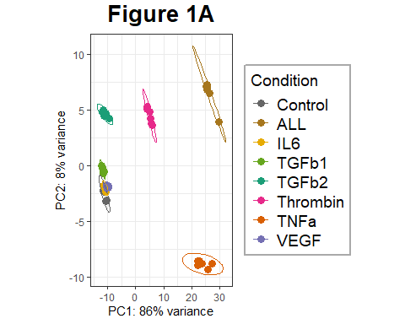
Further style changes were made in an external vector editor to increase legibility for Figure 1A, these include: - stylistic adjustment of ellipses to bound points as a filled object - Adjustments to color scheme - Removal of cocktail group

Numerical PCA
Kruskal test is only really exploratory, and is best applied when performing a single comparison to assess significance of difference between groups.
pca <- prcomp(t(vscounts))
pca.dat <- pca$x
pca.var <- pca$sdev^2 #variance as standard deviation squared
pca.var.percent <- round(pca.var/sum(pca.var)*100, digits = 2) #percentage of explained variance
pca.dat <- as.data.frame(pca.dat) #convert to dataframe so its usable
ggplot(pca.dat, aes(PC1, PC2)) + #check that the PCA being assessed is similar to PCAplot
geom_point(aes(size = 5)) +
geom_text(label = rownames(pca.dat)) +
labs(x = paste0('PC1: ', pca.var.percent[1], ' %'),
y = paste0('PC2: ', pca.var.percent[2], ' %'),
)
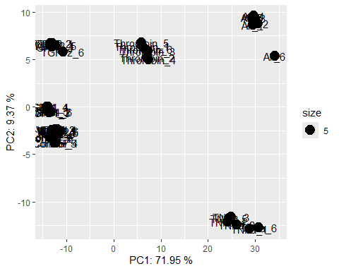
P1 <- kruskal.test(pca.dat$PC1 ~ condition)
##
## Kruskal-Wallis rank sum test
##
## data: pca.dat$PC1 by condition
## Kruskal-Wallis chi-squared = 43.111, df = 7, p-value = 0.0000003176
P2 <- kruskal.test(pca.dat$PC2 ~ condition)
##
## Kruskal-Wallis rank sum test
##
## data: pca.dat$PC2 by condition
## Kruskal-Wallis chi-squared = 44.451, df = 7, p-value = 0.0000001748

Significance Check
Custom, loopable function to export a .csv of DESeq2 log₂ Fold Change, with additional introduced columns: - HGNC gene symbols - ENTREZ gene IDs - Differential expression status (UP, Down or NO) referencing adjustable limits
library(org.Hs.eg.db) #read in annotation DBI human database
significance <- function(condition, treatment, Padj = 0.05, L2FC = 0, version){
library(DESeq2)
res <- results(dds, contrast = c(condition,treatment, "Control"), )
sigdeg_df<- as.data.frame(res) #generate results data frame
sigdeg_df$symbol<- mapIds(org.Hs.eg.db,
keys = rownames(sigdeg_df),
keytype = "ENSEMBL", column = "SYMBOL") #gene symbols
sigdeg_df$ENTREZID<- mapIds(org.Hs.eg.db,
keys = rownames(sigdeg_df),
keytype = "ENSEMBL", column = "ENTREZID") #ENTREZ IDs
sigdeg_df <- sigdeg_df %>%
mutate(diffexpressed = case_when(
log2FoldChange > +(L2FC) & padj < Padj ~ 'UP', #check if up regulated
log2FoldChange < -(L2FC) & padj < Padj ~ 'DOWN', #check if down regulated
padj > Padj ~ 'NO', #check if not significant
TRUE ~ 'NO' #Label anything else as this (good for troubleshooting)
))
sigdeg_df <- sigdeg_df[sigdeg_df$diffexpressed != "NO",]
write.csv(sigdeg_df, file = paste0(out_path,treatment,"_deg_table_",version,".csv"))
print(paste0(treatment," DEG Table with L2FC cut-off = ",L2FC," and adjusted p=value cut-off = ",Padj," generated in ",out_path,"."))
}
When running the function, ensure a condition has been established using metadatapicker
#significance(condition = "condition",
#treatment = "ALL",
#L2FC = 1,
#Padj = 0.05,
#version = "0L2FC_cutoff_003")
#treatments <- c("VEGF","VEGFDMFu","DMFu") #for DMFu study
cytokines <- c("TGFb1","TGFb2","TNFa","Thrombin","IL6","VEGF","ALL")
for (cytokine in cytokines) {
significance(condition = "condition",
treatment = cytokine,
L2FC = 1,
Padj = 0.05,
version = "1L2FC_nobaseMean_cutoff_004")
}
## 'select()' returned 1:many mapping between keys and columns
## 'select()' returned 1:many mapping between keys and columns
## [1] "TGFb1 DEG Table with L2FC cut-off = 1 and adjusted p=value cut-off = 0.05 generated in significant_data/."
## 'select()' returned 1:many mapping between keys and columns
## 'select()' returned 1:many mapping between keys and columns
## [1] "TGFb2 DEG Table with L2FC cut-off = 1 and adjusted p=value cut-off = 0.05 generated in significant_data/."
## 'select()' returned 1:many mapping between keys and columns
## 'select()' returned 1:many mapping between keys and columns
## [1] "TNFa DEG Table with L2FC cut-off = 1 and adjusted p=value cut-off = 0.05 generated in significant_data/."
## 'select()' returned 1:many mapping between keys and columns
## 'select()' returned 1:many mapping between keys and columns
## [1] "Thrombin DEG Table with L2FC cut-off = 1 and adjusted p=value cut-off = 0.05 generated in significant_data/."
## 'select()' returned 1:many mapping between keys and columns
## 'select()' returned 1:many mapping between keys and columns
## [1] "IL6 DEG Table with L2FC cut-off = 1 and adjusted p=value cut-off = 0.05 generated in significant_data/."
## 'select()' returned 1:many mapping between keys and columns
## 'select()' returned 1:many mapping between keys and columns
## [1] "VEGF DEG Table with L2FC cut-off = 1 and adjusted p=value cut-off = 0.05 generated in significant_data/."
## 'select()' returned 1:many mapping between keys and columns
## 'select()' returned 1:many mapping between keys and columns
## [1] "ALL DEG Table with L2FC cut-off = 1 and adjusted p=value cut-off = 0.05 generated in significant_data/."

Volcano Plots
Here, I utilise enhancedVolcano to generate a volcano plot, with the top 10 highest log₂ Fold Change DEGs labelled.
This code will function irrespective of if above Significance Check has been run.
First, read in results object for comparison to be plotted
unhash function lines (397 + 487) to
library(EnhancedVolcano)
cytokine = "TGFb2"
version = "001"
#volcanomaker <- function(cytokine,version){
set.seed(12345)
res <- results(dds, contrast = c("condition", cytokine, "Control"))
sigdeg <- na.omit(res)
sigdeg_df<- as.data.frame(sigdeg)
Next, label with HGNC symbols, and assign Up, Down and NS labels with colors associated based on volcano plot parameters. This is not required in enhancedVolcano as the package will identify and label based on Pcutoff and Fcutoff values, however allows for the custom colour filtering used later.
#Labelling system
sigdeg_df$symbol<- mapIds(org.Hs.eg.db,
keys = rownames(sigdeg_df),
keytype = "ENSEMBL",
column = "SYMBOL")
sigdeg_df <- sigdeg_df %>%
mutate(diffexpressed = case_when(
log2FoldChange > 1 & padj < 0.05 ~ "UP",
log2FoldChange < -1 & padj < 0.05 ~ "DOWN",
between(sigdeg_df$log2FoldChange, -1, 1) ~ "NO",
padj > 0.05 ~ 'NO',
))
sigdeg_df$padj <- ifelse(sigdeg_df$padj == 0, .Machine$double.xmin, sigdeg_df$padj) #ifelse to replace 0 values in padj with machine minimum
keyvals <- ifelse(sigdeg_df$diffexpressed == "DOWN", 'royalblue',
ifelse(sigdeg_df$diffexpressed == "UP", 'red2','grey'))
names(keyvals)[keyvals == 'royalblue'] <- 'Down-Regulated'
names(keyvals)[keyvals == 'red2'] <- 'Up-Regulated'
names(keyvals)[keyvals == "grey"] <- 'NS'
Select a certain number of DEGs to be labelled, this section of code can be lengthened to slice separately for up and down-regulated genes by pulling separate slices based on sigdeg_df$diffexpressed value. Here, the top 10 overall were selected.
selected <- sigdeg_df %>%
arrange(desc(abs(log2FoldChange))) %>%
filter(diffexpressed != 'NO')%>%
filter(!is.na(symbol))%>%
dplyr::slice(1:10)
Generate volcano plot with no labels
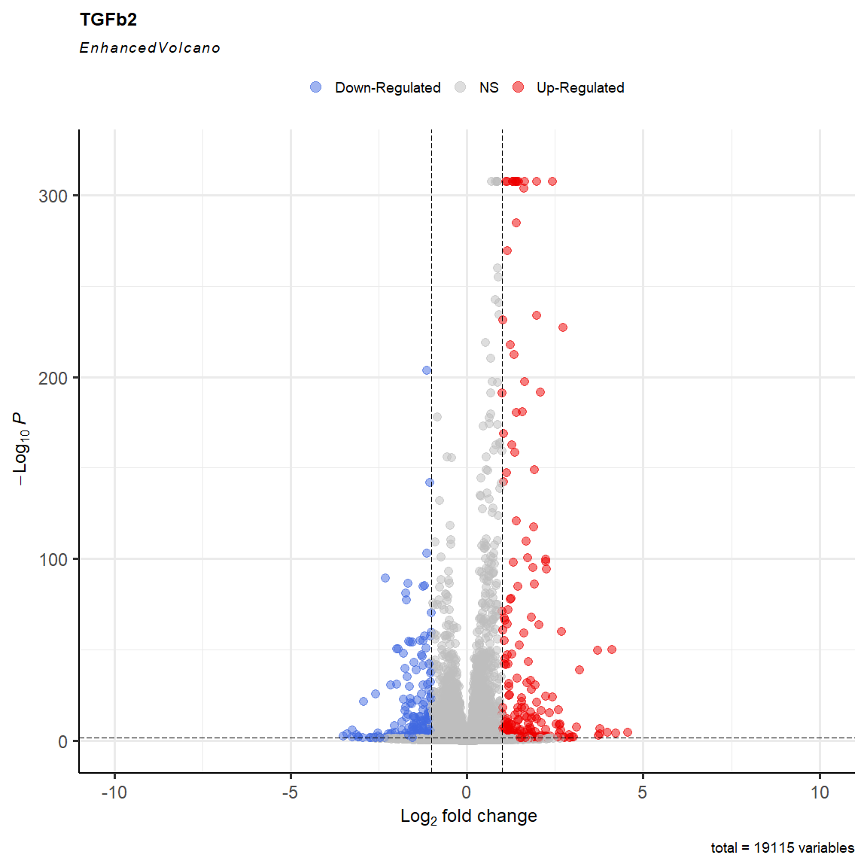
Append down-regulated labels
# Add labels using geom_text_repel
volc2 <- volc + geom_label_repel(data = sigdeg_df[sigdeg_df$log2FoldChange < -1 & sigdeg_df$padj <0.05 & sigdeg_df$symbol %in% selected$symbol, ], #labels negative DEGs in 'selected'
aes(x = log2FoldChange, y = -log10(padj), label = symbol),
size = 5,
label.size = 0.1,
box.padding = 1.0, # Increase box padding
point.padding = 0.5, # Increase point padding
segment.color = 'black',
segment.size = 0.8,
nudge_x = -2,
max.time = 5,
fill = "lightblue",
nudge_y = 0.5,# Nudge labels to the left
max.overlaps = 30) # Ensure all labels are shown
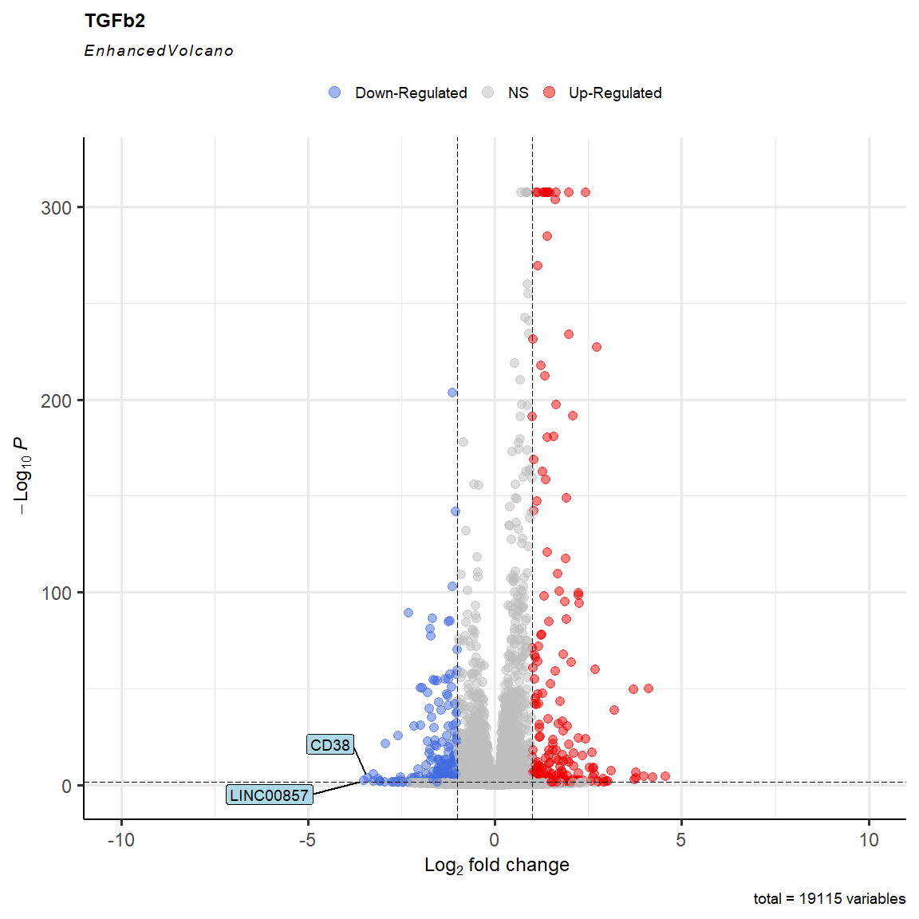
Append up-regulated labels
# Add labels for points with positive log2FoldChange
volc3 <- volc2 + geom_label_repel(data = sigdeg_df[sigdeg_df$log2FoldChange > 1 & sigdeg_df$padj <0.05 & sigdeg_df$symbol %in% selected$symbol, ], #labels postive DEGs in 'selected'
aes(x = log2FoldChange, y = -log10(padj), label = symbol),
size = 5,
label.size = 0.1,
box.padding = 1, # Increase box padding
point.padding = 0.5, # Increase point padding
segment.color = 'black',
fill = "#FF9999",
segment.size = 0.8,
nudge_x = 1,
max.time = 5, # Nudge labels to the right
max.overlaps = 30) # Ensure all labels are shown
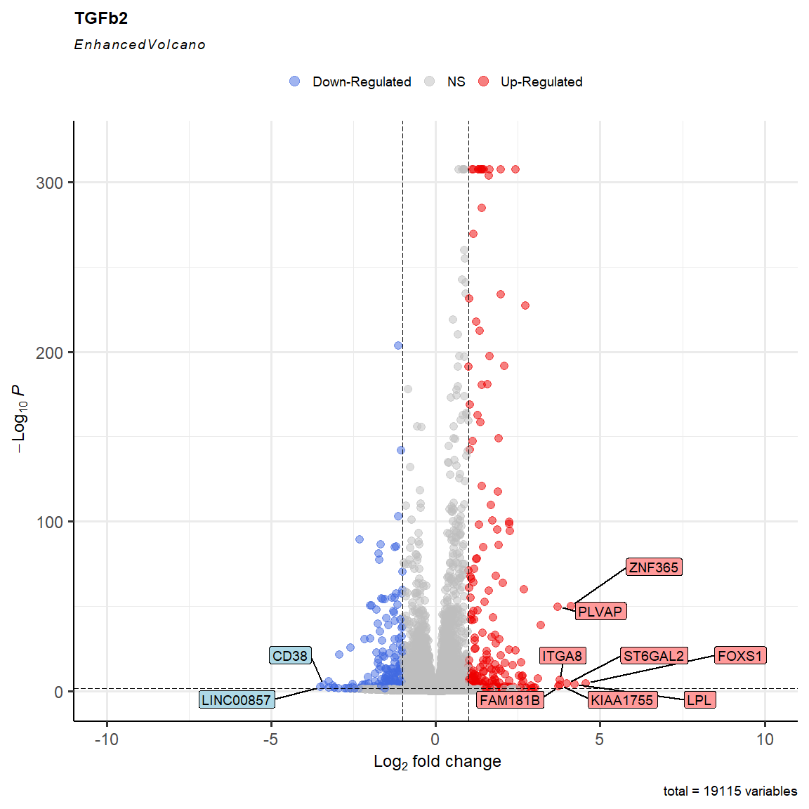
Save and print text to show code has run through (good for if using a function)
ggsave(file =paste0(out_path,cytokine,"_volcano_001.svg"),
plot=volc3, #plot
width=13, #width
height=15) #height
print(paste0("Volcano plot generated for ",cytokine,"."))
## [1] "Volcano plot generated for TGFb2."
#}
#volcanomaker(cytokine = "TNFa", version = "001")

Functional Analyses
The following sections of code outline packages used and steps undertaken to identify biological themes and pathways enriched by each treatment. This includes:
- Over Representation Analysis
- Gene Set Enrichment Analysis
- Phenotype and pathway of interest filtering

Over-Representation Analysis
Pathway enrichment was performed in clusterProfiler, both by direct referencing to downloaded GMT files as well as integrated referencing through clusterProfiler.

Custom .GMT ORA
First, a pathway was assigned to reference lists folder.
ref_path <- "reference_data/"
Next, a background gene list was generated, using all HGNC/NCBI named genes in the raw data file.
library('org.Hs.eg.db')
library('clusterProfiler')
bg <- read.csv(paste0(in_path,"raw_counts.csv"), header = TRUE)
rownames(bg) <- bg$ID
bg <- bg[,c(1,48)]
bg <- bg %>%
mutate("symbol" = mapIds(org.Hs.eg.db,
keys = rownames(bg),
keytype = "ENSEMBL",
column = "SYMBOL"))%>%
mutate("ENTREZ" = mapIds(org.Hs.eg.db,
keys = rownames(bg),
keytype = "ENSEMBL",
column = "ENTREZID"))
bg <- na.omit(bg) %>%
dplyr::select(ID, ENTREZ, symbol)
bgnames <- bg$symbol
GMT files were downloaded from www.gsea-msigdb.org, and a loop was used to identify and create an RDS of overlapping genes between GMT and background list for easier reference.
#subset genes in background from genes in gmt files,
#these ones are from www.gsea-msigdb.org below uses a loop to identify and then make a new file containing gene subset
gmt_files <- list.files(path = ref_path, pattern = '.gmt', full.names = TRUE)
for (i in gmt_files){
file <- gmt_files[i] #set a variable for position in list
pwl <- read.gmt(file)
pwl <- pwf[pwf$gene %in% bgnames,]
filename <- paste(gsub('c2.cp\\.', '',
gsub('.v2023.2.*$', '', file)), '.RDS', sep = '') #assumes you are using 2023.2. files
saveRDS(pwf, filename)
}
#NOTE: only need to do this once, have to manually rename RDS files to source.RDS as I can't figure out how to do it automatically
#NOTE: genes may have multiple functions in the same GSEA set, therefore pwl may have more genes than your background set
#NOTE: have to delete RDS files if you want to run it twice.
A custom function was written to then read in a chosen RDS, run over-representation analysis for up and down regulated significant DEGs at specified limits for a specified treatment, clean pathway names, and output a .CSV and dot plot of findings.
clusteranalysis <- function(cytokine, path_base, padj_cutoff, genecount_cutoff){
#import dataset
file_names <- list.files(path = in_path, pattern = cytokine, full.names = TRUE)
# Loop through the file names
for (file_name in file_names) {
# Read the file
df <- read.csv(file_name)
# Perform operations on 'df'
}
##Begin code for cluster analysis
#Select RDS based on top
if(path_base == 'KEGG'){
bg_genes <- readRDS(paste0(ref_path, 'kegg_medicus.RDS'))
print("KEGG selected")
} else if(path_base == 'reactome'){
bg_genes <- readRDS(paste0(ref_path, 'reactome.RDS'))
print("reactome selected")
}else if(path_base == 'biocarta'){
bg_genes <- readRDS(paste0(ref_path, 'biocarta.RDS'))
print("biocarta selected")
} else if(path_base == 'pid'){
bg_genes <- readRDS(paste0(ref_path, 'pid.RDS'))
print("PID selected")
} else if(path_base == 'wikipathways'){
bg_genes <- readRDS(paste0(ref_path, 'wikipathways.RDS'))
print("wikipathways selected")
} else {
stop('Invalid background genes.')
}
#ensure no non-significant DEGs
df <- df[df$diffexpressed!= 'NO',]
#split dataset into 2 lists
deg_results_list <- split(df, df$diffexpressed)
deg_down <- deg_results_list$DOWN
deg_up <- deg_results_list$UP
#Run clusterprofiler
#set output path
name_of_comparison <- paste0(cytokine,"_vs_control")
filename <- paste0(out_path, 'clusterProfiler/', name_of_comparison, '_', path_base)
#runs the enrichment analysis for up and down-regulated genes separately
res <- lapply(names(deg_results_list),
function(x) enricher(gene = deg_results_list[[x]]$symbol,
TERM2GENE = bg_genes))
#assigns names from deg_results_list to results
names(res) <- names(deg_results_list)
#Convert the list of enrichResults for each sample_pattern to a dataframe with the pathways
res_df <- lapply(names(res), function(x) rbind(res[[x]]@result))
names(res_df) <- names(res)
res_df <- do.call(rbind, res_df)
head(res_df)
res_df <- res_df %>% mutate(minuslog10padj = -log10(p.adjust),
diffexpressed = gsub('\\.GOBP.*$|\\.KEGG.*$|\\.REACTOME.*$|\\.BIOCARTA.*$', '', rownames(res_df)))
# select only target pathways that meet preset parameters
target_pws <- unique(res_df$ID[res_df$p.adjust < padj_cutoff & res_df$Count > genecount_cutoff])
res_df <- res_df[res_df$ID %in% target_pws,]
#long list of substitutions I found online which neaten the descriptions
res_df$Description <- gsub('(H|h)iv', 'HIV',
gsub('pd 1', 'PD-1',
gsub('ecm', 'ECM',
gsub('(I|i)nterleukin', 'IL',
gsub('(R|r)na', 'RNA',
gsub('(D|d)na', 'DNA',
gsub(' i ', ' I ',
gsub('(A|a)tp ', 'ATP ',
gsub('(N|n)adh ', 'NADH ',
gsub('(N|n)ad ', 'NAD ',
gsub('t cell', 'T cell',
gsub('b cell', 'B cell',
gsub('built from .*', ' (...)',
gsub('mhc', 'MHC',
gsub('mhc class i', 'MHC I',
gsub('mhc class ii', 'MHC II',
stringr::str_to_sentence(
gsub('_', ' ',
gsub('BIOCARTA_|PID_|KEGG_MEDICUS_REFERENCE_|REACTOME_', '',
res_df$Description
)))))))))))))))))))
print(paste0('Saving ', path_base,' clusterprofiler results for ',cytokine,"."))
write.csv(res_df, paste0(filename, '_resclusterp.csv'), row.names = FALSE)
if (nrow(res_df) > 0){
enrichres <- new("enrichResult",
readable = FALSE,
result = res_df,
pvalueCutoff = 0.05,
pAdjustMethod = "BH",
qvalueCutoff = 0.2,
organism = "human",
ontology = "UNKNOWN",
gene = df$symbol,
keytype = "SYMBOL",
universe = unique(bg_genes$gene),
gene2Symbol = character(0),
geneSets = bg_genes)
dot <-dotplot(
enrichres,
x = "GeneRatio",
title = paste0(cytokine," enrichment in ", path_base),
orderBy = "x",
label_format = 30,
)
print(dot)
ggsave(file =paste0(out_path,"/",cytokine,"_",path_base,"_enrichment_dotplot.svg"), plot=dot, width=10, height=14)
} else{
print(paste0("no pathways were enriched for ",cytokine," in ",bg_genes))
}
}
cytokines <- c("thrombin", "TGFb2", "TGFb1", "TNFa") # Replace with your actual cytokines
path_base <- c("KEGG", "reactome", "biocarta", "pid", "wikipathways")
clusteranalysis(cytokine = "TNFa",
path_base = "reactome",
padj_cutoff = 0.05, # p-adjusted threshold, used to filter out pathways
genecount_cutoff = 5 # minimum number of genes in the pathway, used to filter out pathways
)
## [1] "reactome selected"
## [1] "Saving reactome clusterprofiler results for TNFa."
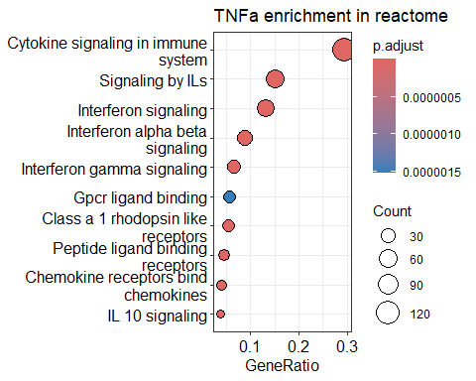
Although useful in allowing a wide array of pathway databases to be investigated simultaneously, this method does not integrate effectively for visualisation, and was thus only run to assess if a treatment was eligible for ORA enrichment and assess the pathway categories reflected by major databases.

GOora and GOChord
library('GOplot')
library(enrichplot)
treatment = "TGFb2" #set treatment if not using function
#GO <- function(treatment, version){ #unhash and collate lines till 1045 to use as a function
#set file name (change path to change selection)
#will look for file names with an _ following, so robust against compound treatments
file_name <- list.files(path = in_path, pattern = paste0(treatment,"_"), full.names = TRUE)
df <- read.delim(file_name, header = TRUE, sep = ",")
GOora <- enrichGO(gene = df$symbol,
'org.Hs.eg.db',
universe = bg$symbol,
minGSSize = 10,
keyType = "SYMBOL",
pAdjustMethod = "fdr",
ont = "BP",
pvalueCutoff = 0.01
)
GOres <- as.data.frame(GOora@result) # split out results
#write.csv(GOres, file =paste0(out_path,treatment,"_GO_results_padj0.01_",version,".csv"))
## ID Description GeneRatio
## GO:0030198 GO:0030198 extracellular matrix organization 28/285
## GO:0043062 GO:0043062 extracellular structure organization 28/285
## GO:0045229 GO:0045229 external encapsulating structure organization 28/285
## GO:0040013 GO:0040013 negative regulation of locomotion 23/285
## GO:0042476 GO:0042476 odontogenesis 13/285
## GO:0060390 GO:0060390 regulation of SMAD protein signal transduction 10/285
## BgRatio pvalue p.adjust
## GO:0030198 327/18353 0.0000000000002467035 0.0000000003300227
## GO:0043062 328/18353 0.0000000000002660397 0.0000000003300227
## GO:0045229 329/18353 0.0000000000002868100 0.0000000003300227
## GO:0040013 403/18353 0.0000000893314117569 0.0000770930083462
## GO:0042476 133/18353 0.0000001574544074197 0.0000919693942550
## GO:0060390 72/18353 0.0000001598541035718 0.0000919693942550
## qvalue
## GO:0030198 0.0000000002608461
## GO:0043062 0.0000000002608461
## GO:0045229 0.0000000002608461
## GO:0040013 0.0000609334261247
## GO:0042476 0.0000726915502558
## GO:0060390 0.0000726915502558
## geneID
## GO:0030198 VWA1/TNR/TGFB2/ANTXR1/DPP4/FAP/ADAMTS9/PTX3/TGFBI/COL1A2/PRSS2/MATN2/OLFML2A/ENG/MMP1/ITGA8/SPOCK2/MANSC4/POSTN/RGCC/COL4A1/COL4A2/FBLN5/MMP2/MMP28/COL9A3/APLP1/ADAMTS1
## GO:0043062 VWA1/TNR/TGFB2/ANTXR1/DPP4/FAP/ADAMTS9/PTX3/TGFBI/COL1A2/PRSS2/MATN2/OLFML2A/ENG/MMP1/ITGA8/SPOCK2/MANSC4/POSTN/RGCC/COL4A1/COL4A2/FBLN5/MMP2/MMP28/COL9A3/APLP1/ADAMTS1
## GO:0045229 VWA1/TNR/TGFB2/ANTXR1/DPP4/FAP/ADAMTS9/PTX3/TGFBI/COL1A2/PRSS2/MATN2/OLFML2A/ENG/MMP1/ITGA8/SPOCK2/MANSC4/POSTN/RGCC/COL4A1/COL4A2/FBLN5/MMP2/MMP28/COL9A3/APLP1/ADAMTS1
## GO:0040013 PODN/RHOB/DPP4/IGFBP5/SEMA3G/ADAMTS9/CHRD/MCTP1/SEMA3A/SERPINE1/STC1/CCN3/IL33/ENG/NRG3/RGCC/TPM1/SEMA7A/CX3CL1/MMP28/LDLRAD4/SMAD7/CLDN5
## GO:0042476 CD34/TGFB2/SCN5A/SCN10A/EDN1/AQP1/INHBA/COL1A2/SERPINE1/AQP3/TMT1A/TNFSF11/JAG2
## GO:0060390 TGFB2/GDF7/INHBA/GDF6/CCN3/ENG/SMAD6/LDLRAD4/SMAD7/PMEPA1
## Count
## GO:0030198 28
## GO:0043062 28
## GO:0045229 28
## GO:0040013 23
## GO:0042476 13
## GO:0060390 10
The Chord diagram generated in GOplot requires a specific data structure. The following code will transform an enrichGO/KEGG/WP etc., object to a usable format for GOChord()
# Chord Diagram -----------------------------------------------------------
#create an object for Chord data and adjust to fit requirements to use GOChord
#Circle_dat object
#Terms
ChordGO <- GOres%>%
dplyr::select(ID, Description, geneID, p.adjust)%>%
dplyr::mutate(new_column = "BP", .before = everything()) #if enrichment was performed in a specific ontology,
#a column must be generated for this, even though it isn't read
#REMOVE THIS LINE IF USING ONT = 'ALL'
#rename columns to fit GOChord setup
rownames(ChordGO) <- NULL
colnames(ChordGO)[1] <- "Category" #rename ONTOLOGY column to fit GOChord setup
colnames(ChordGO)[2] <- "ID"
colnames(ChordGO)[3] <- "Term"
colnames(ChordGO)[4] <- "Genes"
colnames(ChordGO)[5] <- "adj_pval"
#change gene strings to be comma seperated factors (GOChord requirement)
ChordGO$Genes <- str_replace_all(ChordGO$Genes, "/", ", ")
ChordGO$Genes <- as.factor(ChordGO$Genes)
#Genes
#rename columns to fit GOChord setup
genelist <- df%>%
dplyr::select(symbol, log2FoldChange, baseMean, stat, pvalue, padj)
colnames(genelist)[1] <- "ID"
colnames(genelist)[2] <- "logFC"
colnames(genelist)[3] <- "AveExpr"
colnames(genelist)[4] <- "t"
colnames(genelist)[5] <- "P.Value"
colnames(genelist)[6] <- "adj.P.Val"
#circle_dat object for GOChord
circ <- circle_dat(ChordGO, genelist)
#Log Fold Change object
LFC <-data.frame(ID = df$symbol, LogFC = df$log2FoldChange)
#Processes object
set.seed(12345)
pairwise <- pairwise_termsim(GOora, showCategory = 10) #performs pairwise comparison of gene names in top 10 GO categories
termsim <- pairwise@termsim #create object of term simulation results
set.seed(12345)
km <- kmeans(termsim, centers = 3) # run K-means clustering on the termsim matrix, generally use K = sqrt(N)
km_res <- as.data.frame(km$cluster)
km_res <- km_res%>%
rename("cluster" = "km$cluster")%>%
rownames_to_column(var ="Description")%>%
arrange(cluster)
processes <- c(head(km_res$Description, 10)) #export a list of the 10 categories, now arranged into K means clusters
chord <- chord_dat(circ, LFC, processes)
GChor <- GOChord(chord, space = 0.01,
gene.order = 'logFC',
gene.space = 0.15,
gene.size = 3,
border.size = 0,
lfc.min = -2.5,
lfc.max = 2.5)
print(GChor)
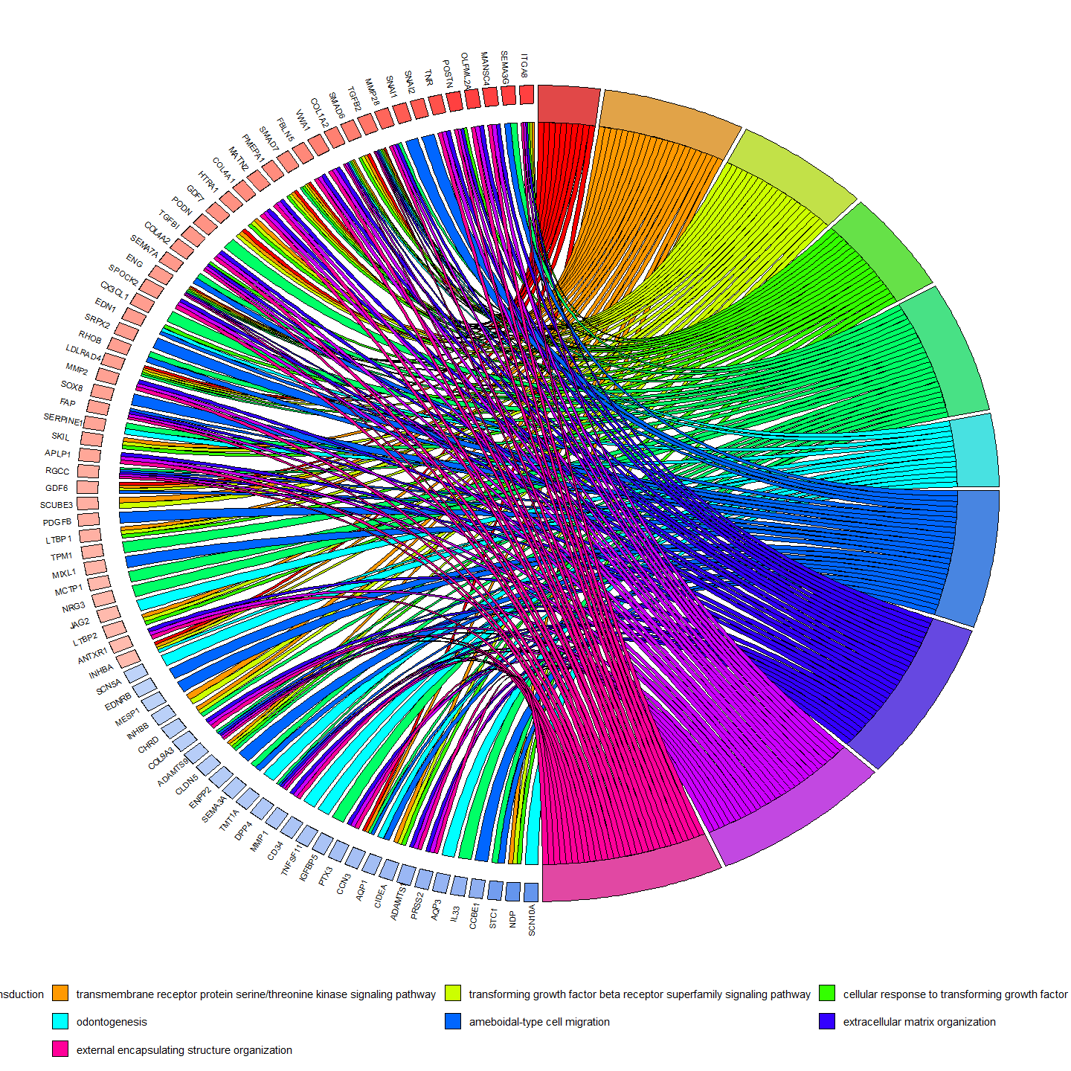
ggsave(file =paste0(out_path,treatment,"_GOChord_",version,".svg"), plot=GChor, width=22, height=20)
print(paste0("Chord 1 Generated for ", treatment,"."))
## [1] "Chord 1 Generated for TGFb2."

Clustered Process Map
Although not shown in my thesis, a clustered process map is a great way to visualise the K-means clustering performed
# Clustered processes map -------------------------------------------------
set.seed(12345)
pairwise <- pairwise_termsim(GOora, showCategory = 30)
termsim <- pairwise@termsim
set.seed(12345)
eplot <- emapplot(pairwise,
showCategory = 30,
node_label = 'all',
cluster.params = list(cluster = TRUE, #cluster logic
legend = TRUE, #legend logic
label_words_n = 5, #number of words in label generation
method = stats::kmeans, #clustering method
n=4, #number of clusters (default is sqrt(nodes))
label_style = "ggforce" #options are shadowtext or ggforce
),
edge.params = list(show = TRUE, #show connections logic
min = 0.2), #minimum connection strength
layout.params = list(layout = 'kk' #layout style
),
cex.params = list(category_node = 1, #node scale
category_label = 0.5, #node label size
line = 0.5,
label_group = 1.5),
highlight.params = list(),
force = 2
)
print(eplot)
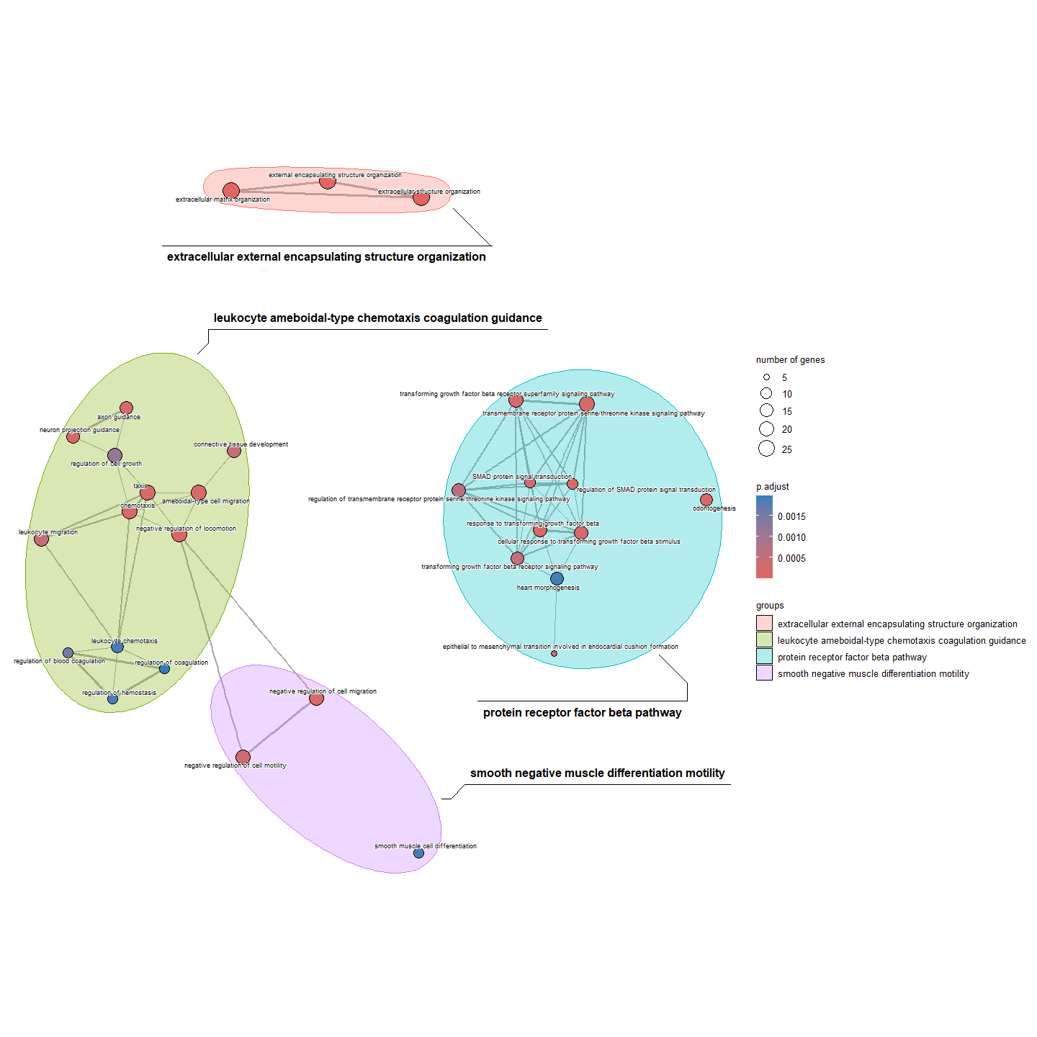
ggsave(file =paste0(out_path,treatment,"_GOTerm_network_",version,".svg"), plot=eplot, width= 20, height=15)
print(paste0("eplot 1 Generated for ", treatment,"."))
## [1] "eplot 1 Generated for TGFb2."
#}
#GO(treatment = "TNFa",
#version = "003")

Gene Set Enrichment Analysis

Individual GSEA
GSEA code below runs all treatments in parallel, generating a list of GSEA objects.
in_path <- "significant_data/"
file_names <- list.files(path = paste0(in_path), pattern = "deg_table_0L2FC_cutoff", full.names = TRUE) #list all files for comparison
gr<- lapply(file_names, function(file) {
data <- read.csv(file) #read in groups as a list
})
names(gr) <- c("Cocktail", "IL6", "TGFb1", "TGFb2", "Thrombin", "TNFa", "VEGF")
gr <- lapply(gr, function(df) { #must be labelled with with entrezID to allow for comparison
df %>%
mutate(ENTREZID = mapIds(org.Hs.eg.db,
keys = df$X,
keytype = "ENSEMBL",
column = "ENTREZID")) %>%
filter(!is.na(ENTREZID))
})
##Order for GSEA
genes <- lapply(gr, function(df) {
df <- df %>%
arrange(desc(log2FoldChange))
named_vector <- setNames(df$log2FoldChange, df$ENTREZID)
named_vector <- na.omit(named_vector)
return(named_vector)
})
names(genes) <- names(gr)
# GO GSEA -----------------------------------------------------------------
gsea <- lapply(genes,function(vec){
data <- gseGO(geneList = vec,
OrgDb = org.Hs.eg.db,
ont = "ALL",
pvalueCutoff = 0.05,
minGSSize = 10
)
return(data)
})
names(gsea) <- names(genes)
dotpl <- lapply(names(gsea), function(df){
data <- gsea[[df]]
if (nrow(data) == 0) {
message(paste("Data frame", df, "is empty and will be skipped."))
return(NULL) # Return NULL for empty dataframes
}else{
dot <- dotplot(data,
color = "NES",
x = "geneRatio",
showCategory = 20,
font.size = 24,
label_format = 75,
title = df)+
#coord_flip()+ #uncomment to flip to portrait
#facet_grid(~.sign,) + #uncomment to seperate activated and repressed
theme(panel.spacing = unit(0.1, "cm",data = NULL),
aspect.ratio = 1/1,
axis.text.x = element_text(size = 12, angle = 90, vjust = 1, hjust = 1), # Rotate y-axis labels
axis.title.x = element_text(size = 14),
axis.text.y = element_text(size = 10),
axis.title.y.left = element_text(vjust = 3),
legend.text = element_text(size = 8), # Adjust legend text size
legend.title = element_text(size = 10),
geom_dotplot(binwidth = 10, dotsize = 1),
)
return(dot)
}
})
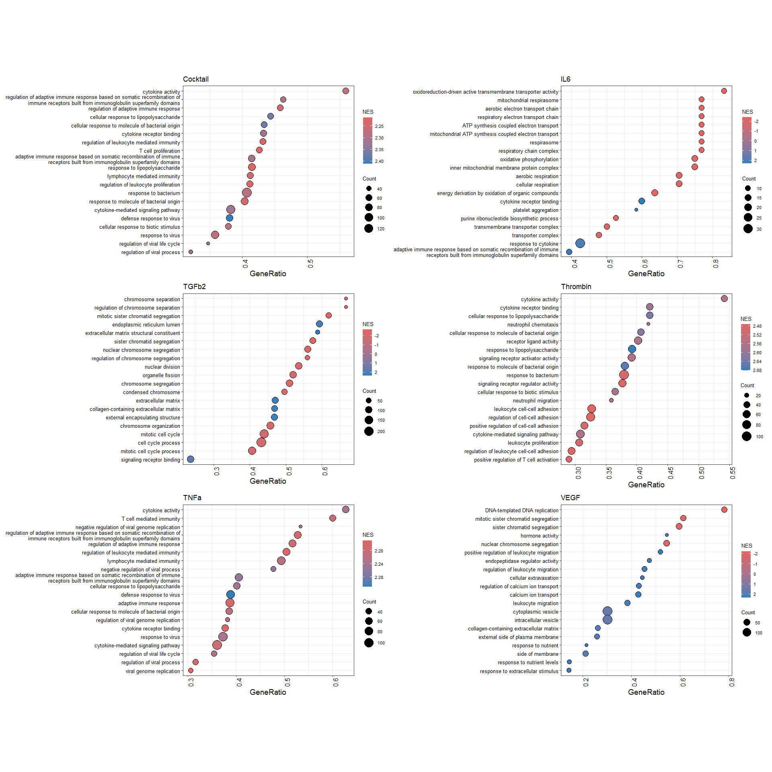
This same workflow can also be applied in KEGG and WikiPathways, however it is important to note the clusterProfiler functions require slightly different inputs.
If this is desired, the below code segments could be inserted to replace GO GSEA.
# KEGG GSEA ---------------------------------------------------------------
gsek <- lapply(genes,function(vec){
data <- gseKEGG(geneList = vec,
organism = "hsa",
pvalueCutoff = 0.05,
minGSSize = 10
)
return(data)
})
lapply(names(gsek), function(df){
data <- gsek[[df]]@result
write.csv(data, file = paste0(out_path,df,"_GSEKEGG_001.csv"))
})
# WP GSEA -----------------------------------------------------------------
gsew <- lapply(genes,function(vec){
data <- gseWP(geneList = vec,
organism = "Homo sapiens",
pvalueCutoff = 0.05,
minGSSize = 10
)
return(data)
})
lapply(names(gsew), function(df){
data <- gsew[[df]]@result
write.csv(data, file = paste0(out_path,df,"_GSEWP_001.csv"))
})
names(gsea) <- names(gr)
lapply(names(gsea), function(df){
data <- gsea[[df]]@result
write.csv(data, file = paste0(out_path,df,"_GSEKEGG_001.csv"))
})

Comparative GSEA
comparecluster combines a pairwise analysis with GSEA, to characterise the overlapping and diverging pathways between multiple treatment groups.
#comparative GSEA
ck <- compareCluster(geneCluster = genes, #compare gene names in lists
fun = gseGO,
OrgDb = org.Hs.eg.db,
ont = "BP",
pvalueCutoff = 0.05,
minGSSize = 20,
)
options(enrichplot.colours = c("#347EB9","#e06663"))
dot <- dotplot(ck,
color = "NES",
showCategory = 5,
font.size = 32,
split = ".sign",
label_format = 75,
)+
coord_flip()+ #remove to return to portrait
#facet_grid(~.sign,) + #remove this line to homogenise activated and repressed
theme(panel.spacing = unit(0.1, "cm",data = NULL),
aspect.ratio = 1/3,
axis.text.x = element_text(size = 14, angle = 90, vjust = 0.5, hjust = 1), # Rotate y-axis labels
axis.text.y = element_text(size = 18),
axis.title.y.left = element_text(vjust = 3),
geom_dotplot(binwidth = 50, dotsize = 1.5)
)
dot
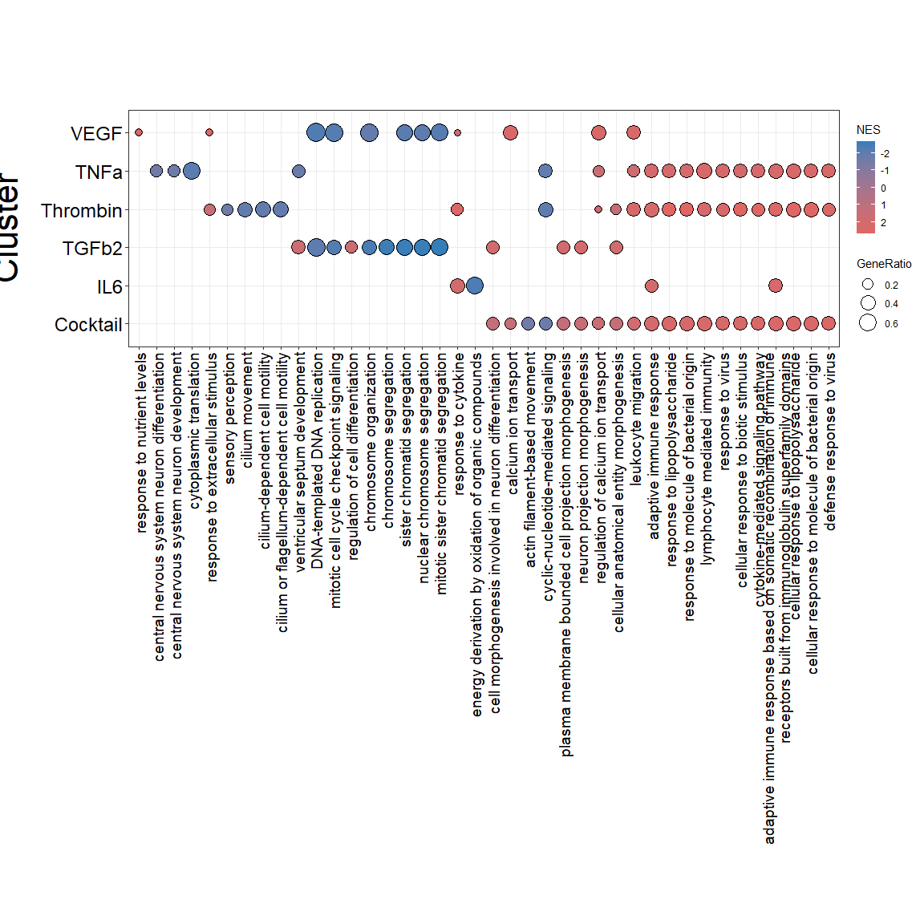

Phenotype filtering
Phenotype filtering was performed by intersecting DEG lists with filter lists, this same technique was applied for any specified filters, including ETC genes.
library(pheatmap)
cytokines <- c("ALL","TNFa","Thrombin","TGFb2") #set treatments
Phenotypes <- c("inflamm","fibro","angio") #set phenotypes
red2blue <- colorRampPalette(c("#2066b4", "#ffffff", "#b4182a"))(100) #set colour scale
pheno_list <- list() #open an empty list outside of for loop
for (phenotype in Phenotypes){
for (cytokine in cytokines) {
res_means <-read.delim(paste0("significant_data/",cytokine,"_deg_table_1L2FC_nobaseMean_cutoff_004.csv"),
header = TRUE, row.names = 1, sep = ",")%>%
mutate_all(~replace(., .=="", "no")) # read in DEGs and remove blanks
potential_targets <- read.delim(paste0("reference_data/",phenotype,"_Genecard_5.0relevance.csv"), header = TRUE, sep = ",") %>%
as.data.frame() #read in filter list
pheno_list[[cytokine]] <- merge(res_means, potential_targets, by.x = "symbol", by.y = "Gene.Symbol") #transect DEG and filter list
print(paste0(cytokine," ", phenotype," filtered list generated")) #print message to show it worked
#write.csv(pheno_list[[cytokine]], file = paste0(out_path,cytokine,"_",phenotype,"_filtered_genes_1L2FC.csv")) # write out a csv
}
heat <- lapply(pheno_list, function(cyto) {
row.names(cyto) <- cyto$symbol #pheatmap must have gene names in rownames
cyto$log2FoldChange <- as.numeric(cyto$log2FoldChange) #select only l2FC values
cyto %>%
dplyr::select(log2FoldChange) %>% #select only symbols
na.omit()
})
names(heat) <- names(pheno_list) #carry over names
heatmaps <- lapply(names(heat), function(cyto) {
p <- pheatmap(heat[[cyto]],
kmeans_k = NA,
breaks = seq(-3, 3, length.out = 101),
scale = "none",
cluster_rows = TRUE,
cluster_cols = FALSE,
clustering_distance_rows = "maximum", # Corrected parameter name
clustering_method = "complete",
color = red2blue,
show_colnames = FALSE,
fontsize = 14)
#ggsave(filename = paste0(out_path, cyto, "_", phenotype, "_DEGs_001.svg"), plot = p[[4]], width = 15, height = (nrow(heat[[cyto]]) * 0.5), units = "cm")
})
names(heatmaps) <- names(heat)
pheno_overlap <- Reduce(function(x, y) merge(x, y, by = "symbol", all = TRUE), pheno_list)
pheno_overlap <- pheno_overlap %>% # as the reduce function generates replicate names,
setNames(make.unique(names(.))) # we have to manually change them to be unique
heat_overlap <- pheno_overlap %>%
dplyr::select(3,18,33,48) %>%
rename_with(~ c("ALL","TNFa", "Thrombin", "TGFb2")) %>%
mutate_all(~replace(., is.na(.), 0)) %>%
mutate(across(everything(), as.numeric)) %>%
as.matrix
rownames(heat_overlap) <-pheno_overlap$symbol
p_over <- pheatmap(heat_overlap,
kmeans_k = NA,
breaks = seq(-3, 3, length.out = 101),
scale = "none",
cluster_rows = TRUE,
cluster_cols = FALSE,
clustering_distance_rows = "euclidean", # Corrected parameter name
clustering_method = "median",
color = red2blue,
show_colnames = TRUE,
fontsize = 14)
#ggsave(filename = paste0(out_path, phenotype,"_overlapped_DEGs_001.svg"), plot = p_over[[4]], width = 15, height = (3 + (nrow(heat[[cyto]]) * 0.5)), units = "cm")
#write.csv(pheno_overlap, file = paste0(out_path,cytokine,"_",phenotype,"_filtered_genes_1L2FC.csv"))
}
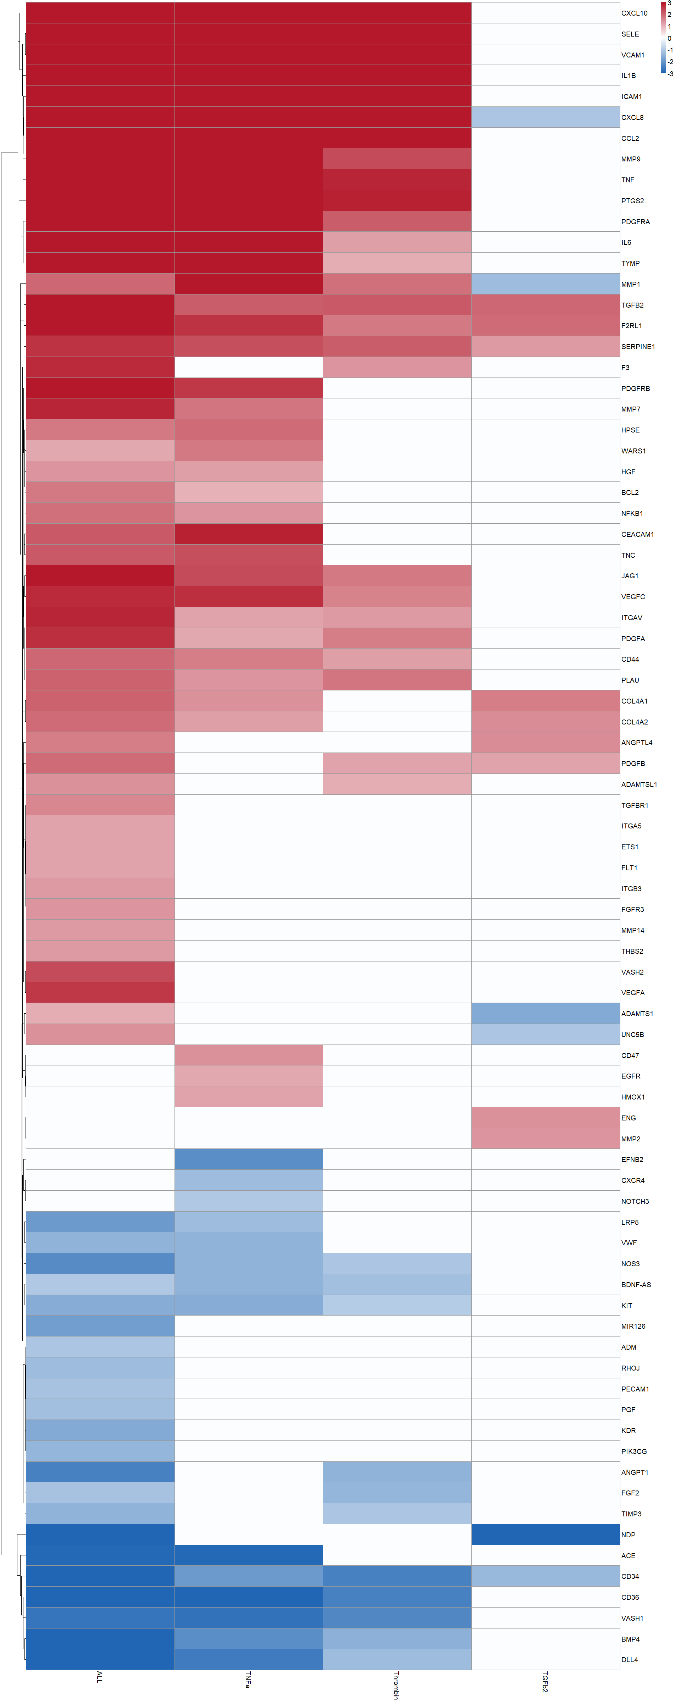
Similarly, phenotype filtering can also be applied to a volcano plot, as shown here:
cytokine = "ALL"
version = "001"
#volcanomaker <- function(cytokine,version){
set.seed(12345)
res <- results(dds, contrast = c("condition", cytokine, "Control"))
sigdeg <- na.omit(res)
sigdeg_df<- as.data.frame(sigdeg)
#Labelling system
sigdeg_df$symbol<- mapIds(org.Hs.eg.db,
keys = rownames(sigdeg_df),
keytype = "ENSEMBL",
column = "SYMBOL")
sigdeg_df <- sigdeg_df %>%
mutate(diffexpressed = case_when(
log2FoldChange > 1 & padj < 0.05 ~ "UP",
log2FoldChange < -1 & padj < 0.05 ~ "DOWN",
between(sigdeg_df$log2FoldChange, -1, 1) ~ "NO",
padj > 0.05 ~ 'NO',
))
sigdeg_df$padj <- ifelse(sigdeg_df$padj == 0, .Machine$double.xmin, sigdeg_df$padj) #ifelse to replace 0 values in padj with machine minimum
filtered_sigdeg_df1 <- sigdeg_df %>%
dplyr::filter(diffexpressed != "NO") %>%
dplyr::filter(!is.na(symbol))
fibr_pt <- read.csv(paste0(ref_path,"fibro_Genecard_5.0relevance.csv"), header= FALSE)
fibr_selected <- filtered_sigdeg_df1[filtered_sigdeg_df1$symbol %in% fibr_pt$V1,]
inf_pt <- read.csv(paste0(ref_path,"inflamm_Genecard_5.0relevance.csv"), header= FALSE)
inf_selected <- filtered_sigdeg_df1[filtered_sigdeg_df1$symbol %in% inf_pt$V1,]
angio_pt <- read.csv(paste0(ref_path,"angio_Genecard_5.0relevance.csv"), header= FALSE)
angio_selected <- filtered_sigdeg_df1[filtered_sigdeg_df1$symbol %in% angio_pt$V1,]
fxi <- fibr_selected[fibr_selected$symbol %in% inf_selected$symbol,]
fxa <- fibr_selected[fibr_selected$symbol %in% angio_selected$symbol,]
ixa <- inf_selected[inf_selected$symbol %in% angio_selected$symbol,]
ixaxf <- fibr_selected[fibr_selected$symbol %in% ixa$symbol,]
pheno_sigdeg_df1 <- filtered_sigdeg_df1 %>% #creates a column in data frame which reflects which phenotypes the
mutate(phenotype = case_when(
symbol%in% ixaxf$symbol ~ 'fully pleitropic',
symbol%in% ixa$symbol ~ 'inflam and fibro',
symbol%in%fxa$symbol ~ 'fibro and angio',
symbol%in%fxi$symbol ~ 'fibro and inflam',
symbol%in%fibr_selected$symbol ~ 'fibro',
symbol%in%inf_selected$symbol ~ 'inflam',
symbol%in%angio_selected$symbol ~ 'angio',
TRUE ~ 'NO'
))
keyvals <- ifelse(sigdeg_df$symbol %in% ixaxf$symbol,"#796261", #all 3
ifelse(sigdeg_df$symbol %in% fxi$symbol,"#ff26fa" , #fibrosis and inflammation only
ifelse(sigdeg_df$symbol %in% fxa$symbol,"#f4ff58", #fibrosis and angiogenesis only
ifelse(sigdeg_df$symbol %in% ixa$symbol,"#63ff6f", #inflammation and angiogenesis only
ifelse(sigdeg_df$symbol %in% fibr_selected$symbol, 'purple3', #fibrosis only
ifelse(sigdeg_df$symbol %in% inf_selected$symbol,"#ff9757", #inflammation only
ifelse(sigdeg_df$symbol %in% angio_selected$symbol, "#3affa6", #angiogenesis only
ifelse(sigdeg_df$diffexpressed == "DOWN", 'royalblue',
ifelse(sigdeg_df$diffexpressed == "UP", 'red2','grey'
)))))))))
names(keyvals)[keyvals == 'purple3'] <- 'Fibrosis Associated'
names(keyvals)[keyvals == 'royalblue'] <- 'Down-Regulated'
names(keyvals)[keyvals == 'red2'] <- 'Up-Regulated'
names(keyvals)[keyvals == "#ff9757"] <- 'inflammation Associated'
names(keyvals)[keyvals == "#3affa6"] <- 'Angiogenesis Associated'
names(keyvals)[keyvals == "#ff26fa"] <- 'Fibrosis + Angiogenesis Associated'
names(keyvals)[keyvals == "#f4ff58"] <- 'Fibrosis + inflammation Associated'
names(keyvals)[keyvals == "#63ff6f"] <- 'inflammation + Angiogenesis Associated'
names(keyvals)[keyvals == "#796261"] <- 'All 3'
names(keyvals)[keyvals == "grey"] <- 'NS'
# Plot variables ----------------------------------------------------------
unique(keyvals)
## [1] "grey" "red2" "royalblue" "#ff26fa" "purple3" "#63ff6f"
## [7] "#ff9757" "#796261" "#3affa6" "#f4ff58"
volc <- EnhancedVolcano(sigdeg_df,
x = "log2FoldChange",
y = "padj",
lab = NA, # Remove labels for now
title = cytokine,
colCustom = keyvals,
pCutoff = 0.01,
FCcutoff = 1,
ylim = c(-2, 320),
xlim = c(-12, 12), # Widen x-axis limits
pointSize = 4.0,
parseLabels = TRUE,
max.overlaps = 25) # Allow more overlaps
# Add labels using geom_text_repel
volc2 <- volc + geom_label_repel(data = sigdeg_df[sigdeg_df$log2FoldChange < 0 & sigdeg_df$symbol %in% ixaxf$symbol, ],
aes(x = log2FoldChange, y = -log10(padj), label = symbol),
size = 5,
label.size = 0.1,
box.padding = 1.0, # Increase box padding
point.padding = 0.5, # Increase point padding
segment.color = 'black',
segment.size = 0.8,
nudge_x = -2,
max.time = 5,
fill = "lightblue",
nudge_y = 0.5,# Nudge labels to the left
max.overlaps = 20) # Ensure all labels are shown
# Add labels for points with positive log2FoldChange
volc3 <- volc2 + geom_label_repel(data = sigdeg_df[sigdeg_df$log2FoldChange > 0 & sigdeg_df$symbol %in% ixaxf$symbol, ],
aes(x = log2FoldChange, y = -log10(padj), label = symbol),
size = 5,
label.size = 0.1,
box.padding = 1, # Increase box padding
point.padding = 0.5, # Increase point padding
segment.color = 'black',
fill = "#FF9999",
segment.size = 0.8,
nudge_x = 1,
max.time = 5, # Nudge labels to the right
max.overlaps = 20) # Ensure all labels are shown
volc3
