CPRE 3810 Final Project Part 1
Troy Tomson and Isaiah Steele

2.d:
Hand-Drawn Version:
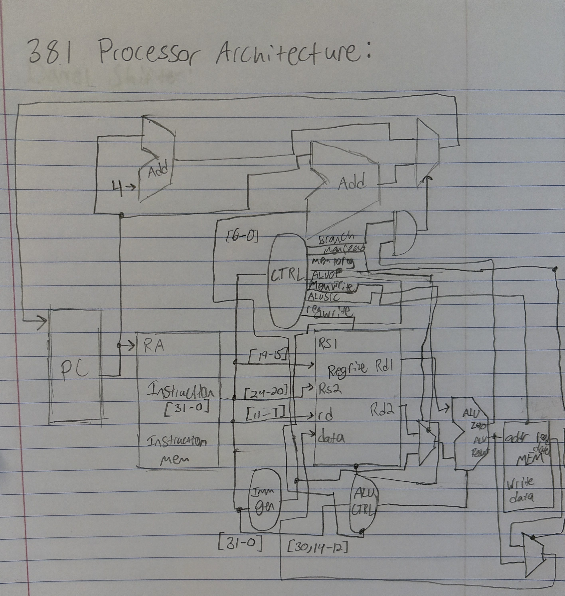

Digital Version:

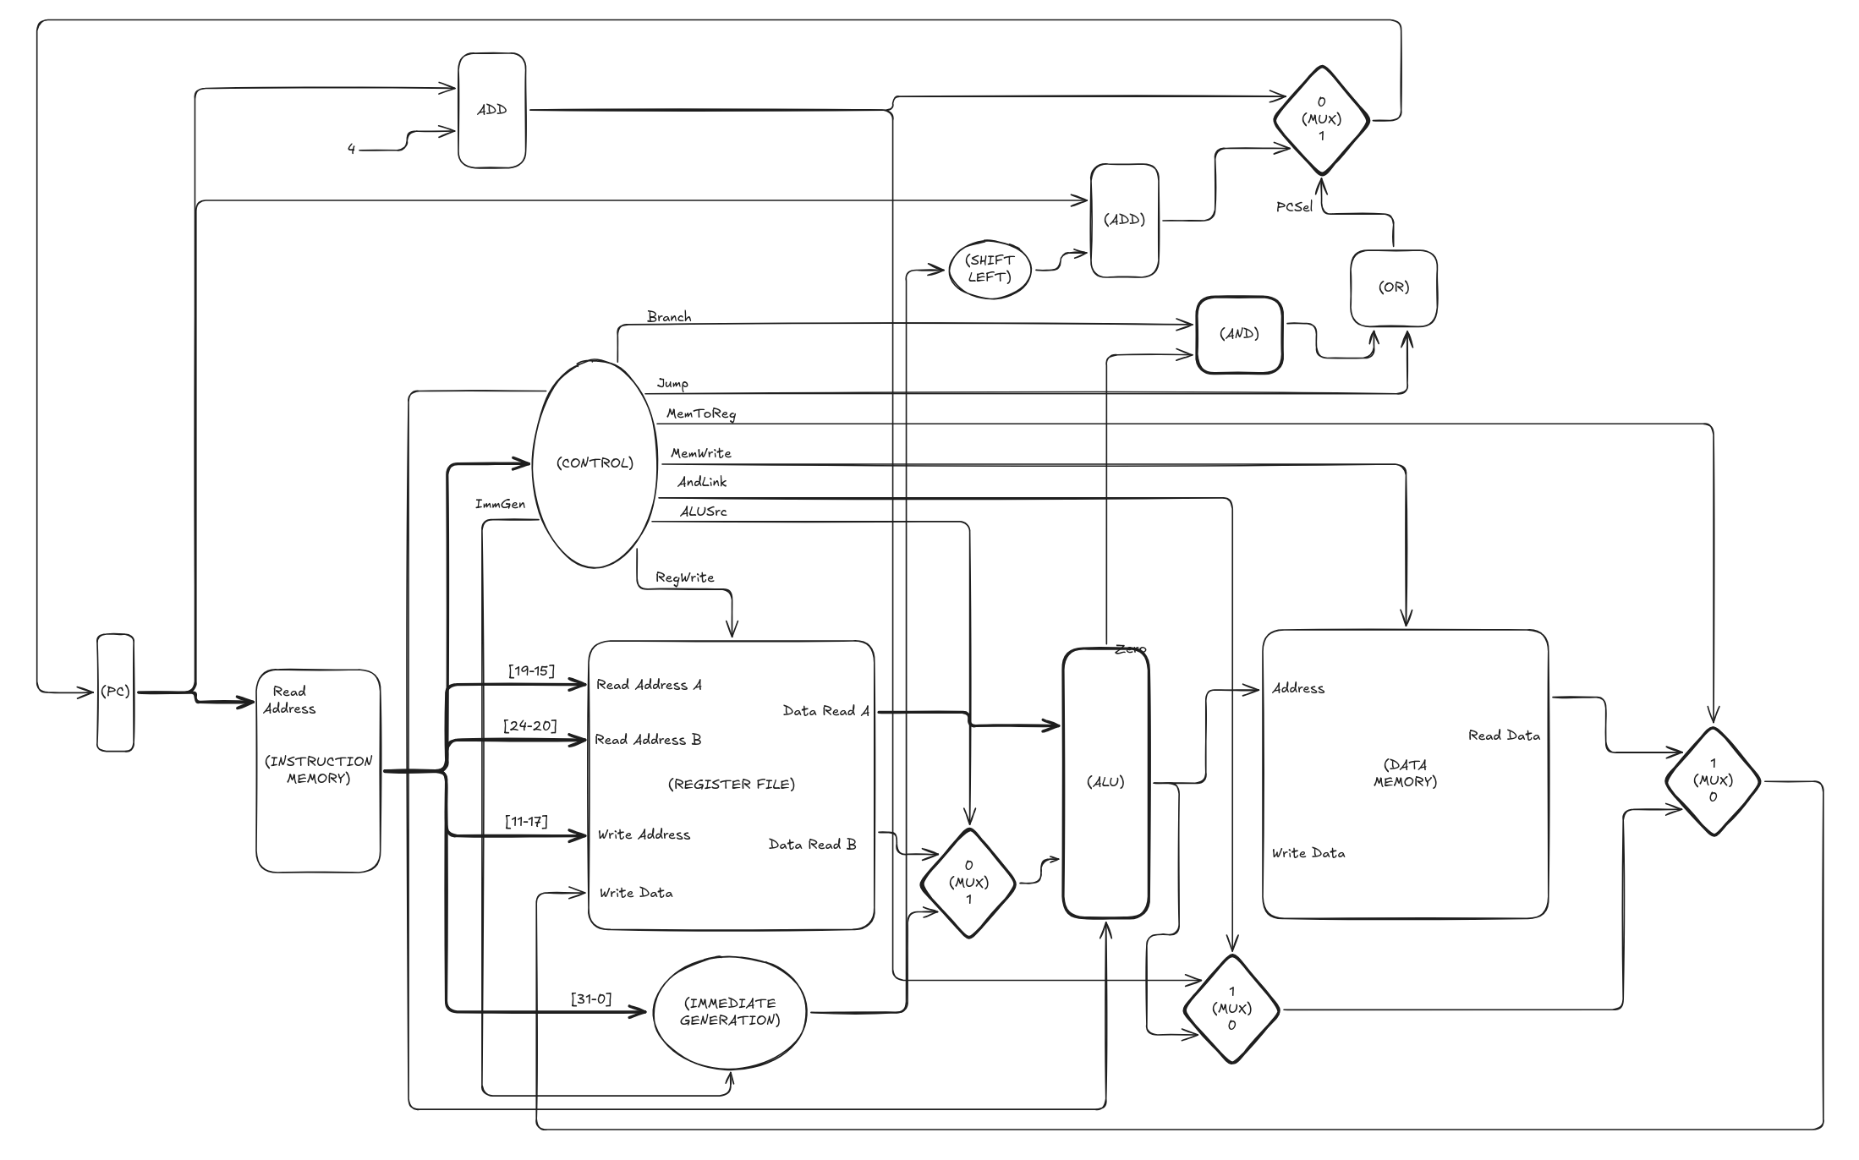

3.1.a:

3.1.b:

3.2.a:
The PC should (in the typical case) be incremented by 4 for each command. Additionally, in the case of a j, jal, or jalr register it should set the PC to the value of the immediate. For branch instructions, the branch condition must resolve true to update the address to the address of the function it must branch to.

3.2.b:
See digital diagram for more. Fetch logic is heavily integrated into the design of the processor. All instructions start with the PC. 4 is added in the default case (proceed to the next instruction). As the current PC is passed into the instruction memory. This path is selected with the exceptions of a jump/jal/jalr command, or a branch command if the branch condition is met. In that case, the value from the immediate generation is added to the current PC value, and that result is put back into the PC.

3.2.c:

3.3.1.a:

3.3.1.b:

3.3.1.c:

3.3.1.d:

3.3.2.a:

3.3.2.b:

3.3.3:

3.3.5:

3.3.8:

4.a:
See Proj1_base_test.s

4.b:
See Proj1_cf_test.s

4.c:
see Proj1_mergesort.s

5:

