CprE 3810, Computer Organization and

Assembly Level Programming

Lab 1 Report

Student Name:____________________Isaiah Steele__________________________

Submit a typeset pdf version of this on Canvas by the due date. Refer to the highlighted language in the lab document for the context of the following questions.

[Part 3.1.c] Think of three more cases and record them in your lab report.

- Case 1:
  - inputs: iW = 10; iLdW = 1; iX = 1; iY = 1; (wait 2 cycles for outputs to be true)
  - outputs: oX = 1; oY = 11
- Case 2:
  - inputs: iW = 11; iLdW = 1; iX = 2; iY = 5; (wait 2 cycles for outputs to be true)
  - outputs: oX = 2; oY = 27 (I was born on the 27th; it is the day of my birth)
- Case 3:
  - inputs: iW = 12; iLdW = 1; iX = 3; iY = 10; (wait 2 cycles for outputs to be true)
  - outputs: oX = 3; oY = 46

[Part 3.1.e] For labels 1, 7, 22, and 28, specify where (VHDL file and line number) these values are located – some will be found in more than one place. Also attempt to explain the functionality of each label as it occurs in the code

1: In the attached diagram area, (1) is the whole of the MAC module, which is defined as having 4 inputs (iX, iW, iLdW, iY) aside from the clock on lines 29 – 32 of TPU_MV_Element.vhd and having 2 outputs (oY, oX) on lines 33 and 34. These inputs and outputs each have a width of 8 except for oY and iLdW. oY has a width of 32 bits, and iLdW is a control line and is a single bit. The entire module functions as a single unit in a TPU MV element from a Google TPU.

7: In the attached diagram area, (7) is the label of the g_Add1 module, which has two inputs (aside from the clock), iA and iB, and one output, oC. These are specified in file Adder.vhd on lines 33 and 34 for the inputs, and 35 for the output. The two inputs and the one output are 32 bits. This module adds the output of the multiplier module with the

22: In the attached diagram area, (22) is oQ, the output inside the g_Weight module, which is defined as a DATA_WIDTH-bit std_logic_vector (32 bits) on line 30 of RegLd.vhd and line 72 of TPU_MV_Element.vhd. It is used in line 96 of TPU_MV_Element.vhd and is mapped as s_W in the attached document as the output of g_Weight. oQ is also mapped as an input to the mux in g_Weight, which is specified on line 96 of TPU_MV_Element.vhd.

28: In the attached diagram area, (28) is the s_X1 output of g_Delay (specified in g_Delay1 on line 106 of TPU_MV_Element.vhd) and into g_Delay3 line called iD (specified on line 128 of TPU_MV_Element.vhd called ). The line is defined as a DATA_WIDTH-bit std_logic_vector on line 29 of Reg.vhd.

[Part 3.1.f] Implement your test cases from part c into this testbench. Remember to include these in your waveform screenshot.

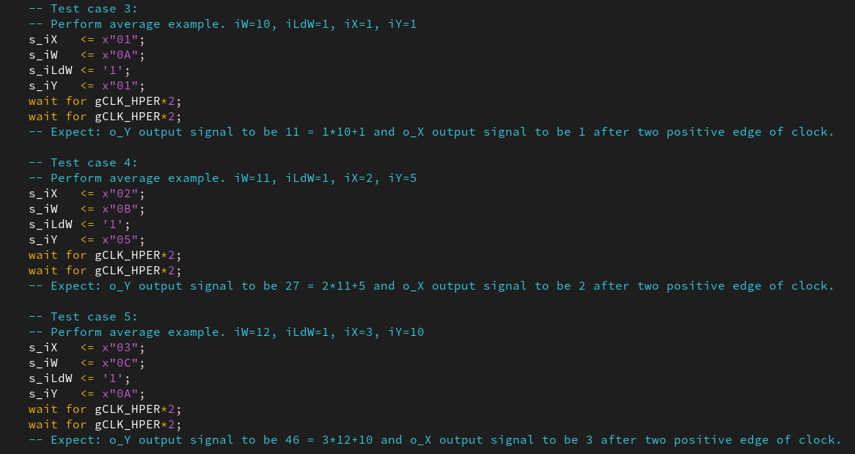

[Part 3.1.g.v] In your lab report, include a screenshot of the waveform. Describe, in plain English, any differences between what you expected and what the simulation showed.

(provided test case 2 was duplicated by me three times in order to aid debugging)
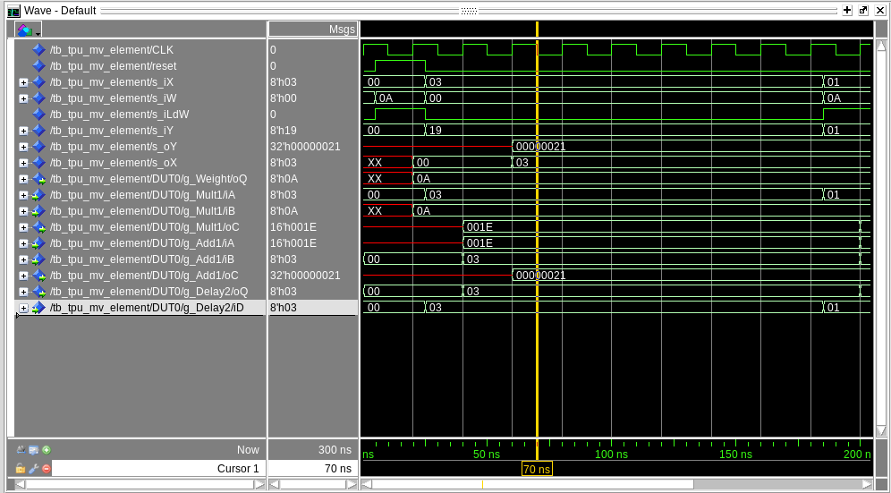

At 25 nanoseconds, the inputs of s_iX, s_iW, s_iLdW, and s_iY are set. However, the expected output on oY is not 55 as expected. It is 33. There is a similar problem with the rest of the test cases.

[Part 3.1.h] In your lab report, include a screenshot of the waveform. Describe, in plain English, how your waveform matches the expected result (e.g., reference the specific cycles and times). In your submission zip file, provide the completed TPU_MV_Element.vhd file in a folder called ‘MAC’.

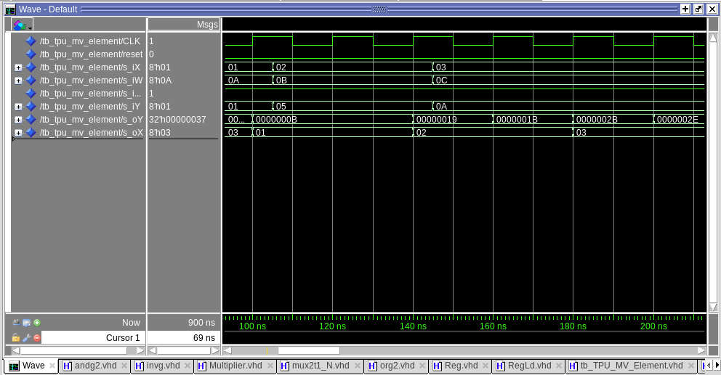
We can see that the oY line has the three correct outputs from my three tests (outputs of 0xB (for 11), 0x1B (for 27), and 0x2E (for 46). These outputs come every two clock edges, which is correct according to my test cases (new inputs are given every 2 clock cycles). There are garbage results in-between the expected 2-clock-aligned outputs.

[Part 3.3.a] Draw the truth table, Boolean equation, and Boolean circuit equivalent (using only two-input gates) that implements a 2:1 mux. Include this in your lab report.

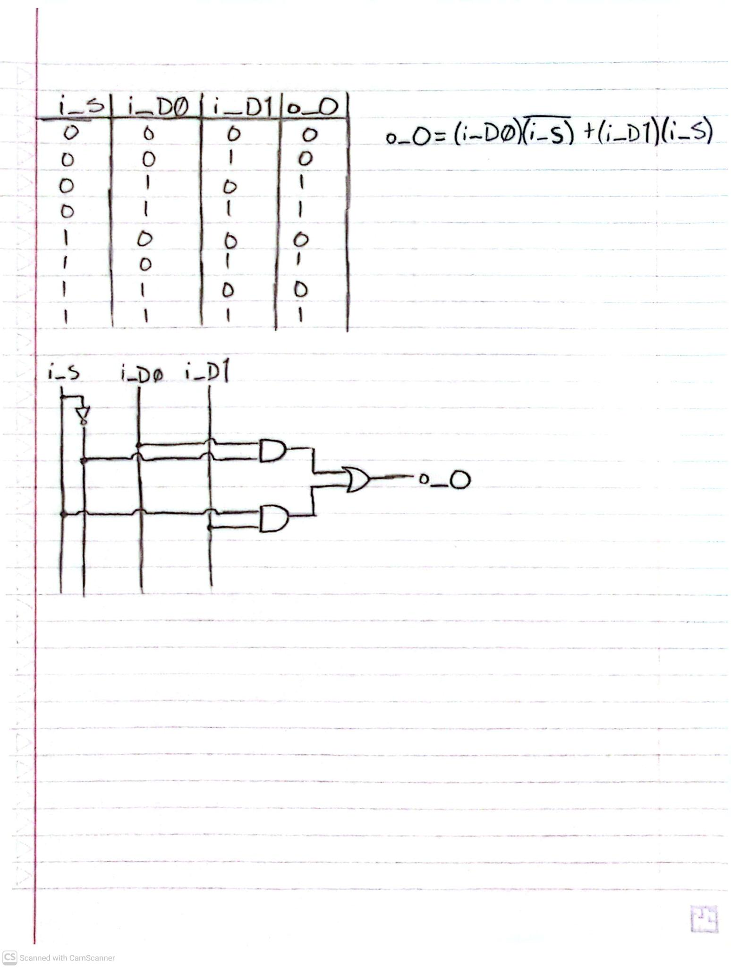

[Part 3.3.d] In your lab report, include a screenshot of the waveform. Make sure to label the screenshot with which module it is testing.

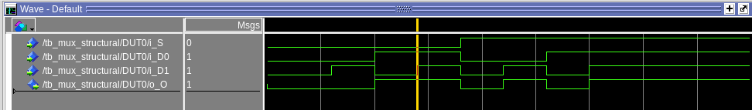
LABEL: Module “mux_structural” is being tested here.

[Part 3.3.e] Again, in your lab report, include a labeled screenshot of the waveform showing the dataflow mux implementation working.
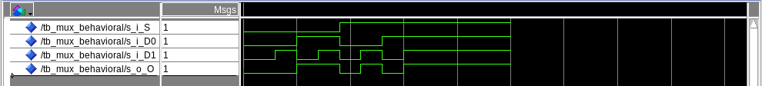
LABEL: Module “mux_behavioral” is being tested here.

[Part 3.4] Include a waveform screenshot and corresponding description demonstrating it is working correctly.
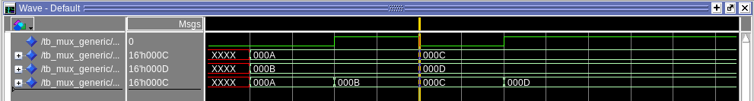
The test cases shown in the screenshot are four. Two test cases that have the hex numbers A and B as inputs, one with the select as 0 and the other as 1. The other two are similar, using C and D, and switch from 0 to 1. This produces the four outputs A, B, C, and D.

[Part 3.5.b] Include a waveform screenshot and description in your lab report.
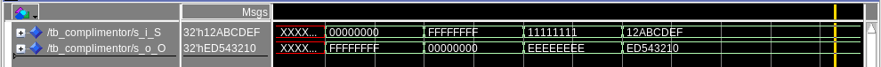
Four test cases are seen here in the 32-bit configuration testing complimentor.hdl. The following hex values are tested: 0x00000000, 0x FFFFFFFF, 0x11111111, and 0x12ABCDEF. They are all inverted correctly, as is demonstrated on the waveform diagram.

[Part 3.6.a] A full adder takes three single-bit inputs and produces two single-bit outputs – a sum and carry for the addition of the three input bits. Draw the truth table, Boolean equation, and Boolean circuit equivalent (using only two-input gates) that implements a 1-bit full adder. Include this in your report.
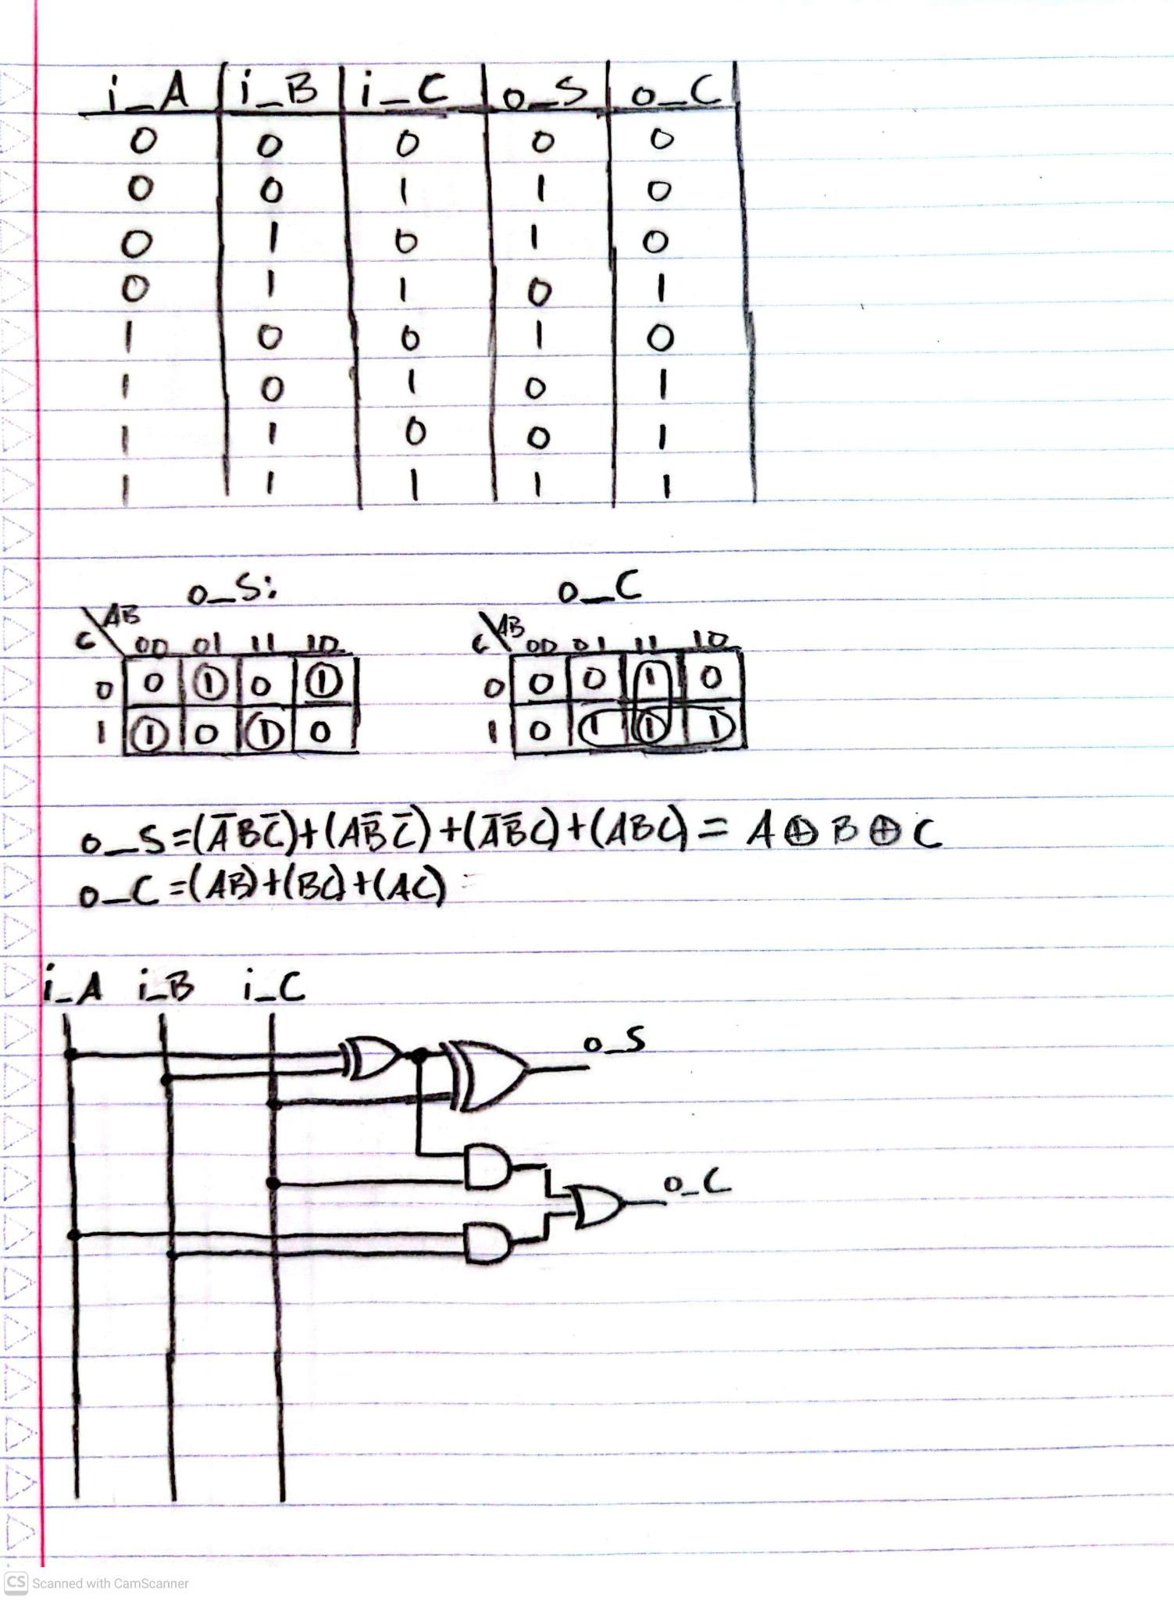

[Part 3.6.c] Then draw a schematic of the intended design, including inputs and outputs and at least the 0, 1, N-2, and N-1 stages. Include this in your report.
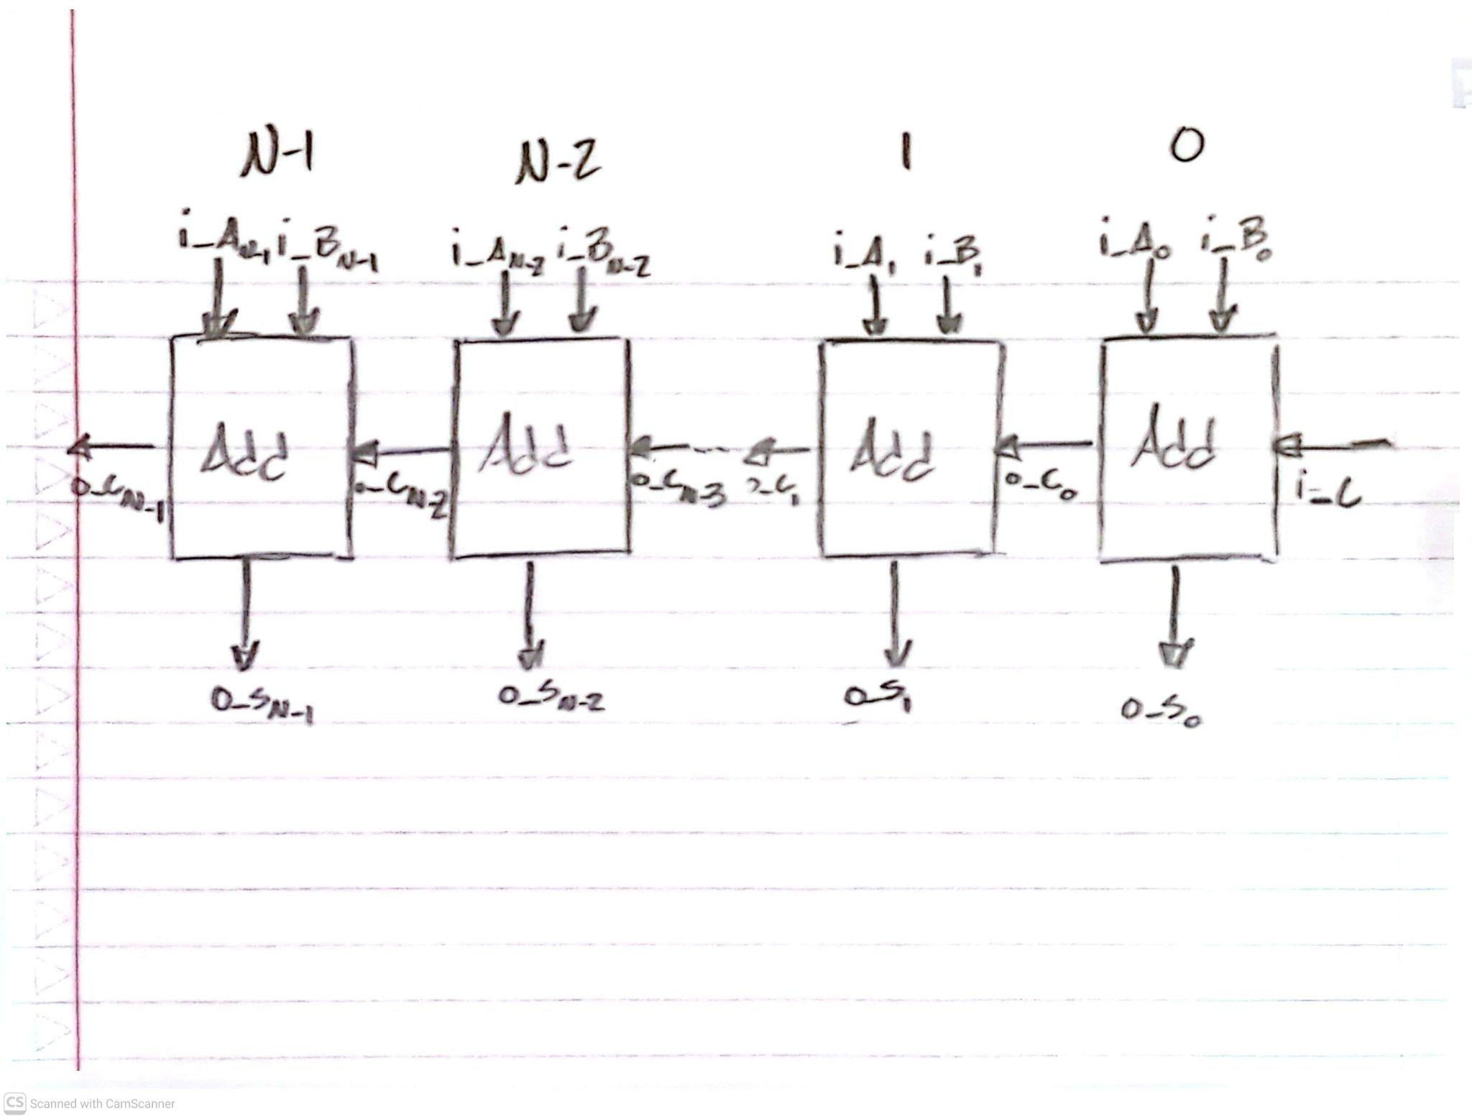

[Part 3.6.d] Include an annotated waveform screenshot in your write-up.
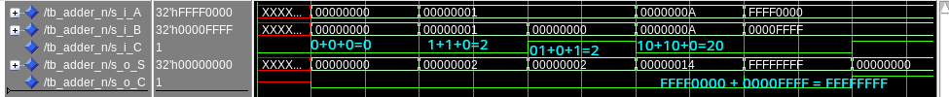

[Part 3.7.a] Draw a schematic (don’t use a schematic capture tool) showing how an N-bit adder/subtractor with control can be implemented using only the three main components designed in earlier parts of this lab (i.e., the N-bit inverter, N-bit 2:1 mux, and N-bit adder). How is the ‘nAdd_Sub’ bit used? Include this in your report.

The nAdd_Sub bit is used both as a selector for the complimented/not complimented mux (to decide whether subtraction is happening or not) and is also acting as a carry bit (incidentally, a carry bit when subtraction is used to facilitate 2s compliment math).
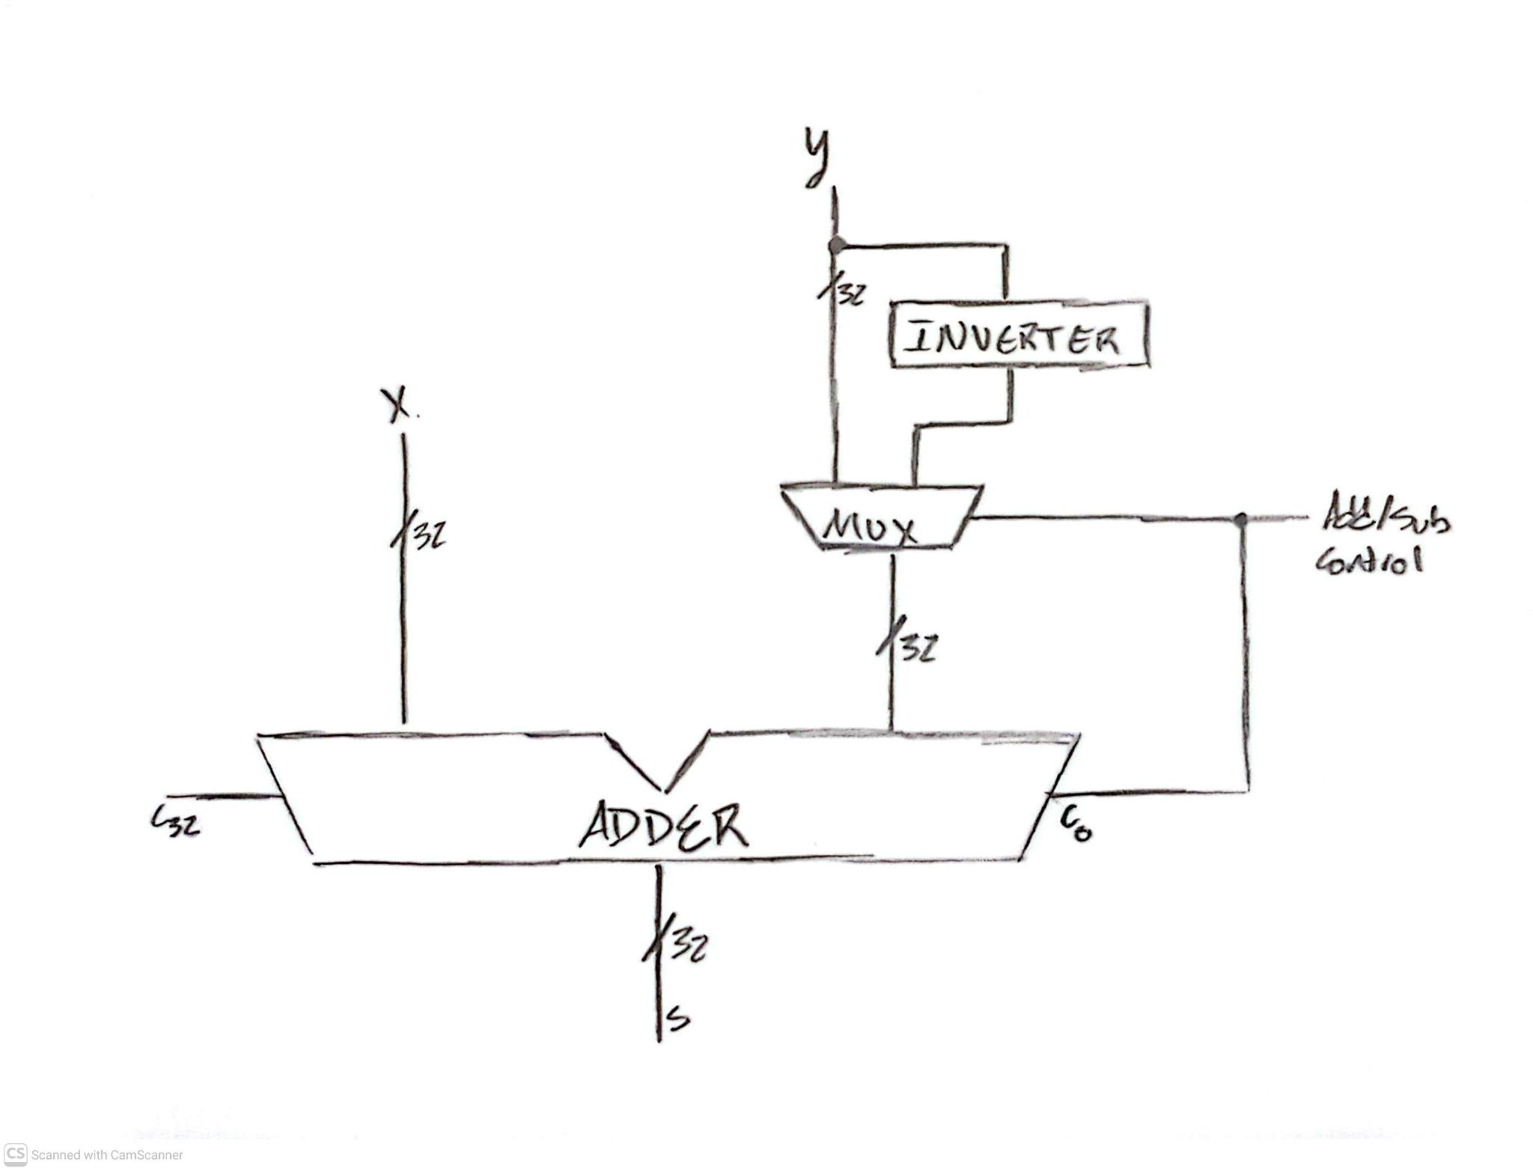

[Part 3.7.c] Provide multiple waveform screenshots in your write-up to confirm that this component is working correctly. What test-cases did you include and why?
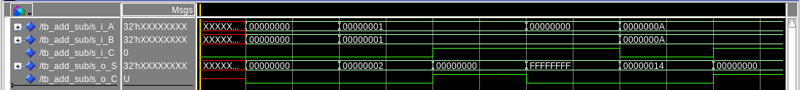
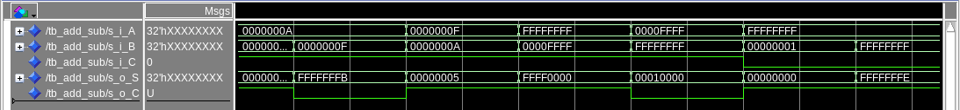

I wrote 12 tests. These 12 represent the array of possible kinds of inputs and edge cases. There are tests ranging from simple addition and simple subtraction to different carry and borrow scenarios to test the complementor, the mux, the addition of 2s compliment numbers in the adder, the carry in, and the carry out functionality.

