CPRE 3810 Final Project Part 1
Troy Tomson and Isaiah Steele

2.d:
Hand-Drawn Version:
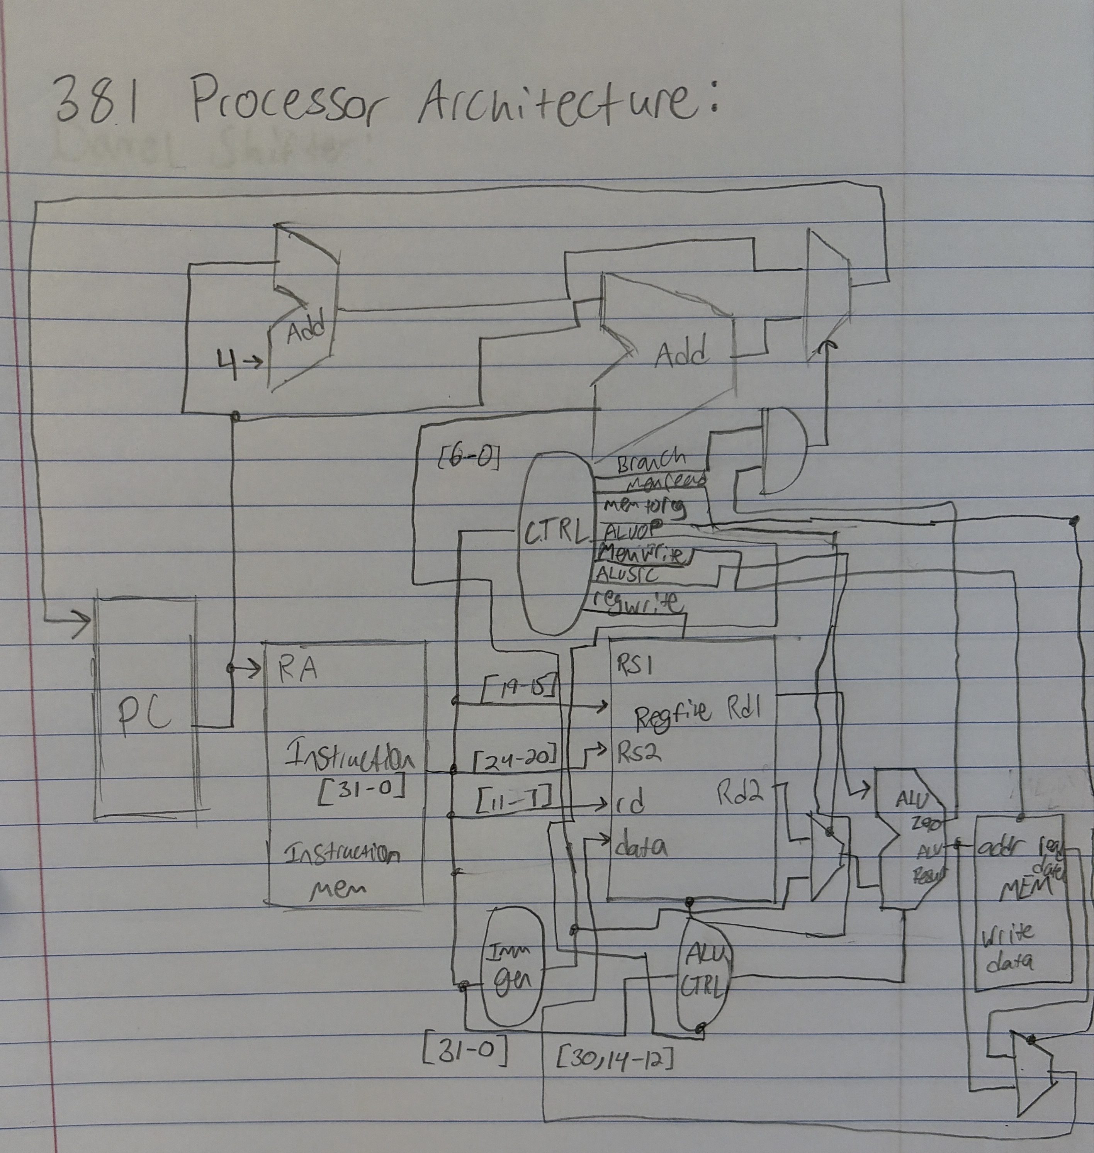

Digital Version:

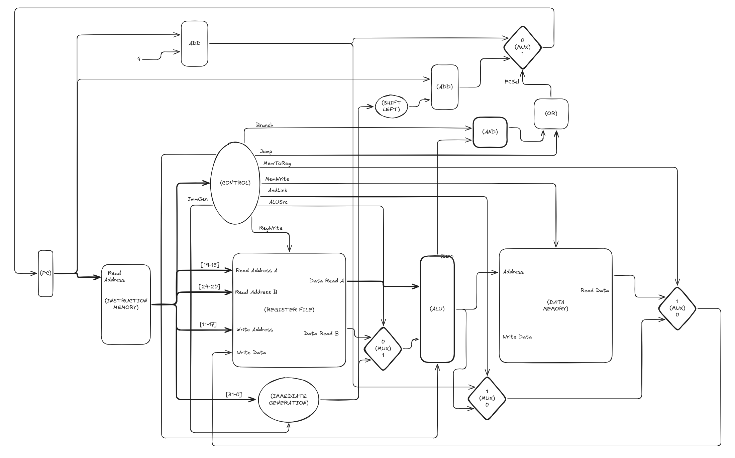

3.1.a:

3.1.b:

3.2.a:
The PC should (in the typical case) be incremented by 4 for each command. Additionally, in the case of a j, jal, or jalr register it should set the PC to the value of the immediate. For branch instructions, the branch condition must resolve true to update the address to the address of the function it must branch to.

3.2.b:
See digital diagram for more. Fetch logic is heavily integrated into the design of the processor. All instructions start with the PC. 4 is added in the default case (proceed to the next instruction). As the current PC is passed into the instruction memory. This path is selected with the exceptions of a jump/jal/jalr command, or a branch command if the branch condition is met. In that case, the value from the immediate generation is added to the current PC value, and that result is put back into the PC.

3.2.c:

3.3.1.a:
sra is sign extended while srl always pads the rest of the word with 0’s. Sra is intended for use with signed integers, while srl is for unsigned integers. Because sla would just pad the left bits with 0’s, it’s effectively the same as a sll.

3.3.1.b:
The shifter works by taking in a 5 bit input and shifting the register based on the input. First by 16, then 8, 4, 2, and 1 bits which allow for 31 bits of movement. There’s also a left/right and arithmetic selector which just fills the remaining bits at the end of the shifting with 1’s if the value being shifted is negative.

3.3.1.c:
You can simply check for a shift right bit and move in the opposite direction if it’s enabled. This was done by using an if statement in my code.

3.3.1.d:

3.3.2.a:

3.3.2.b:

3.3.3:

3.3.5:

3.3.8:

4.a:
See Proj1_base_test.s
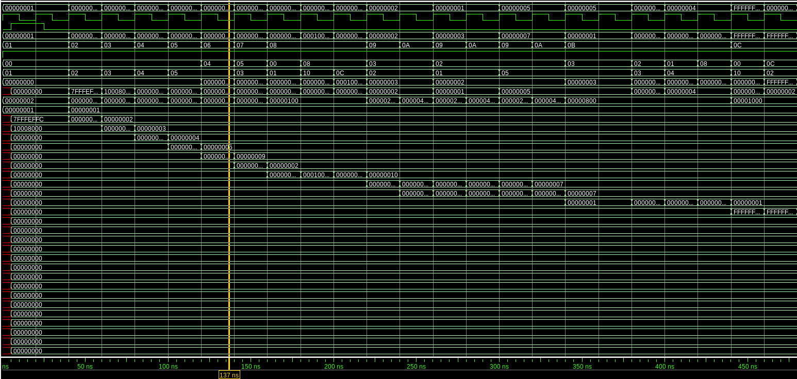

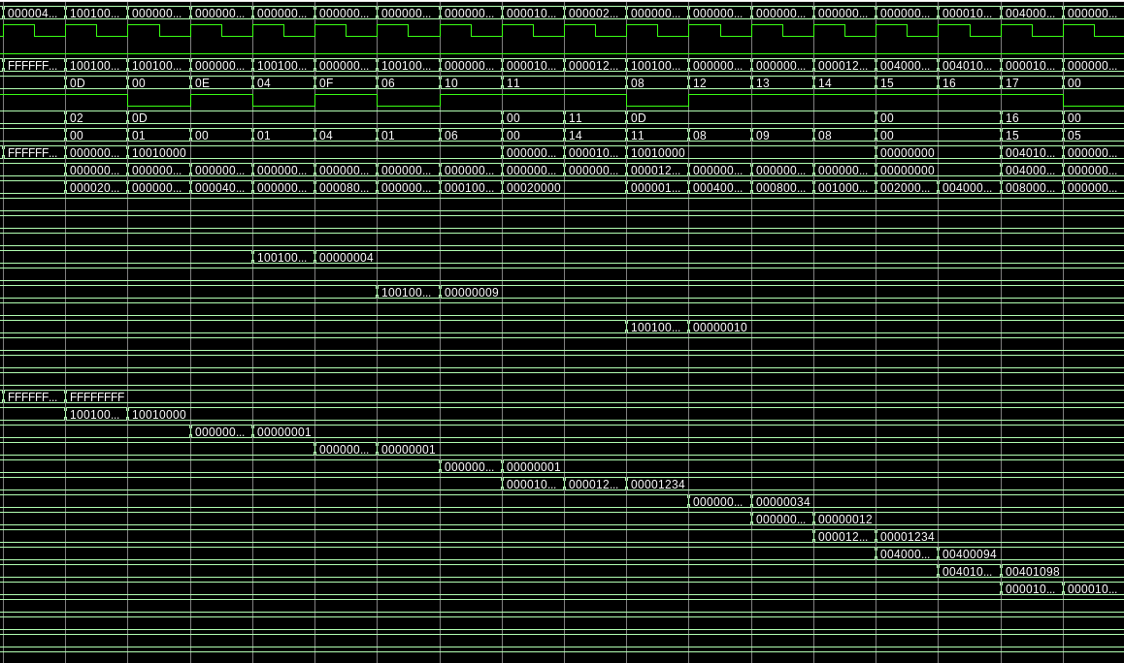
The first 5 instructions just add vals 1-5 to reges 1-5.
Next is an add, sub, another addi, a right shift, and a left shift. All match up correctly with the expected values.
Comparisons with and/or/xor and their immediate versions are also correctly matching their expected values.
The set comparisons are also working as intended, along with loads and stores. Essentially, all of the values in the registers are the same as the expected ones when walking through/making the test program manually.

4.b:
See Proj1_cf_test.s
It branches when branch is true AND the beq resolves to true. The last 5 instructions repeat for 5 layers.
Everything matches up with the comments I put into the testbench when developing it.

4.c:
see Proj1_mergesort.s
The contents of the memory produce a sorted list (in order of ascending value).
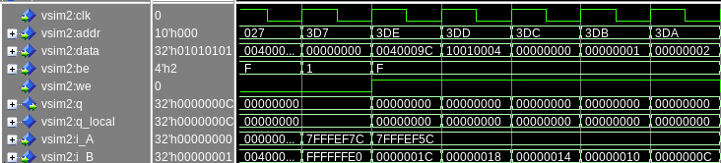
Here is a small snippet. The testbench successfully accesses, retrieves, (and can store, as the data was originally stored in the memory by my program). The actual program is quite complex, but all other operations (such as comparison, arithmetic operations, pc operations, etc) are all functional.

5:

