Introduction to Microservices: API Tests

Farid Aghazada
Postman test evidence for the Microservices Fundamentals Module 1 changes.
Resource files are stored in S3 (LocalStack) and the database keeps only the file key. Upload no longer calls the Song Service, so two requests were added to create song metadata explicitly where a later test needs it. Delete removes the file from S3, the record from the database and the song metadata. Screenshots follow the order in which the tests were run.
# | Test | Expected | Tests passed | Section
1 | Create Test Song Metadata (200) | 200 OK | 7/7 | Happy Path
2 | Upload Valid Mp3 Resource (200) | 200 OK | 6/6 | Happy Path
3 | Get Existing Resource (200) | 200 OK | 8/8 | Happy Path
4 | Create Song Metadata For Uploaded Resource (200) | 200 OK | 2/2 | Happy Path
5 | Get Existing Song Metadata (200) | 200 OK | 16/16 | Happy Path
6 | Delete Resources With Metadata (200) | 200 OK | 13/13 | Happy Path
7 | Get Deleted Resource (404) | 404 Not Found | 12/12 | Happy Path
8 | Get Deleted Song Metadata (404) | 404 Not Found | 12/12 | Happy Path
9 | Upload Invalid Resource (400) | 400 Bad Request | 9/9 | Error Cases / Resource Service
10 | Delete Invalid CSV - Length (400) | 400 Bad Request | 12/12 | Error Cases / Resource Service
11 | Get Non-existent Resource (404) | 404 Not Found | 12/12 | Error Cases / Resource Service
12 | Get Invalid ID - Decimal (400) | 400 Bad Request | 12/12 | Error Cases / Resource Service
13 | Get Invalid ID - Negative (400) | 400 Bad Request | 12/12 | Error Cases / Resource Service
14 | Get Invalid ID - Zero (400) | 400 Bad Request | 12/12 | Error Cases / Resource Service
15 | Delete Non-existent Resource (200) | 200 OK | 7/7 | Error Cases / Resource Service
16 | Get Invalid ID - Letters (400) | 400 Bad Request | 12/12 | Error Cases / Resource Service
17 | Delete Invalid CSV - Letters (400) | 400 Bad Request | 11/11 | Error Cases / Resource Service
18 | Create Song Metadata - Invalid Fields - Duration 02:77, Year 01977 (400) | 400 Bad Request | 21/21 | Error Cases / Song Service
19 | Create Song Metadata - Invalid Fields - Duration 0299 (400) | 400 Bad Request | 14/14 | Error Cases / Song Service
20 | Create Song Metadata - Invalid Fields - Duration 35 (400) | 400 Bad Request | 14/14 | Error Cases / Song Service
21 | Create Song Metadata - Invalid Fields - Year 1 (400) | 400 Bad Request | 14/14 | Error Cases / Song Service
22 | Create Song Metadata - Invalid Fields - All Empty (400) | 400 Bad Request | 12/12 | Error Cases / Song Service
23 | Create Song Metadata - Missing Fields - Name (400) | 400 Bad Request | 17/17 | Error Cases / Song Service
24 | Create Song Metadata - Missing Fields - All Except Id (400) | 400 Bad Request | 12/12 | Error Cases / Song Service
25 | ! Upload Mp3 Before the Next Request | 200 OK | 3/3 | Error Cases / Song Service
26 | ! Create Song Metadata For Uploaded Resource | 200 OK | 2/2 | Error Cases / Song Service
27 | Create Song Metadata - Already Exists (409) | 409 Conflict | 12/12 | Error Cases / Song Service
28 | Get Non-Existent Song Metadata (404) | 404 Not Found | 12/12 | Error Cases / Song Service
29 | Get Song Metadata - Invalid ID - Letters (400) | 400 Bad Request | 12/12 | Error Cases / Song Service
30 | Get Song Metadata - Invalid ID - Decimal (400) | 400 Bad Request | 12/12 | Error Cases / Song Service
31 | Get Song Metadata - Invalid ID - Negative (400) | 400 Bad Request | 12/12 | Error Cases / Song Service
32 | Get Song Metadata - Invalid ID - Zero (400) | 400 Bad Request | 12/12 | Error Cases / Song Service
33 | Delete Non-existent Song Metadata (200) | 200 OK | 7/7 | Error Cases / Song Service
34 | Delete Invalid CSV - Letters (400) | 400 Bad Request | 11/11 | Error Cases / Song Service
35 | Delete Invalid CSV - Length (400) | 400 Bad Request | 12/12 | Error Cases / Song Service
Green rows are the two requests added to the original collection because upload no longer creates song metadata.

Happy Path

1. Create Test Song Metadata (200)
Result: 200 OK | Tests passed: 7/7
Creates song metadata directly in the Song Service with a random test id (733718).
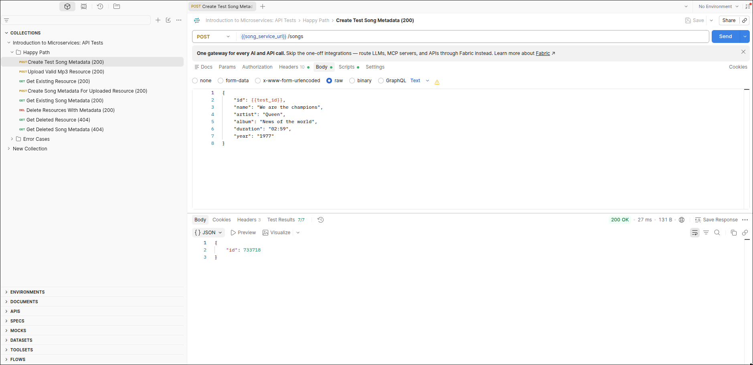

2. Upload Valid Mp3 Resource (200)
Result: 200 OK | Tests passed: 6/6
The MP3 is sent as a binary body. The Resource Service stores it in S3 (LocalStack), saves the file key in the database and returns the new id (3). It does not call the Song Service.
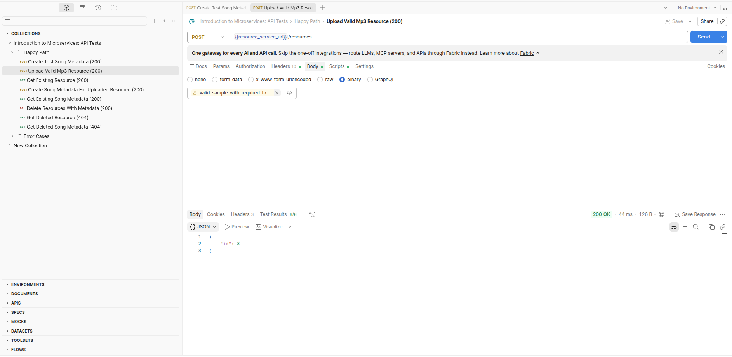

3. Get Existing Resource (200)
Result: 200 OK | Tests passed: 8/8
The file is read back from S3. Postman's audio preview shows the 7-second track (185.47 KB).
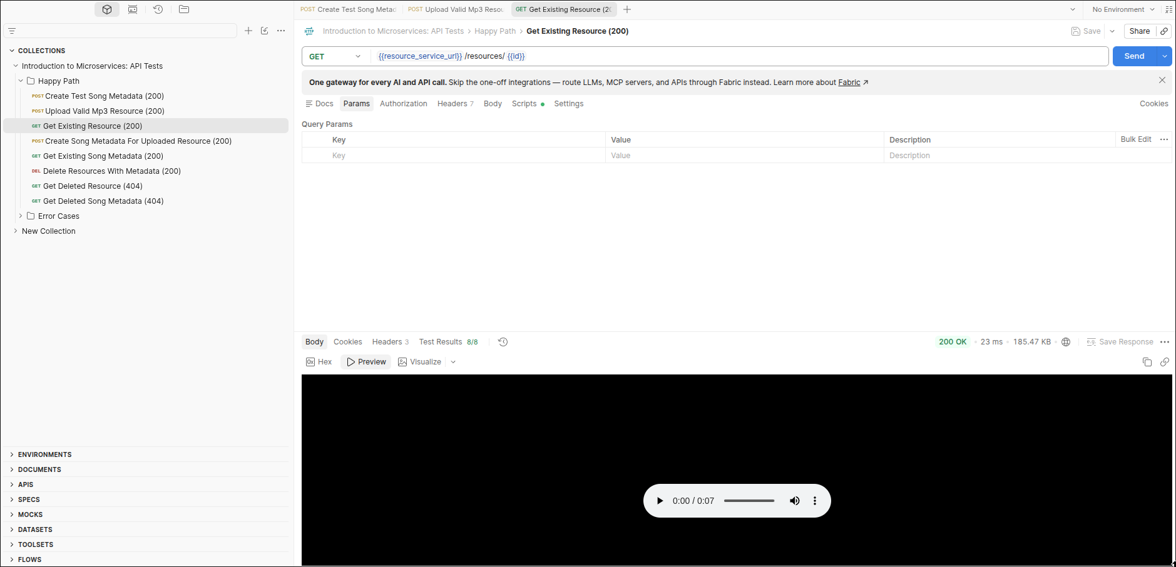

4. Create Song Metadata For Uploaded Resource (200)
Result: 200 OK | Tests passed: 2/2
Added request. Upload no longer creates song metadata, so it is created here for the uploaded resource id (3).
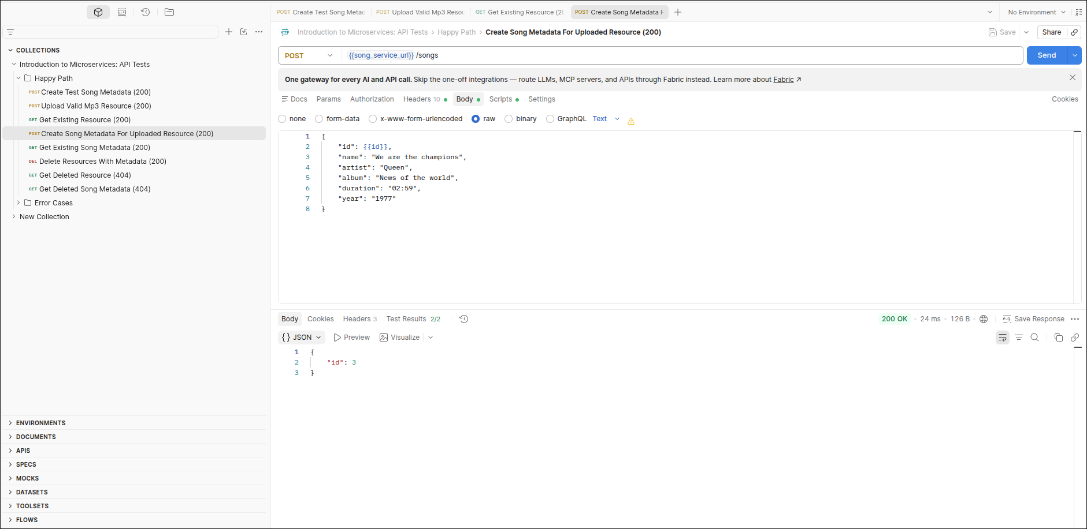

5. Get Existing Song Metadata (200)
Result: 200 OK | Tests passed: 16/16
Song metadata for id 3 is returned with all six fields.
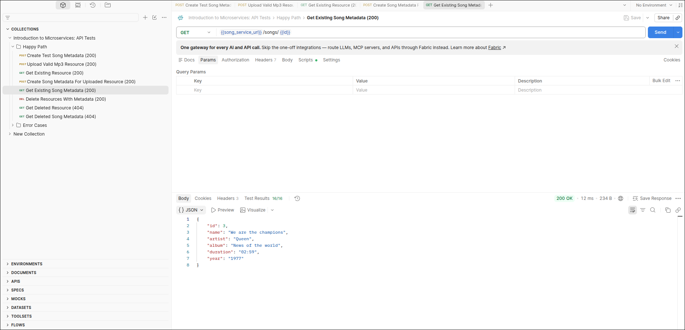

6. Delete Resources With Metadata (200)
Result: 200 OK | Tests passed: 13/13
Called with the uploaded id plus 101 and 102. Only id 3 exists, so only 3 is returned. The file is removed from S3, the row from the database and the song metadata from the Song Service.
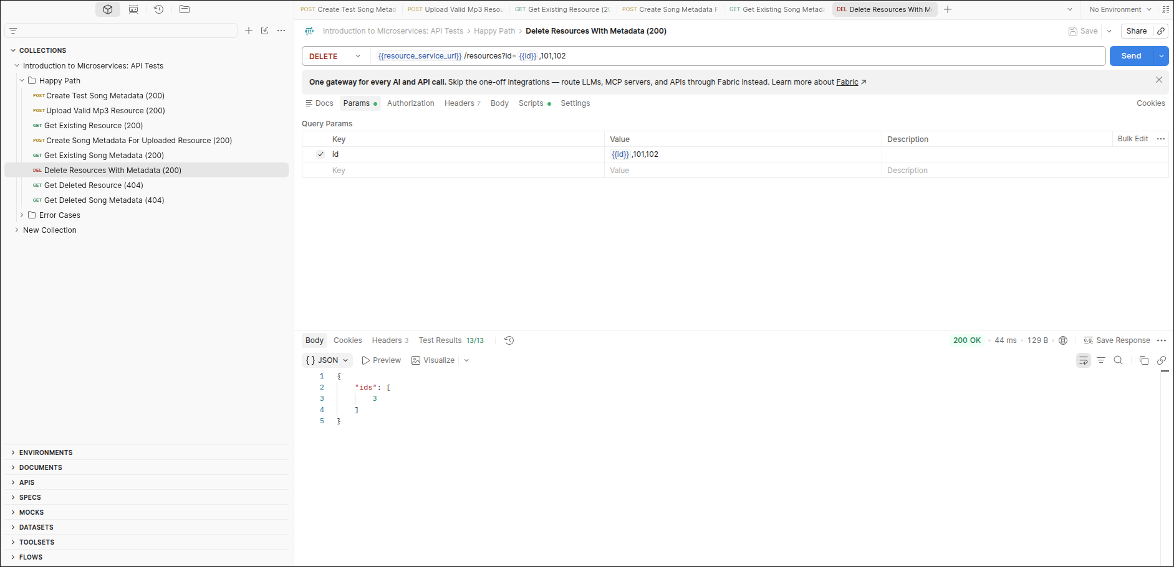

7. Get Deleted Resource (404)
Result: 404 Not Found | Tests passed: 12/12
The resource record is gone after deletion.
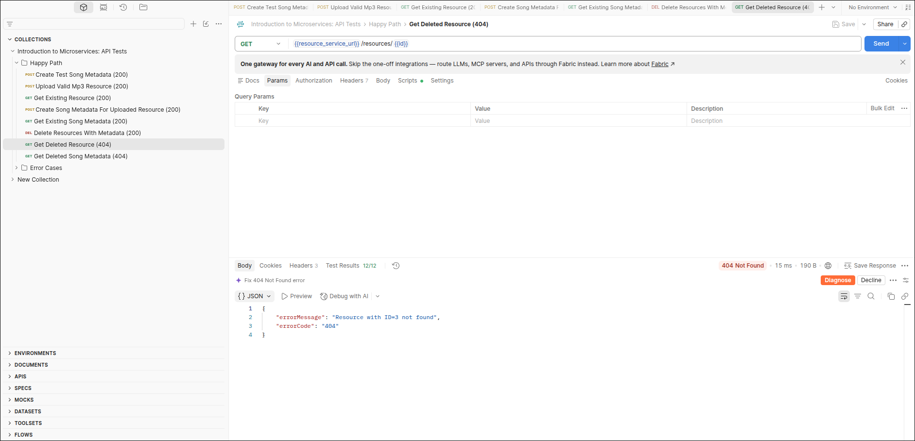

8. Get Deleted Song Metadata (404)
Result: 404 Not Found | Tests passed: 12/12
The song metadata was removed by the cascade delete.
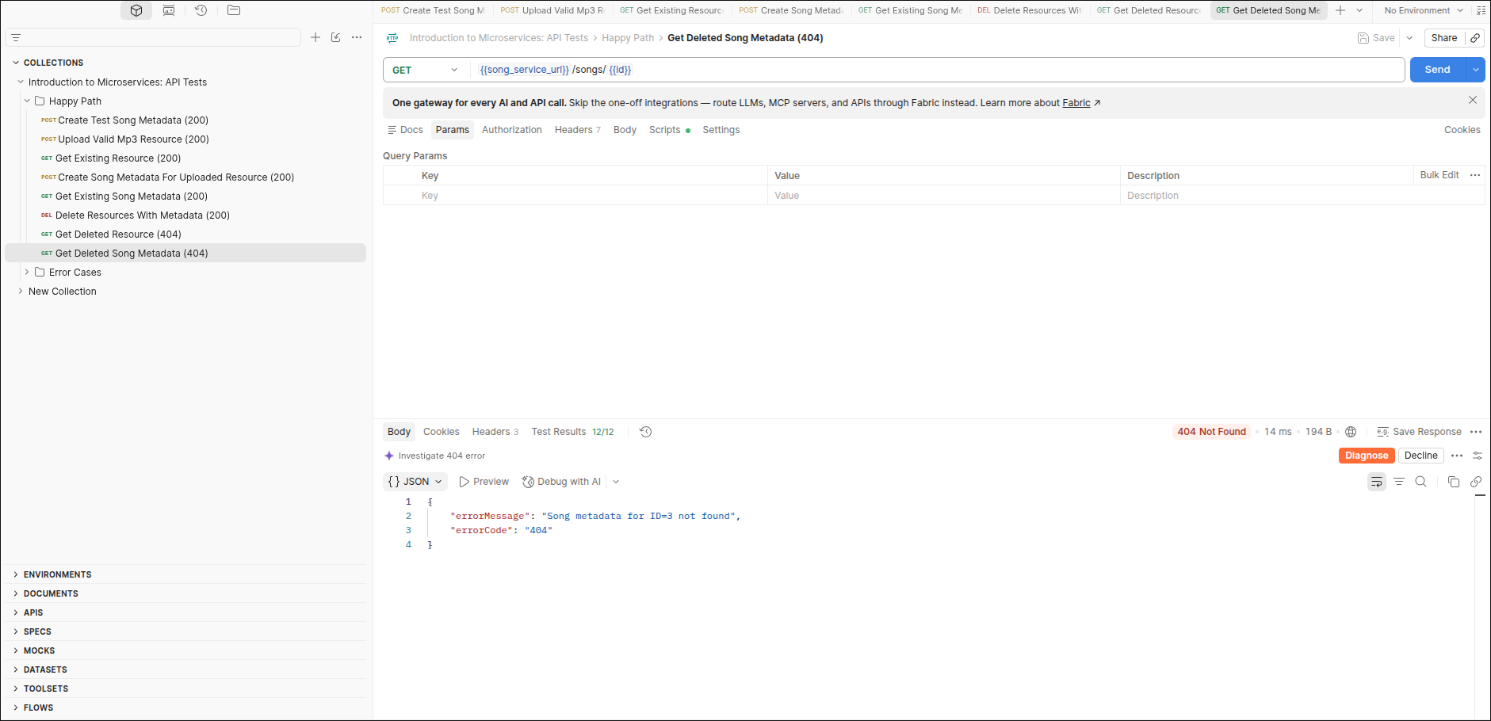

Error Cases / Resource Service

9. Upload Invalid Resource (400)
Result: 400 Bad Request | Tests passed: 9/9
Request with Content-Type application/json is rejected. Only MP3 files are allowed.
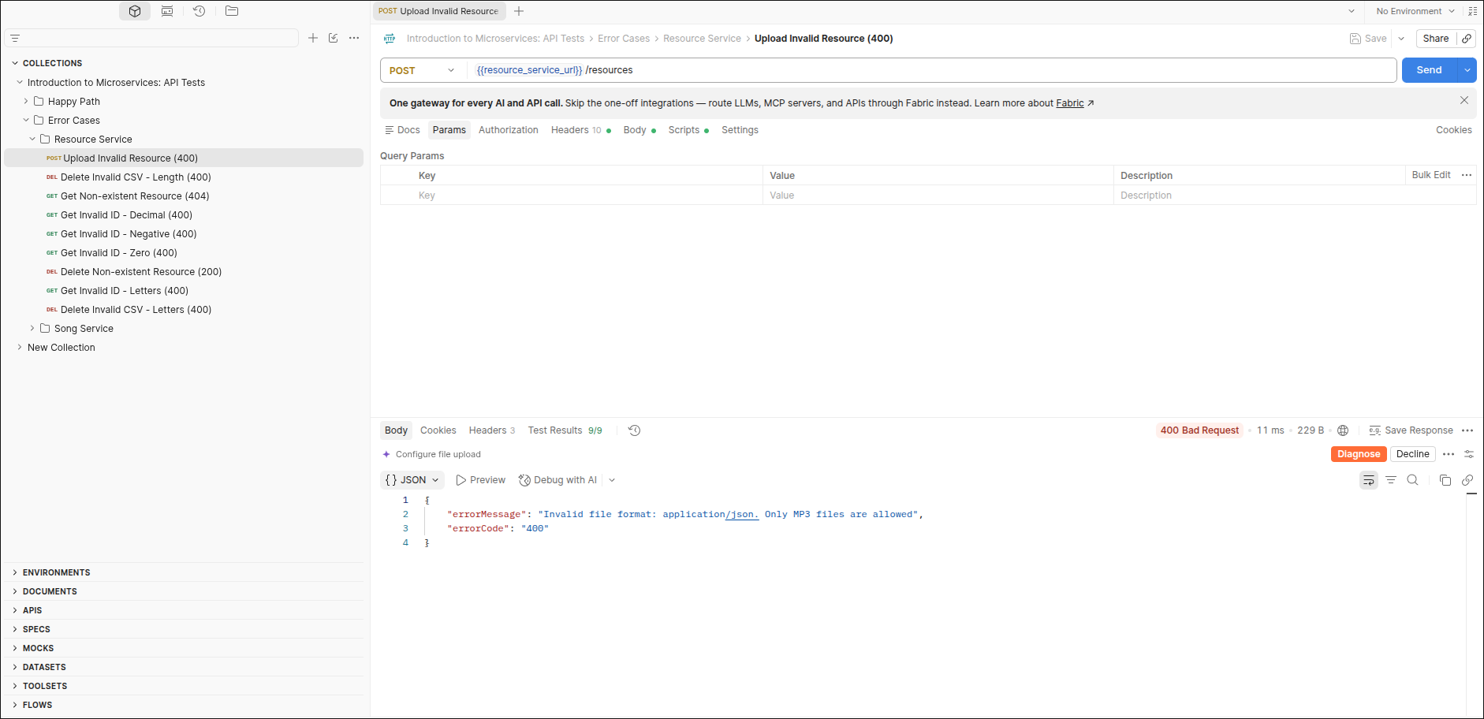

10. Delete Invalid CSV - Length (400)
Result: 400 Bad Request | Tests passed: 12/12
The CSV id list is 208 characters, above the 200 character limit.
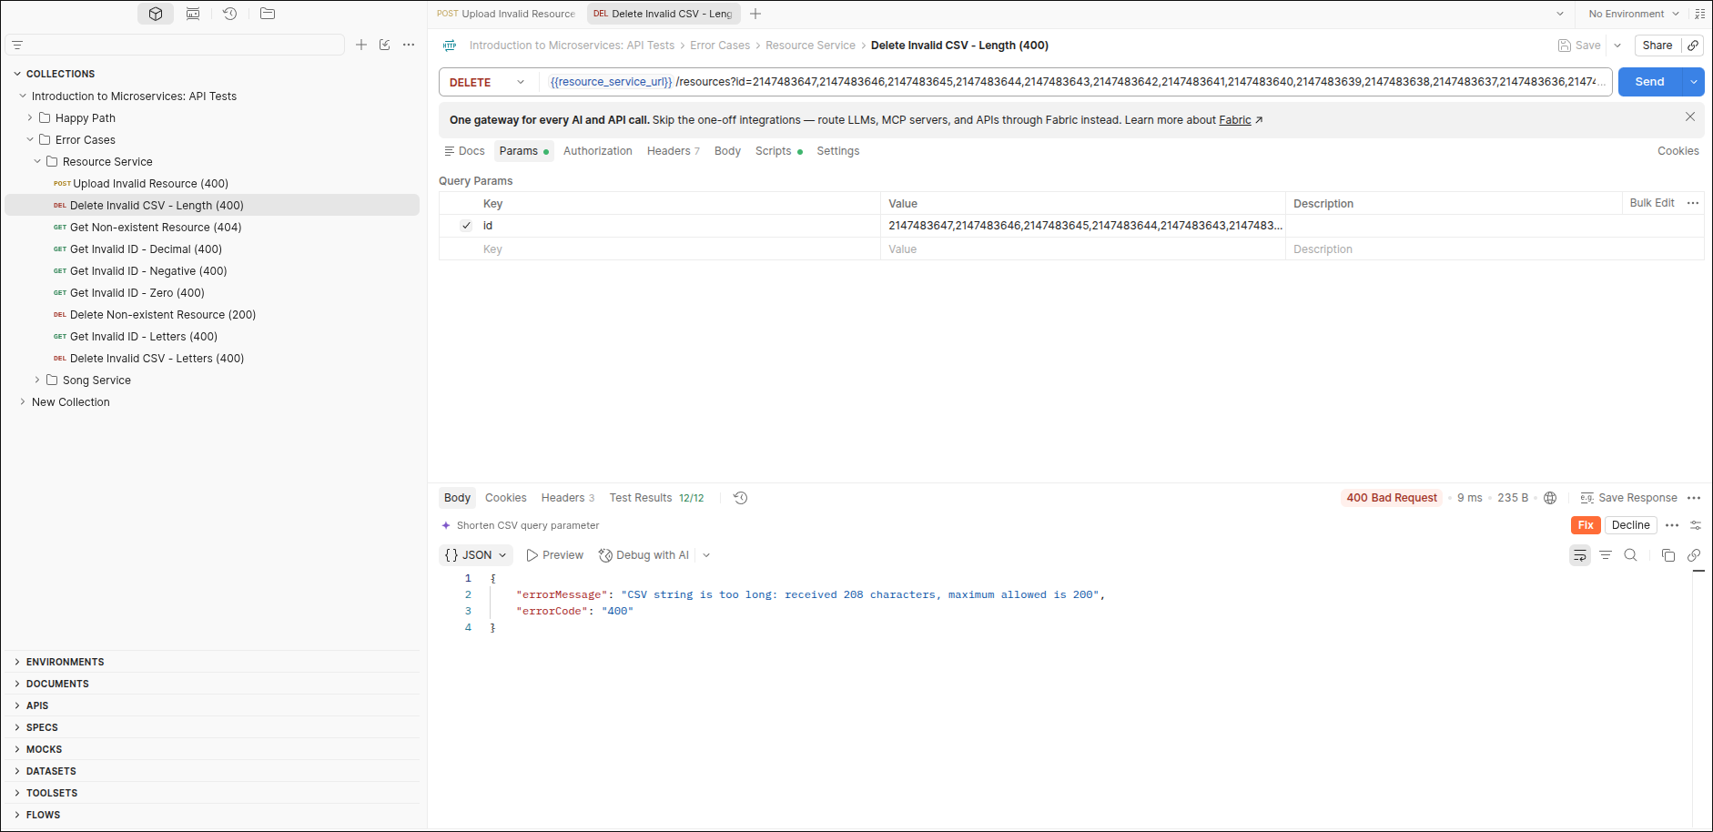

11. Get Non-existent Resource (404)
Result: 404 Not Found | Tests passed: 12/12
No resource exists with id 99999.
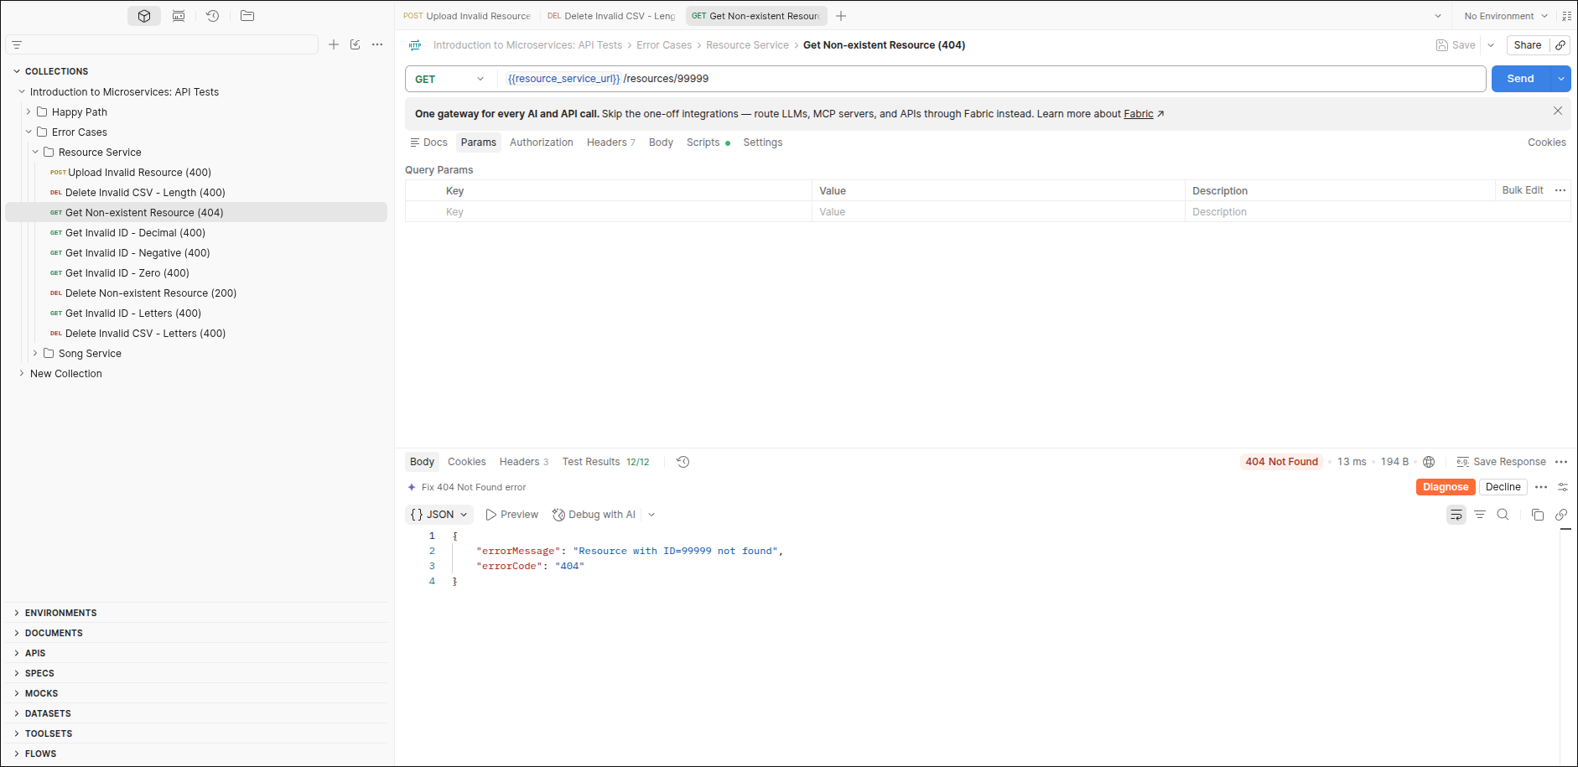

12. Get Invalid ID - Decimal (400)
Result: 400 Bad Request | Tests passed: 12/12
Id 1.1 is not a positive integer.
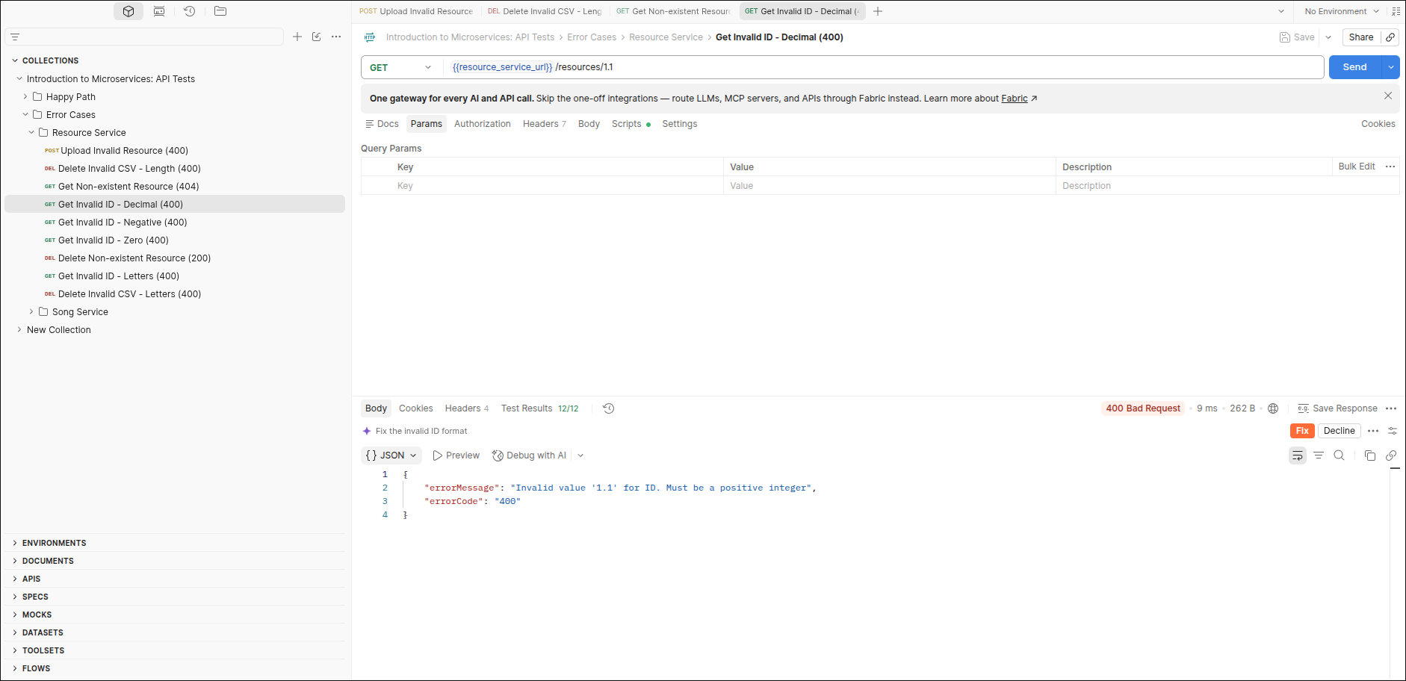

13. Get Invalid ID - Negative (400)
Result: 400 Bad Request | Tests passed: 12/12
Id -1 is not a positive integer.
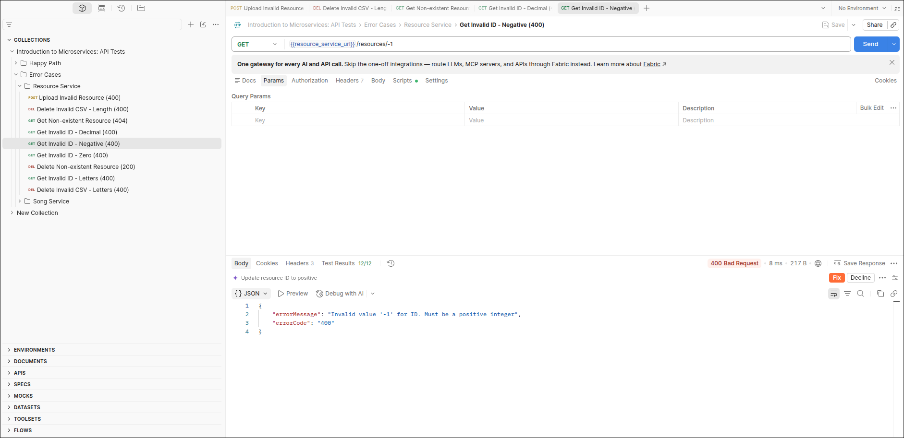

14. Get Invalid ID - Zero (400)
Result: 400 Bad Request | Tests passed: 12/12
Id 0 is not a positive integer.
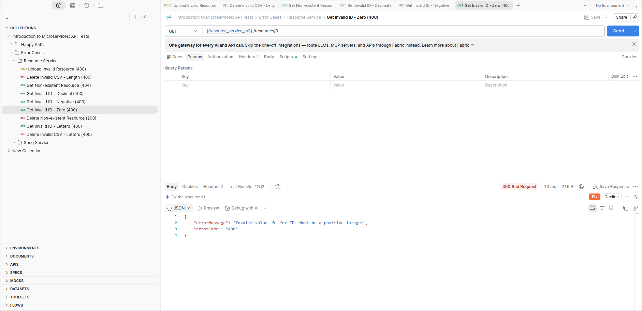

15. Delete Non-existent Resource (200)
Result: 200 OK | Tests passed: 7/7
Unknown id 99999 is ignored and an empty ids list is returned.
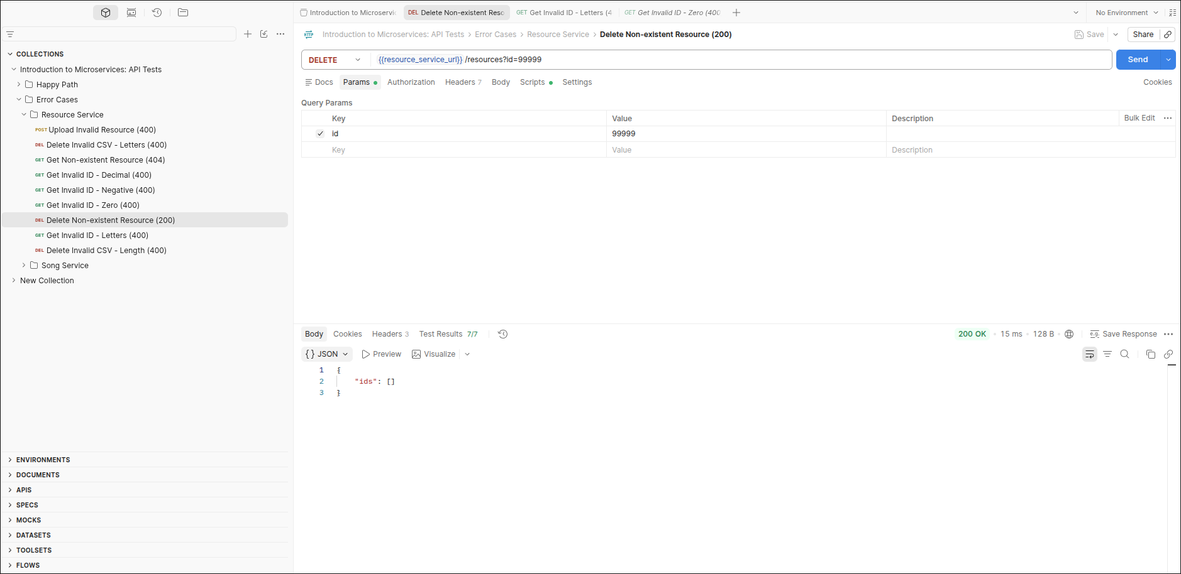

16. Get Invalid ID - Letters (400)
Result: 400 Bad Request | Tests passed: 12/12
Id ABC is not a positive integer.
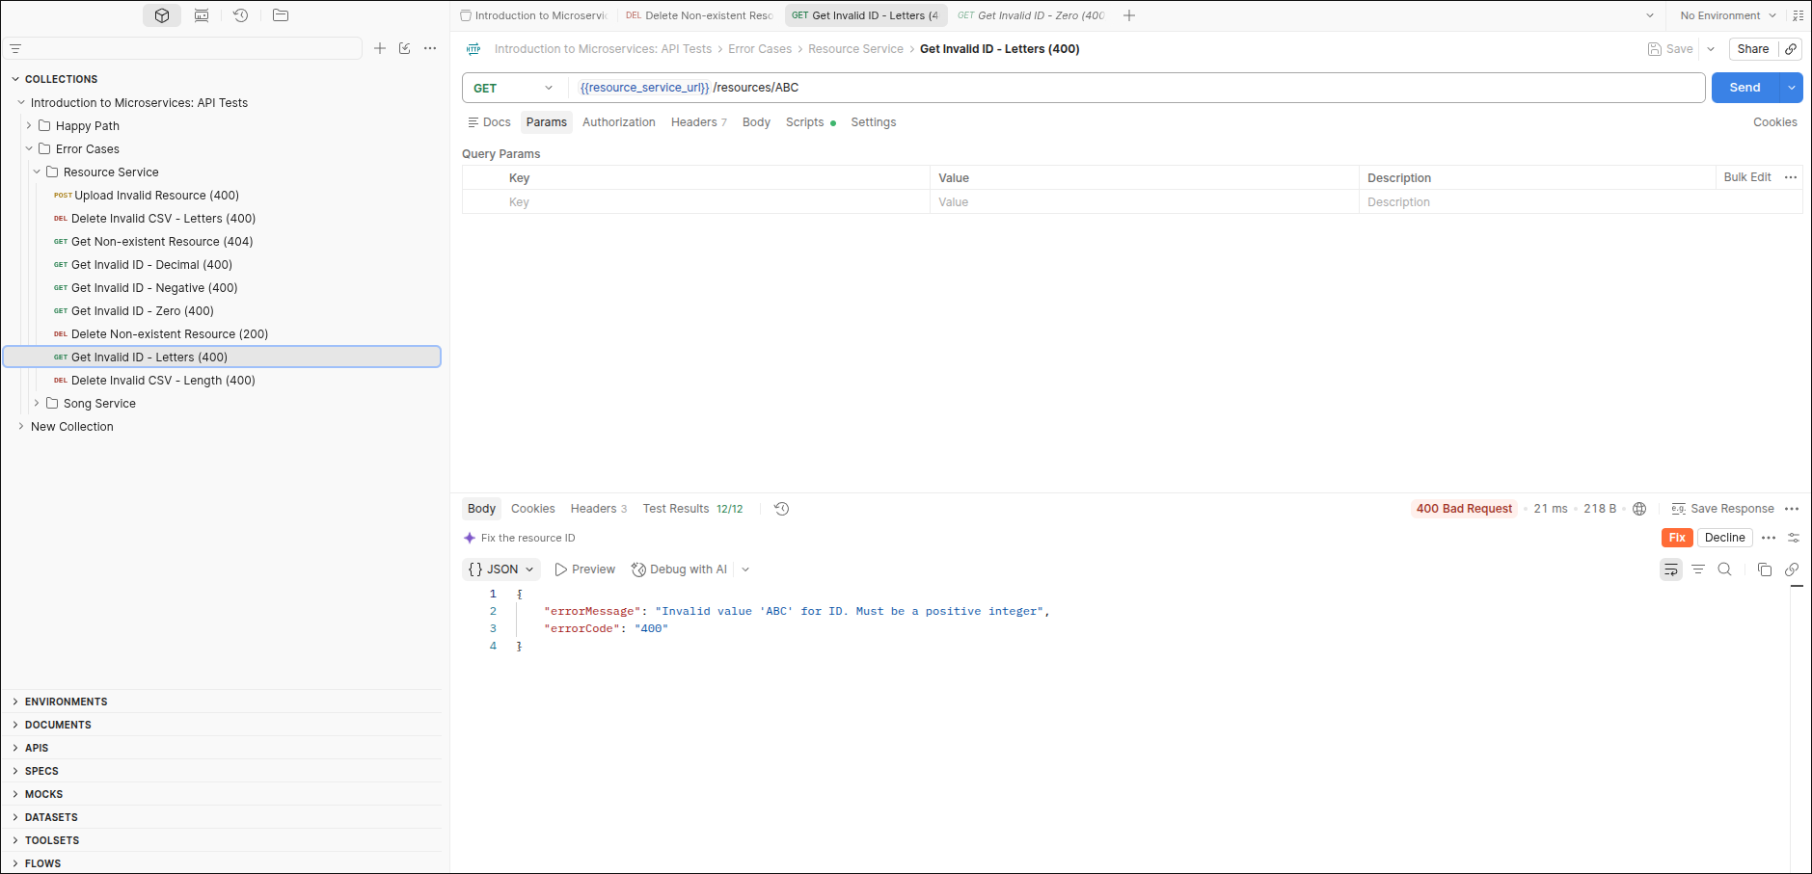

17. Delete Invalid CSV - Letters (400)
Result: 400 Bad Request | Tests passed: 11/11
The id list 1,2,3,4,V contains a non-numeric value.
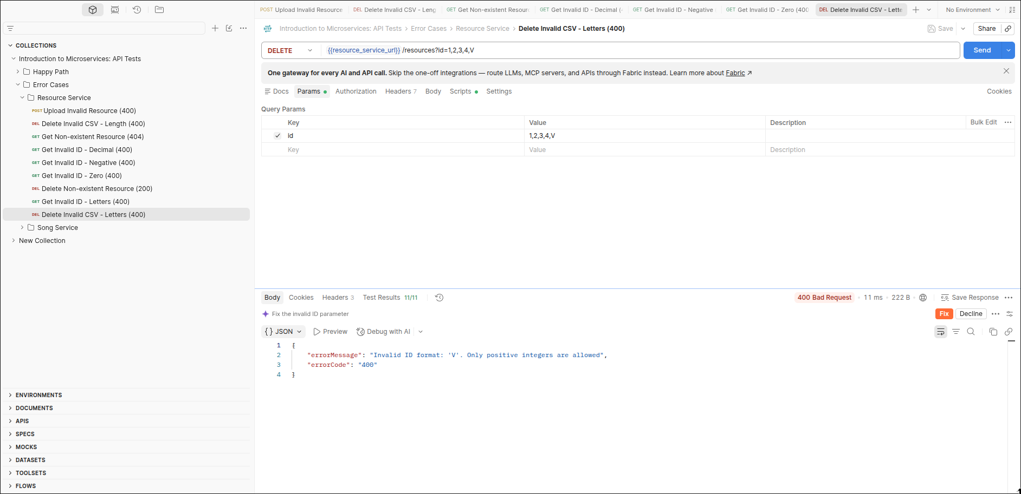

Error Cases / Song Service

18. Create Song Metadata - Invalid Fields - Duration 02:77, Year 01977 (400)
Result: 400 Bad Request | Tests passed: 21/21
Both the duration and the year fail validation.
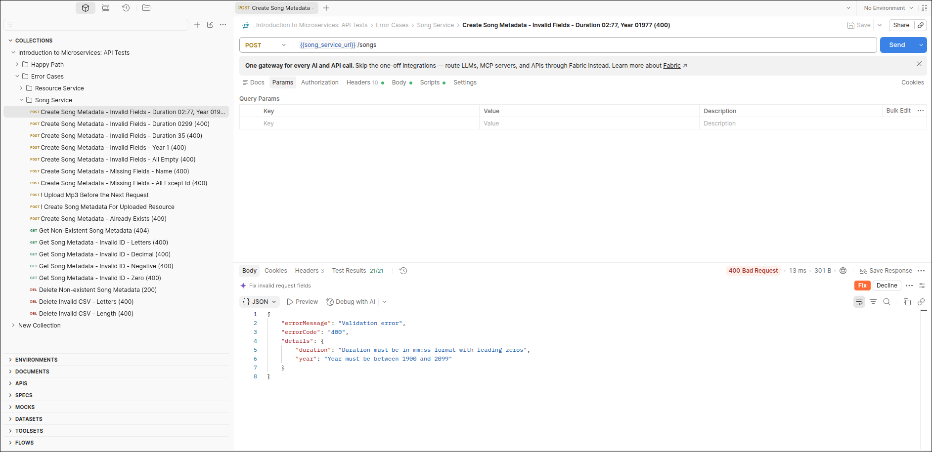

19. Create Song Metadata - Invalid Fields - Duration 0299 (400)
Result: 400 Bad Request | Tests passed: 14/14
Duration must be in mm:ss format.
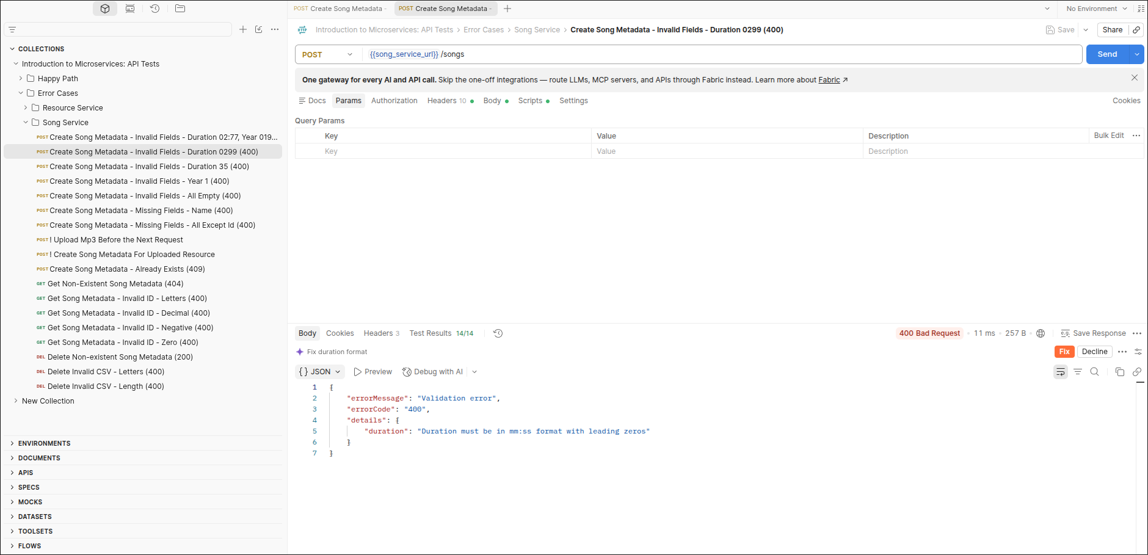

20. Create Song Metadata - Invalid Fields - Duration 35 (400)
Result: 400 Bad Request | Tests passed: 14/14
Duration must be in mm:ss format.
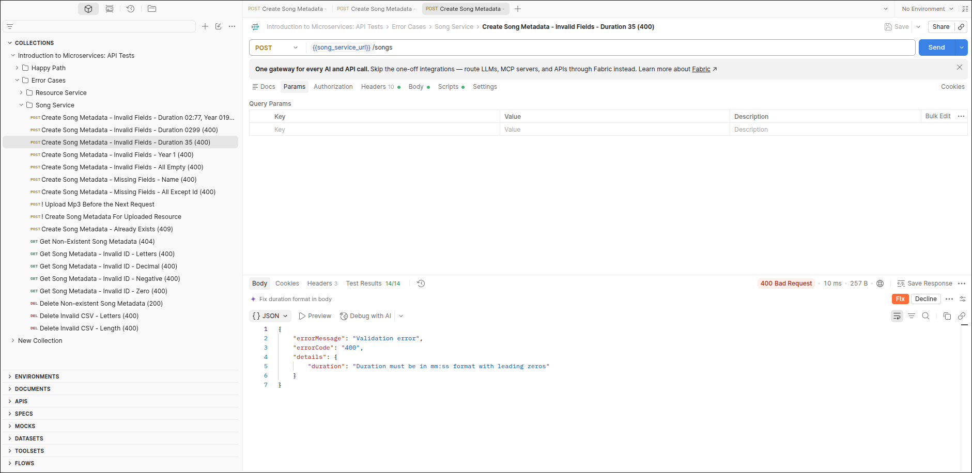

21. Create Song Metadata - Invalid Fields - Year 1 (400)
Result: 400 Bad Request | Tests passed: 14/14
Year must be between 1900 and 2099.
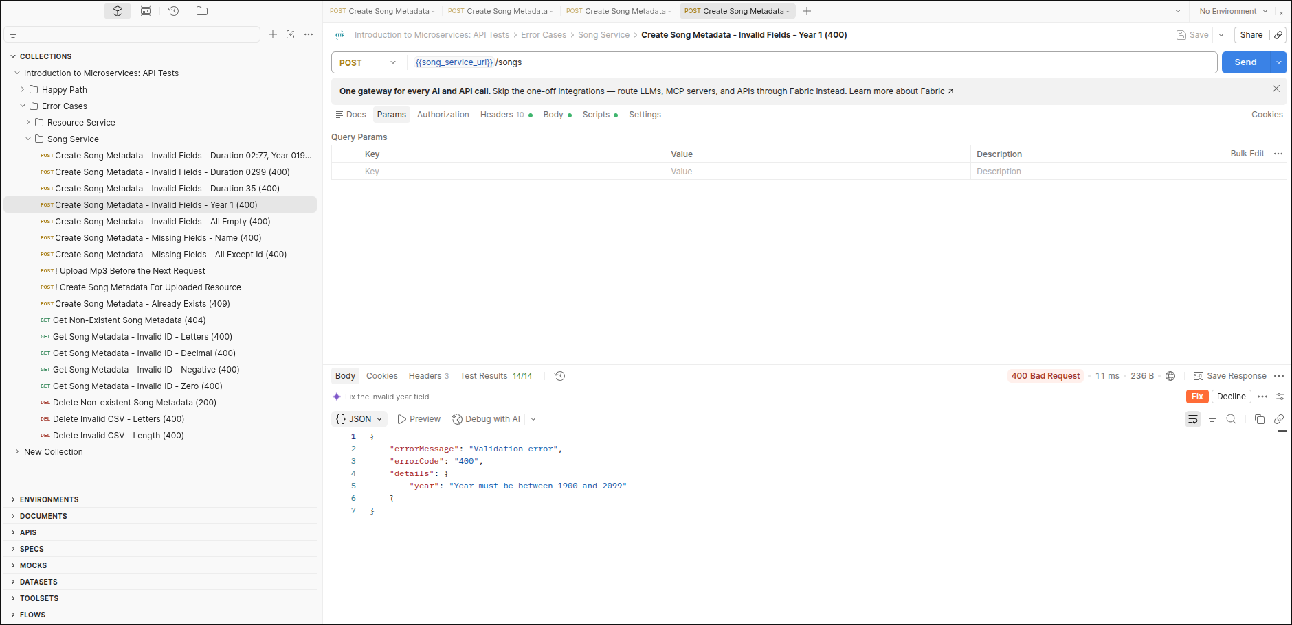

22. Create Song Metadata - Invalid Fields - All Empty (400)
Result: 400 Bad Request | Tests passed: 12/12
Every empty field is reported in the validation details.
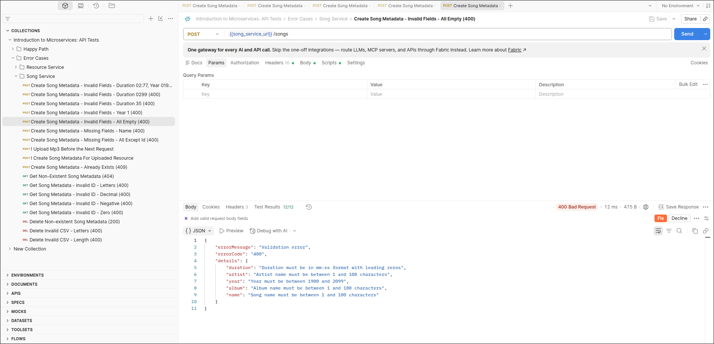

23. Create Song Metadata - Missing Fields - Name (400)
Result: 400 Bad Request | Tests passed: 17/17
The name field is required.
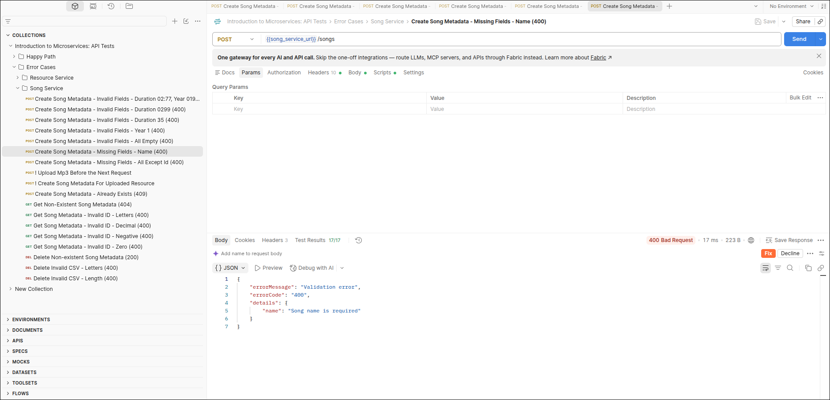

24. Create Song Metadata - Missing Fields - All Except Id (400)
Result: 400 Bad Request | Tests passed: 12/12
All fields except the id are missing.
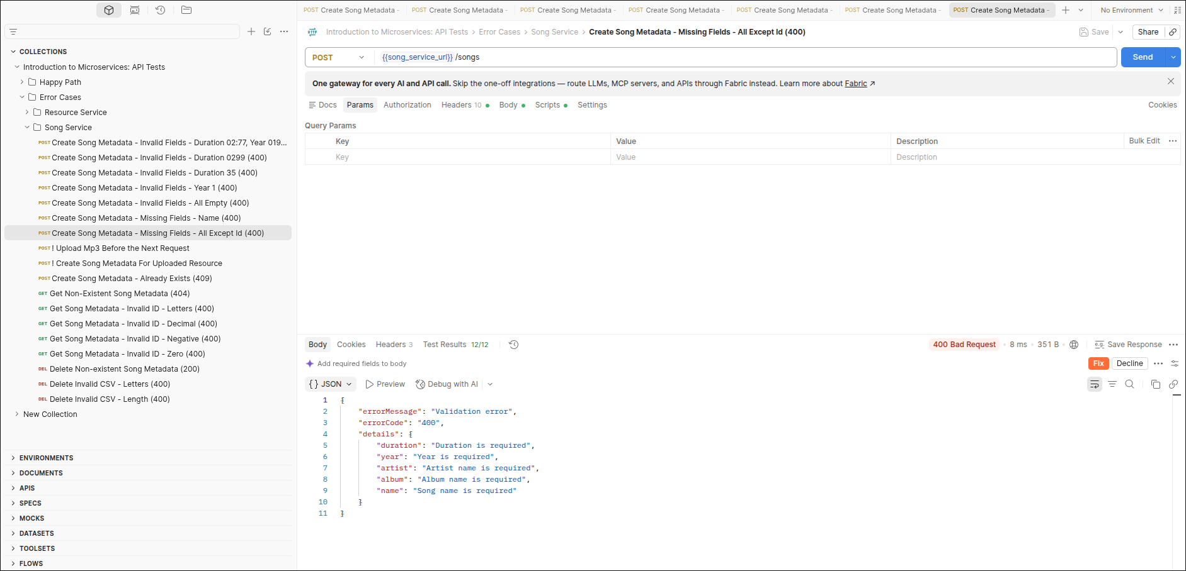

25. ! Upload Mp3 Before the Next Request
Result: 200 OK | Tests passed: 3/3
Setup step. Uploads an MP3 to get a fresh resource id (4).
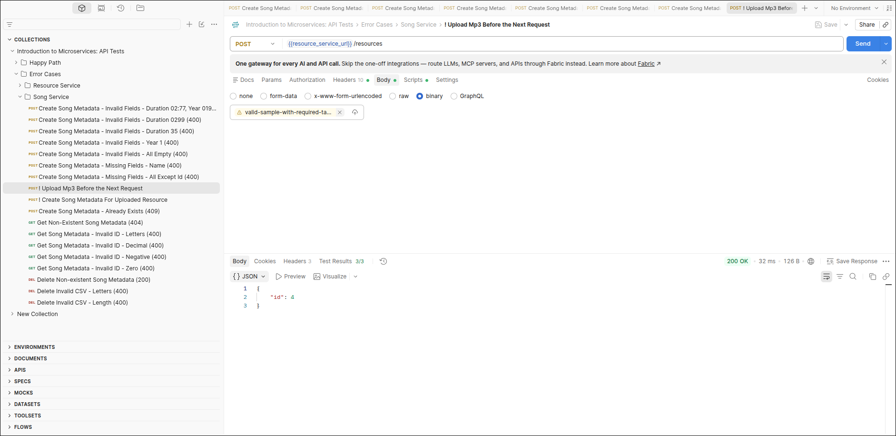

26. ! Create Song Metadata For Uploaded Resource
Result: 200 OK | Tests passed: 2/2
Added setup step. Creates the song for id 4 so the next request finds an existing record.
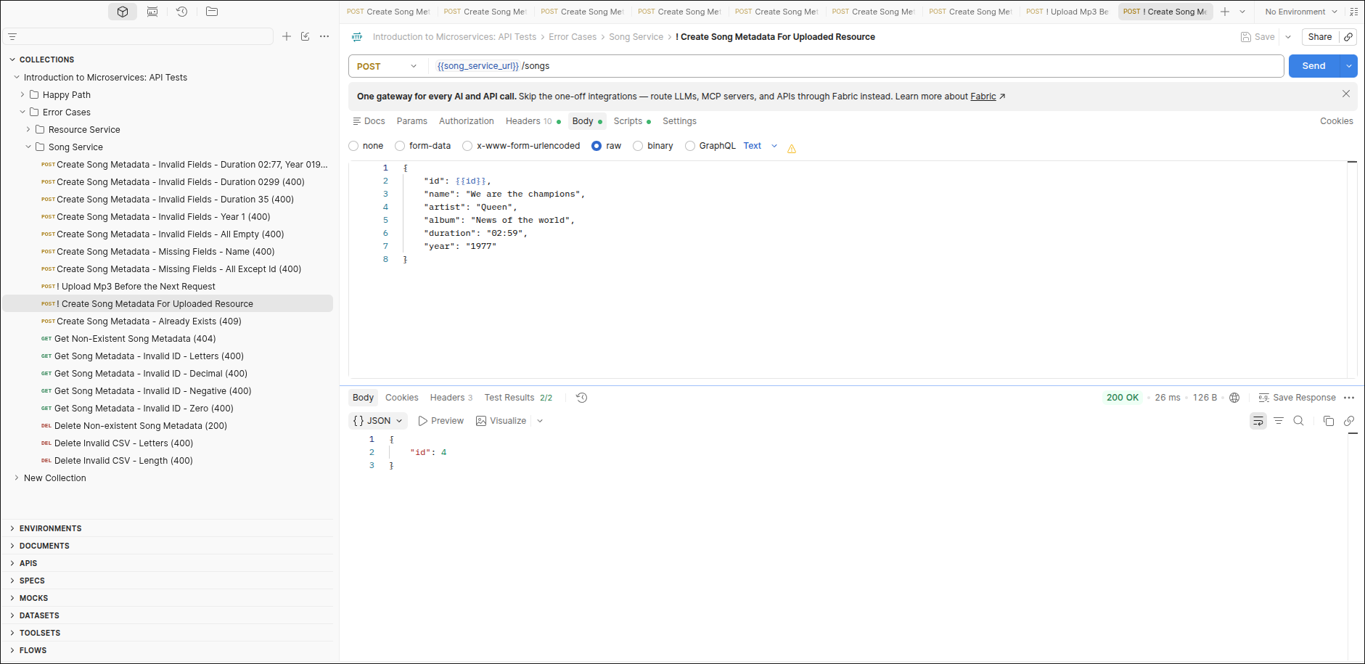

27. Create Song Metadata - Already Exists (409)
Result: 409 Conflict | Tests passed: 12/12
Creating metadata for id 4 again is rejected.
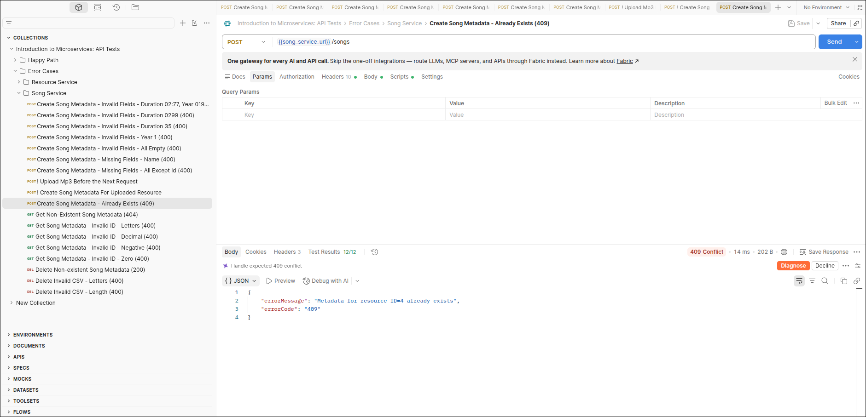

28. Get Non-Existent Song Metadata (404)
Result: 404 Not Found | Tests passed: 12/12
No song metadata exists for id 99999.
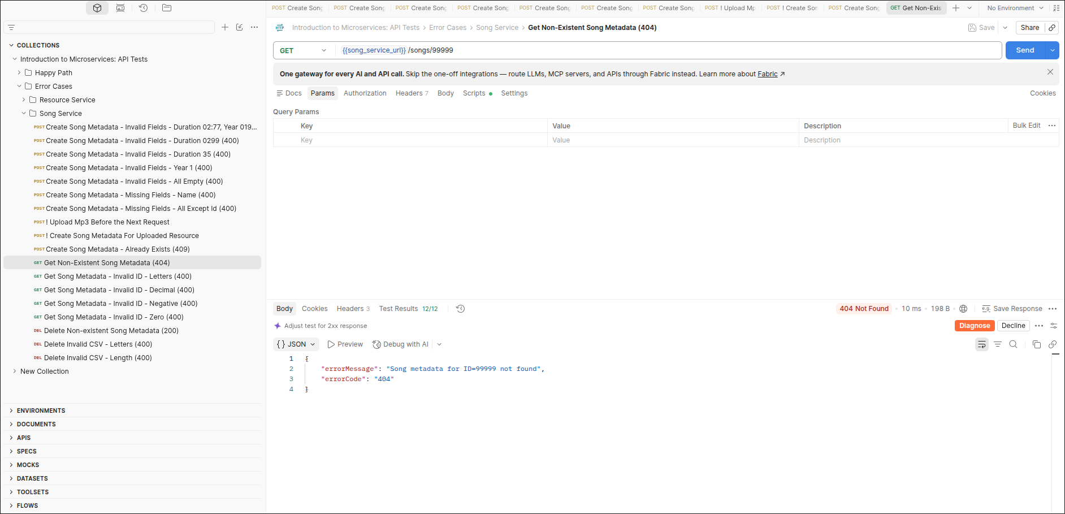

29. Get Song Metadata - Invalid ID - Letters (400)
Result: 400 Bad Request | Tests passed: 12/12
Id ABC is not a positive integer.
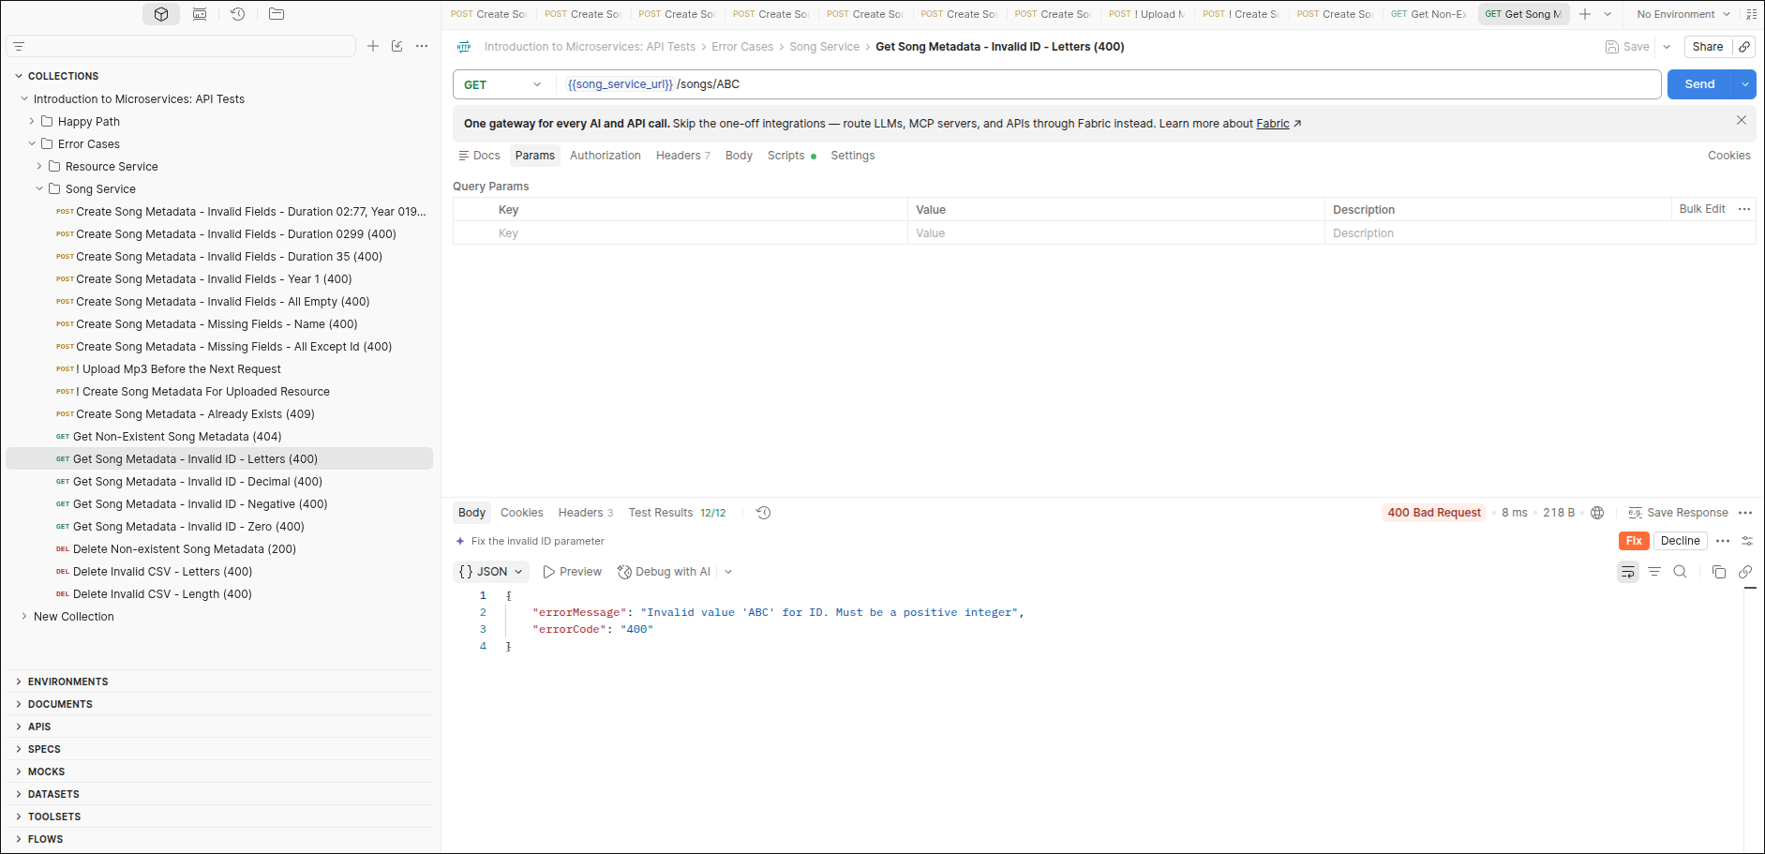

30. Get Song Metadata - Invalid ID - Decimal (400)
Result: 400 Bad Request | Tests passed: 12/12
Id 1.1 is not a positive integer.
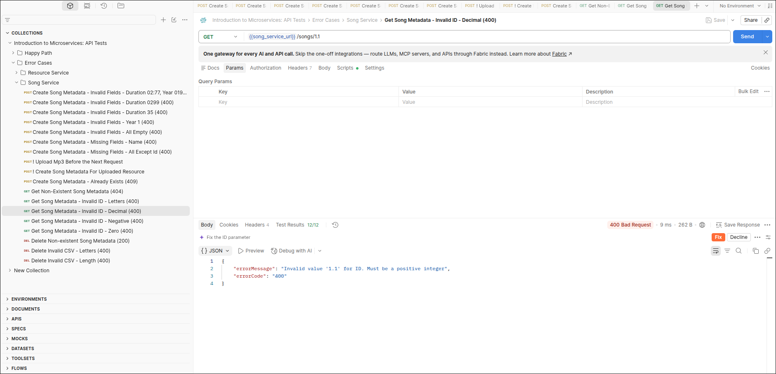

31. Get Song Metadata - Invalid ID - Negative (400)
Result: 400 Bad Request | Tests passed: 12/12
Id -1 is not a positive integer.
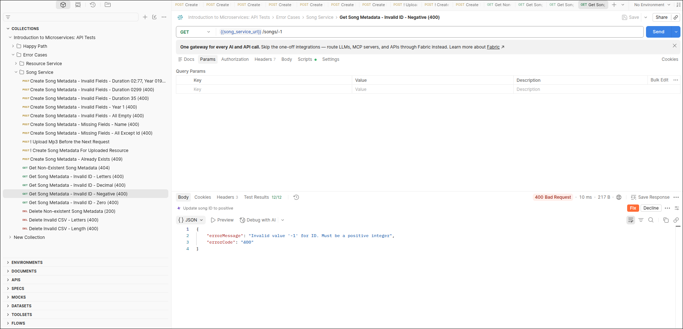

32. Get Song Metadata - Invalid ID - Zero (400)
Result: 400 Bad Request | Tests passed: 12/12
Id 0 is not a positive integer.
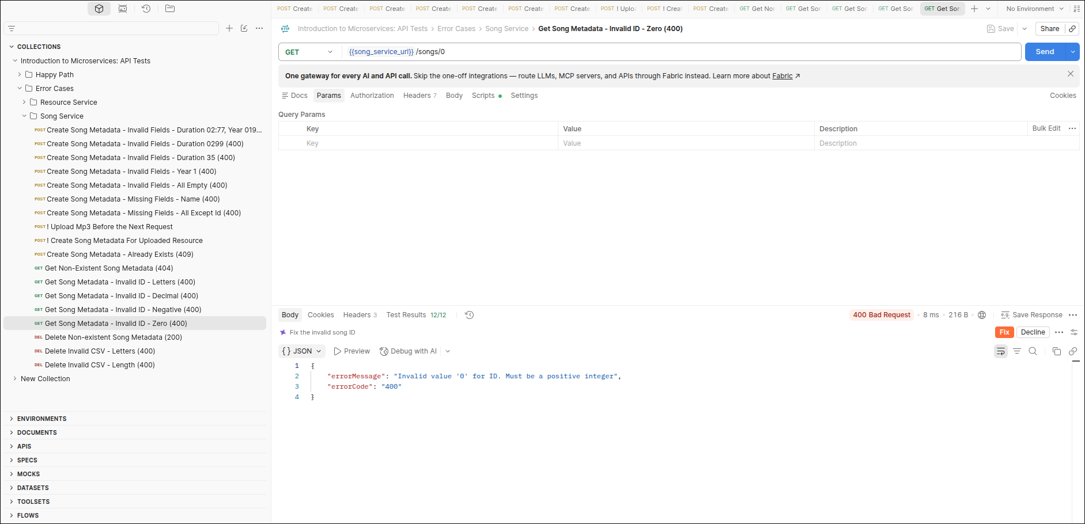

33. Delete Non-existent Song Metadata (200)
Result: 200 OK | Tests passed: 7/7
Unknown id 99999 is ignored and an empty ids list is returned.
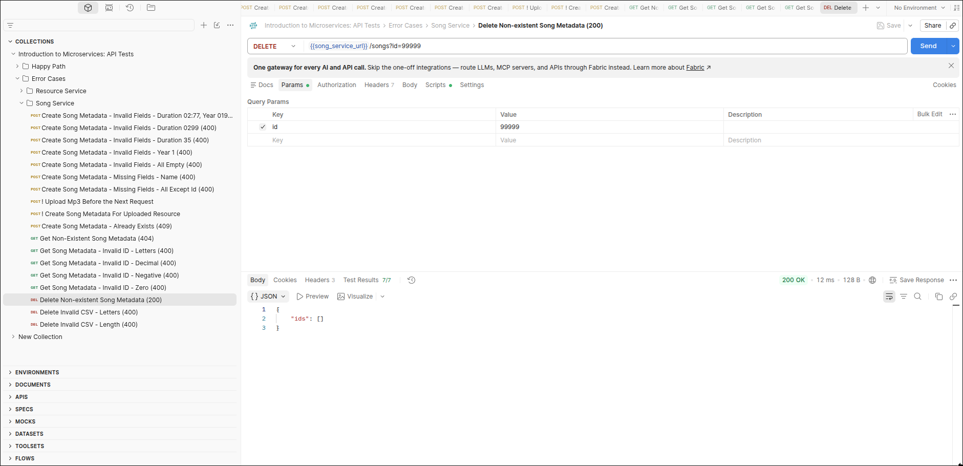

34. Delete Invalid CSV - Letters (400)
Result: 400 Bad Request | Tests passed: 11/11
The id list 1,2,3,4,V contains a non-numeric value.
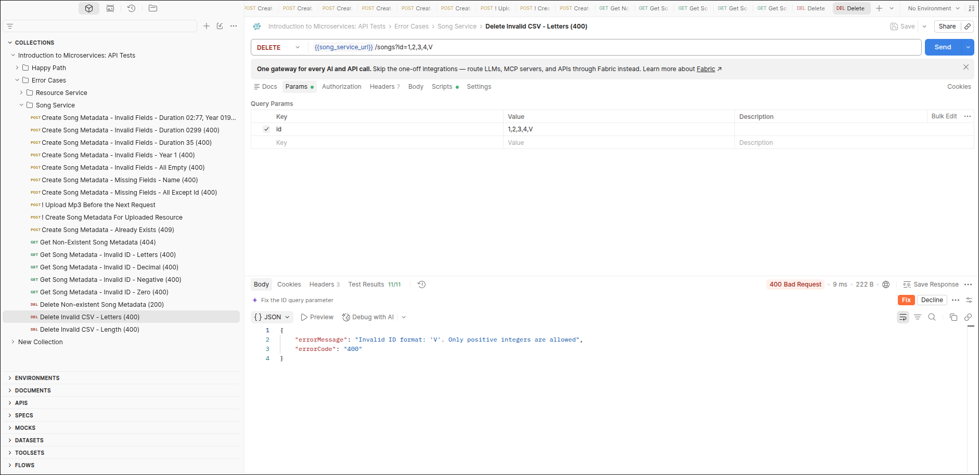

35. Delete Invalid CSV - Length (400)
Result: 400 Bad Request | Tests passed: 12/12
The CSV id list is 208 characters, above the 200 character limit.
