CSE1142 TERM PROJECT

HOOK GAME

FERİHAN ÇABUK -150116059

BÜŞRA GÖKMEN -150116027

May 20, 2018

PROBLEM DEFINITION

This game consists of buttons and bars.The main purpose of the game is pressing the correct buttons to move the lines without collision and make all the lines and buttons disappear. If the wrong button is pressed, the game ends and the next level is not passed.There are also disconnector in the game .It is used to determine which direction the lines will move.This game is played alone.

INFORMATION ABOUT OUR PROJECT

To begin with , this project is beneficial our improving while writing code.While doing this project firstly we do gui part this is the easy part for us,then we start main part which is lines disappearing and collision detection.The most hard one is collision detection we struggled while doing it.We finished all of the parts in the project. Unfortunately we can not add functionality to the project because of shortage of the time.

IMPLEMENTATION DETAILS

|  |  |
| --- | --- |
| *<<interface>>*  *ButtonStyle* | |
| ~  ~ | *buttonsize* :int; |
| buttonShapeAndColor(Button button):void  buttonShrink(Button button):void |

* The ButtonStyle interface represents the button shape and shrinking.
* Buttonsize is the final size of the button which is 30
* ButtonStyle default method make the buttons circle and add color.
* buttonShrink default method shrinks the button.

|  |  |
| --- | --- |
| *<<interface>>*  *Disappear* | |
| ~ | disappear(Object arr[]):void |

* The Disappear interface represents disappearing.
* disappear default method takes argument of Object array and remove arrays element in the pane.

|  |  |
| --- | --- |
| Arc1 | |
| +  + | Arc1(centerX: int, centerY: int) |
| arcTranslationLeftorRight(endValue: int):void |

* Arc1 class represent the arcs extends Pane class .
* Arc1constructor specify the center x and y also this constructor specify the radius of arcs , arcs angle and their color and add the arc in the pane.
* arcTranslationLeftorRight method provide arcs translation to left or right with given value.

|  |  |
| --- | --- |
| Arc2 | |
| +  + | Arc2(centerX: int, centerY: int) |
| arcTranslationUporDown (int endValue):void |

* Arc2 class represent the arcs extends Pane class .
* Arc2constructor specify the center x and y also this constructor specify the radius of arcs , arcs angle and their color and add the arc in the pane.Rotates the arc 90 degree.
* arcTranslationUporDown method provide arcs translation up and down with given value .

|  |  |
| --- | --- |
| Arc3 | |
| +  + | Arc3(centerX: int, centerY: int) |
| arcTranslationUporDown (int endValue):void |

* Arc3 class represent the arcs extends Pane class .
* Arc3constructor specify the center x and y also this constructor specify the radius of arcs , arcs angle and their color and add the arc in the pane.Rotates the arc 270 degree.
* arcTranslationUporDown method provide arcs translation up and down with given value.

|  |  |
| --- | --- |
| LineBlack | |
| +  +  +  +  + +  + | LineBlack(x: int, y:int, endx: int, endy: int)  lineTranslationToLeftorRight(endValue:int):void  lineTranslationToDownorTop(endValue:int):void  expandLeftAndRight():void  expandBelowAndAbove():void  shrinkAndDisappear():void  shrinkAndDisappear2():void |

* LineBlack object represent black and thick lines.
* It extends Pane class
* lineTranslationToLeftorRight method scrolls the lines to left or right
* expandLeftAndRight method enlarge the lines to right and left
* expandBelowAndAbove method expand the lines to below and above
* shrinkAndDisappear method first shrink the horizontal line then make it disappear.
* shrinkAndDisappear2 method first shrink the vertical line then make it disappear.

|  |  |
| --- | --- |
| LineGray | |
| + | LineBlack(x: int, y:int, endx: int, endy: int) |

* LineGray object represents gray and thin lines .
* It extends Pane class.

|  |  |
| --- | --- |
| Rectangle_ | |
| + | Rectangle_(x: **int**, y: **int**, width **int**, height **int**) |

* Rectangle_ object represent rectangles.
* It extends Pane class.
* It will use for disappearing objects.

|  |  |
| --- | --- |
| Level1 | |
|  | collision: boolean button1Controller: boolean; button2Controller: boolean; level1_control: boolean; |
| +  +  + | start(Stage primaryStage):void  checkCollision():boolean  main(String[] args):void |

* Level1 extends Pane implements Disappear and ButtonStyle.
* The data field collision represents that there is collision in the level or not.
* The data field button1Controller indicates whether the button is pressed or not
* The data field button2Controller indicates whether the button is pressed or not
* The data field level1_control represents the level1 finishes .
* Start metod is the most important metod all gui part and also animations are created in this method.
* checkCollision method controls the collision.
* main method execute the code.

|  |  |
| --- | --- |
| Level2 | |
|  | collision: boolean  collision2:boolean button1Controller: boolean; button2Controller: boolean;  button3Controller: boolean; button4Controller: boolean; level2_control: boolean; |
| +  +  + | start(Stage primaryStage):void  checkCollision():boolean  main(String[] args):void |

* Level1 extends Pane implements Disappear and ButtonStyle.
* The data field collision,collision2 represents that there is collision in the level or not.
* The data field button1Controller, button2Controller , button3Controller , button4Controller indicates whether the button is pressed or not for corresponding button.
* The data field level2_control represents the level2 finishes .
* Start metod is the most important metod all gui part and also animations are created in this method.
* checkCollision method controls the collision.
* main method execute the code.

|  |  |
| --- | --- |
| Level2 | |
|  | collision: boolean  collision2:boolean button1Controller: boolean; button2Controller: boolean;  button3Controller: boolean; button4Controller: boolean; level2_control: boolean; |
| +  +  + | start(Stage primaryStage):void  checkCollision():boolean  main(String[] args):void |

* The data field collision,collision2 represents that there is collision in the level or not.
* The data field button1Controller, button2Controller , button3Controller , button4Controller indicates whether the button is pressed or not for corresponding button.
* The data field level2_control represents the level2 finishes .
* Start metod is the most important metod all gui part and also animations are created in this method.
* checkCollision method controls the collision.
* main method execute the code

|  |  |
| --- | --- |
| Level3 | |
|  | buttonsize:int;  a:boolean;  b:boolean;  button1Controller:boolean;  button2Controller:boolean;  button3Controller:boolean;  level3_control:boolean  collisionfinal:boolean |
| +  +  + | start(Stage primaryStage):void  checkCollision():boolean  main(String[] args):void |

* The data field a,b represents that there is collision in the level or not.
* The data field button1Controller, button2Controller , button3Controller indicates whether the button is pressed or not for corresponding button.
* The data field level3_ control represents the level3 finishes .
* Start metod is the most important metod all gui part and also animations are created in this method.
* checkCollision method controls the collision.
* main method execute the code.

|  |  |
| --- | --- |
| Level4 | |
|  | buttonsize:int;  control:int;  collision4:boolean;  disconnector:boolean;  disconnector2:boolean;  button1Controller:boolean;  button2Controller:boolean;  level4_control:boolean;  collisionfinal:boolean; |
| +  +  + | start(Stage primaryStage):void  checkCollision():boolean  main(String[] args):void |

* The data field collision4,collisionfinal represents that there is collision in the level or not.
* The data field button1Controller, button2Controller indicates whether the button is pressed or not for corresponding button.
* The data field control indicates whether disconnecter moves to other direction or not.
* The data field disconnector and disconnector2 checks whether the disconnector is working.
* The data field level4_ control represents the level4 finishes .
* Start metod is the most important metod all gui part and also animations are created in this method.
* checkCollision method controls the collision.
* main method execute the code.

|  |  |
| --- | --- |
| Level5 | |
|  | collision3:boolean;  collision4:boolean;  collision5:boolean;  control:int;  control2:int;  disconnector :boolean;  disconnector2:boolean;  level5_control:boolean; |
| +  + | start(Stage primaryStage):void  main(String[] args):void |

* The data field collision3,collision4,collision5 represents that there is collision in the level or not.
* The data field control and control2 indicates whether disconnecters moves to other direction or not.
* The data field disconnector and disconnector2 checks whether the disconnectors are working.
* The data field level5_ control represents the level5 finishes .
* Start metod is the most important metod all gui part and also animations are created in this method.
* main method execute the code.

INFORMATION ABOUT GAME

There is 5 level in the game and levels become difficult.When the player clicked button button is growed and the black line between the buttons starts to shorten and when it shortening finishes black line gray line and corresponding button is disappear.It is significant which button clicked first because if the wrong button is pressed, the line connected to the button collides with another line while the line is shortened.If the level completed successfully without any collision then new level opens.

TEST CASES

LEVEL 1

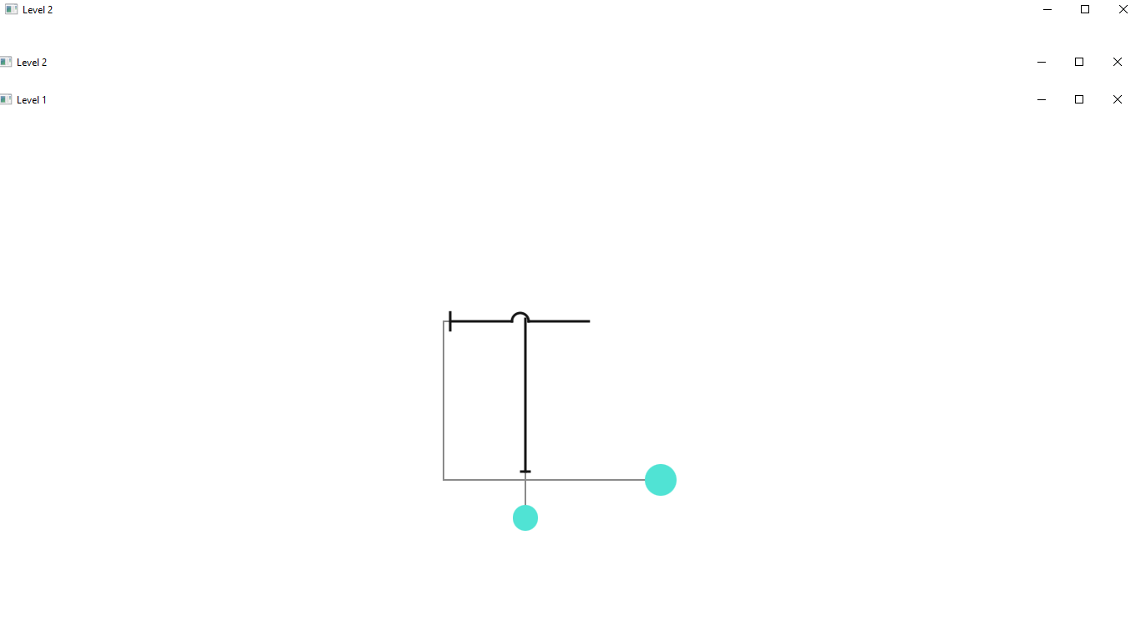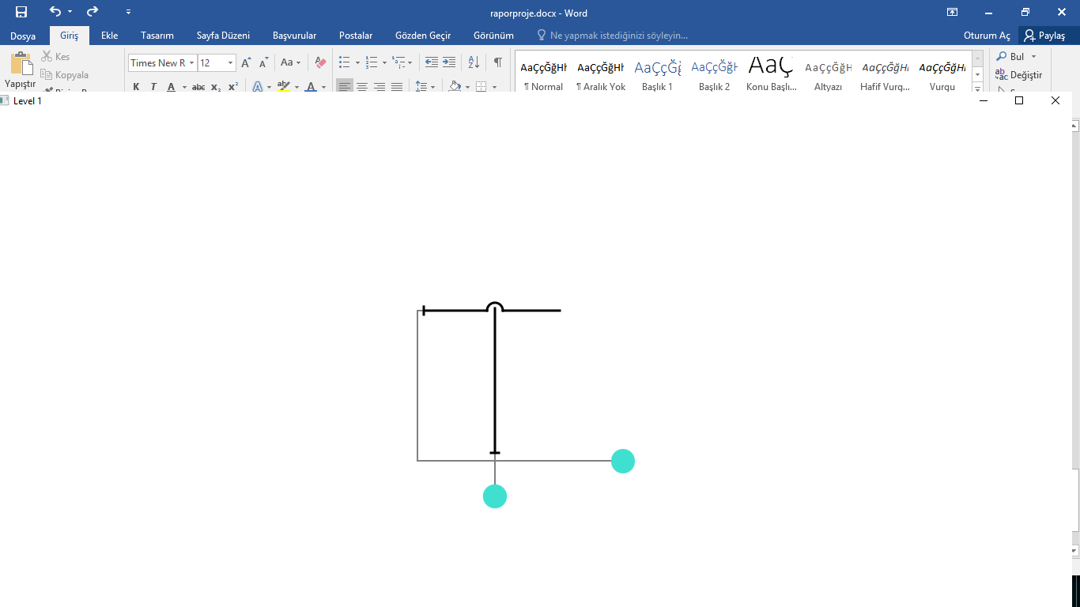

Level 1 Collision

When user clicked on right button collision occur and level finishes.

Level 1 General Outlook

LEVEL 2

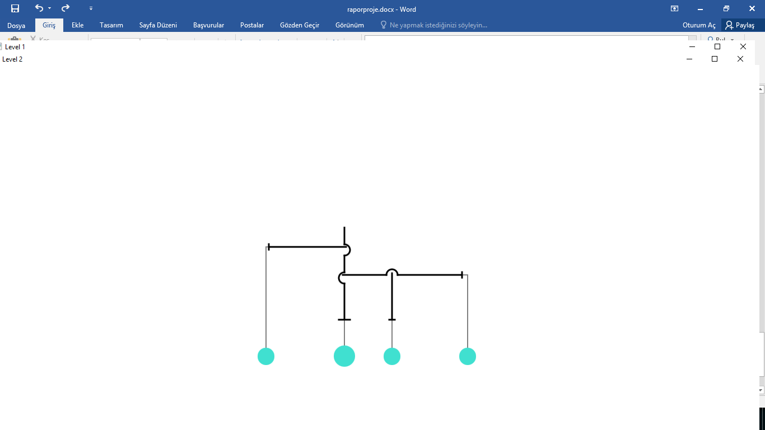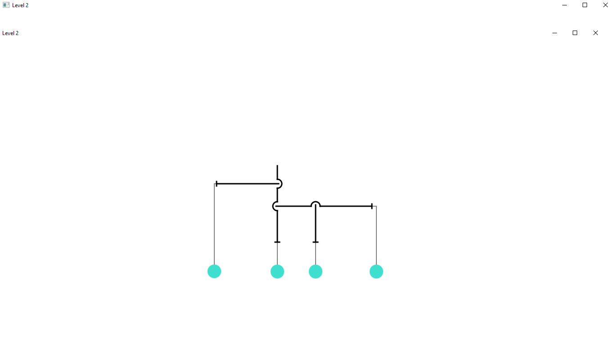

Level 2 General Appearance

Level 2 Collision

When the user clicked wrong button collision occur and game is over.

LEVEL 3

LEVEL 3

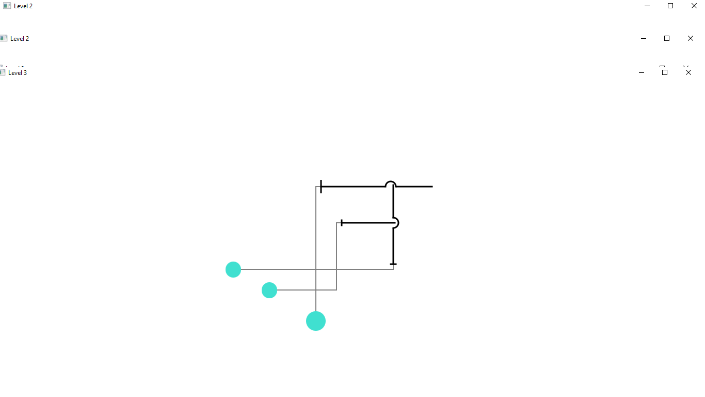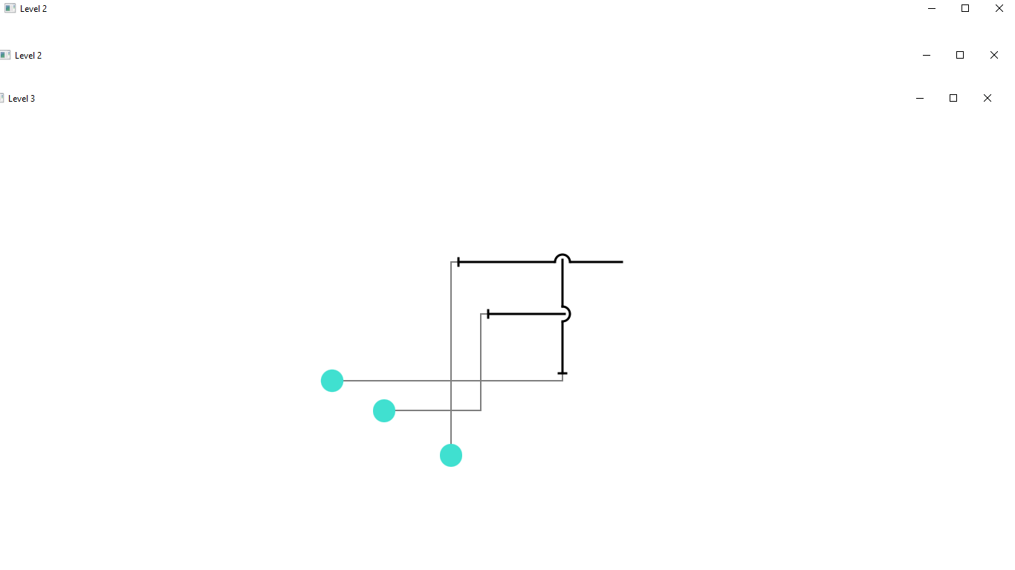

Level 3 Collision

When the user clicked wrong button collision occur and game is over.

Level 3 General Appearance

LEVEL 4

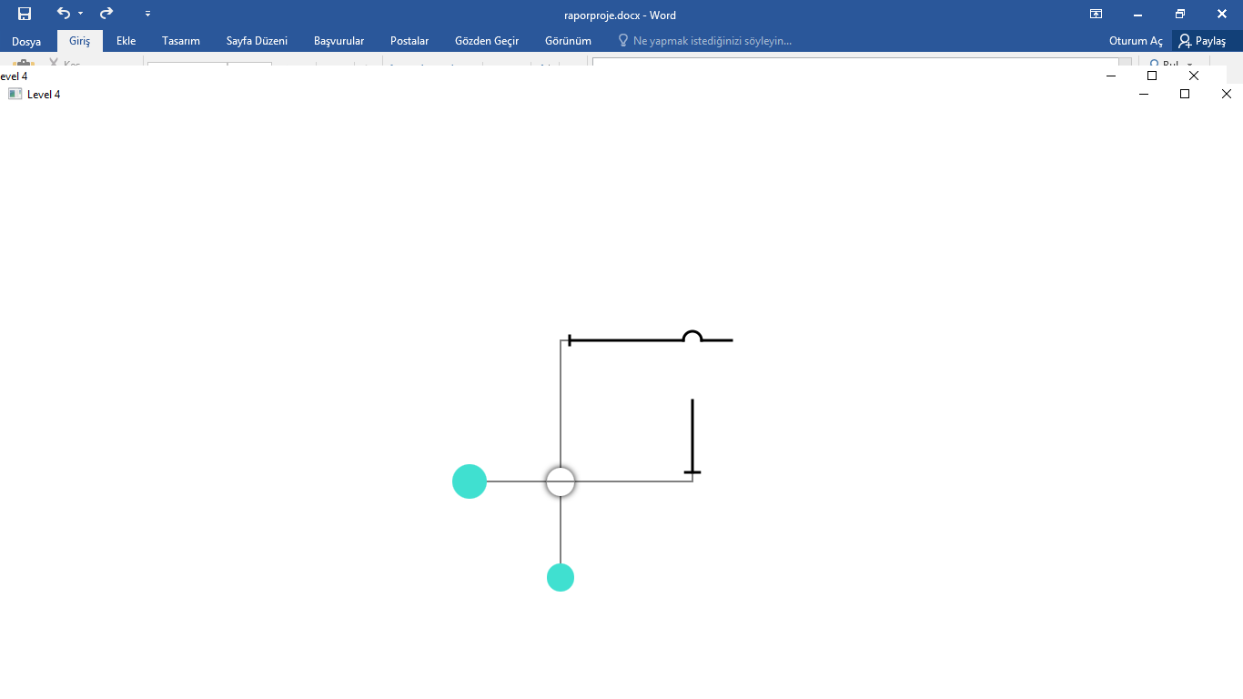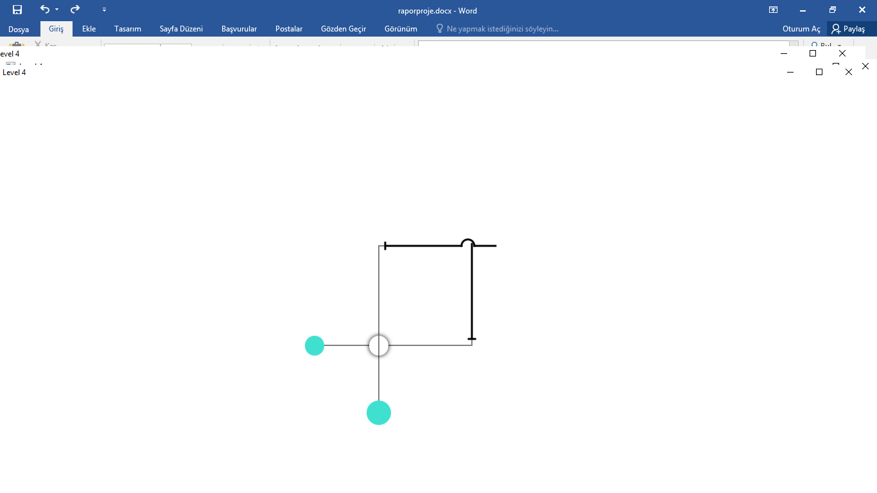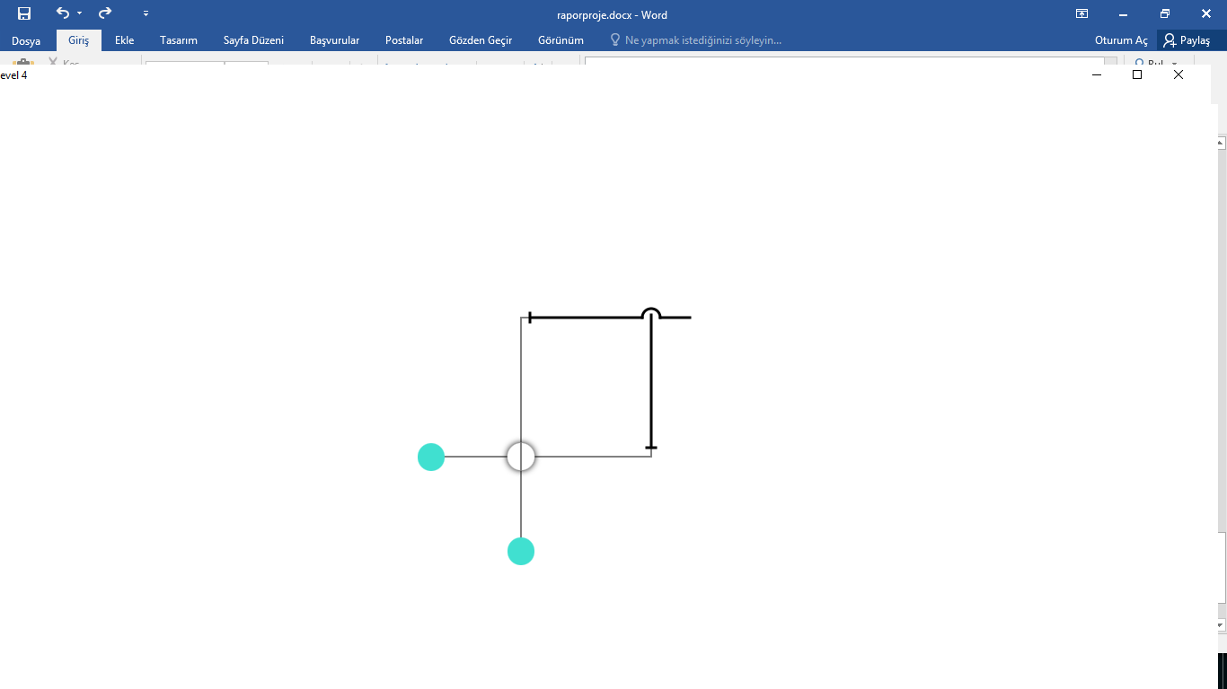

Level 4 General Appearance

Level 4 Collision

In this level user try to find correct way to complete level .If wrong button is clicked game will be over.

In level 4 there is disconnector which provide the direction when the clicked on the disconnector line will rotate 90 degree.

LEVEL 5

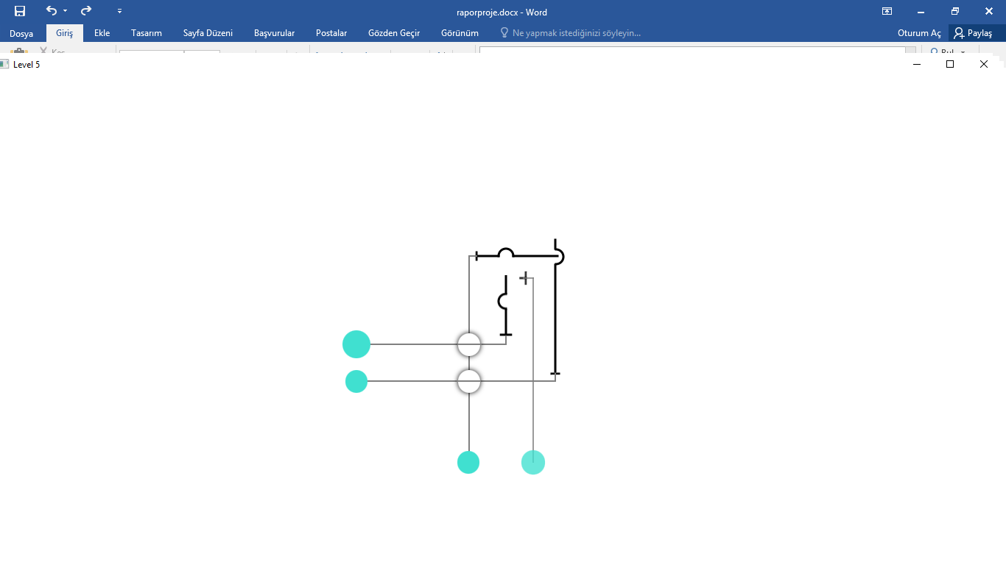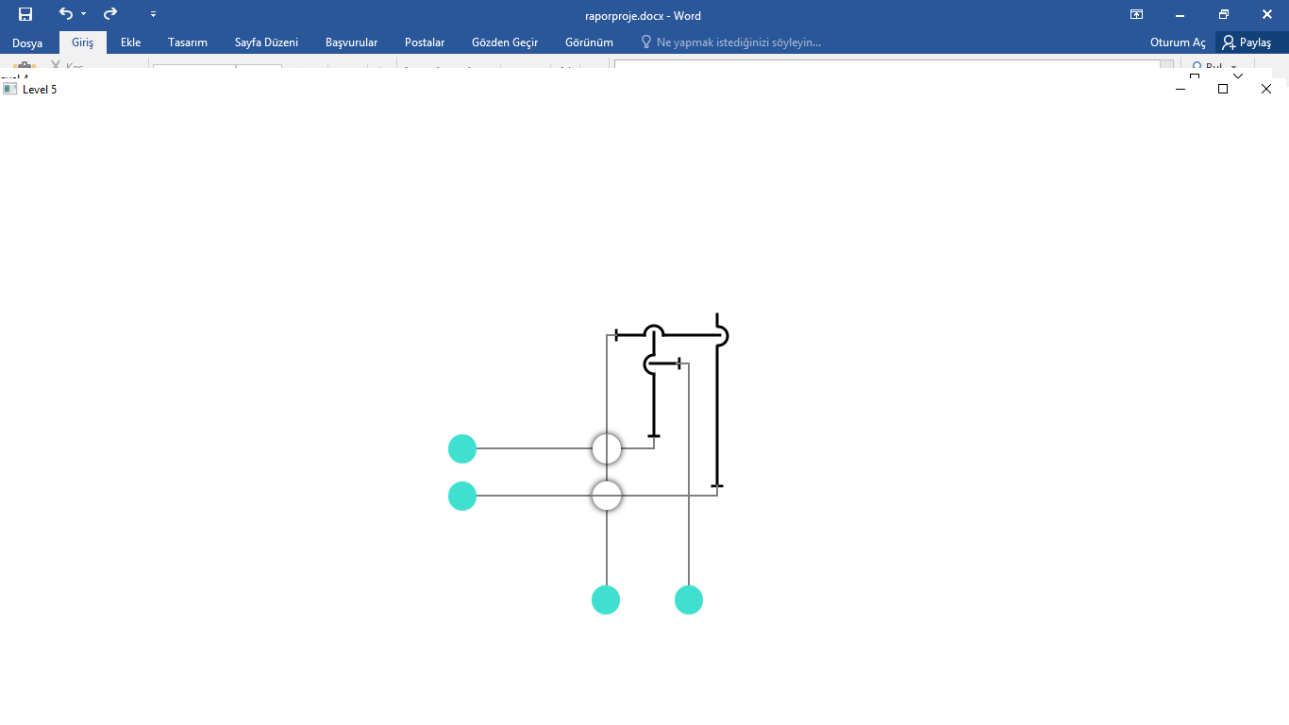

Level 5 General Outlook

Normal execution from Level 5

Level 5 Colllison

In this level there are two disconnector and three arcs player should be careful about collision.

