HA4IoT

Room Sensor V1.0

|  |  |  |  |
| --- | --- | --- | --- |
| Date | Version | Comment | Author |
| 2016-04-12 | 0.1 | First draft | Christian Kratky |

Table of contents

Summary 2

Addressing 3

Physical addressing 3

Dynamic addressing 3

Sensors 3

Temperature 3

Humidity 3

Signal transmitters 3

Infrared 3

433MHz 4

Power supply 4

Micro controller 4

Power consumption 4

Debugging interface 4

Protocol 5

Physical protocol 5

Logical protocol 5

Case 5

Naming and versioning 5

Prototype 6

# Summary

The “HA4IoT Room Sensor” is a module which can be mounted at every room and contains several sensors and signal transmitters.

It is powered using an external 12V power supply and the module is communication with external controllers via 1-Wire. This requires only 3 wires (+12V, GND, DATA) for installation.

The following sensors are built-in:

• Temperature

• Humidity

• Luminosity

# Addressing

It is required to setup each module with a unique address because more than one module can be part of the 1-Wire bus. The count of available addresses is set to 15, based on a statistically amount of rooms in a house. The address 0 is a special address and used for broadcast signals (see Dynamic addressing).

Two different kinds of addressing.

## Physical addressing

This kind of addressing requires 4 separate pin headers which are wired to either GND or +5V by modifying the jumper position. These pins are GPIOs from the micro controller.

## Dynamic addressing

The dynamic addressing is using the reserved broadcast address 0.

# Sensors

## Temperature

The temperature is measured using a DHT22[1] (AM2302) sensor. This sensor has a tolerance of +-0.5°C. The sensor can be read only every 2 seconds. This must be respected by the micro controller. The DATA wire of the device requires a 4.7k pull-up resistor to +5V.

## Humidity

The humidity sensor is integrated at the DHT22 (AM2302) sensor. No further wires etc. are required.

# Signal transmitters

## Infrared

The module includes a high power 5.0mm infrared 850nm infrared LED (SFH 4550)[2] which is used to send signals to devices like TVs, RGB-LED-Strips etc. A receiver (for signal recording) is not part of the module. Due to the fact that the LED is a high power LED, a transistor is required. The LED must be located at the holes of the case (see Case) or a dedicated 5.0mm hole at the front has to be introduced where the LED is located. This provides a better result but it looks odd.

## 433MHz

The module includes a transmitter for 433MHz signals which is commonly used for remote switches etc. An already soldered module like TE122[3] should be used. It is important that the used module supports 12V input voltage. This is required to extend the range of the signal to reach higher floors of a house. The receiver (for signal recording) is not part of the module. The most commonly signals are already available at the HA4IoT-SDK.

# Power supply

The entire module requires an external +12V power supply. This +12V are only mandatory for the 433MHz. Even without the transmitter, +12V should be used because a +12V power supply is already available at the installation due to relay boards where +12V is mandatory. Introducing another power supply with +5V requires additional power supplies which need more space at the power distributor and dedicated cables which should be avoided.

All components are compatible with +5V and thus a voltage regulator is added to the PCB which provides the required +5V. For power stabilization a capacitor is added to the +12V input (25V ?uF).

The physical connection is done by a three-port screw terminal.

# Micro controller

The sensors and signal transmitters are all wired to a micro controller which reads values and sends signals. The micro controller itself is exposed via the 1-Wire bus. The used micro controller for this board is an “ATmega328“. This micro controller can be programmed using the Arduino IDE and also used for the Arduino Nano[4].

# Power consumption

The power consumption of the module is optimized by using the sleep mode of the micro controller. The 1-Wire DATA line is wired to the interrupt pin of the micro controller. This allows the micro controller to enable low power mode until a new request is received.

## Debugging interface

The debugging interface is a pin header which exposes the RX, TX, +5V, RESET and GND pins of the micro controller. These pin headers are required for deploying a new firmware to the device or debugging the firmware using the serial port.

# Protocol

## Physical protocol

The communication with the master is done by a 1-Wire compatible signal. The parasite power supply feature is not supported. The module is not sending any data by its own. It is a slave at the bus and needs to wait for requests. Then it responds with an appropriate response.

## Logical protocol

The communication is organized via a request from the controller (HA4IoT-Controller) and a response which is sent back.

TODO: List of requests and responses

# Case

The case of the module must be a case with holes at the bottom and the upper side. This is mandatory to ensure that the air will flew through the module and the temperature and humidity are correct. It is also important that the temperature and humidity sensor are soldered directly above the holes at the bottom of the case to avoid measuring internal temperature which is increased caused by the micro controller, voltage regulators etc.

The case “SUPERTRONIC BOX-SENS-WHITE”[5] is the default case for the module and the PCB must fit in this case. Other colors of that case are available.

The case must be modified to enable wiring with the PCB inside of it. There should be a hole at the backside of the module which has a caliber of 8mm. This ensures that cables which are commonly used for installations can be easily wired to the module. The position of the installation hole should be any edge of the case but with a distance of about 2.0cm.

# Naming and versioning

The full name of the module is “HA4IoT Room Sensor” (case sensitive). The short name of the module is “Room Sensor” (case sensitive). All components which are supported by the HA4IoT SDK directly are labeled with “HA4IoT Certified” (case sensitive). The version of the PCB board starts from 1.0.0 which is used for prototypes. All changes to the prototype are leading to an increased minor version (like 1.0.1, 1.0.2 etc.). The final release of the board is labeled with version 1.1.0. Further changes to the hardware which are not extending or decreasing functionality are leading to an increased minor version (like 1.1.1, 1.1.2, 1.1.3 etc.). Prototypes of new versions are starting with a new major version (like 2.0.0).

The following information has to be printed on the PCB:

1. Full name
2. Certification
3. Version

Manufacturers are allowed to add their name as a fourth information.

# Prototype

The following picture shows the prototype of the sensor containing the temperature sensor, humidity sensor, 433MHz transmitter and infrared LED.

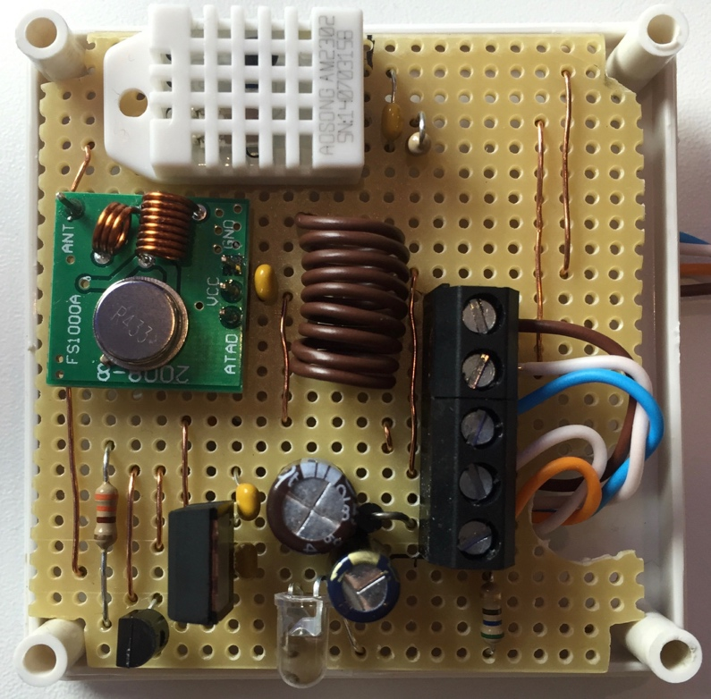

Image 1: Prototype

1. <https://www.sparkfun.com/datasheets/Sensors/Temperature/DHT22.pdf>
2. <http://cdn-reichelt.de/documents/datenblatt/X100/sfh_4550.pdf>
3. <http://www.ebay.com/itm/5X-433-Mhz-RF-Sender-Empfanger-Receiver-Modul-Arduino-Wireless-Transmitter-TE122-/201312653471?hash=item2edf2b509f:g:hlwAAOSwezVW0TyU>
4. <https://www.arduino.cc/en/Main/ArduinoBoardNano>
5. http://www.tme.eu/en/details/box-sens-white/enclosures-for-alarms-and-sensors/supertronic/