Markdown file

# Assignment 2

## **Probability distribution**

Xinhai Li

Group 1, ID:123456789

## Data

I measured the weight of 22 rats.

obs = c(7,5,6,6,7,5,3,4,5,8,2,4,5,6,7,6,4,5,9,3,6,4)  
mean = mean(obs)  
SD = sd(obs)

mean

## [1] 5.318182

SD

## [1] 1.701158

hist(obs,freq = F)

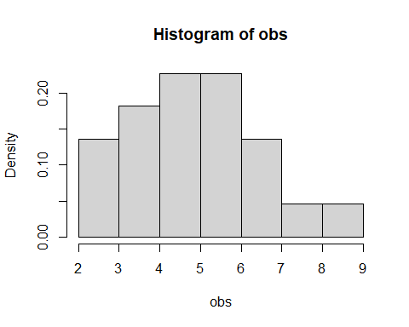

**Figure 1.Histogram of rat weight**

x = seq(min(obs),max(obs),by=.1)  
norm = dnorm(x,mean = mean,sd = SD)  
hist(obs,freq = F)  
lines(x,norm,type = 'l',col='red')  
abline(v=c(mean-2*SD,mean+2*SD),col="brown")

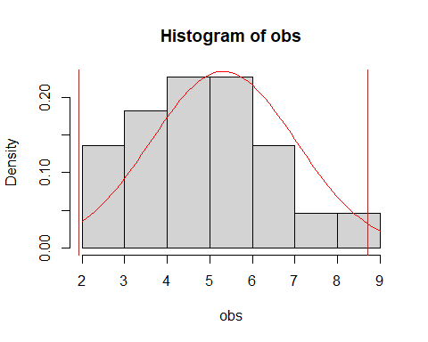

**Figure 2.Probability distribution of the weight of rats and the 95% confident interval**

## Result

The 95% confident interval of the rat weight is:

c(qnorm(.025,mean,SD),qnorm(.975,mean,SD))

## [1] 1.983973 8.652391