**PROGRAMACIÓN WEB II**

**Mtra. Liliana Gámez Zavala**

**PRACTICA 1: (Verificar el funcionamiento de mysql)**

1. Enciende el xampp control para iniciar el servicio de apache y mysql
2. Accesa a la siguiente ruta: C:\xampp\mysql\bin

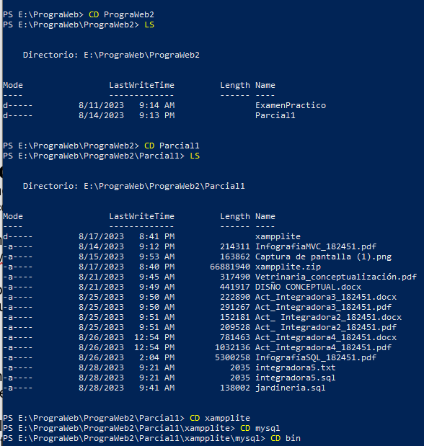

1. Una vez que te aparezca el prompt de mysql, teclea lo siguiente:

mysql –h localhost –u root -p

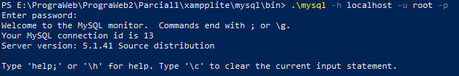

1. Como password no es necesario teclear ningún dato y oprime enter
2. Prueba los siguientes comandos:
   * select now();

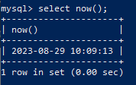

* + select version ();

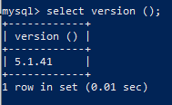

* + show databases;

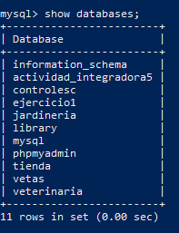

1. Una vez que hayas mostrado las bases de datos existentes, teclea el siguiente comando:

use mysql;



1. utiliza el comando “show tables;” y verifica las tablas que están contenidas en la base de datos seleccionada.

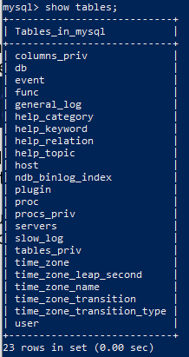

1. Muestra los campos que se encuentran en la tabla users con el siguiente comando:

show fields from user;

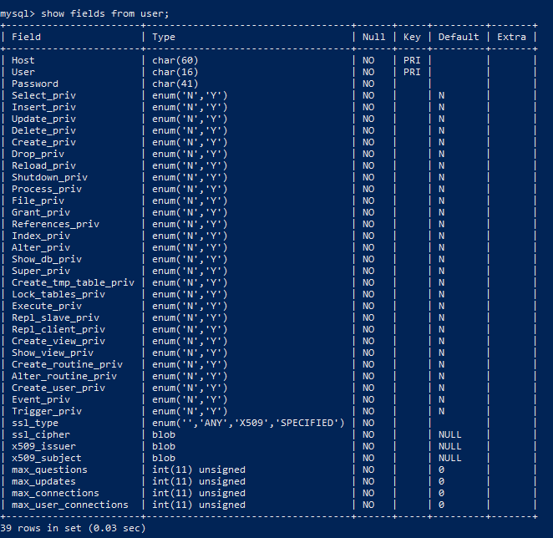

Windows PowerShell

Copyright (C) Microsoft Corporation. Todos los derechos reservados.

Prueba la nueva tecnología PowerShell multiplataforma https://aka.ms/pscore6

PS C:\Users\182451> CD..

PS C:\Users> CD..

PS C:\> E:

PS E:\> C:

PS C:\> E:

PS E:\> LS

Directorio: E:\

Mode LastWriteTime Length Name

---- ------------- ------ ----

d----- 8/11/2023 9:14 AM PrograWeb

d----- 8/15/2023 9:18 AM Proga

d----- 8/22/2023 8:49 AM Superrepas

d----- 8/22/2023 4:11 PM Labo_Progra

d----- 8/21/2023 10:26 AM pilaasss

d----- 8/24/2023 10:34 AM Nueva carpeta

-a---- 8/28/2023 10:31 PM 149473 Boletos_Rifa.docx

PS E:\> CD PrograWeb

PS E:\PrograWeb> LS

Directorio: E:\PrograWeb

Mode LastWriteTime Length Name

---- ------------- ------ ----

d----- 8/11/2023 9:14 AM PrograWeb2

d----- 8/15/2023 9:18 AM PrograWeb1

PS E:\PrograWeb> CD PrograWeb2

PS E:\PrograWeb\PrograWeb2> LS

Directorio: E:\PrograWeb\PrograWeb2

Mode LastWriteTime Length Name

---- ------------- ------ ----

d----- 8/11/2023 9:14 AM ExamenPractico

d----- 8/14/2023 9:13 PM Parcial1

PS E:\PrograWeb\PrograWeb2> CD Parcial1

PS E:\PrograWeb\PrograWeb2\Parcial1> LS

Directorio: E:\PrograWeb\PrograWeb2\Parcial1

Mode LastWriteTime Length Name

---- ------------- ------ ----

d----- 8/17/2023 8:41 PM xampplite

-a---- 8/14/2023 9:12 PM 214311 InfografiaMVC_182451.pdf

-a---- 8/15/2023 9:53 AM 163862 Captura de pantalla (1).png

-a---- 8/17/2023 8:40 PM 66881940 xampplite.zip

-a---- 8/21/2023 9:45 AM 317490 Vetrinaria_conceptualización.pdf

-a---- 8/21/2023 9:49 AM 441917 DISÑO CONCEPTUAL.docx

-a---- 8/25/2023 9:50 AM 222890 Act_Integradora3_182451.docx

-a---- 8/25/2023 9:50 AM 291267 Act_Integradora3_182451.pdf

-a---- 8/25/2023 9:51 AM 152181 Act_ Integradora2_182451.docx

-a---- 8/25/2023 9:51 AM 209528 Act_ Integradora2_182451.pdf

-a---- 8/26/2023 12:54 PM 781463 Act_Integradora4_182451.docx

-a---- 8/26/2023 12:54 PM 1032136 Act_Integradora4_182451.pdf

-a---- 8/26/2023 2:04 PM 5300258 InfografíaSQL_182451.pdf

-a---- 8/28/2023 9:21 AM 2035 integradora5.txt

-a---- 8/28/2023 9:21 AM 2035 integradora5.sql

-a---- 8/28/2023 9:41 AM 138002 jardineria.sql

PS E:\PrograWeb\PrograWeb2\Parcial1> CD xampplite

PS E:\PrograWeb\PrograWeb2\Parcial1\xampplite> CD mysql

PS E:\PrograWeb\PrograWeb2\Parcial1\xampplite\mysql> CD bin

PS E:\PrograWeb\PrograWeb2\Parcial1\xampplite\mysql\bin> .\mysql -h localhost -u root -p

Enter password:

Welcome to the MySQL monitor. Commands end with ; or \g.

Your MySQL connection id is 13

Server version: 5.1.41 Source distribution

Type 'help;' or '\h' for help. Type '\c' to clear the current input statement.

mysql> select now();

+---------------------+

| now() |

+---------------------+

| 2023-08-29 10:09:13 |

+---------------------+

1 row in set (0.00 sec)

mysql> select version ();

+------------+

| version () |

+------------+

| 5.1.41 |

+------------+

1 row in set (0.01 sec)

mysql> show databases;

+------------------------+

| Database |

+------------------------+

| information_schema |

| actividad_integradora5 |

| controlesc |

| ejercicio1 |

| jardineria |

| library |

| mysql |

| phpmyadmin |

| tienda |

| vetas |

| veterinaria |

+------------------------+

11 rows in set (0.00 sec)

mysql> use mysql;

Database changed

mysql> show tables;

+---------------------------+

| Tables_in_mysql |

+---------------------------+

| columns_priv |

| db |

| event |

| func |

| general_log |

| help_category |

| help_keyword |

| help_relation |

| help_topic |

| host |

| ndb_binlog_index |

| plugin |

| proc |

| procs_priv |

| servers |

| slow_log |

| tables_priv |

| time_zone |

| time_zone_leap_second |

| time_zone_name |

| time_zone_transition |

| time_zone_transition_type |

| user |

+---------------------------+

23 rows in set (0.00 sec)

mysql> show fields from user;

+-----------------------+-----------------------------------+------+-----+---------+-------+

| Field | Type | Null | Key | Default | Extra |

+-----------------------+-----------------------------------+------+-----+---------+-------+

| Host | char(60) | NO | PRI | | |

| User | char(16) | NO | PRI | | |

| Password | char(41) | NO | | | |

| Select_priv | enum('N','Y') | NO | | N | |

| Insert_priv | enum('N','Y') | NO | | N | |

| Update_priv | enum('N','Y') | NO | | N | |

| Delete_priv | enum('N','Y') | NO | | N | |

| Create_priv | enum('N','Y') | NO | | N | |

| Drop_priv | enum('N','Y') | NO | | N | |

| Reload_priv | enum('N','Y') | NO | | N | |

| Shutdown_priv | enum('N','Y') | NO | | N | |

| Process_priv | enum('N','Y') | NO | | N | |

| File_priv | enum('N','Y') | NO | | N | |

| Grant_priv | enum('N','Y') | NO | | N | |

| References_priv | enum('N','Y') | NO | | N | |

| Index_priv | enum('N','Y') | NO | | N | |

| Alter_priv | enum('N','Y') | NO | | N | |

| Show_db_priv | enum('N','Y') | NO | | N | |

| Super_priv | enum('N','Y') | NO | | N | |

| Create_tmp_table_priv | enum('N','Y') | NO | | N | |

| Lock_tables_priv | enum('N','Y') | NO | | N | |

| Execute_priv | enum('N','Y') | NO | | N | |

| Repl_slave_priv | enum('N','Y') | NO | | N | |

| Repl_client_priv | enum('N','Y') | NO | | N | |

| Create_view_priv | enum('N','Y') | NO | | N | |

| Show_view_priv | enum('N','Y') | NO | | N | |

| Create_routine_priv | enum('N','Y') | NO | | N | |

| Alter_routine_priv | enum('N','Y') | NO | | N | |

| Create_user_priv | enum('N','Y') | NO | | N | |

| Event_priv | enum('N','Y') | NO | | N | |

| Trigger_priv | enum('N','Y') | NO | | N | |

| ssl_type | enum('','ANY','X509','SPECIFIED') | NO | | | |

| ssl_cipher | blob | NO | | NULL | |

| x509_issuer | blob | NO | | NULL | |

| x509_subject | blob | NO | | NULL | |

| max_questions | int(11) unsigned | NO | | 0 | |

| max_updates | int(11) unsigned | NO | | 0 | |

| max_connections | int(11) unsigned | NO | | 0 | |

| max_user_connections | int(11) unsigned | NO | | 0 | |

+-----------------------+-----------------------------------+------+-----+---------+-------+

39 rows in set (0.03 sec)

**PRACTICA 2: (Crear una base de datos)**

Teclea la siguiente secuencia de comandos y realiza una tabla resumen en la que indiques que es lo que hace cada línea de codigo sql separado por punto y coma:

1. create database discosnet;



1. show databases;

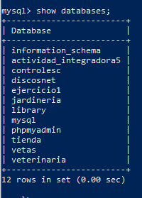

1. use discosnet;



1. CREATE TABLE discos( iddisco INT unsigned auto_increment not null primary key, nombre tinytext, interprete tinytext, cds tinyint unsigned, precio float, stock smallint unsigned) ;



1. describe discos;

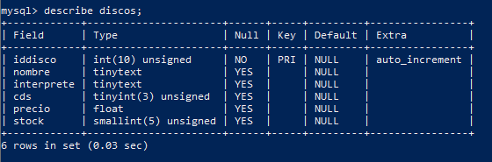

1. rename table discos to discosbackup;



1. show tables;

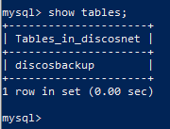

1. describe discosbackup;

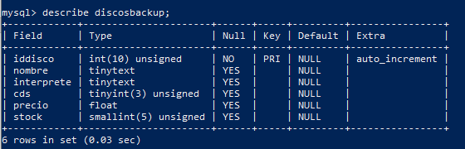

1. create table prueba (id_prueba int);



1. show tables;

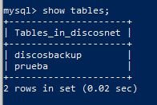

1. insert into prueba (id_prueba) values (1);



1. insert into prueba (id_prueba) values (2);



1. insert into prueba (id_prueba) values (3);



1. select * from prueba;

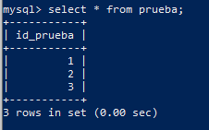

1. drop table prueba;



1. drop table discos;



1. drop database discosnet;



mysql> create database discosnet;

Query OK, 1 row affected (0.03 sec)

mysql> show databases;

+------------------------+

| Database |

+------------------------+

| information_schema |

| actividad_integradora5 |

| controlesc |

| discosnet |

| ejercicio1 |

| jardineria |

| library |

| mysql |

| phpmyadmin |

| tienda |

| vetas |

| veterinaria |

+------------------------+

12 rows in set (0.00 sec)

mysql> 3.use discosnet;

mysql> use discosnet;

Database changed

mysql> CREATE TABLE discos(iddisco INT unsigned auto_increment not null primary key, nombre tinytext, interprete tinytext, cds tinyint unsigned, precio float, stock smallint unsigned);

Query OK, 0 rows affected (0.09 sec)

mysql> describe discos;

+------------+----------------------+------+-----+---------+----------------+

| Field | Type | Null | Key | Default | Extra |

+------------+----------------------+------+-----+---------+----------------+

| iddisco | int(10) unsigned | NO | PRI | NULL | auto_increment |

| nombre | tinytext | YES | | NULL | |

| interprete | tinytext | YES | | NULL | |

| cds | tinyint(3) unsigned | YES | | NULL | |

| precio | float | YES | | NULL | |

| stock | smallint(5) unsigned | YES | | NULL | |

+------------+----------------------+------+-----+---------+----------------+

6 rows in set (0.03 sec)

mysql> rename table discos to discosbackup;

Query OK, 0 rows affected (0.03 sec)

mysql> show tables;

+---------------------+

| Tables_in_discosnet |

+---------------------+

| discosbackup |

+---------------------+

1 row in set (0.00 sec)

mysql> describe discosbackup;

+------------+----------------------+------+-----+---------+----------------+

| Field | Type | Null | Key | Default | Extra |

+------------+----------------------+------+-----+---------+----------------+

| iddisco | int(10) unsigned | NO | PRI | NULL | auto_increment |

| nombre | tinytext | YES | | NULL | |

| interprete | tinytext | YES | | NULL | |

| cds | tinyint(3) unsigned | YES | | NULL | |

| precio | float | YES | | NULL | |

| stock | smallint(5) unsigned | YES | | NULL | |

+------------+----------------------+------+-----+---------+----------------+

6 rows in set (0.03 sec)

mysql> create table prueba (id_prueba int);

Query OK, 0 rows affected (0.08 sec)

mysql> show tables;

+---------------------+

| Tables_in_discosnet |

+---------------------+

| discosbackup |

| prueba |

+---------------------+

2 rows in set (0.02 sec)

mysql> insert into prueba (id_prueba) values (1);

Query OK, 1 row affected (0.02 sec)

mysql> insert into prueba (id_prueba) values (2);

Query OK, 1 row affected (0.00 sec)

mysql> insert into prueba (id_prueba) values (3);

Query OK, 1 row affected (0.00 sec)

mysql> select * from prueba;

+-----------+

| id_prueba |

+-----------+

| 1 |

| 2 |

| 3 |

+-----------+

3 rows in set (0.00 sec)

mysql> drop table prueba;

Query OK, 0 rows affected (0.06 sec)

mysql> drop table discos;

ERROR 1051 (42S02): Unknown table 'discos'

mysql> drop database discosnet;

Query OK, 1 row affected (0.08 sec)

mysql>

**PRACTICA 3: (Crear e importar desde un script)**

Coloca todos los comandos siguientes en un block de notas:

CREATE DATABASE EJERCICIO1;

USE EJERCICIO1;

CREATE TABLE departamentos (

dept_no TINYINT(2) NOT NULL,

dnombre VARCHAR(15),

loc VARCHAR(15)

);

INSERT INTO departamentos VALUES (10,'CONTABILIDAD','SEVILLA');

INSERT INTO departamentos VALUES (20,'INVESTIGACIÓN','MADRID');

INSERT INTO departamentos VALUES (30,'VENTAS','BARCELONA');

INSERT INTO departamentos VALUES (40,'PRODUCCIÓN','BILBAO');

DESCRIBE DEPARTAMENTOS;

y guardalos en un archivo “archivo.sql en la carpeta raìz de tu memoria o disco duro, luego en mysql teclea “source c:\archivo.sql”

Verifica que se haya ejecutado. Envia por blackboard tu archivo sql y la pantalla de Windows en donde se ejecutó el script de sql.

