Aranas Technical Assesment

**Test #1**

Create a web service running on flask, the web service must have 2 endpoints GET and POST the overall solution should receive a Json Object and store it on memory using a POST call, and the GET method should return all the properties of the JSON object concatenated split by coma.

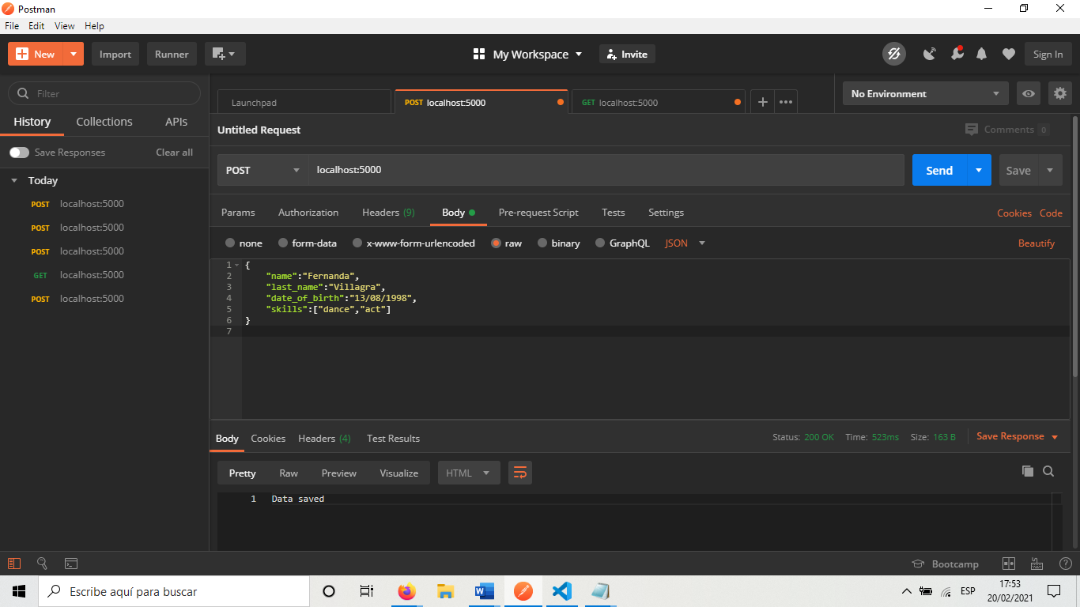

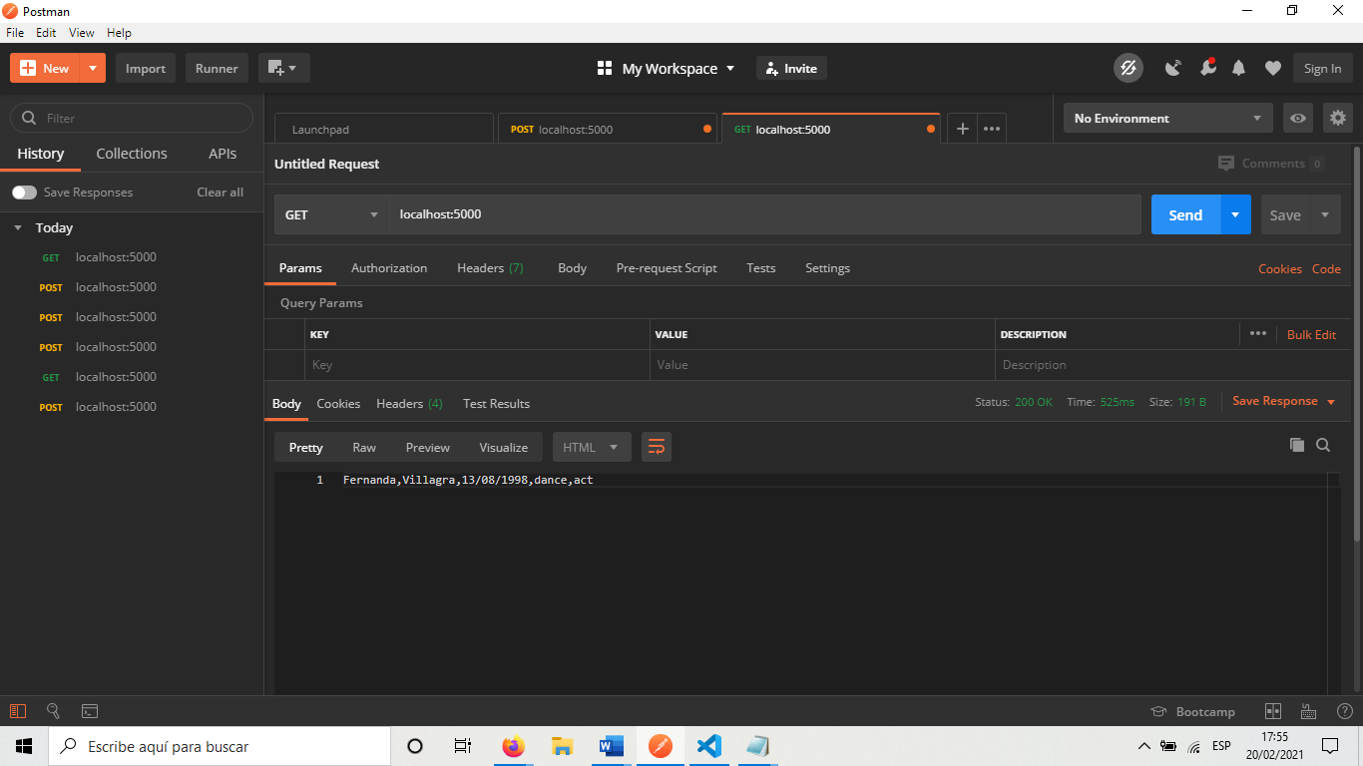

**Test #2**

Create a single page to-do app that allow the user to create to-dos, update to-dos and delete to-dos, no user login is required.

