CS 255 Business Requirements Document Template

Complete this template by replacing the bracketed text with the relevant information.

This template lays out all the different sections that you need to complete for Project One. Each section has guiding questions to prompt your thinking. These questions are meant to guide your initial responses to each area. You are encouraged to go beyond these questions using what you have learned in your readings. You will need to continually reference the interview transcript as you work to make sure that you are addressing your client’s needs. There is no required length for the final document. Instead, the goal is to complete each section based on your client’s needs.

Tip: You should respond in a bulleted list for each section. This will make your thoughts easier to reference when you move into the design phase for Project Two. One starter bullet has been provided for you in each section, but you will need to add more.

System Components and Design

Purpose
What is the purpose of this project? Who is the client and what do they want their system to be able to do?
- DriverPass is seeking a secure, web-based system that helps students prepare for driving tests through online practice exams and scheduling on-the-road training.
- The system must support multiple stakeholders (customers/students, DriverPass staff, instructors, management, and IT) and provide role-based access to features and data.
- Primary business outcome: reduce student test failure rates by providing structured practice, progress tracking, and convenient lesson scheduling.

System Background
What does DriverPass want the system to do? What is the problem they want to fix? What are the different components needed for this system?
- Problem: many applicants rely on memorizing old questions and still fail driving exams; DriverPass wants a guided training experience that combines knowledge checks with behind-the-wheel instruction.
- Core components include: an online portal for customers, an administrative portal for staff/instructors, a practice exam/question bank, scheduling and reservation management, and reporting/progress tracking.
- The system must support content updates (e.g., exam question changes) and reliable access across common devices and browsers.

Objectives and Goals
What should this system be able to do when it is completed? What measurable tasks need to be included in the system design to achieve this?
- Provide customers with an account to purchase training packages, take practice exams, view results, and schedule driving lessons.
- Enable staff to manage customer accounts, lesson schedules, instructor availability, and package offerings, with appropriate auditability.
- Support instructors with access to their lesson calendar, customer information needed for lessons, and the ability to record lesson completion and notes.
- Maintain accurate records for transactions, appointments, and customer progress; ensure data can be backed up and restored.
- Deliver a usable interface for both desktop and mobile users with clear workflows and minimal training required.

Requirements

Nonfunctional Requirements
In this section, you will detail the different nonfunctional requirements for the DriverPass system. You will need to think about the different things that the system needs to function properly.

Performance Requirements
What environments (web-based, application, etc.) does this system need to run in? How fast should the system run? How often should the system be updated?
- The system shall be web-based and accessible on modern browsers on desktop and mobile devices.
- The system shall load key pages (login, dashboard, scheduling, practice exam start) within a few seconds under normal network conditions.
- The system shall support concurrent users (customers taking exams and scheduling lessons) without noticeable degradation.
- The system shall support routine content updates (practice exam questions, package details, schedules) without requiring extended downtime.
- The system shall log critical events (logins, purchases, schedule changes) for troubleshooting and audit purposes.

Platform Constraints
What platforms (Windows, Unix, etc.) should the system run on? Does the back end require any tools, such as a database, to support this application?
- The system shall run as a browser-based application (no required client installation for customers).
- The system shall use a server-side database to store users, roles, schedules, transactions, practice exam content, and results.
- The solution shall support common operating systems (Windows, macOS, iOS, Android) through the web interface.
- The system shall integrate with payment processing (if required) and email/SMS notifications using standard, widely supported APIs.

Accuracy and Precision
How will you distinguish between different users? Is the input case-sensitive? When should the system inform the admin of a problem?
- The system shall uniquely identify users via a unique username/email and role-based permissions (customer, instructor, admin, IT).
- The system shall validate required inputs (dates, times, payment fields, exam answers) and provide clear error messages for invalid entries.
- The system shall prevent double-booking of instructors and lesson time slots by enforcing scheduling rules at save time.
- The system shall notify admins of critical failures (e.g., payment processing errors, database connectivity errors) through logs and alerts.

Adaptability
Can you make changes to the user (add/remove/modify) without changing code? How will the system adapt to platform updates? What type of access does the IT admin need?
- The system shall allow authorized staff to add/modify/remove users, packages, lesson types, and practice exam content through an admin interface (without code changes).
- The system shall be designed to accommodate updates to practice exam questions and business rules with minimal disruption.
- The system shall support configurable scheduling parameters (lesson duration, availability windows, blackout dates).
- The IT admin shall have access to system configuration, logs, user role management, backup/restore, and monitoring dashboards.

Security
What is required for the user to log in? How can you secure the connection or the data exchange between the client and the server? What should happen to the account if there is a “brute force” hacking attempt? What happens if the user forgets their password?
- The system shall require authentication (username/email + password) for all non-public features; privileged roles require stronger protections (e.g., MFA where available).
- The system shall enforce role-based access control so customers cannot access admin/instructor features or other customers’ data.
- The system shall secure data in transit using HTTPS/TLS and protect sensitive data at rest using appropriate encryption and hashing (e.g., salted password hashing).
- The system shall implement account lockout or throttling after repeated failed login attempts and log suspicious activity for review.
- The system shall support password reset via verified email and ensure session timeouts for inactive users.

Functional Requirements
Using the information from the scenario, think about the different functions the system needs to provide. Each of your bullets should start with “The system shall . . .” For example, one functional requirement might be, “The system shall validate user credentials when logging in.”
- The system shall allow new customers to register for an account and verify their contact information.
- The system shall validate user credentials and create an authenticated session when a user logs in.
- The system shall allow customers to view and purchase DriverPass training packages.
- The system shall record purchases and associate purchased packages with the customer account.
- The system shall allow customers to take practice exams and submit answers.
- The system shall score practice exams, display results, and store attempt history for customer review.
- The system shall allow customers to schedule, reschedule, or cancel on-the-road training sessions based on instructor availability.
- The system shall prevent scheduling conflicts and enforce business rules for lesson booking.
- The system shall allow instructors to view their assigned lesson schedule and relevant customer details.
- The system shall allow instructors (or staff) to mark lessons as completed and record lesson notes/outcomes.
- The system shall allow admins/staff to manage user accounts, roles, and account status (active/locked).
- The system shall allow admins/staff to manage practice exam content (questions, answers, categories) and publish updates.
- The system shall generate basic reports for management (e.g., lesson volume, package sales, customer progress, exam performance trends).
- The system shall send notifications (email/SMS) for key events such as account creation, purchase confirmation, and lesson reminders (if enabled).
- The system shall maintain an audit log of administrative actions and schedule changes.

User Interface
What are the needs of the interface? Who are the different users for this interface? What will each user need to be able to do through the interface? How will the user interact with the interface (mobile, browser, etc.)?
- Customers: web portal to register/login, view packages, purchase, take exams, view scores, and manage lesson appointments.
- Admins/staff: dashboard to manage users, packages, exam content, and scheduling, with search and filtering for quick access.
- Instructors: simplified dashboard focused on calendar/schedule, lesson details, and lesson completion notes.
- Interface should be responsive for mobile and desktop, with clear navigation and accessible form controls (labels, error messages).
- The UI should provide confirmation prompts for high-impact actions (purchase, cancel lesson) and display status messages.

Assumptions
What things were not specifically addressed in your design above? What assumptions are you making in your design about the users or the technology they have?
- Customers have reliable access to the internet and a modern browser on a desktop or mobile device.
- DriverPass will provide or approve the practice exam content and any rules for scoring and reporting.
- Payment processing and notification services are available through third-party providers if those features are included.
- Instructors and staff will maintain accurate availability information to keep the schedule reliable.

Limitations
Any system you build will naturally have limitations. What limitations do you see in your system design? What limitations do you have as far as resources, time, budget, or technology?
- Early estimates may change as requirements are refined and as integrations (payment/notifications) are confirmed.
- System functionality depends on third-party services for payments and messaging; outages may impact those features.
- A web-only interface may limit certain offline capabilities; users will need connectivity to access exams and schedules.
- Scope is constrained by project timeline and resources; advanced analytics, complex personalization, or native mobile apps may be deferred.

Gantt Chart
Figure 1 provides the proposed project schedule for DriverPass, based on the Schedule Planning table and task dependencies discussed during planning.

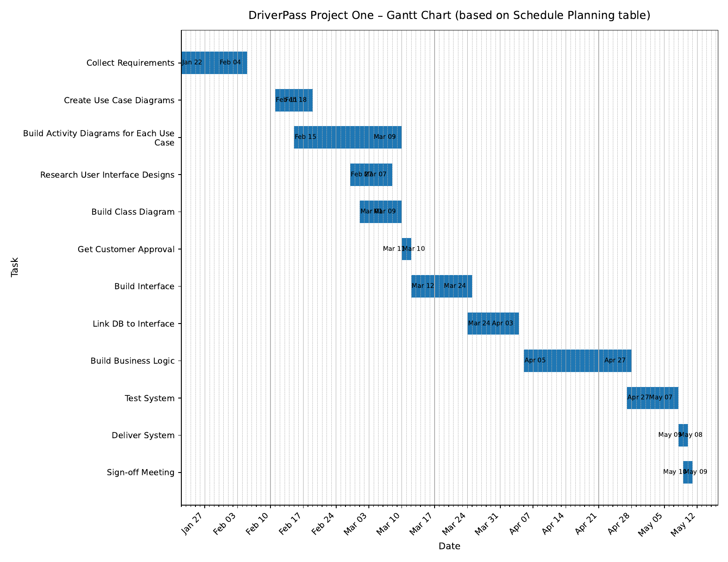
Schedule summary (based on Gantt chart):
• Collect requirements (Jan 22-Feb 04)
• Create use case diagrams (Feb 11-Feb 18)
• Build activity diagrams for each use case (Feb 15-Mar 09)
• Research user interface designs (Feb 27-Mar 07)
• Build class diagram (Mar 02-Mar 09)
• Get customer approval (Mar 01-Mar 10)
• Build interface (Mar 12-Mar 24)
• Link DB to interface (Mar 24-Apr 03)
• Build business logic (Apr 05-Apr 27)
• Test system (Apr 27-May 07)
• Deliver system (May 08-May 09)
• Sign-off meeting (May 09-May 10)

