DriverPass System Design Document
Prepared by: Fernando Rivas

UML Diagrams

UML Use Case Diagram
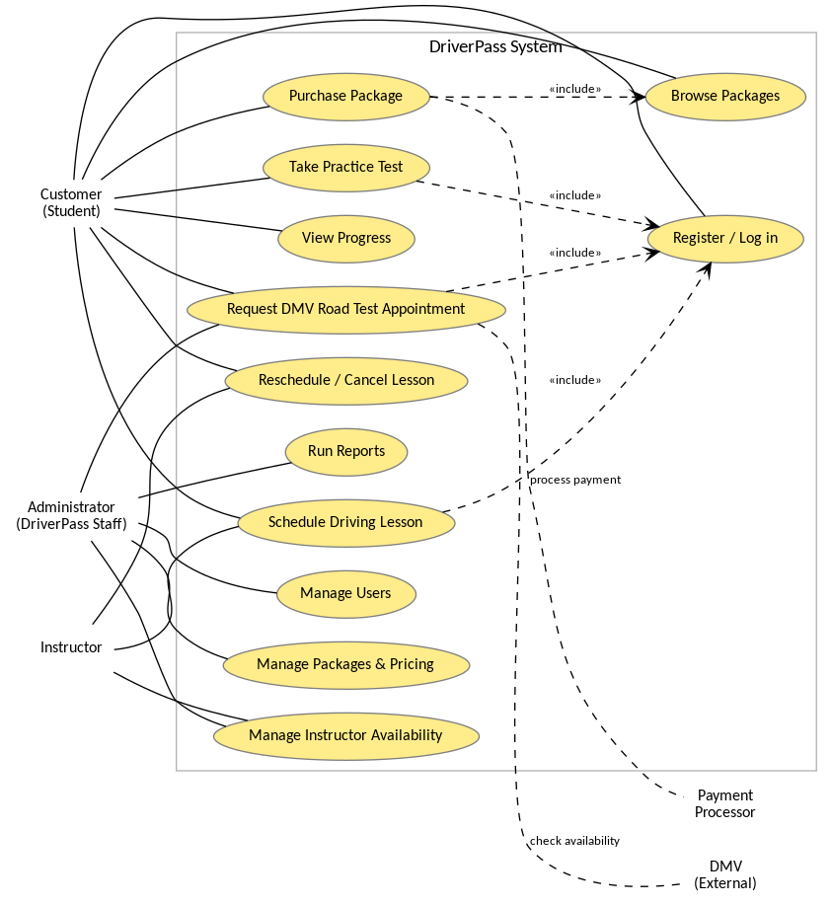
Figure 1. DriverPass Use Case Diagram

UML Activity Diagrams
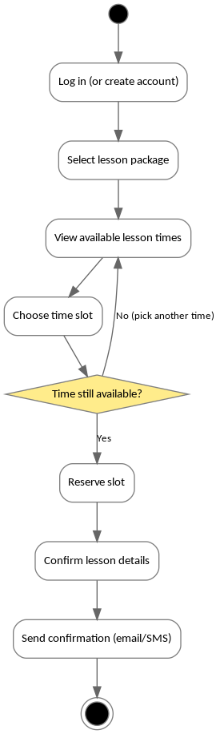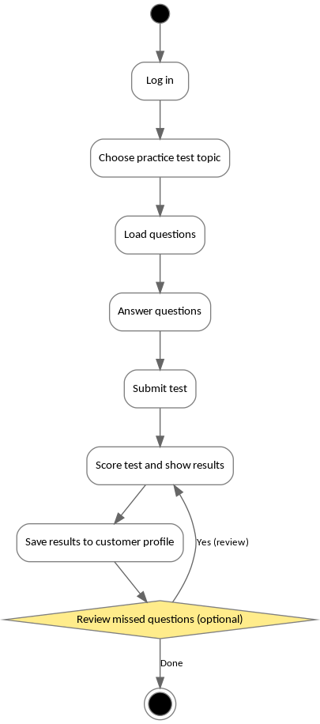
Figure 2. Activity Diagrams (Schedule Lesson and Take Practice Test)

UML Sequence Diagram
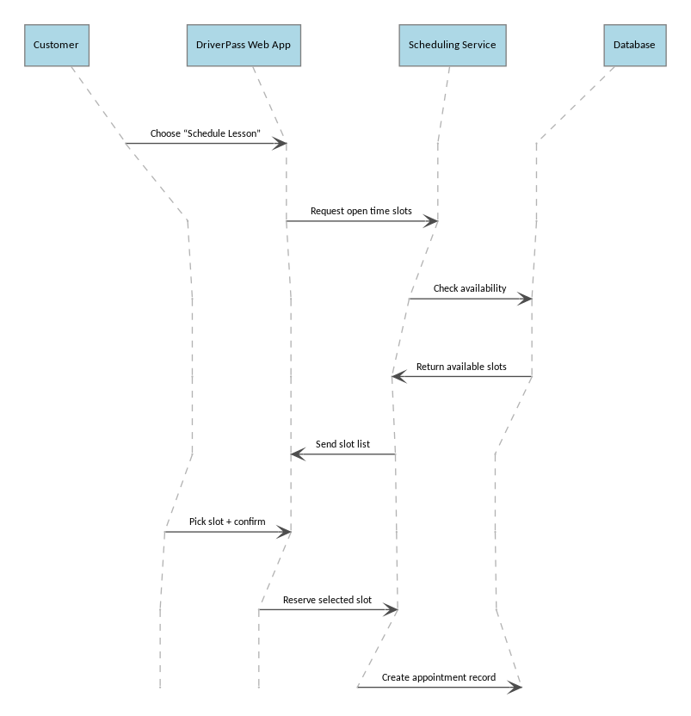
Figure 3. Sequence Diagram (Schedule Driving Lesson)

UML Class Diagram
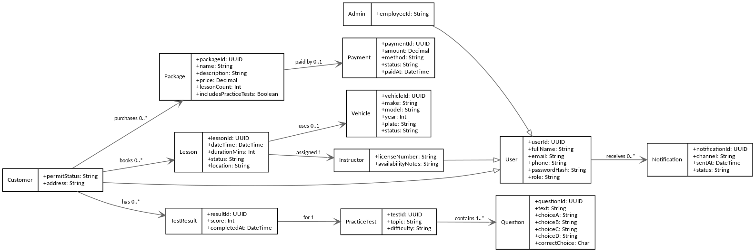
Figure 4. DriverPass Class Diagram

Technical Requirements
Technical requirements for the DriverPass system include the following:
Hardware:
• Web/application server (cloud VM or managed app service) sized for expected peak traffic
• Managed relational database with automated backups and point-in-time recovery
• Staff computers for administrative users; customer access via modern browsers and mobile devices
Software:
• Web application + API layer and relational DBMS (for example, PostgreSQL or MySQL)
• TLS/SSL for HTTPS across all logins and transactions
• Email/SMS provider integration for confirmations and reminders
• Optional payment processor integration for package purchases
Tools:
• Git for version control, issue tracking/Agile board, and CI/CD pipeline for automated builds and deployments
• Centralized logging/monitoring and audit logs for troubleshooting and compliance
Infrastructure:
• Secure hosting with firewalls/WAF, role-based access control, and least-privilege permissions
• Separate dev/test/prod environments
• Encryption at rest for sensitive data and a documented backup/disaster recovery plan

