**React:** A JavaScript library for building user interfaces. It uses JavaScript in the browser to update the page and the user interface without reloading the page.

Using “Just JavaScript” Typically isn’t a great option because

* Writing complex JavaScript code quickly becomes cumbersome
* Complex JavaScript code quickly becomes error-prone
* Complex JavaScript code often is hard to maintain or edit
* React offers a simpler mental mode

When working with React, in the end, you are writing declarative code which means you define the target your user interface states. Not the necessary steps to get there. Instead, React will figure out and perform the necessary steps. On the other hand, when writing JavaScript code, you are writing imperative code, not declarative which means, you are not defining the goal, but instead the steps needed to get there.

You can practice creating a react proyect by typing “react.new” in the search bar without installing anything locally.

**Installing React**

If you want to use install react locally, you will need to install [Node.js](https://nodejs.org/es) because it comes with tools like “vite”. There is an alternative to vite that’s named Create React App. Both of these give you simple commands to create a proyect.

When using vite, you have to write

To check if you have them installed use:

node -v

npm -v

npm create vite@latest react-proyect

Whenever you first install a proyect, you have to run

npm install to download and install all packages

npm run dev to start a development preview server

**Why do you need a special proyect setup to run react?**

React code is JavaScript code that Typically uses JSX (html in JavaScript). This code needs to be transformed and optimized by a build tool like Vite. Then the browser can read this code without JSX.

<script src="assets/scripts/app.js" defer></script> you can use the “defer” option to execute the script only after the rest of the html document has been read and parsed.

It’s also quite common to have a type=”module”. This lets us use the import sintax which allows us to import from script A to script B.

## Javascript refresher

React projects use a build process: the code you write is not he code that gets executed in the browser. Instead, the code is transformed before it’s handed off to he browser. The library that does this is called react-scripts and is located in the package.json

React projects use a build process because:

1. Raw, unprocessed React code won’t execute in the browser because React uses a special JSX feature which is not a default JavaScript feature.
2. The code would not be optimized for production. (e.g., not minifield)

#### Importing

When exporting variables, if you choose to export default “xxx”, you can only have one exporting value.

You can also import everything using import * as util from “./util.js”;

#### Destructuring



***Destructuring in Function Parameter Lists***

For example, if a function accepts a parameter that will **contain an object** it can be destructured to *"pull out"* the object properties and make them available as **locally scoped variables** (i.e., variables only available inside the function body).

Here's an example:

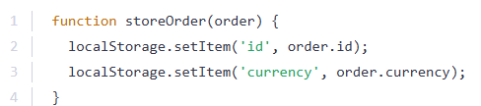

Instead of accessing the order properties via the *"dot notation"* inside the storeOrder function body, you could use destructuring like this:

The destructuring syntax is the same as taught in the previous lecture - just without creating a constant or variable manually.

Instead, id and currency are *"pulled out"* of the incoming object (i.e., the object passed as an argument to storeOrder).

It's very important to understand, that storeOrder **still only takes one parameter** in this example! It does **not** accept two parameters. Instead, it's one single parameter - an **object** which then just is destructured internally.

The function would still be called like this:

1. storeOrder({id: 5, currency: 'USD', amount: 15.99}); // one argument / value!

**Destructuring allows you to easily access the values of arrays or objects and assign them to variables.**

Here's an example for an array:

And here for an object:

Destructuring is very useful when working with function arguments. Consider this example:

Here, we only want to print the name in the function but we pass a complete person object to the function. Of course this is no issue but it forces us to call personObj.name inside of our function. We can condense this code with destructuring:

We get the same result as above but we save some code. By destructuring, we simply pull out the name  property and store it in a variable/ argument named name  which we then can use in the function body.

#### The spread operator

If we want to merge the hobbies list with another newHobbies list, I could use the special spread operator which is the three dots and then the name of the first array. These three dots will pull all the elements of the array and add them as separate values to this new list.

#### ES6 Arrow Functions

Read more: [Arrow function expressions - JavaScript | MDN](https://developer.mozilla.org/en-US/docs/Web/JavaScript/Reference/Functions/Arrow_functions)

Arrow functions are a different way of creating functions in JavaScript. Besides a shorter syntax, they offer advantages when it comes to keeping the scope of the this  keyword (see [here](https://developer.mozilla.org/en-US/docs/Web/JavaScript/Reference/Functions/Arrow_functions#No_binding_of_this)).

Arrow function syntax may look strange but it's actually simple.

which you could also write as:

becomes:

**Important:**

When having **no arguments**, you have to use empty parentheses in the function declaration:

When having**exactly one argument**, you may omit the parentheses:

When **just returning a value**, you can use the following shortcut:



That's equal to:

#### Methods of arrays

The following page gives a good overview over the various methods you can use on the array prototype - feel free to click through them and refresh your knowledge as required: <https://developer.mozilla.org/en-US/docs/Web/JavaScript/Reference/Global_Objects/Array>

Particularly important in this course are:

* map()  => <https://developer.mozilla.org/en-US/docs/Web/JavaScript/Reference/Global_Objects/Array/map>
* find()  => <https://developer.mozilla.org/en-US/docs/Web/JavaScript/Reference/Global_Objects/Array/find>
* findIndex()  => <https://developer.mozilla.org/en-US/docs/Web/JavaScript/Reference/Global_Objects/Array/findIndex>
* filter()  => <https://developer.mozilla.org/en-US/docs/Web/JavaScript/Reference/Global_Objects/Array/filter>
* reduce()  => <https://developer.mozilla.org/en-US/docs/Web/JavaScript/Reference/Global_Objects/Array/Reduce?v=b>
* concat()  => <https://developer.mozilla.org/en-US/docs/Web/JavaScript/Reference/Global_Objects/Array/concat?v=b>
* slice()  => <https://developer.mozilla.org/en-US/docs/Web/JavaScript/Reference/Global_Objects/Array/slice>
* splice()  => <https://developer.mozilla.org/en-US/docs/Web/JavaScript/Reference/Global_Objects/Array/splice>

## React Essentials

#### Components

Components are reusable building blocks which you can create and which you then combine to build the overall user interface. **React apps are built by combining components.**

Why components?

* Reusable building blocks: create small building blocks and compose the UI from them.
* Related code lives together: Related HTML, JS and CSS code is stored together.
* Separation of concerns: different components handle different data & logic. It vastly simplifies the process of working on complex apps.

#### Setting up the starting project

First you have to have node js. You can use this commands in cmd to check if you have them installed

node -v & npm -v

Then you have to use npm install before running the project.

Then you use

npm run dev

to start the development server. This development server will allow you to visit a preview of the website.

The files have the extension .jsx because it is a JavaScript file that uses non-standard JavaScript syntax. It uses a JavaScript syntax extension called JSX which stands for JavaScript Syntax eXtension. This extension allows developers to describe and create HTML elements by writing HTML markup code inside of JavaScript files. But it is a feature that’s not supported by browsers. Instead, the code is transformed by the development server before it reaches the browser.

#### Rules of components

* Name should start with uppercase character
* Returns “Renderable” content

Look how I write the header in a function and utilize it in the html.

#### Loading images

Using src/… is not the best way to add images because it is pointing to an image in the src folder and the image might get lost once we prepare this react project for deployment.

So, to load images, you have to use an import statement

#### Props

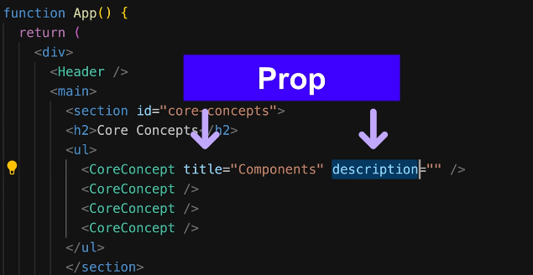React allows you to pass data to components via a concept called **Props**.

In normal JavaScript functions, you would simply add one or more parameters to accept input values and then use those input values. But when working with React component functions you can only accept one parameter which typically is named props. Since it’s react who will execute this function, its him who will pass a value for this props parameter to the function when it calls it. And the value that will be passed for this parameter to the function by react will be an object that has all the key value pairs that were assigned here.

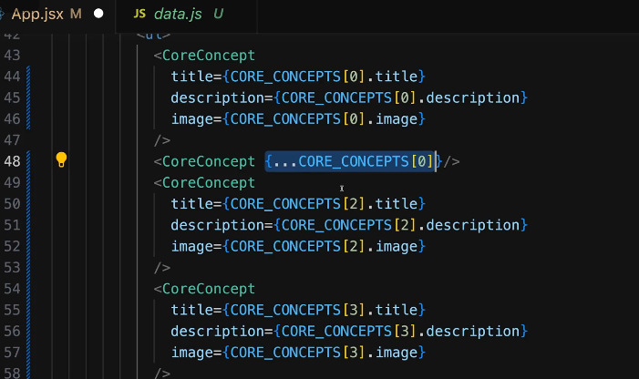If your prop names are similar to the properties of the object that you are using, you can use the spread operator to pull out all the key value pairs of an object

You can also use object destructuring by adding opening and closing curly braces as an input parameter

## Buttons

There is one prop which you will always get, the special, built-in children prop. This prop refers to the content between you component text.

