ArchIoTect

IoT Architecture Solution Knowledge Base
IoT Design Decision Assistant

User Manual Version 1.0 – JUNE 2025
Sumário
1. Introduction 3
2. Who is this Manual For? 3
3. Key Features 3
4. System Requirements 3
4.1. Logging In & User Roles 4
4.2. Using the Knowledge Base Explorer 4
4.2.1. Navigating the Knowledge Tree 4
4.2.2. Viewing Item Details 5
4.3. AI Assistant 8

Introduction
Welcome to the ArchIoTect User Manual. The "IoT Architectural Design Assistant" is an application engineered to function as an interactive interface, enabling software architects, engineers, and researchers to effectively engage with a curated knowledge base on Internet of Things (IoT) software system architectures. The system's development was driven by the objective of translating systematically compiled knowledge, derived from peer-reviewed literature and established industry practices, into actionable architectural guidance.
It combines a structured knowledge base explorer with an intelligent AI assistant to provide comprehensive support for the architectural design process.

Who is this Manual For?
This manual is designed for:
- Software Architects and Engineers who need to design, evaluate, or modernize IoT systems.
- Researchers and Academics studying trends and patterns in IoT software architecture.
- System Administrators responsible for maintaining and curating the knowledge base content.

Key Features
Knowledge Base Explorer: A hierarchical, tree-like interface to navigate all curated architectural solutions, patterns, domains, technologies, and quality requirements.
Knowledge Filtering: Filtering the knowledge base by multiple criteria, allowing you to pinpoint relevant information quickly.
AI Design Assistant: An intelligent chatbot that leverages the knowledge base to answer complex design questions, compare technologies, and provide synthesized architectural recommendations.
Managing Knowledge Base: A secure interface for authorized users to perform CRUD (Create, Read, Update, Delete) operations on the knowledge base.
Administrative Dashboard: A graphic oriented knowledge base statistics.

System Requirements
- A modern web browser (e.g., Chrome, Firefox, Edge, Safari).
- An active internet connection.

Logging In & User Roles
There are two primary user roles:
Standard User (User): Can access the Knowledge Base Explorer and the AI Assistant.
Administrator (Admin): Has all standard user permissions, plus access to the administrative tool for managing knowledge base content.
Logout action is located at the user avatar menu (Figure 1).
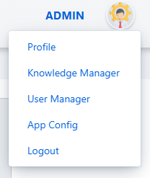
Figure 1: Administrator Menu options.

Using the Knowledge Base Explorer

Navigating the Knowledge Tree
The knowledge base is organized as a tree (Figure 2). To expand a category (e.g., "IoT Domains"), click the > icon next to its name.
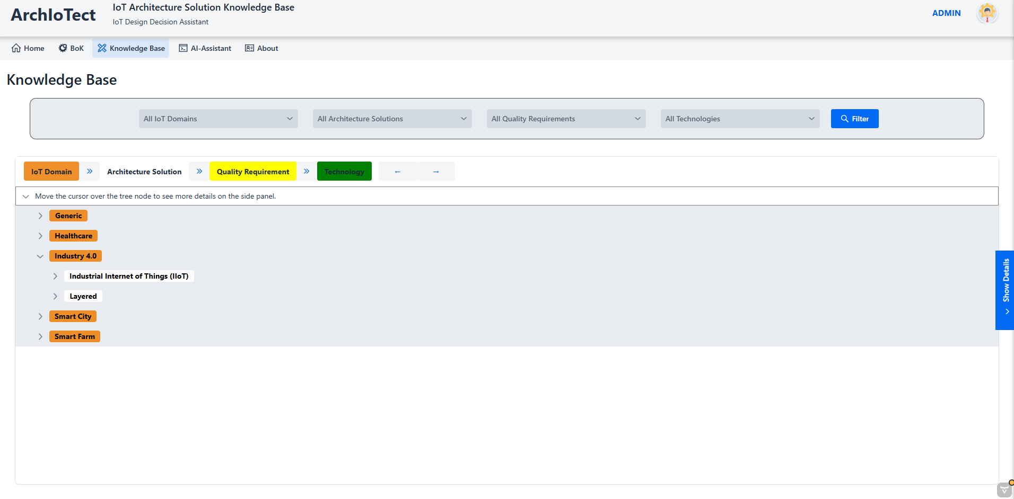
Figure 2: Knowledge Base Tree.

Viewing Item Details
When you open an item in the Tree and move the mouser point over it, the Details View Panel (Figure 3) will display all associated attributes, such as:
Description, Source Paper / Reference, Target IoT Domain(s), Addressed Quality Requirements (QRs), and Associated Technologies.
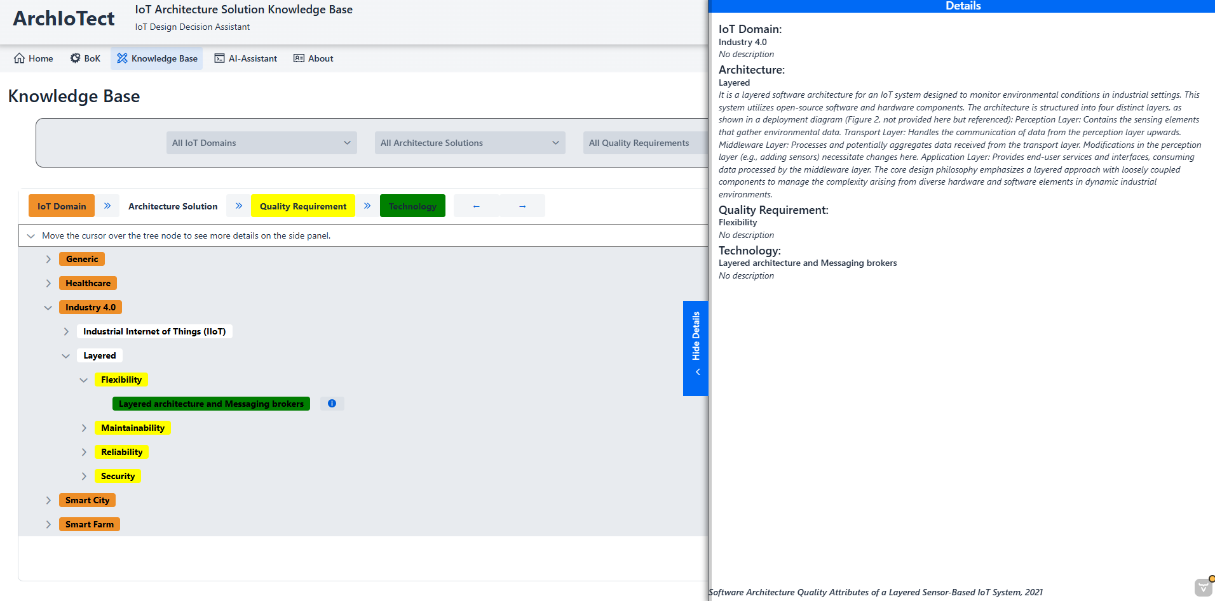
Figure 3: View Details Panel.
You can make the Details View Panel visible or hidden, by clicking on the Show/Hide Details buttons (Figure 4).
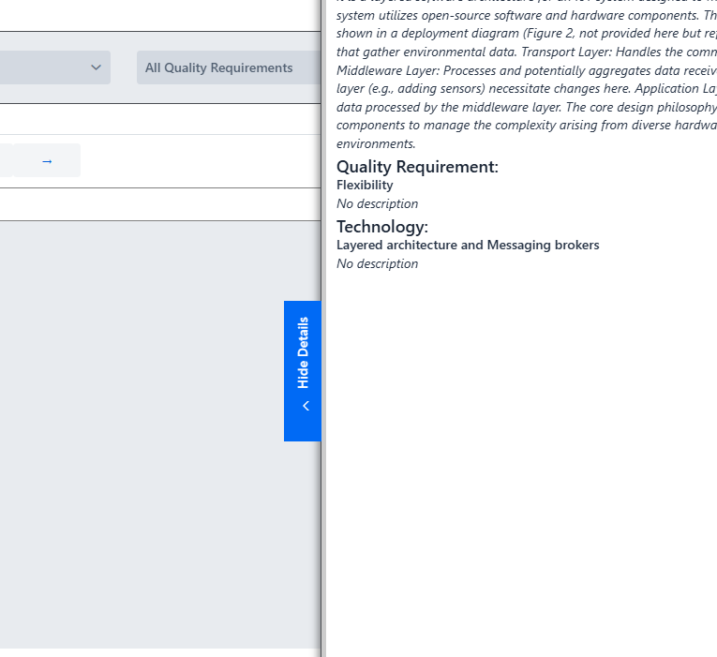
Figure 4: Show/Hide button.
    - Filtering the Knowledge Base
The filtering mechanism (Figure 5) allows for precise refinement of the knowledge base view. To apply filters, proceed as follows:
- Select one or more of the following: Architecture (Pattern/Name), IoT Domain, Quality Requirement, Technology or combine more than one option. Then, click the Filter button to perform the action.

- Combining Filters: When you select multiple criteria (e.g., Domain: 'Healthcare' AND QR: 'Security'), the system will only show results that match all selected criteria.
- To reset the view, click the Cancel button.
Figure 5: Filtering Knowledge data.
    - Viewing Source Evidence Details
Next to each Technology listed in the tree, you will find a Details button . Just click it, and a window will pop up with the full reference details for the source paper(s) (Figure 6). You will see information like the title, author, and where it was published.
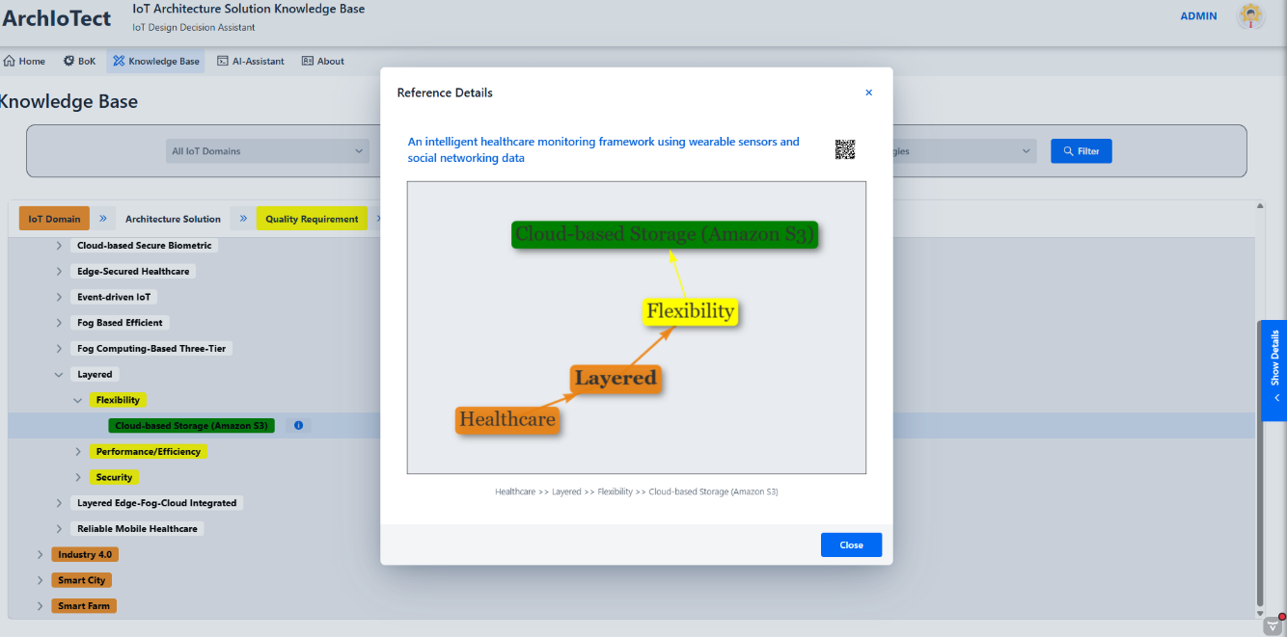
Figure 6: Reference details window.
You can access the original source document for any reference in two ways:
- Direct Link: Click on the reference's title. This will open the source document (e.g., the PDF or web page) directly in a new browser tab.
- QR Code: Scan the provided QR code with your mobile device's camera. This is a convenient way to open the reference on a phone or tablet for reading or sharing.

    - Selecting a Primary Viewpoint (Root Node)
The ArchIoTect application provides flexibility to re-organize the hierarchical presentation of the knowledge base by selecting a different root node. This feature allows you to analyze the data from various perspectives, such as focusing on specific quality attributes or technologies instead of IoT domains.
To change the root node of the Knowledge Tree:
Locate the Root Selection component positioned directly above the Knowledge Tree (as shown in Figure 7). The legend displays a sequence of color-coded labels. The order of these labels corresponds directly to the hierarchical levels in the tree; the first color represents the top-level nodes, the second color represents the second-level nodes, and so on.
Figure 7: Root selection component.
By default, this is set to IoT Domain. Click on the direction buttons 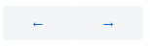 to change the available viewpoints. The options typically include: IoT Domain, Quality Requirement, and Architectural Pattern. Technology is always the last node of the tree.
Select the new viewpoint you wish to use as the root. The tree will automatically re-render with the chosen entity as the primary organizational structure.
    - Taking Notes About Any Tree Node
To help you keep track of your insights and questions as you explore the knowledge base, ArchIoTect provides a powerful annotation feature. You can attach a personal note to any item in the tree, allowing you to record observations, formulate questions for later, or save contextual reminders without leaving the application. Simply click on an item and use the Take Notes function to get started (Figure 8).
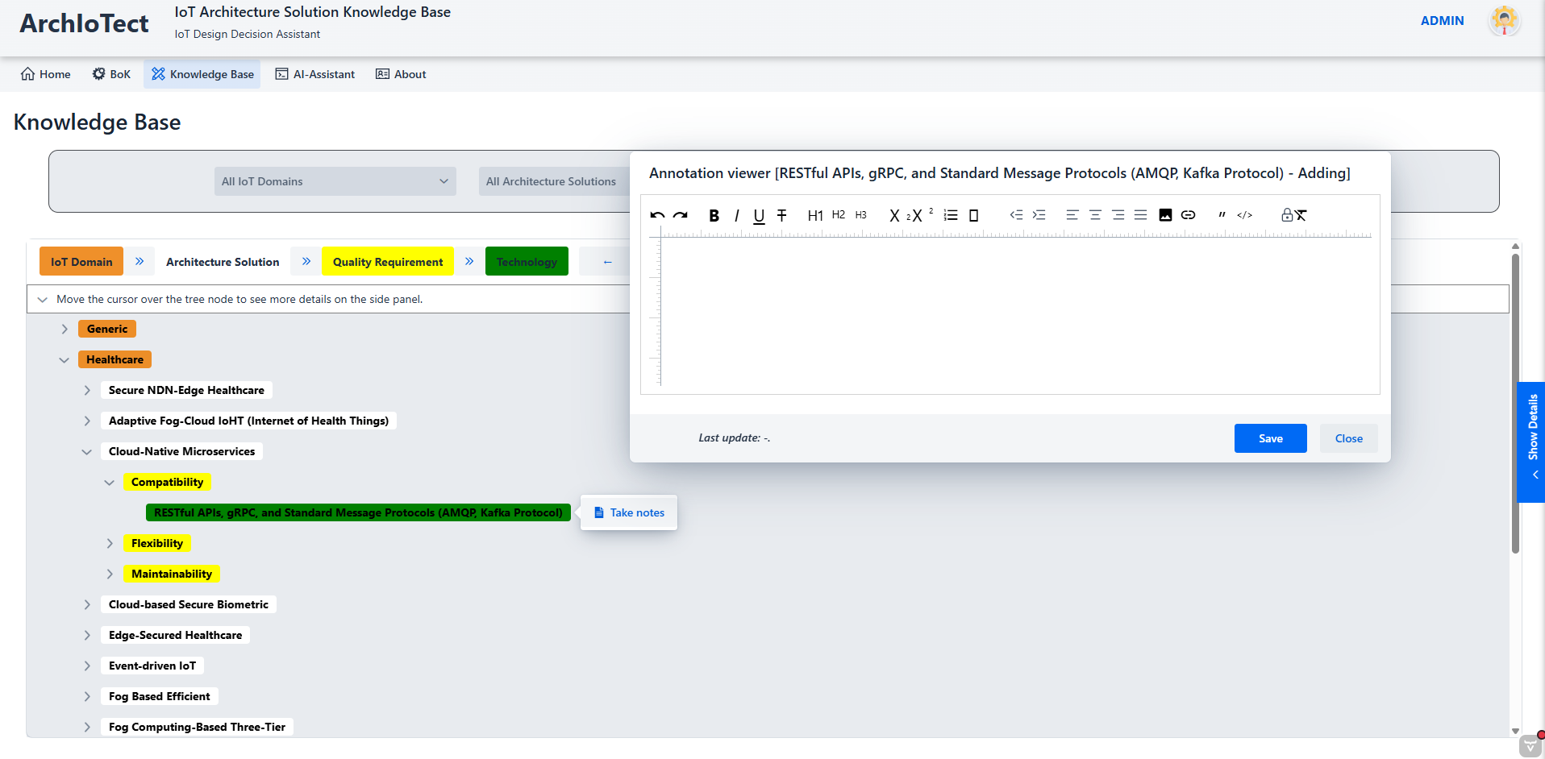
Figure 8: Taking notes window.

AI Assistant
The AI Assistant (Figure 9) is a powerful feature of ArchIoTect that functions as an interactive partner in your design process. It leverages the entire curated knowledge base to provide intelligent, synthesized answers to your architectural questions.
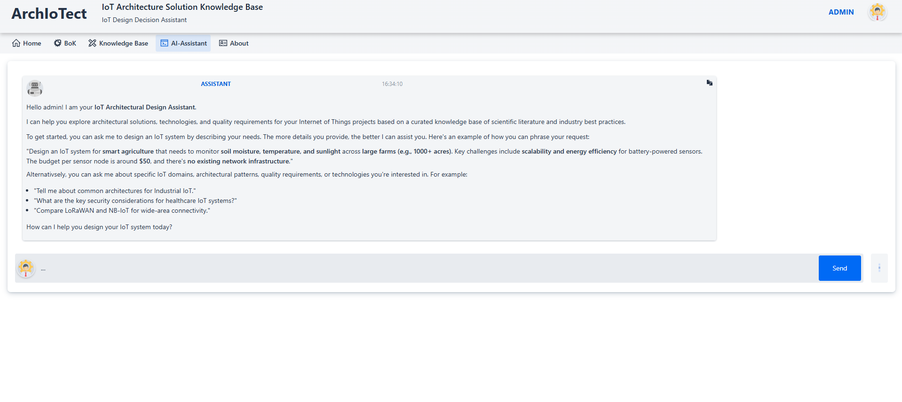
Figure 9: AI assistant chat.
    - Accessing the Assistant
The AI Assistant is accessible via the top menu [AI Assistant] of the application window.
To begin a conversation, simply type your question into the input field and press Ctrl + Enter or click the Send button.
To copy the content of any message, simply click the copy icon  located in the upper-right corner of the message bubble. The full text of the message will be instantly copied to your clipboard, ready to be pasted elsewhere.
    - How to Ask Effective Questions
The quality and relevance of the AI's response are directly related to the detail and clarity of your query. The assistant is designed to handle complex, specific questions rather than broad, vague ones.
Here are some tips for formulating effective questions:
Tip 1: Be Specific in Design Scenarios
Provide as much context as possible, including the IoT domain, the goal, and any known constraints or quality requirements.
Less Effective (Vague): Design an IoT system.
Highly Effective (Specific): Design an IoT system for smart agriculture to monitor soil moisture and temperature across a 1000-acre farm with limited power and a budget of $50 per node.
Tip 2: Ask for Comparisons
The assistant can compare and contrast different technologies or patterns based on the knowledge base.
Less Effective (Ambiguous): What about LoRa?
Highly Effective (Comparative): Compare LoRaWAN and NB-IoT for a low-power, wide-area application like smart metering.
Tip 3: Narrow the Scope for Factual Questions
Instead of asking about a broad topic, focus on a specific aspect within a particular context.
Less Effective (Too Broad): Tell me about security.
Highly Effective (Scoped): What are the key security considerations and recommended technologies for healthcare IoT systems?
In short, the more context and detail you provide, the more precise and useful the assistant's response will be.
Tip 4: You can ask for the Assistant to provide examples of effective questions (Figure 10).
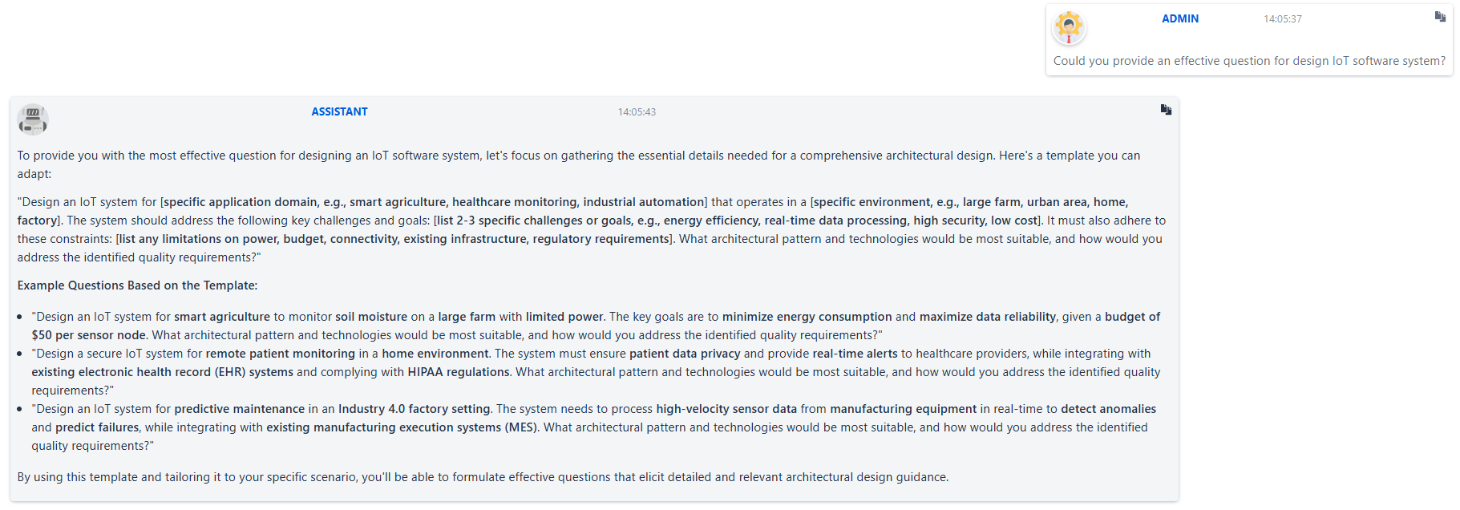
Figure 10: Asking the Assistant for an effective example of a question.
    - Understalquernding the AI's Response
The AI provides detailed, structured answers formatted in HTML for maximum clarity. When you ask a design-related question, a typical response will include:
Architectural Solutions Recommendation: A clear suggestion for a suitable architectural pattern and technologies.
Key Quality Attributes: A breakdown of the most relevant quality requirements (e.g., Reliability, Security) and how the proposed design addresses them.
Technology Choices & Rationale: A list of specific technologies (e.g., MQTT, ESP32) with a justification for why they were chosen over common alternatives.
References from Knowledge Base: A list of the source documents from the knowledge base that were used to construct the answer, ensuring full traceability.
    - Important Considerations and Limitations
To use the assistant effectively, please keep the following in mind:
Knowledge-Bound: The AI's knowledge is strictly limited to the documents within the curated ArchIoTect knowledge base. It does not search the internet or access any external information. If your query uses terms not present in the knowledge base, it may state that it cannot find relevant information.
Domain-Focused: The assistant is an expert in IoT architecture. It will gracefully decline to answer out-of-scope questions (e.g., about general news, cooking recipes, or other unrelated topics).
A Support Tool, Not a Replacement: The AI is a powerful assistant designed to augment your expertise, not replace it. The generated guidance should be used as a well-informed starting point and validated against your project's specific context and your own professional judgment.

