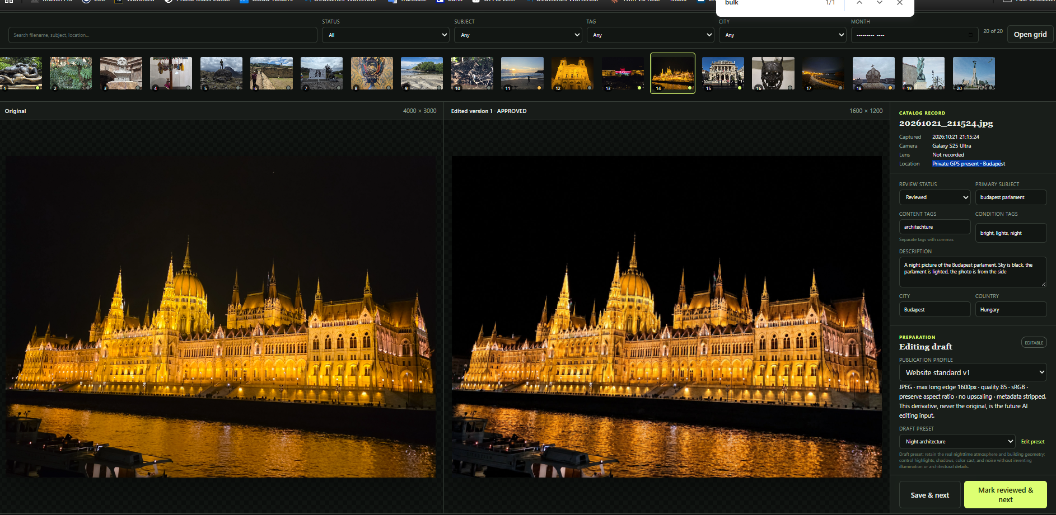

STRIP
ORIGINAL
Generated
WORK AND EDITING AREA

