Create project on git bash go to the directory you want it to be created and run

ng new project_name

Import project to IntelliJ

File -> New Project from existing sources -> select the path from created project

Add Project to Github

On Intellij VCS-> Import into Version Control -> share project on Github -> fill data and share

Add project into SourceTree

New Tab clicking -> Add -> enter the path where the project is locally

New component

On git bash where the project is located ng generate component component_name

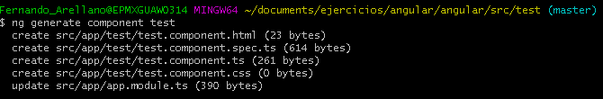

Run Project

Ng serve -p port_number

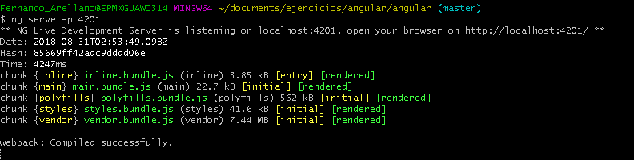

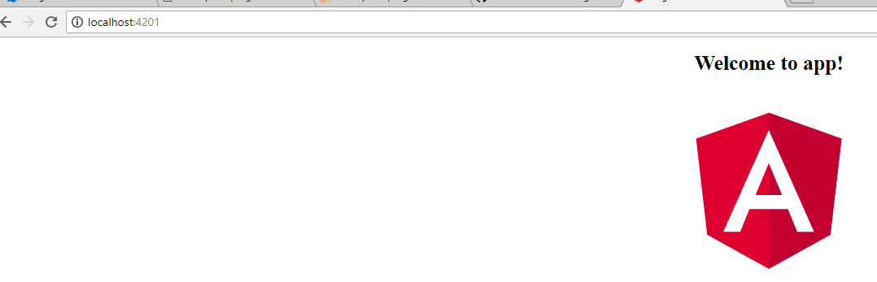

Test created component on app

Open app component.html, tak the selector from the created component on the ts file and add it on the app html

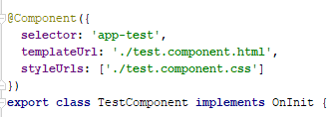

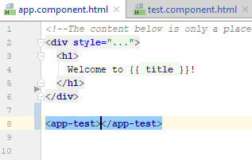

Add Css style to the component

On the css file, normally on the one for the component or there is also another global css

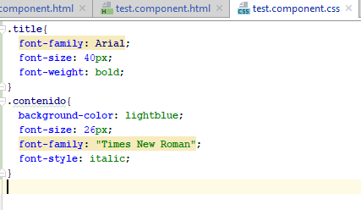

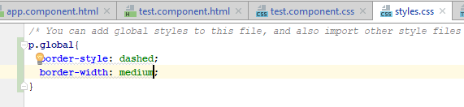

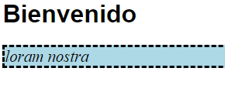

PRACTICA 2

Declare array on Ts

Arreglo: Array<string> = new Array();

ngFor:



ngIf:



Temp Var:

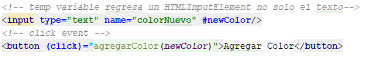



Parse values on tss:

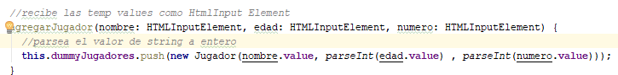

Pass value from parent component to child:

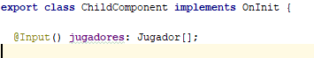

When a new jugador is added its updated and send to the child

Model example:

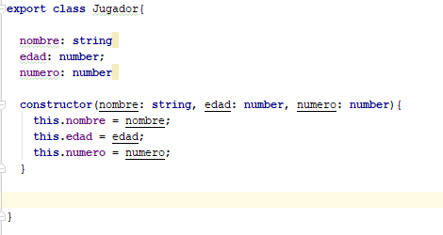

Writing property on String:



