Configuration without servlet config only extending application to configure a rest endpoint with jax rs

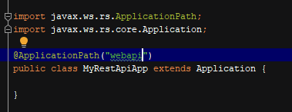

@ApplicationPath has the prefix of the url for our resources

Every request generates a new instance of the resource (request scope)

When the request is served then it is destroyed

@Singleton

Permite convertir un recurso en singleton asi q solo sera creado una instancia para todos los request

Instance variables path and query params:

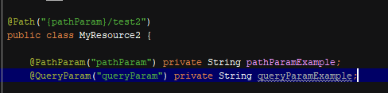

Don’t work for Singleton

Param converter

Allows to convert any sent param (path, query, etc) to a own created model type



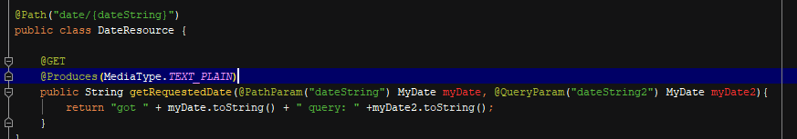

Method is converting from string to a custom data type MyDate

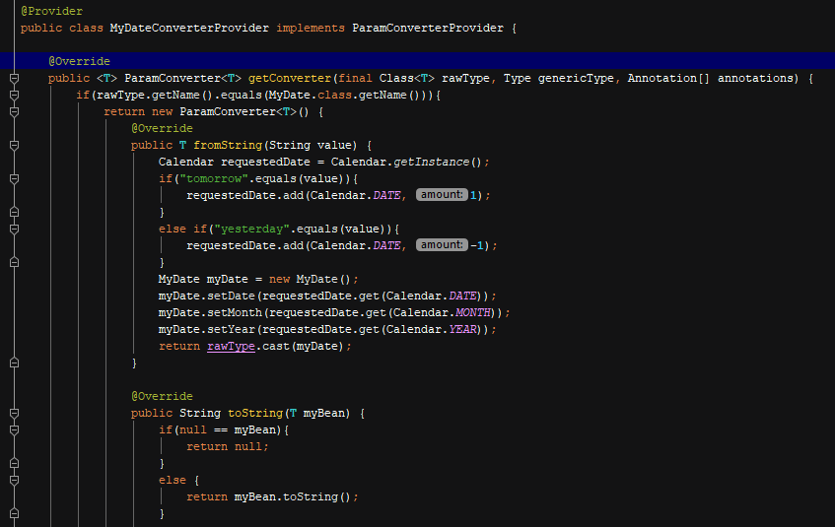

Provider must be registered which will be able to map the param to the requested custom data type

MessageBodyWriter MessageBodyWriter

Converts the raw content sent in the request to our custom data type

Param converter for params message body reader writer for raw content

Message body writer

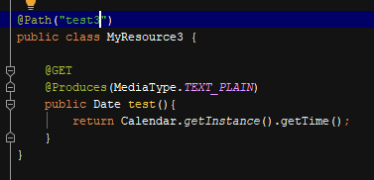

Date to text plain should be converted, it needs a message body writer which can convert this

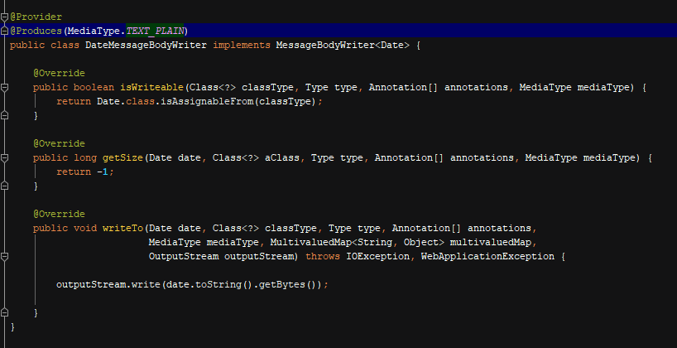

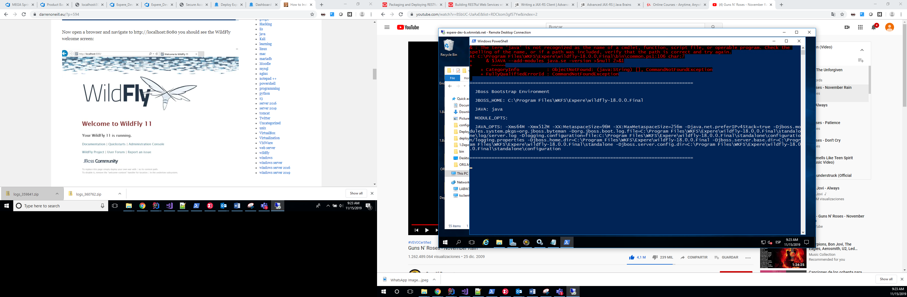

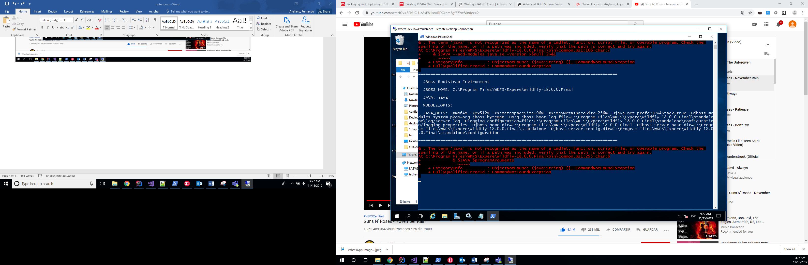

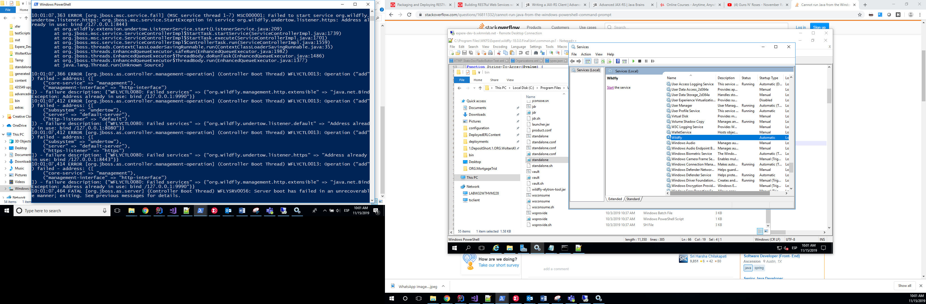

Invocation

You create an object with all the request information which is not sent yet, it can be passed to someone else for them to make the actual call whenever they want even being able to modify the request before

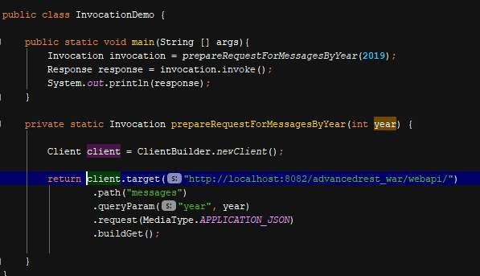

Getting a generic type as response

Needs an implementation of generic type with the generic type which will be the response

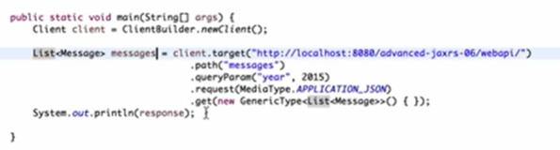

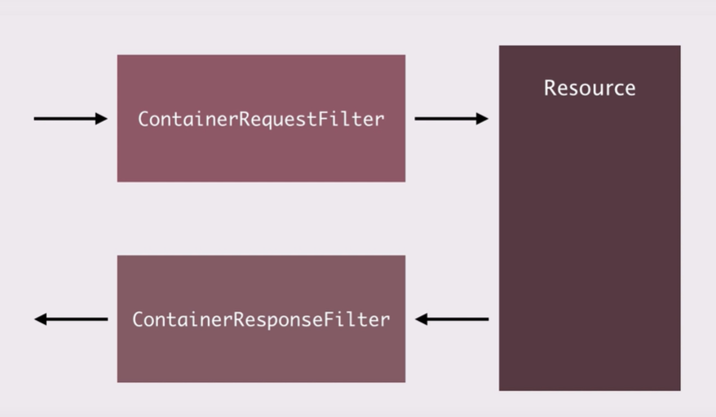

Filters help for cross cutting concerns

Container Response Filter will be called when the response is about to be sent back

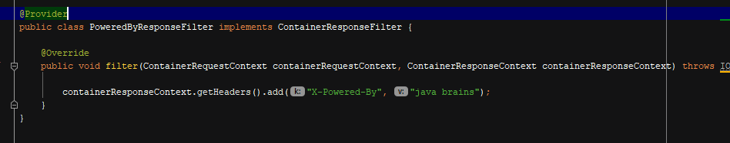

Filters is guaranteed to be executed no matter if the response is an exception

Filters manipulate headers or metadata

Interceptors manipulate entities (input and output streams