The JAX-RS provides support for creating Web services according to REST architectural style. JAX-RS uses annotations to simplify the development of RESTful Web services. By simply adding annotations to your Web service, you can define the resources and the actions that can be performed on those resources.

Example Rest service using jersey

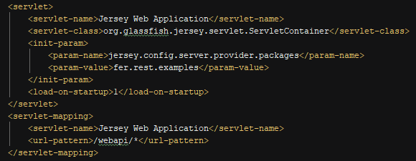

Add your resource on the param value package or add the package of the resources in this param

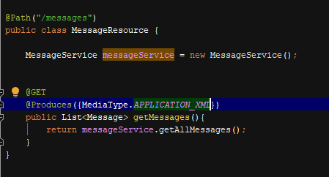

Resource with path to specify the path of the resource, the method to access it and the response it produces.



If it responses a new data model you need to specify XmlRootElement for the message writer to be able to transform it on xml or json



Header param



Matrix param

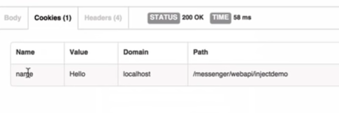

Cookie param

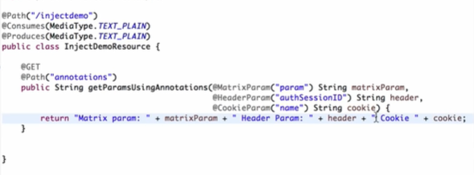

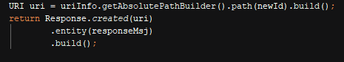

Response.created, returns status code 201 and adds the sent uri on the header response

Create Exception

If a model will be created, do it as a similar model with @XmlRootElement

Create a mapper for the wanted exception implementing Exception mapper and annotating it with @Provider for Jax rs to register it

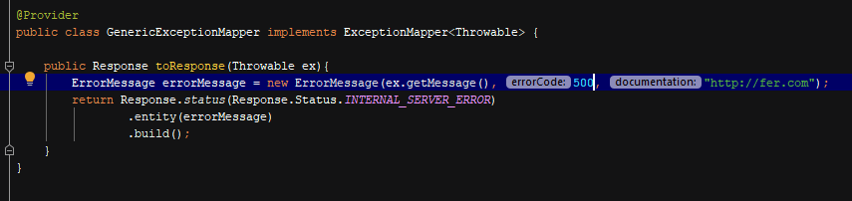

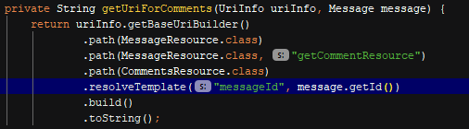

Path can take a resource class which will replace with the value of @Path at the level of the class, also can take one with the method name if you have subresources, if a path param has to be provided then you can do it with resolveTemplate, sending the path param name and the value