MONGO

Revenue máximo por país
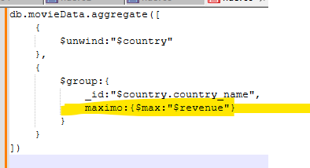

Peliculas con mas de 1 idioma usando $numlan
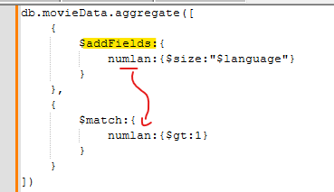

Create transaction

$setWindowFields aggregation
Peliculas donde el runtime es mayor al promedio //$setWindowFields like over partition by in sql, don’t lose the fields of the documents, it is added as a field into the doc to use
db.movieData.aggregate([
{
$setWindowFields: {
output: {
avgRuntime: {$avg:"$runtime"}
}
}
},
{
$match:{
$expr:{$gt:["$runtime","$avgRuntime"]}
}
}
])

DB MOVIE COLLECTION MOVIE DATA

Películas donde vote_average es distinto de 5 y 6
Db.movieData.find({vote_average:$nin:[5,6]})

Peliculas con idioma English pero no spanish en el arreglo language
Db.movieData.find({language:”English”, language:{$ne:”Spanish”}})
Peliculas entre 80 y 110 de runtime
Db.movieData.find({runtime:{$gt:80,$lt:110}})

Numero de peliculas por combinación de idioma y genero
db.movieData.aggregate([
{
$unwind:"$genre"
},
{
$unwind:"$language"
},
{
$group:{
_id:{
genre:"$genre",
language:"$language"
},
tot:{$sum:1}
}
}
])
Peliculas q contienen al menos 2 consonantes (2 no vocales)
db.movieData.find({
title: { $regex: "([^aeiou])\\1", $options: "i" } //dentro del [] q no inicie con
})

Películas q INICIEN con 2 vovales:
db.movieData.find({
title: { $regex: "([^aeiou])\\1", $options: "i" }
})

Q contenga vocal
db.movieData.find({
title: { $regex: "([aeiou])", $options: "i" }
})

Q inicie con vocal
db.movieData.find({
title: { $regex: "(^[aeiou])\\1", $options: "i" }
})

Peliculas con exactamente 4 palabras en el titulo
db.movieData.find({$expr:{$eq:[{$size:{$split:["$title"," "]}},4]}})

Peliculas con titulo con longitud par
Db.movieData.find({$expr:{$eq:[{$mod:[{$strLenCP:”$title”} ,2] },0]}})

Peliculas donde regex contenga 2 vocales al menos
Db.movieData.find({title:{$regex:”([aeiou].*){2}”, $options:”i”}})
Peliculas donde el idioma (array) contiene i
Db.movieData,find({language:{$elemMatch:{$regex:”i”,$options:”i”}}})

Peliculas donde el titulo tiene exactamente 3 palabras: ($split)
Db.movieData.find({
$expr:{$eq:[{$size:{$split:[“$title”,” “]}},3]}
})

Promedio de revenue de todas las peliculas
db.movieData.aggregate([
{
$group:{
_id:null,
promedio:{$avg:"$revenue"}
}
}
])
Languages que contienen a
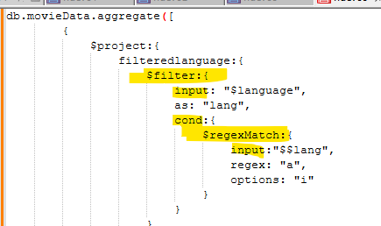

Crear campo con idiomas concatenados:
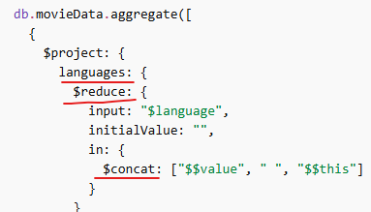

Filtrar solo itiomas q contienen a

Peliculas q empiezan en vocal
Db.movieData.find({title:{$regex:”^[AEIOU]”,$options:”i”}}

Obtener el titulo de las películas en mayúsculas
db.movieData.aggregate([
{ $project:
{
movieTitle: {$toUpper:"$title"}
}
}
])

Peliculas que el primer elemento dentro del array languages sea igual a English
db.movieData.find({ $expr: { $eq: [{ $arrayElemAt: [ "$language" , 0] }, "English" ] } })

Pelicula con revenue entre 50m y 150m
Db.movieData.find({$expr:{$and:[{$gt:50000000},{$lt:150000000}]}})

Pelicula donde el character y el nombre real del actor tengan la misma longitud utilizando $strLenCP
Db.movieData.find({$expr:{$eq:[{$strLenCP:”$main_character.character_name”},{$strLenCP:”$main_character.person_name”}]}})

Peliculas donde el language array tiene un idioma q inicia con S
Db.movieData.find({language:{$elemMatch:{$regex:” ^S”, $options:”i”}}})

Peliculas donde el revenue sea mas del doble que el Budget
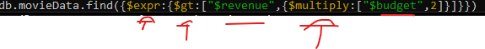
Peliculas donde el titulo contenga exactamente 2 palabras usando $split!
Db.movieData.find({$expr:{$eq:[{$size:{$split:[“$title”,” “]}},2]}})

Películas con revenue mayor al promedio global
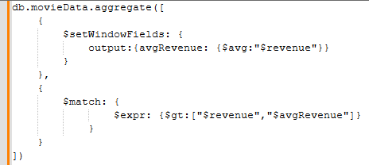

Películas donde el titulo comience con a
Db.movieData.find({title: {$regex:”^A”, $options:”i”}})

Peliculas donde el titulo termina en n
Db.movieData.find({title:{$regex:”n$”, $options:”i”}})

Películas donde el revenue existe y no es null
Db.movieData.find({revenue: {$exists:true, $ne:null}})

Peliculas donde el revenue este en cierto rango
db.movieData.find({revenue: {$gt:10000000, $lt:20000000}})
MongoDB does not have a dedicated isNull or isNotNull operator, but you can achieve this functionality using a combination of comparison ($ne, $eq) and existence ($exists) operators.
Peliculas donde production_company array esta vacio
db.movieData.find({production_company:{$size:0}})

Películas con el mismo rating (agrupadas)
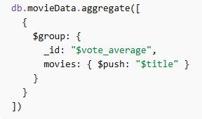
Contar cuántas películas hay por género
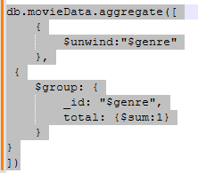
Promedio de rating por género
Same but $avg:”$rating” instead of $sum:1
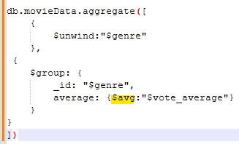
Total revenue por año ordenada por año
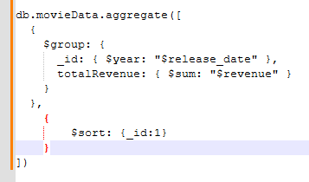
Películas lanzadas después del 2000
db.movieData.find({release_date: {$gt:ISODate('1999-12-31')}})

Número de películas por idioma
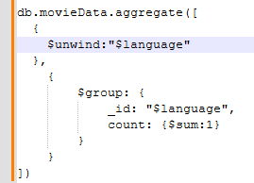

Obtener la película con mayor Budget
db.movieData.find({}).sort({budget:-1}).limit(1)

Calcular ganancia (revenue - budget) and keep just who had any positive benefit
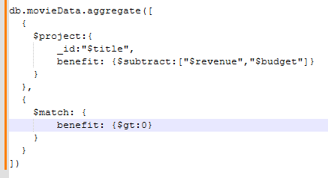

Películas con más de 2 idiomas
db.movieData.find({$expr: { $gt: [{$size:"$language"},2] }})

Películas que contienen tanto English como Spanish
db.movieData.find({language: {$all: ['English', 'Spanish']}})

Top 3 géneros con mayor revenue total
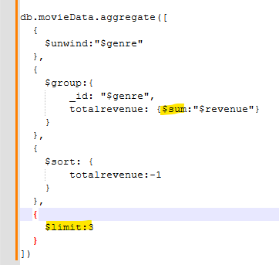
Actor principal con más películas
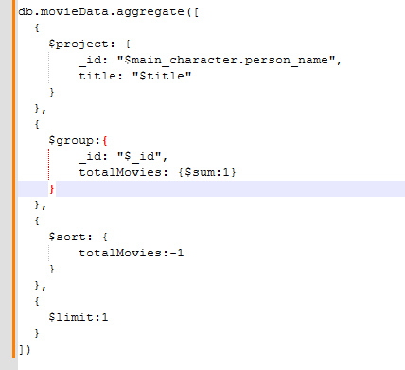

Películas donde el budget es menor al 50% del revenue
db.movieData.find({$expr: {$gt:["$revenue",{$multiply:["$budget",0.5]}] }})

Agrupar por década
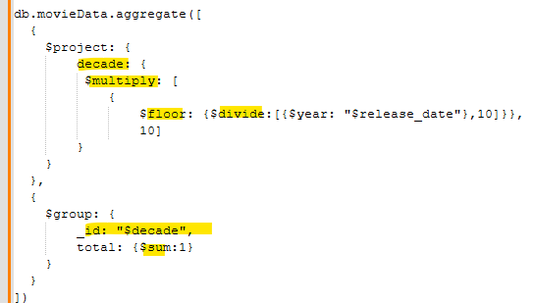

Obtener el nombre de la película por genero con mayor cantidad de votos
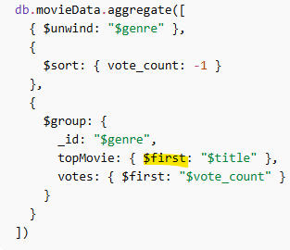

DB RETAIL COLLECTION PRODUCT
-Filter example to find product chich exist in Alabama and California only, no other states
All as long as they exist no matter if there are others will come
Will return only if the elements inside the array all come in the exact same position, otherwise they will not come

-Find where edad greater than 35
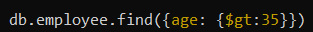
-Find where California OR Alabama is included
If alabama or California is there it will return the document

-Find where don’t include Alabama nor California

- bring all branches which don’t have Alabama or Florida on it

- $gt, gte, lt
- will return any where California OR Alabama is included with projection of productName, stock and branchOffice
-find if categoryName in Beverages and condiments
- $and find Monday discount greater than 0.25 and branch Office Florida

-$or find Monday discount less than 0.15 or greater than .30

-$not category name not in "Beverages","Seafood","Condiments

-$nor return all which don’t match these criteria: categories.suppliers.country":"UK, categories.suppliers.country":null, categories.suppliers.country":1

DB RETAIL COLLECTION EMPLOYEE

-$exists bring documents where age field exists
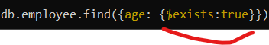

-$type bring documents which homePhone is of type String

-$regex bring documents where tittle has “Support” ignoring case

-$all select docs where the value of the field is an array which contains all specified elements. returns docs with Florida and Ohio included no matter if there is any other
-$elemMatch hobbies is a property which has a embedded document, take a look to hobbies.title = Voley and hobbies.frequency gte 3 if both match the doc is returned

-$size hobbies array of size eq 3 then return the docs

-sort() product name asc, desc
-skip() skip first 2 elements sorted asc
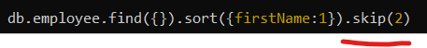
-limit() get only first document sorted desc
-count() product unit price gt 18

DB MOVIE COLLECTION MOVIEDATA

-update movie id mv07, vote average to 8.8
-$inc increase voteaverage of Titanic in 1
-$min if there are any vote average less than 7.6 then change it to 7.6

-$unset add a property to all documents in movie and then remove that property
-$push add language Portuguese to movieId mv08
-$pop delete the last language of movie id mv08
-$pop from beginning
-Delete movie mv05

-See available index

-explain query with execution stats
-create cluster index:
a clustered index is created by specifying the clusteredIndex option when you create a new collection using the db.createCollection() method. You cannot add a clustered index to an existing collection. The clusteredIndex key must be { _id: 1 }
-create non clustered index
In MongoDB, all standard indexes (single-field, compound, multikey, etc.) are non-clustered secondary indexes by default. MongoDB automatically creates a unique, non-clustered index on the _id field for every collection unless a clustered index is explicitly specified during collection creation.

-create compose index
CombinedIndex: db.inventory.createIndex( { "item": 1, "stock": -1 } )
-create unique index
db.users.createIndex({ username: 1 }, { unique:true, name: "custom_username_index"})

-create text index
db.products.createIndex({ description: "text" });
After creating the index, you can perform a text search using the $text operator:
db.products.find({ $text: { $search: "silk" } });

-hash index
db.users.createIndex( { user_id: "hashed" } )

-drop an index
Db.employee.dropIndex(“indexName”)
-$match get employees, single males using aggregation
-$group, from previous example group based country and location as id and count of it
-$sort, add sorting removing the count and just leaving country and state
-$project aggrupation, show gender marital status and name, hide id
db.orders.aggregate([
// Stage 1: $match - Filter active orders
{
$match: {
status: "active"
}
},

// Stage 2: $group - Calculate total spent per customer
{
$group: {
_id: "$customerId",
totalSpent: { $sum: "$amount" }
}
},

// Stage 3: $sort - Sort customers by total spent in descending order
{
$sort: {
totalSpent: -1
}
},

// Stage 4: $lookup - Join with the 'customers' collection to get customer names
{
$lookup: {
from: "customers", // The collection to join
localField: "_id", // Field from the input documents (from $group output, which is customerId)
foreignField: "_id", // Field from the "customers" collection
as: "customerDetails" // Output array field name to add to the input documents
}
},

// Stage 5: $project - Reshape the output documents
{
$project: {
_id: 0, // Exclude the default _id field
customerName: { $arrayElemAt: ["$customerDetails.name", 0] }, // Get the first name from the customerDetails array
totalSpent: 1 // Include the totalSpent field
}
}
]);

SQL

Países cuya suma acumulada de población no supera el 50% del total global
SELECT NAME
FROM (
SELECT NAME,
SUM(POPULATION) OVER (ORDER BY POPULATION DESC) running,
SUM(POPULATION) OVER () total
FROM countries
) t
WHERE running <= total * 0.5;

Paises con area mayor que el promedio de los países con nombre mas corto Comparar where contra el resultado de un query
select c.name
from countries c
where area_km2> (select avg(area_km2) from countries
where length(name)= (select min(length(name))
from countries))

Países con 2 vocales seguidas
Select name from countries where name regexp “[aeiou]{2,}”
Regiones donde la desviación (max-min) de población es mayor a 50M
Select región_id from countries group by region_id having max(population)-min(population)>50000000

Países con doble consonante
Select name from countries
Where capital regexp ‘([bcdfghjklmnpqrstvwxyz])\\1’
Países con suma acumulada de población mayor a 500M
Select name from
(select name, sum(population) over(order by population desc) running
From countries)t )
Where running>500000000

País cuyo nombre es substring de su capital
Select name from countries where capital like concat(‘%’,name,’%’)

Países con 2 vocales juntas en el nombre
Select name from coutries where capital regexp(‘[aeiouAEIOU]{2}’)

Países donde la población sea mayor q la suma de población de los 2 paises mas pequeños
Select name, population from countries where population > ( select sum(population) from (select sum(population) from countries order by population limit 2) t)

Países cuya población NO esta entre 2000000 y 10000000
Select name, population from countries where population NOT BETWEEN 2000000 AND 10000000

Paises que tienen al menos otro país en su misma región
Select c.name, c.región_id from countries c where exists(select 1 from countries cc where c.name!=cc.name and c.region_id=cc.region_id

Países cuyo nombre contiene más vocales que consonants
select name
from countries
where length(REGEXP_REPLACE(name, '[^AEIOUaeiou]',''”))
>
length(REGEXP_REPLACE(name, '[AEIOUaeiou]',''”))

Países que son palindrome
select name
from countries
where name=Reverse(name)

Países con exactamente 1 espacio en el nombre
select name
from countries
where length(name) - length(replace(name, " ", ""))=1

Países que tienen la misma área que otro en distinta region
select c.name, c.area_km2
from countries c
join countries cc
on c.AREA_KM2=cc.AREA_KM2 and c.REGION_ID!=cc.REGION_ID

Diferencia de población respecto al siguiente
SELECT NAME, POPULATION,
POPULATION - LEAD(POPULATION) OVER (ORDER BY POPULATION DESC) diff
FROM countries;

Diferencia entre país y líder de su region
SELECT NAME,
POPULATION,
MAX(POPULATION) OVER (PARTITION BY REGION_ID) - POPULATION AS diff
FROM countries;

Write a query identifying the type of each record in the TRIANGLES table using its three side lengths (ONLY GETTING THE VALUE OF THE CASE, NOT NEED TO SELECT ANY COLUMND!, A, B, C ARE THE COLUMNS AND ARE USED DIRECTLY IN THE CASES)
SELECT
CASE
WHEN (A + B <= C) OR (B + C <= A) OR (A + C <= B) THEN 'Not A Triangle'
WHEN (A = B AND B = C) THEN 'Equilateral'
WHEN (A = B OR B = C OR A = C) THEN 'Isosceles'
ELSE 'Scalene'
END
FROM TRIANGLES

LOWER AND CONCAT USES
SELECT CONCAT('There are a total of ', COUNT(OCCUPATION), ' ', LOWER(OCCUPATION),'s.')

Query a list of CITY names from STATION for cities that have an even ID number. Print the results in any order, but exclude duplicates from the answer.
SELECT DISTINCT CITY FROM STATION WHERE ID MOD 2 = 0

Find the difference between the total number of CITY entries in the table and the number of distinct CITY entries in the table.
SELECT COUNT(CITY) - COUNT(DISTINCT CITY) FROM STATION

Query the two cities in STATION with the shortest and longest CITY names, as well as their respective lengths (i.e.: number of characters in the name). If there is more than one smallest or largest city, choose the one that comes first when ordered alphabetically.
(SELECT CITY, LENGTH(CITY)
FROM STATION ORDER BY LENGTH(CITY) ASC, CITY ASC
LIMIT 1)
UNION ALL
(SELECT CITY, LENGTH(CITY)
FROM STATION ORDER BY LENGTH(CITY) DESC, CITY ASC
LIMIT 1)

Query the list of CITY names from STATION which have vowels (i.e., a, e, i, o, and u) as both their first and last characters. Your result cannot contain duplicates.
SELECT DISTINCT CITY FROM STATION WHERE LEFT(city, 1) IN('a','e','i','o','u') AND RIGHT(city, 1) IN('a','e','i','o','u')

Regiones donde todos los países tienen población > 1M
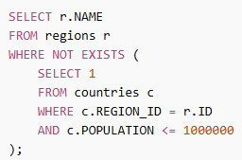
Países cuya población está arriba del 75% percentil (aprox)
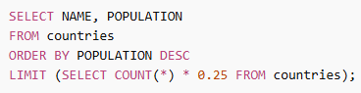
Países con capital NULL
SELECT NAME
FROM countries
WHERE CAPITAL IS NULL;

Países con población mayor que ANY de la región 2
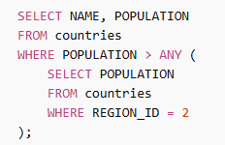
Países donde el nombre tiene más de 10 caracteres
SELECT NAME
FROM countries
WHERE LENGTH(NAME) > 10;

Países cuyo nombre empieza con 'M'
SELECT NAME
FROM countries
WHERE NAME LIKE 'M%';

Join con regiones y subregiones
SELECT c.NAME, r.NAME AS REGION, s.NAME AS SUB_REGION
FROM countries c
LEFT JOIN regions r ON c.REGION_ID = r.ID
LEFT JOIN sub_regions s ON c.SUB_REGION_ID = s.ID;

Cantidad de países por región
select r.name, COUNT(*) as total_countries
from countries as C
join regions as r on c.REGION_ID=r.ID
group by r.name

Países con población mayor al promedio
select name, population
from countries
where population > (select AVG(population) from countries)

Regiones con más de 30 países
select r.name, count(*)
from countries c
join regions r on c.REGION_ID=r.ID
group by r.name
having count(*)>30

Ranking de países por población
SELECT NAME, POPULATION,
RANK() OVER (ORDER BY POPULATION DESC) AS ranking
FROM countries
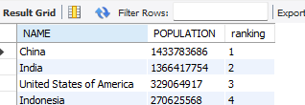

Top 3 países por region
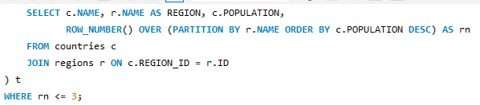
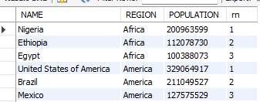

Diferencia de población respect al promedio:
select name, population -(select AVG(population) from countries)
from countries

Pais con mayor población por región
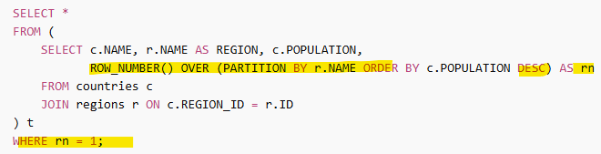

Subregión con mayor área total
SELECT s.name, sum(c.AREA_KM2) as total_area
from countries as c
join sub_regions as s on s.ID=c.SUB_REGION_ID
group by s.name
order by total_area DESC
limit 1
-create trigger
Pais de la subregión con mayor población que el resto de la misma subregión
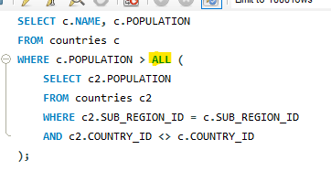

Porcentaje de población por país dentro de su region
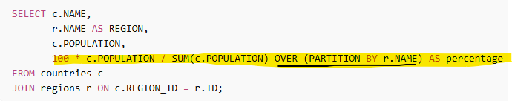

Países de la misma región q mexico
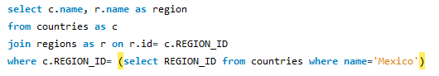

DELIMITER $$
CREATE TRIGGER logOrder
AFTER INSERT
ON orders
FOR EACH ROW
BEGIN
SET @last_client_id = NEW.customer_id;
SET @quantity = NEW.quantity;
SET @product_id = NEW.product_id;

SET @customerName = (SELECT customer_name from customers where customer_id= @last_client_id);

INSERT INTO log(description, quantity, product_id) VALUES (CONCAT('client was: ',@last_client_id), @quantity, @product_id);

END$$

DELIMITER ;
-create stored procedure
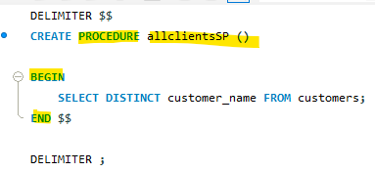
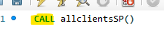

- second biggest

- sql transaction (use inside stored procedure to add rollback and handle exceptions)
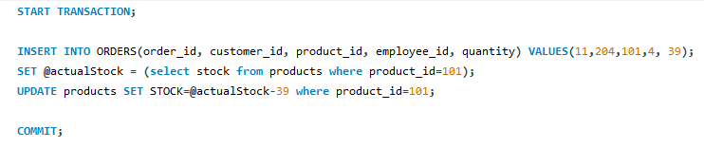
- default value
- create view and materialized view
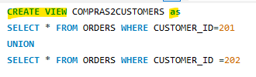
MATERIALIZED NOT AVAILABLE IN MYSQL BUT YOU CAN CREATE A PHYSICAL TABLE FROM A SELECT:
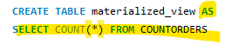

IN POSTGRES:
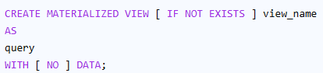

-unique constraint
-add constraint to table
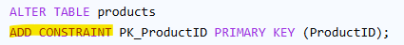
- count(), avg(), sum()
- union
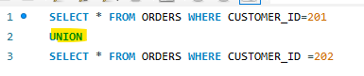
-create use cursor
- create index, unique index, text index
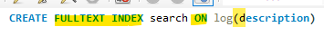
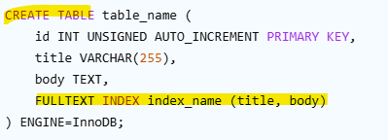

In MySQL (specifically for the default InnoDB storage engine), all indexes other than the primary key are inherently non-clustered, or "secondary" indexes. You cannot explicitly use a NONCLUSTERED keyword in MySQL; the CREATE INDEX statement automatically creates a non-clustered index.
In MySQL's InnoDB storage engine, you do not use a dedicated CREATE CLUSTERED INDEX statement. Instead, the PRIMARY KEY automatically serves as the clustered index.

-create local temporary table and global temporary table
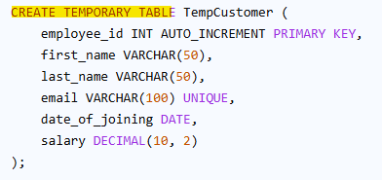

MySQL does not support CREATE GLOBAL TEMPORARY TABLE syntax; all temporary tables in MySQL are session-specific by nature. They are visible only within the current connection and are automatically dropped when that session ends.

- update values
-primary and foreign key
CREATE TABLE log(id int PRIMARY KEY, description varchar(300), quantity int, product_id int,
CONSTRAINT products_fk FOREIGN KEY (product_id) REFERENCES products(product_id))

ALTER TABLE orders ADD PRIMARY KEY(order_id)

-Where between, in, like

- distinct only
Select distinct employee_name from employees

-having
-joins
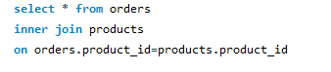
-intersect
-except
-change transaction isolation levels
-exists
-rank()
-row_number()
-CTE

-offset
-partition
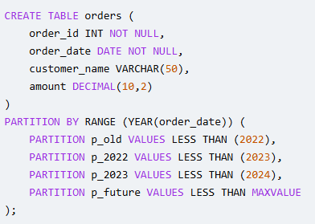

-sql string into date

-declare variable
SET @customerName = (SELECT customer_name from customers where customer_id= @last_client_id);

ANGULAR

Todo list, add remove tasks using signals array and htmlElement as a parameter of the addtodo, remove will remove elements in the signals array
Cart summing the total with computed signal and adding products to a signal

Filtrar por categoria y además dar otro filtro de texto sobre los ítems que quedaron de esa categoría
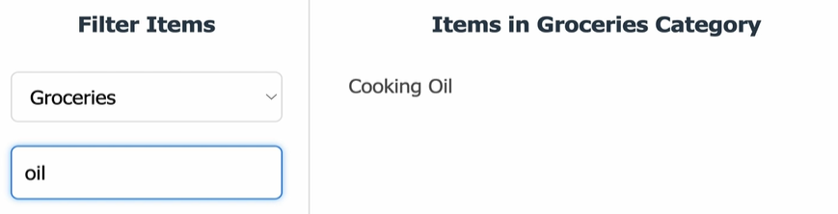

Créate ngrx store

Example using rxjs concat map and switch map

Example using rxjs merge map

Create a map un using rxjs from console its values

Create an observable with of with numbers, transform that observable with the pipe, map operator to multitply it by 2

Implement fetch from https://dummyjson.com/products/category-list and print the list in the screen

Create an observable which sends 4 numbers, then a timeout of 2 seconds and then sends the 5 number

Implement lazy loading and preloading in a component

Form group inside another form group using the validation touched to display a message if empty after focus

Addquery params when selecting a link to the url path
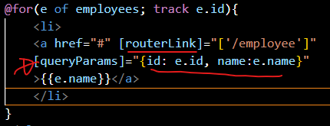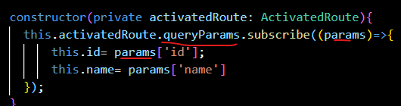

Employee component list of employees, click one and go to employee detail sending id and name as query parameters, will get those parameters in employee detail and will pring id and name taken from the query parameters

-print an array matrix
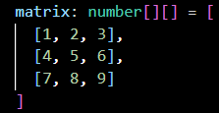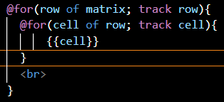

-add select and per option display with switch case statements
User display users with user role
Admin display users with admin role
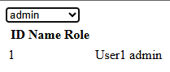

Change between dark and white mode with a button and [ngClass]

Add a form name, email, change color from red to green when enter data in name and when email is valid with ngStyle

If list has elements display them in a for else display ng template no items content using ng template outlet from ng container

Show a message enter name as long as there Is no text in the input

Create a method which updates and console a counter from 1 to 5 each second inside ngoninit

-add a defer block with @loading
@defer(on viewport){<p>hi message from {{user}}</p>} @placeholder{<p>initial hi</p>}@loading(minimum 3s){ <p>3 s message will display</p>}

-send an event from a child to a parent with output and show it with a signal
Child
Saludador = output<string>();
sendHi(message:string){ saludador.emit(message)}

Parent
<app-child (saludador)=agregarSaludo($event)>
agregarSaludo(saludo:string){ signalname.set(saludo)}

-send the key pressed in a input and alert its value
<input (keyup)=sendKey($event”)
sendKey(event: KeyboardEvent){
alert(event.key + “pressed”)

-disable a button based on a property
<button [disabled]=”aBooleanProperty”>

-send a property from parent into child with input.required
<app-child [user]=”userObj” />
On child:
User = input.required<User>();

-declare array
Numeros: number[] = [1,2,3]
Personas: Person[] = [{ name:”fer”, edad:40}]

-@for
@for(user of users; track user.id){
<p>{{user.name}}</p>}

-mouse over effect
<div (mouseover)=”mouseReceived()”>
mouseReceived(){ alert(“mouse received”)

- text interpolation
{{aProperty}}
-send a component as input to another component
@for(url of urlList; track $index){
<app-home-pictures [url]="url"/>}
Child
url = input.required<string>();

-lifecycle printing to see each phase
Logger component example
-ngSrc load images ex
<img [ngSrc]=”imagepath”>
-modify css style properties in tags
<button [style.background-color]=”isEnabled ? ‘blue’:’yellow’”>Clickme</button>
-keyup event example
<input type=”text” (keyup.enter)=”submit()”/>
-twowaybinding [()] write in input and immediately show in screen
Value = input/model<string>(‘’): //model will receive an output automatically
In child
{{Value}}
Parent
<app-child [(Value)]=”parentValue()”/>
parentValue = signal<string>(‘’);

-@if to display or not sections
@if(isProd){ <p>it is prod</p>}

-@for ant its contextual variables $count, $index.$first,$last,
@for(item of items; track $index){
{{item.name}}
}

-@switch
@switch(getScore()){
@case(‘A’){ <p> high score</p> }
@case(‘B’){ <p>regular score </p>}
@default {<p> failed </p>}

-pipes, pipe with parameter, create custom pipe, pipe on array or object
{{ aDate | date }}

For(item of array | slice 1:3 ; track $index; ) //from 1 to 3 exclusive is sent with pipe
{ <p> {{ item }} </p> }}
@let
@let user = $user | async; //async operation assigned to user

-ngmodel
Name: string = ‘’;
<input [(ngModel)]=”name” />

-create a form which validates range of age, and if email contains @ with reactive forms
formGroup = new FormGroup({
email: new FormControl(‘’, validators:[Validator.email, Validators.required],
age: new FormControl(0, validators: [Validators.min:18,Validators.max: 100]
})

-inject a service in a component, constructor and using inject
userService: UserService = inject(UserService)
constructor(private userService: UserService) //private will be available only in component

-@Input
Name = input<string>(‘’)

-vars with ? and ??
Console.log(user.name?) //is name is undefined wont return an error
Console.log(user.name?? ’defaultvalue’)
-#filter example on a list
Items: <string>[]{…elements}
searchFilter: string = ‘’;
filteredItems:<string>[…items];

filterElements(){
if(!searchFilter){
this.filteredItems = […this.items];
return;}

const loweredSearchFilter = this.searchFilter.toLowerCase();
this.filteredItems= this.items.filter(i=> i.toLowerCase.includes(lowerdSearchFilter))}

-Element reff to change style color
-create routes file
-routes with multiple route parameters, all routes for a path
-get the actual page parameters with activated route
-redirect to another route
-children routes
-router outlet
-routerlink
-multiple router outlet in same component
-router.navigate()
-create signal var and show it in template
-create Angular type object
-ngonInit
-initialize an angular type signal var from a service on ngoninit
-client call
-observable .pipe, .subscribe
-create custom directive
- ngclass
-union example
- computed expression
-effects
-linkedsignal, array of options might change, selected one option linked signal from array options make sure it has proper value, if the array of options changed then the selected value should also change
-component attribute and class selectors
-ng-content
-add remove objects from array
-ngStyle
-ngClass
-@Output
-@ViewChild
-viewContainerRef to load a component
-Observable
-create a jasmine test
-fetch from back end service
-filter result
-inject ElementRef and updates background of an element
-loadChildren example
-redirect path to another path
In routes:
{ path:’login’, redirectTo: ‘/register’}

- Add a nested route
{
path: ‘employees/:id’,
component:’EmployeeComponent’,
Children:[
{Path:’info’,
Component: EmployeesInfo}, //employees/123/info
{path:’profile’,
Component:’EmployeeProfile’} //employees/456/profile
]
- Create a nested route structure where the parent component has a nav bar with routerlinks and when you click one the section of the page below changes based on the component (with router-outlet)
-multiple outlets in same component with <router-outlet name=”read-more=/> and outlet property inside routes file

- router.navigate when clicking in a button navigate to another path
-console the actual path and path params
-create a computed signal
Name = signal<string>(‘Fer’);
computedEx= computed(()=> value.toUppercase()); //never has a input parameter
{{computedEx()}} //prints FER

-create an effect
Effect(() =>{ log.info(‘updated signal to Unused state’}
-create an effect with untrack (this untrack changes of state will not trigger the effect)
Effect(() => { `the counter increases: $count and the user is ${untracked(counter)} `}

-add a token into the localStorage
localStorage.setItem(‘tokenName’, ‘jwt value’);

-add ng content

In component cards html
<ng-content select=”body”>
Using the component in parent html
<cards>
<body><p>body to add</p></body>
<cards>

-view child example
Component has in its html <input #nameInput…>
In its ts file
@ViewChild(‘nameInput’) inputElement: ElementRef;
ngAfterViewInit(){ this.inputElement.nativeElement.focus(); }

-example with ng-content, ng-template and ng-template-outlet
<ng-content select=”header”><ng-content> //parent will sent content to replace it
(<child><h1 header>Header to replace in child</h1></child>

<ng-template #randomTemplate>
{{randomNumber}}
</ng-template>

@if(randomNumber){
<ng-container *ngTemplateOutlet=”randomTemplate”>//template replace here
}

-add element to array, remove first, remove last added, keep first half

-add a style with ngstyle, add a class with ngClass
<h2 [ngClass]=”randomNumber%2==0 ? ‘vipClass’ : ‘poorClass’”>

-load a component with ngComponentOutlet

KAFKA
-implement:

-Generate kafka message and consume it
-Create multi partition, multi group consumer example
-send a message with key and validate it will go to same partition
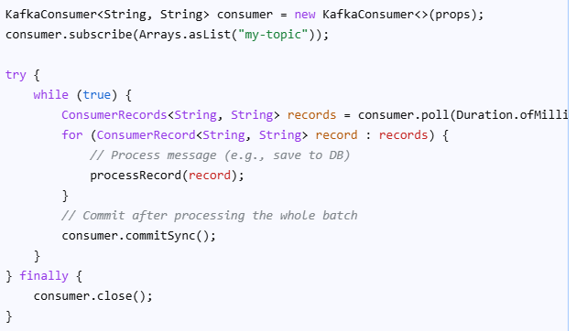
-Create a kafka transaction

THREADS
-create a virtual thread from thread builder, factory and executor
Thread.Builder.ofVirtual().unstarted(runnable)
Thread.ofVirtual().factory().new Thread(runnable) //create factory and a thread from it
Executors. newVirtualThreadPerTaskExecutor().submit(runnable)
-force to wait daemon threads to complete before exiting with latch
CountdownLatch latch = new CountdownLatch(2) //count to end main
… latch.await() //will wait until count goes to 0 (after 2 daemon threads)
…latch.countDown() //rest 1 to current count
-create executor service for virtual threads
ExecutorService es =Executors.new newVirtualThreadPerTaskExecutor()
Es.submit(callable/runnable), es.execute(runnable only)

-submit a task and validate the response if it is done and get its result
Future<Product> future =ExecutorServiceins.submit(()->Client.getProduct(1));
If(future.isDone()) return future.get();
-Semaphore example
Semaphore s = new Semaphore(2); i=0;
While(i<100){ s.aquire() sout(“semaphore”); i++; s.release()};

-create a scheduler with virtual threads
ThreadFactory f = Thread.ofVirtual().factory();
ScheduledExecutorService s=Executors.newScheduledThreadPool(1, f);
s.scheduleAtFixedRate(()->{…}, 1,2,TimeUnit.Seconds) //delay 1, cada 2 segundos
s.shutdown()
-create local thread
ThreadLocal<String> tl = new ThreadLocal<>();
Tl.set(“tokened”); tl.get()
OR
ThreadLocal<String> tl = ThreadLocal.withInitial (()->“Example”)

-create ScopedValue (jdk 25 improved thread local)
ScopedValue<String> SESSION_TOKEN = ScopedValue.newInstance().
ScopedValue.where(SESSION_TOKEN, “sesion123”).run(()->{check()}); //check prints SESSION_TOKEN successfully, after ending run() value is removed

Spring Boot
-Import with @Value and @ConfigurationProperties
-init detroy methods
-exclude an auto configuration
-create an interceptor
-create an exception
-use actuator
-transactional
-implement optimistic locking, pessimistic locking
-create a one to many, many to one
-spring security authentication flow
-use aop
-spring security implement custom entry point, denied handler, invalid session page, concurrent session for same user to just 1 and deny at login if a second same user wants to login, authentication events, onsuccess, on failure, authentication success handler, authentication failure handler, invalidate http session and delete cookies
-normal mvc that injects a @ModelAttribute from a form and redirects to a view, if the form has errors refirect to the submit form page and highlight the errors
-activate different profiles
-create a open feign client
-circuit breaker with fallback method, limit and retries
-saga pattern
-distributed tracing ex
-create a gateway
-implement cache
-implement kafka
Added kafka starter dependency on producer and consumer, added properties on both with kafka server and producer, consumer, added a producer with kafkatemplate (injected by spring), send a message, added a consumer with @KafkaListener adding topic and groupId and received the message.
To visualize kafka topic, partitions, replicas I used kafka ui, created a compose file and added kafka with zookeeper dependency (must had been an older version of kafka) then added provectuslabs/kafka-ui:latest as service, created a network for them to communicate and run the docker compose file, took a look in the declared port for kafka ui and it shows the dashboard.
To add a second broker add a second service in the compose file same as the broker but changing ids and ports, needed to change replication factor and partitions in the topic(with a bean for the topic) and add the second port in the yaml properties
If replicas are not correct, probably existed before both brokers were there or failed in automatic creation, could create it in kafka ui or rebalance it

- implement kafka with spring cloud streams

Created a bean for producer but it was sending messages each second, we can use poller fixed delay to avoid it but since I was using streamBridge to send the message it was not needed anyway so commented it, added a consumer to consume the message sent by the producer, a configuration bean, it can be a supplier if you just want to consume, but I added it as a Function to forward it into another topic.
Added spring-cloud-starter-stream-kafka in pom and its dependency management, and in properties need to configure the functions definitions name (method name in the consumer and binding name in the send stream bridge of the producer, configure destination (the topic it goes to) and the bindings for in and out methods for each function definition (appending in/out-0) and binder to the kafka broker servers

Kafka provectuslabs/kafka-ui image used to see kafka details in a dashboard, topics, brokers, replicas, messages, current offsets, etc

- Add another broker KAFKA WILL NOT REBALANCE AUTOMATICALLY
Run another docker container changing ids and ports and adding network, it wont move partitions automatically or start using the new broker by itself, need to reassign partitions (created a json file with topics and ran the kafka-reassign-partitions inside docker (needed to copy the file inside docker as well))
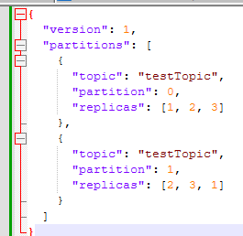

- Add another partition
Run a command inside docker with topic and new partitions adding –-alter flag, run reassignment againg to balance load across brokers, existing data is not redistributed, new starts empty, YOU CAN ADD BUT CANT DECREASE THEM, IT NEEDS TO CREATE NEW TOPIC WITH DESIRED PARTITIONS AND WRITE A PROGRAM TO COPY IT TO THE NEW TOPIC

- Create a topic with 4 partitions
docker exec -it broker kafka-topics --create --topic orders --partitions 4 --replication-factor 3 --bootstrap-server broker:9093
-validate topic
Docker exec -it broker kafka-topics –describe –topic orders –bootstrap-server broker:9093
- Create topic in spring boot

@Bean
Public NewTopic ordersTopic(){
Return TopicBuilder().name(“orders”).partitions(3) .replicas(2).build(); }

- Ms that saves an event to a nosql db and forwards it to another to also save
Added a inventory ms which gets a message in to the notificationTopic and then send to a processedOrdersTopic, using a @Bean with a function which receives an Order alter it based on inventory and returns the order which can be later consumed for the order which originally created it to mark its status and if failed trigger a compensating action

- Fix uneven leader distribution (same leader for all replicas)
Docker exec -it broker kafka-leader-election –bootstrap-server:9093 –election-type:preferred –all-topic-partitions //kafka redistributes leaders to balance

- Increase replication factor
Create json adding topic, partition and replicas and run it in docker kafka-reassign-partitions

- Lag on consumer of 100
docker what is the use of docker exec -it broker kafka-consumer-groups --bootstrap-server broker:9093 --describe --group my-consumer-group
Este comando se utiliza para monitorear el estado y el progreso de un grupo de consumidores específico, info de topic, particiones y lag del grupo
Con esto identificas si es necesario incrementar particiones, incrementar consumers, si tienes menos consumers que partitions, sube consumers para igualar partitions, si ya hay igual numero entonces incrementa partitions y consumers, ver si se están distribuyendo equitativamente entre partitions

-how to guarantee same events must be ordered
Use same key on them for the same partition to be chosen and partitions does keep order

-simulate broker failure
Stop a broker (docker stop broker)
New leader elected

Fix SerializationException (Can't convert value of class [B to StringSerializer)
Add kafka producer value serializer property or in streams output content type

- Add consumers
@KafkaListener(topics = "orders", concurrency = "4")
public void listen(String message) {
System.out.println(message);
}

- eureka server
- Add a project with eureka server dependency, added properties to not auto register and the port 8761, add service name and port 0 to all ms also added the default zone to find eureka server (no longer needed to add @EnableEurekaClient)
- eureka needs spring-cloud-starter With Spring Boot 4 + Spring Cloud 2025, you must include the base starter or autoconfiguration may not fully kick in. Eureka client needs a web environment. spring-boot-starter-web added to all ms clients.

- Gateway
Added the project with gateway reactive (load balancer working with it) added the properties port, app name, and the routes from the microservices it will gateway, added as a eureka client as well, prefer-ip-address: true because if not it will not resolve to the correct service.
Add prefer-ip-address: true in the eureka properties to all ms

Feign Client
Added a feign client in the orders ms to validate in the inventory ms if there are availability before creating the order (createSafeOrder), in order to create it, I had to add the feign client dependency in pom xml, add @EnableFeignClient, create a @FeignClient interface with the name of the service (as it is registered with eureka), the method and the path of the request in order to call the inventory ms:
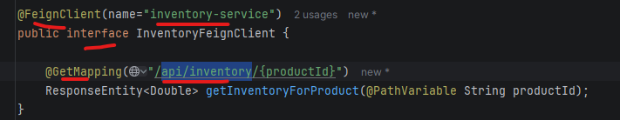
The use the feign client:
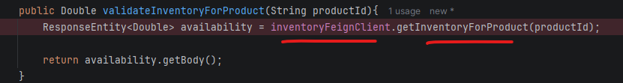
Inventory service used to be a event driven endpoint only, had to add a rest endpoint, add the service to the gateway configured routes and be sure it is registered with eureka client.

- Circuit breaker
Added the circuit breaker dependency, it also must have aop dependency because circuit breaker works with aop, added circuit properties, annotate a method with @CircuitBreaker name=same as in property instances in yml. And fallback method,
Fallback method should be in same class with same signatura but adding parameter Throwable ex.
After each time the annotated circuit breaker method fails, it will trigger the fallback method. This example is calling another ms I confirmed that while the state of the circuit is closed it was reaching the inventory ms, once it changed to opened the inventory ms was not triggering, once the waitDurationInOpenState: 30s passed, it was now again triggering the inventory ms.
Open feign was configured in properties to have a connectTimeout for the testing of circuit breaker to work
The annotated method with @CircuitBreaker was moved to another @Service, it works with proxies, I was calling it from the same class so it wont work, unless it is called from outside. Also I had this class injected with @AllArgsCostructor but with the final identifier, so proxies wont work for final classes, I had to remove the final keyword for it
@EnabledAspectJAutoProxy as well in the application

- Failed messages into db to retry later
Added dlq for the topic (configured it to retry 3 times with a 2 seconds interval, if failed then the message will be send to the dlq topic) then added a consumer function stream to listen on the dlq topic and it will insert the failed order into the db with some extra properties like retries, to control how many times we want to retry to complete the message. Then added an scheduler, needs to enable scheduling, the scheduler is running each 30 seconds, retrieves data from the db with the failed messages, using stream bridge send that message into the notificationTopic again so the inventory will re run it, if success then it removes from db if not increase retry count to make sure it will not run in circles forever.

- Failed messages into a topic-based retry pipeline, several topics to attempt after time instead of saving it into a database:
notificationTopic
↓
retry-5s-topic
↓
retry-30s-topic
↓
retry-5min-topic
↓
DLQ (final) (no more attemps for this topic)

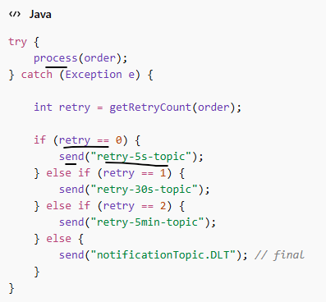

Implement dlq (DLQ (o Dead Letter Topic - DLT como se le llama en Spring Kafka) but without kafka streams using kafka listener and @RetryableTopic
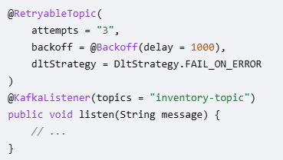

- Added validation to dlq to retry only retryable exceptions like timeouts
by adding a property, catch an exception in the function processing and if it was timeout throw custom retryableexception which was configure to do retry

- Added retry to circuit breaker method
By adding @Retry(name=nameInPropertiesOfRetry) to the method annotated with @CircuitBreaker.. ORDER MATTERS BECAUSE AOP, NEED TO BE @CIRCUITBREAKER THEN @RETRY BECAUSE IF IT IS INVERSED IT WILL GO DIRECTLY TO CIRTUIT BREAKER FALLBACK WITHOUT RETRYING.
TO WORK FALLBACK SHOULD NOT BE CONFIGURED IN CIRCUIT BREAKER OTHERWISE IT WILL GO THERE WITHOUT RETRY, ADD APPART THE FALLBACK MANUALLY AFTER RETRIES IN THE FLOW

- Add Saga Pattern
Added saga pattern between the orders and inventory ms, added a endpoint in orders for a saga pattern flow, this calls the service which gets the orderdto and sends it using streambridge to the inventoryTopic, created a stream function in inventory so it will listen to inventoryTopic and execute the update into the database of the quantity (pending to add another topic so it will restore quantity for failing orders), it will then send the result as inventoryresultevent into the inventory-result-topic, added a consumer in orders listening to this topic and execute the update of the order to CONFIRMED or CANCELLED, here I could modify it to a function, send it to another queue for inventory to update if CANCELLED

- Add distributed tracing
We tried to add distributed tracing using Grafana tempo, Grafana loki and Grafana, version incompatibilities failed to send spans to the requests so it didn’t work that part. ran docker containers for the 3 grafana services, it required properties added into docker for tempo and loki to be able to connect and have permissions. Then in Grafana localhost 3000 added as data sources loki port 3100 and tempo port 3200, it was http://loki:3100, localhost didn’t work since it is inside docker and didn’t recognize it. Then added a derived field in locke for the trace_id to link it with tempo.
Added dependencies and properties (not working for spring boot 4 yet). Needs the streambridge to not used withPayload and instead just send the entity and leave spring configure it, it needs the headers added which is what keeps the trace id across ms

- Added JWT token with oauth authentication
For this case added an endpoint in the gateway for the login, with url permitted in the security filter, this will return the jwt token generated with the secret key.
Added dependencies, and a Jwt util bean which generates the jwt token based on a secret key and also a validates method which also uses the secret to validate. Then need to send the authorization bearer with that token on the requests, since the microservices also have the secret they can validate the jwt token to allow the resource

-bulkhead pattern
-kafka security layer
-@async, @enableasync
-create a mongo repository
-@Transactional all propagation and isolation with retry

JAVA
Stream sort entry set for key or for value:
Comparator null last to sort and leave null at the end, it has also null first
Collectors.partitioningBy
Collectors.teeing()

Get average age
double avg = people.stream()
.collect(Collectors.averagingInt(Person::getAge));

Duplicados
Set<Integer> duplicates = numbers.stream()
.filter(n -> Collections.frequency(numbers, n) > 1)
.collect(Collectors.toSet());
Implement Saga Orchestration example:
import java.util.ArrayList;
import java.util.List;
import java.util.function.Consumer;
import java.util.function.Supplier;

// Represents a step in the saga, with an action and a compensating action
class SagaStep<T> {
private final String name;
private final Supplier<T> action;
private final Consumer<T> compensation;
private T result; // To store the result for potential compensation

public SagaStep(String name, Supplier<T> action, Consumer<T> compensation) {
this.name = name;
this.action = action;
this.compensation = compensation;
}

public void execute() {
System.out.println("Executing step: " + name);
this.result = action.get();
}

public void compensate() {
System.out.println("Compensating step: " + name);
if (compensation != null && result != null) {
compensation.accept(result);
}
}
}

// The central orchestrator that manages the transaction flow
class SagaOrchestrator {
private final List<SagaStep<?>> steps = new ArrayList<>();

public void addStep(SagaStep<?> step) {
steps.add(step);
}

public void runSaga() {
List<SagaStep<?>> completedSteps = new ArrayList<>();
try {
for (SagaStep<?> step : steps) {
step.execute();
completedSteps.add(step);
}
System.out.println("Saga completed successfully.");
} catch (Exception e) {
System.out.println("Saga failed: " + e.getMessage());
// Rollback: compensate for all completed steps in reverse order
for (int i = completedSteps.size() - 1; i >= 0; i--) {
completedSteps.get(i).compensate();
}
System.out.println("Saga compensation complete.");
}
}
}

// --- Mock Service Clients (representing different microservices) ---

class OrderClient {
public String createOrder() {
System.out.println("Order Service: Order created (PENDING).");
return "orderId123";
}
public void cancelOrder(String orderId) {
System.out.println("Order Service: Order " + orderId + " cancelled.");
}
}

class PaymentClient {
public String processPayment(String orderId) {
System.out.println("Payment Service: Processing payment for order " + orderId + ".");
// Simulate a potential failure
if (Math.random() < 0.2) { // 20% failure rate
throw new RuntimeException("Payment failed");
}
System.out.println("Payment Service: Payment successful.");
return "paymentId456";
}
public void refundPayment(String paymentId) {
System.out.println("Payment Service: Refunding payment " + paymentId + ".");
}
}

class InventoryClient {
public String reserveStock(String orderId) {
System.out.println("Inventory Service: Reserving stock for order " + orderId + ".");
System.out.println("Inventory Service: Stock reserved.");
return "reservationId789";
}
public void releaseReservation(String reservationId) {
System.out.println("Inventory Service: Releasing reservation " + reservationId + ".");
}
}

public class SagaDemo {
public static void main(String[] args) {
OrderClient orderClient = new OrderClient();
PaymentClient paymentClient = new PaymentClient();
InventoryClient inventoryClient = new InventoryClient();

SagaOrchestrator orchestrator = new SagaOrchestrator();

// Add steps to the orchestrator
orchestrator.addStep(new SagaStep<>("Create Order",
() -> orderClient.createOrder(),
orderClient::cancelOrder));

orchestrator.addStep(new SagaStep<>("Process Payment",
() -> paymentClient.processPayment(/*...*/"orderId123"), // Pass necessary data
paymentClient::refundPayment));

orchestrator.addStep(new SagaStep<>("Reserve Inventory",
() -> inventoryClient.reserveStock(/*...*/"orderId123"),
inventoryClient::releaseReservation));

// Run the saga
orchestrator.runSaga();
}
}

Java min heap
Implementing a Min-Heap in Java creates a binary tree (typically stored as an array) where the parent node is always smaller than its children, with the minimum element at the root. The objective is to efficiently manage a collection with lookup for the minimum element, and for insertion and extraction
PriorityQueue<Integer> minheap = new PriorityQueue<>();
Singleton with instance properties
CANT be sending the properties inside the getInstance()
CANT call the constructor either
Whe can declare a private static final of the instance which calls the private constructor (no args) we could have default properties for the instance, in a db a default connection for example, and then provide setters and getters for making changes
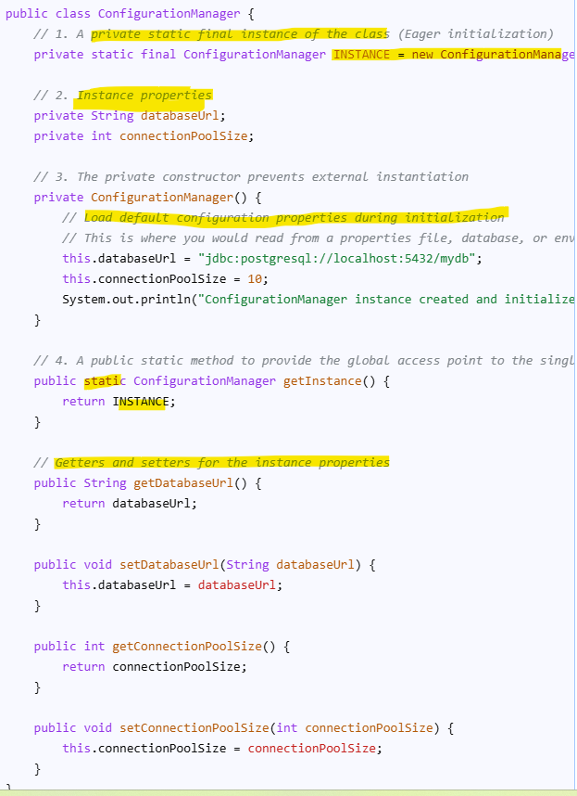
Implement Stack using queue
The poll() method in Java's Queue interface is used to retrieve and remove the head (first element) of the queue. This method returns null if the queue is empty
Poll vs remove, if empty poll send null remove sends no such element exception
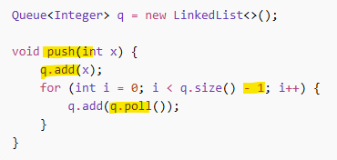

Find common elements in 3 arrays
El método set.retainAll(Collection<?> c) en Java modifica un conjunto (Set) conservando únicamente los elementos que también están presentes en otra colección especificada, eliminando los demás. Es la forma estándar de realizar una operación de intersección entre conjuntos, devolviendo true si el conjunto original cambió
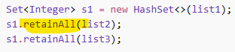

Basic Rate limiter
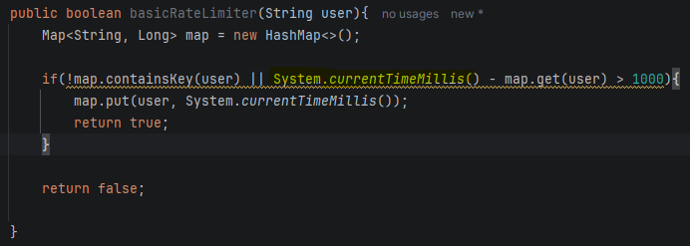
Créate reactive endpoint
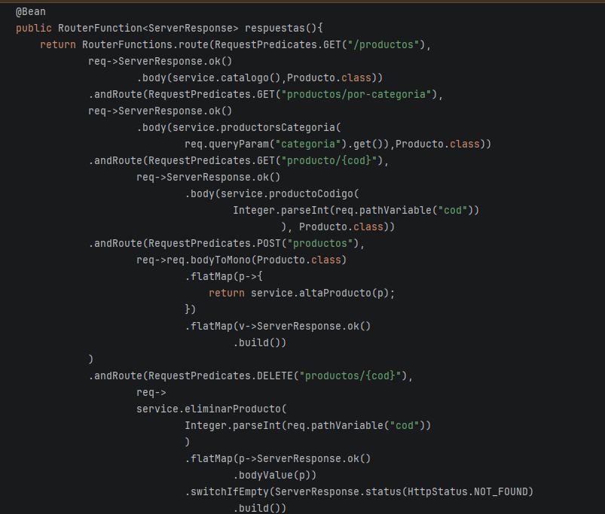

Créate optimistic, pesimistic locking

Redis sesión between ms

Grafana alarm and logging trace

Config server with github

Use rest client

Jwt security filter

Normal mvc app crud

Aspect for logging before and after accessing

Spring data jpa projection

Spring data criteria, QuerydslPredicateExecutor, JpaSpecificationExecutor

Spring data pageable, page examples

Spring data cascades example and validation

Implement circuit breaker with retry with delay and randomnes so al retries wont be at the same time, fallback method, bulk pattern, feing client, rate limiting configured at gateway level

Configure dlq in kafka with error handler

Spring gateway route locator bean

@Transactional requires, y todas las otras opciones

@PreAuthorize, @PreFilter, post examples
Implement CQRS example
Implement saga
Create spring cloud functions and invoke them as rest endpoint

Create graphql to query (read) and mutation(write) ex

Graphiql
Access to the information of available operations like swagger for rest without manual configuration but need to add the dependency for it
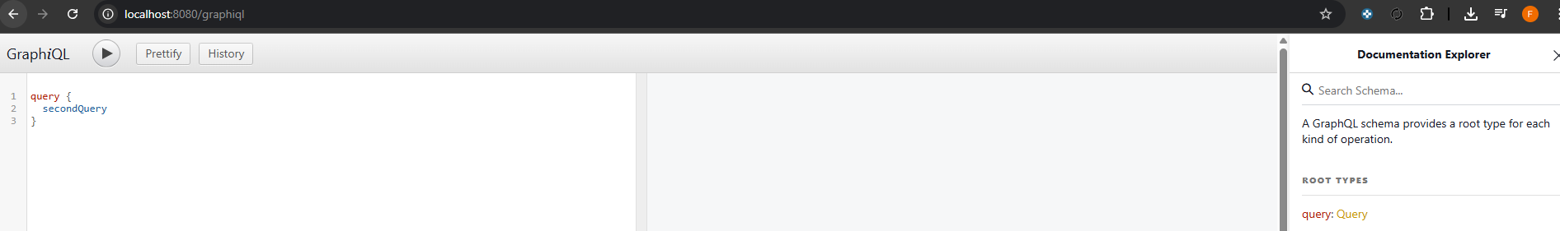
Using altair chrome plugin, and hitting graphql endpoint
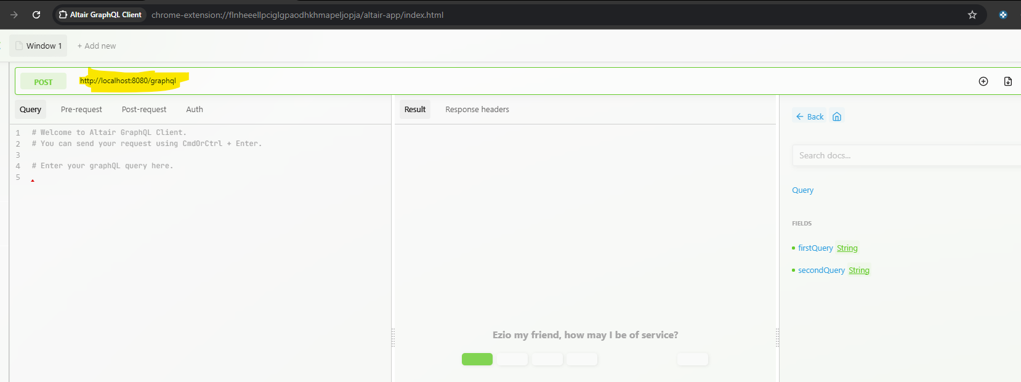

All Graphql converter with filters, list

