Part 1- Impact of the different model parameters and network characteristics in the predictin performance using BMRF.

Using human and yeast data, we choose values for the differnet model parameters (Appendix I, tables 1-3). Then, using chicken data, we defined a network for this species. The conclusions were as follows:

(i) Using human data
- Using domain information increases the overall performance considerably (0.043 higher AUC). Thus, domain information will be used

- The filters of number of GO terms does not seem to have an effect. However, this may be the case only in those cases in which the number of GO terms remains high.

- Increasing the number of folds in the k-validation from 2 to 5 or 10 leads to an improvement of AUC of 0.026 and 0.037, respectively. K:10 will be used whenever possible.

- Due to time constrains, we will apply the filterminGOsize:20 and maxGOsize:0.1. However, the anlaysis could be extended to GO terms withminGOsize>9.

(ii) Using yeast data

- The GO-size filters affect the overall prediction perfoamnce. We observed that as the filter form ninGOsize becomes more strict and the filter for mxGOsiuze beceome less strict, the overall predeiction performance increases.
- the GO-size filter seem toi cause e some alterations at the level of individual GO terms. In line with this, the preditiocn of one GO term are not enterlly indeoendt of the other GO terms considerd in the analysis.
- We will perform the anlaysis with 20 replicates
- Subsetting...

(iii) Using chicken data

- A peasin correlation of 0.35 will be considered

(iv) Other conlcussions.
- Non-validated data seem to be more reliable for yeast than for humans.

Then, we investigated which characteristics in the network data have a larger impact of the prediction performance. For this, we used data from different species, since the network data differs considerably between these (Tables 7-9 in Appendix I). For a more detailed description of the differences in data between the species, as well as the data sources, see Tables 4-7 and Illustraions 1-3 in Appendix I.

The main conclusions from part 1b are:
- epp/tpepp seem to be the network parameter with a larger impact in the prediction performance.
- The epp/tpepp standirez is very smilar for the species considered.
- Reducing Epn increases the perfomance
- Approaches like Positive-Unlabelled learnig can improve these parameter.

Part 2 – BMRF results

Table 1: Overall prediction performance for the differnet speciesusing BMRF
The across replicates for a given GO term was around 0.015

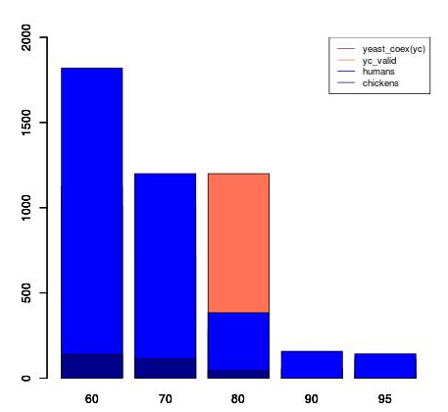

Part 3- Results using PU.

Illustration 1: Compariosn accuracy of prediction BMRF vs PU-BMRF

W eobserved a correlation of 0.67 between the number of labels of the GO-term and th eincrease in accuracy when PU-bMRF was used instead of BMRF, indicating that PU is more effective when the number of known assoictaion sis large.

Accuracy in the extraction of RN:

Part 4- Biological support.

