Hex Class

Test: ChatGPT2HexTest

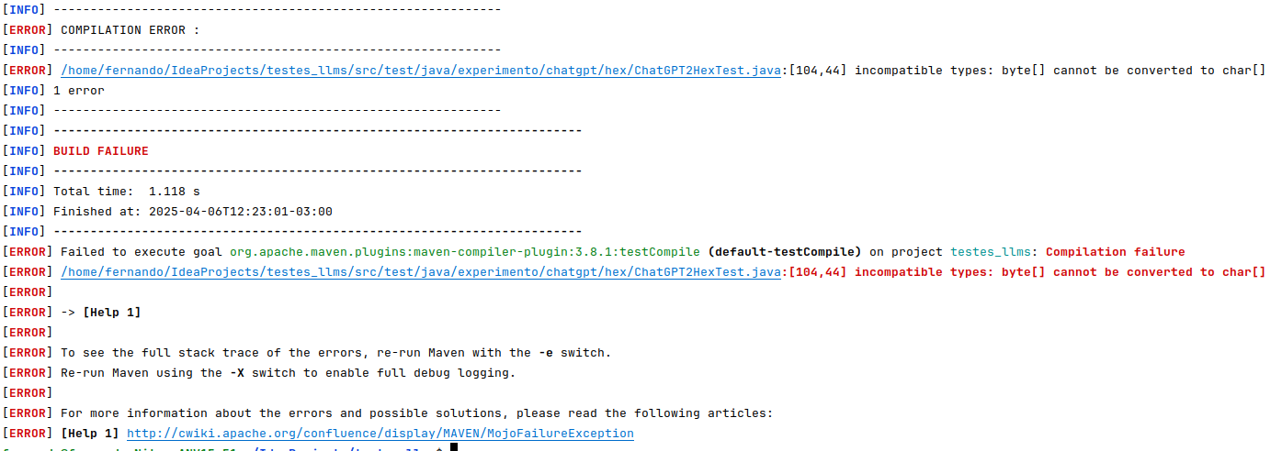

Test: ChatGPT3HexTest

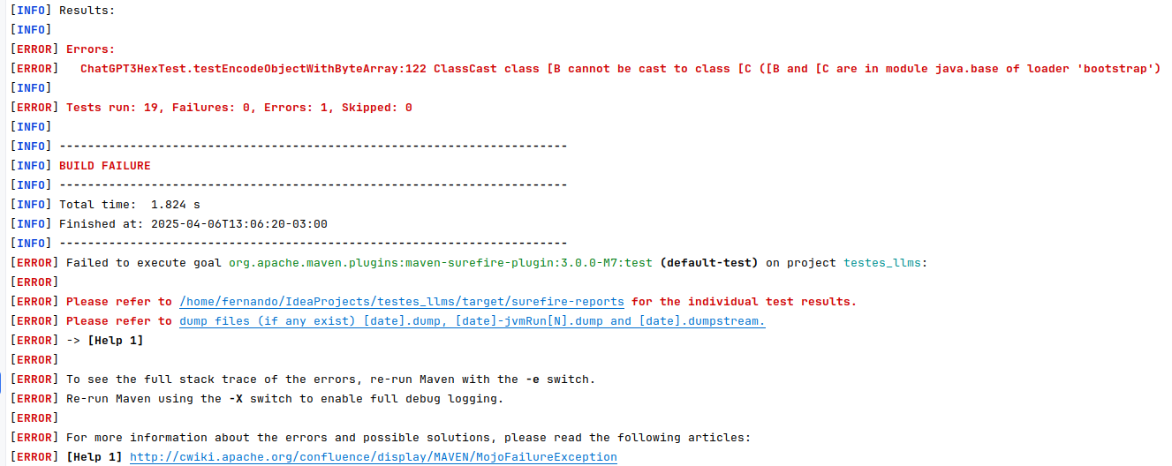

Test: ChatGPT5HexTest

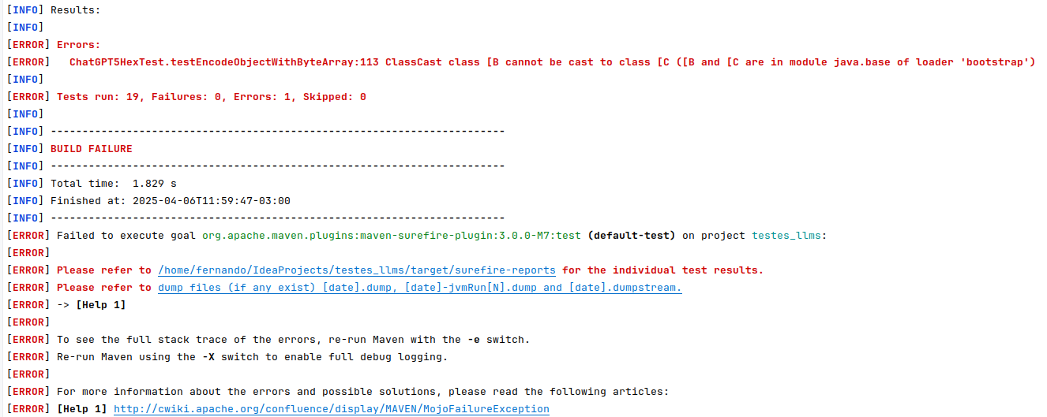
BinaryCodec Class

Test: ChatGPT1BinaryCodecTest

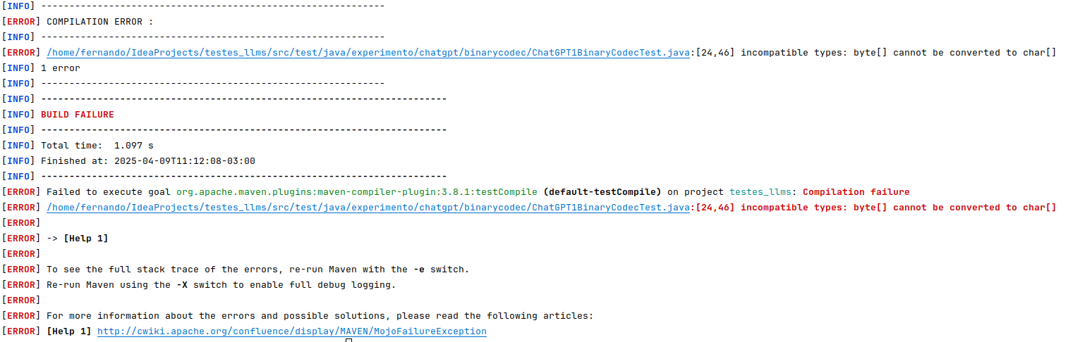

Test: ChatGPT2BinaryCodecTest

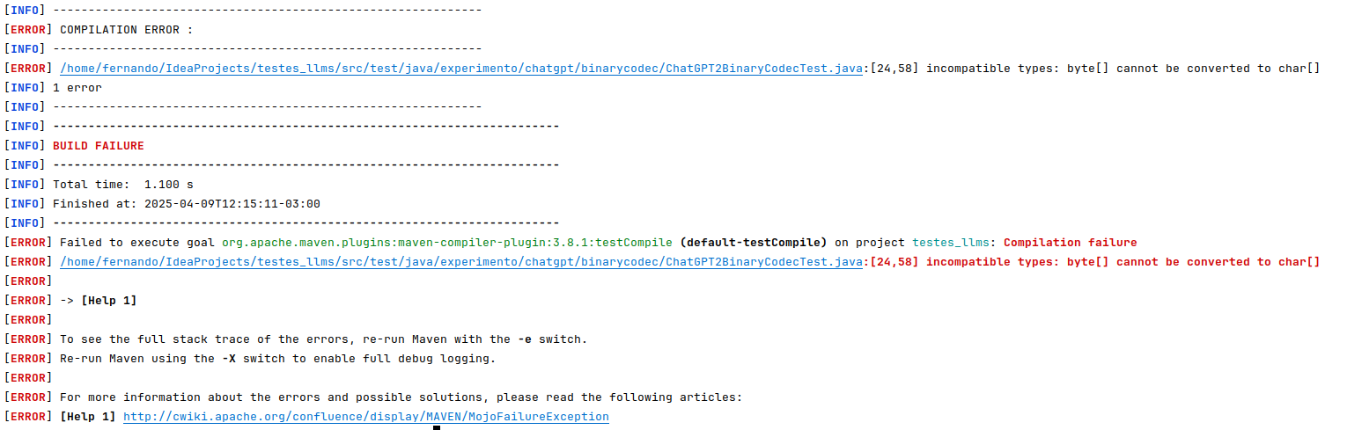

Test: ChatGPT3BinaryCodecTest

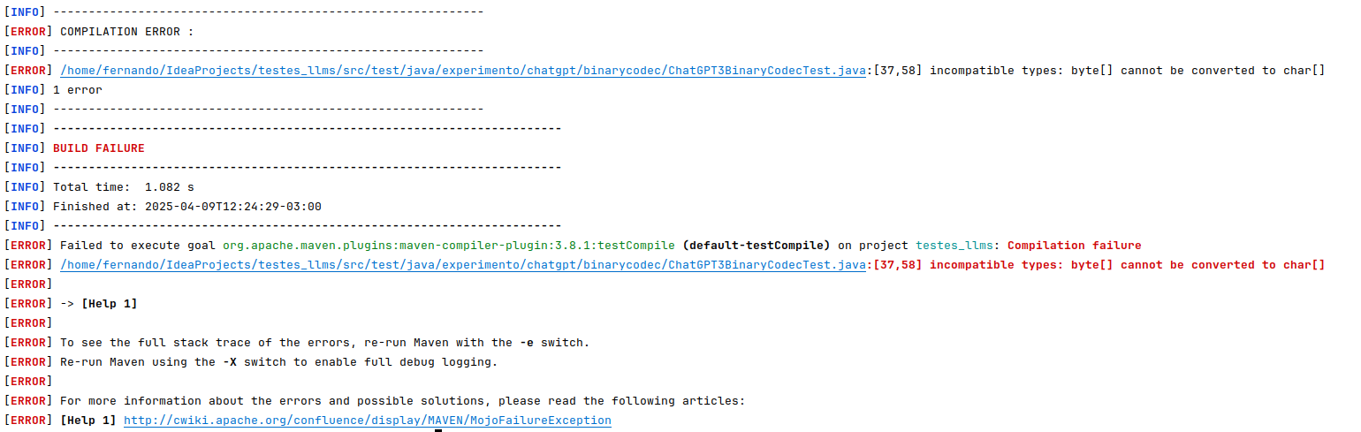

Test: ChatGPT4BinaryCodecTest

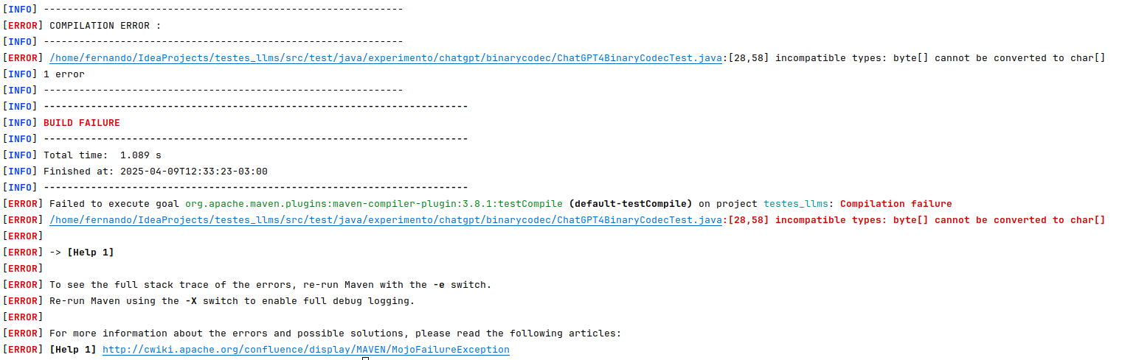
Test: ChatGPT5BinaryCodecTest

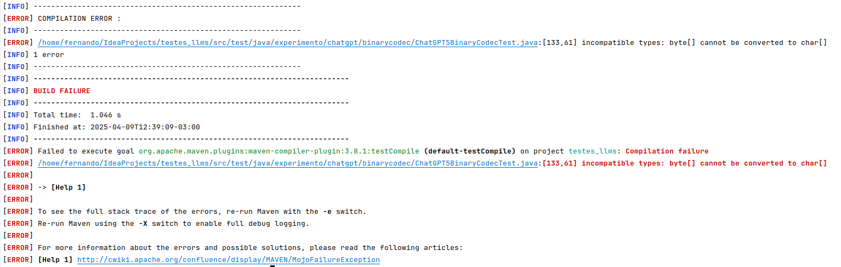

CharRange Class

Test: ChatGPT1CharRangeTest

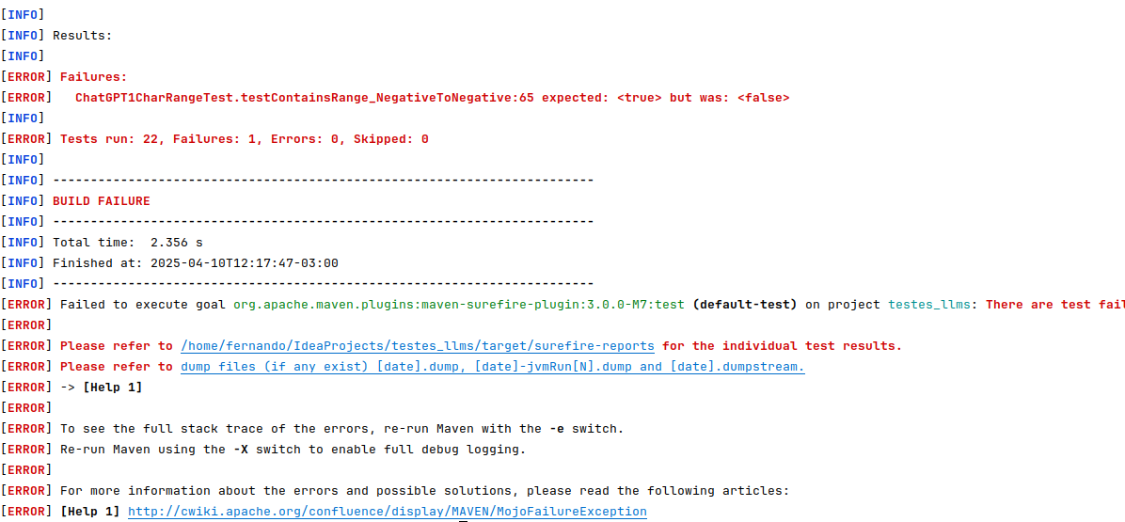

Test: ChatGPT2CharRangeTest

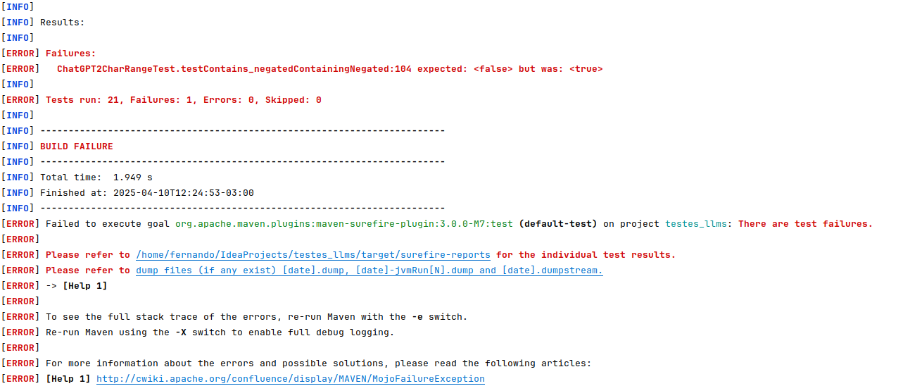
Test: ChatGPT3CharRangeTest

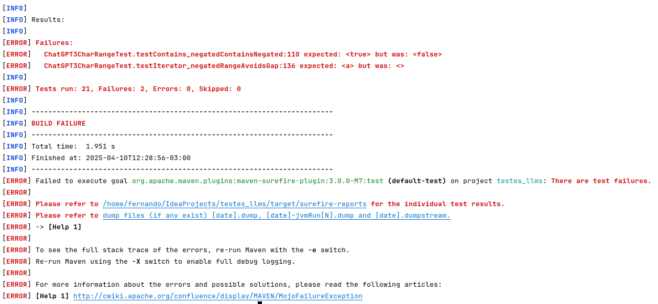
Test: ChatGPT4CharRangeTest
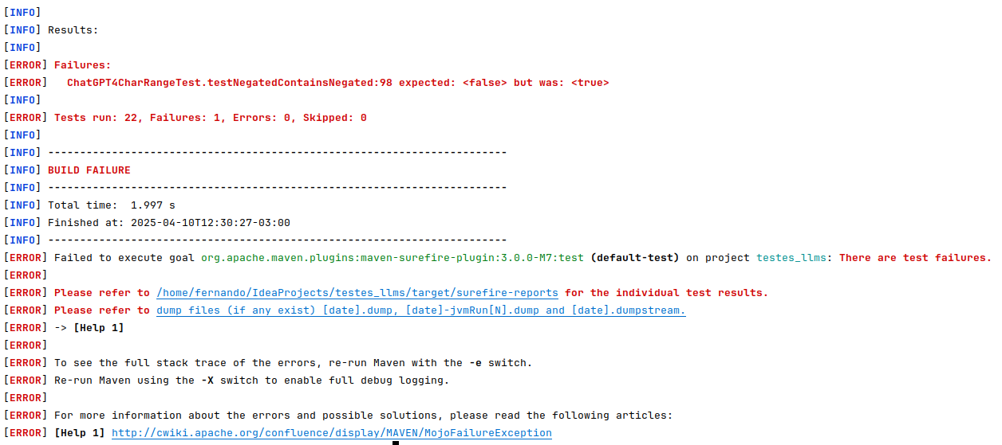

Test: ChatGPT5CharRangeTest

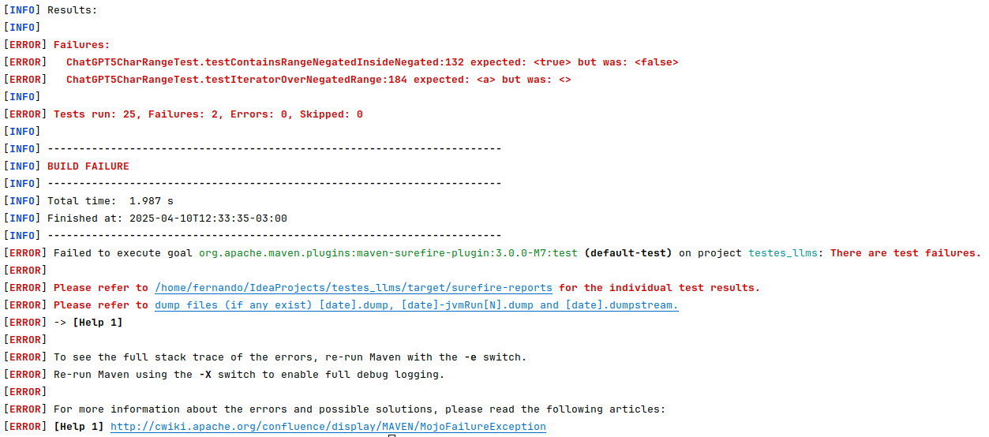

Fraction Class

Test: ChatGPT1FractionTest

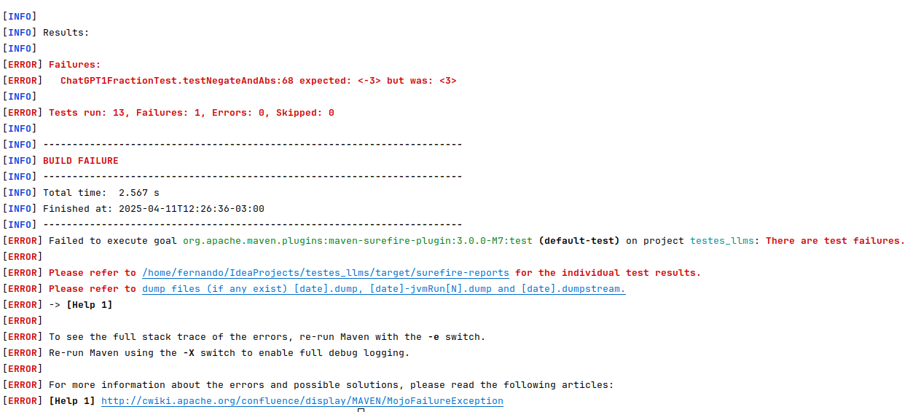

Test: ChatGPT3FractionTest

