Primes Class

Test: DeepSeek2PrimesTest

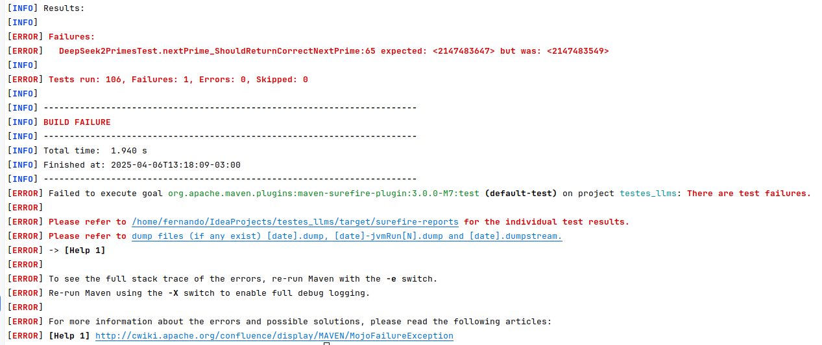
Test: DeepSeek3PrimesTest

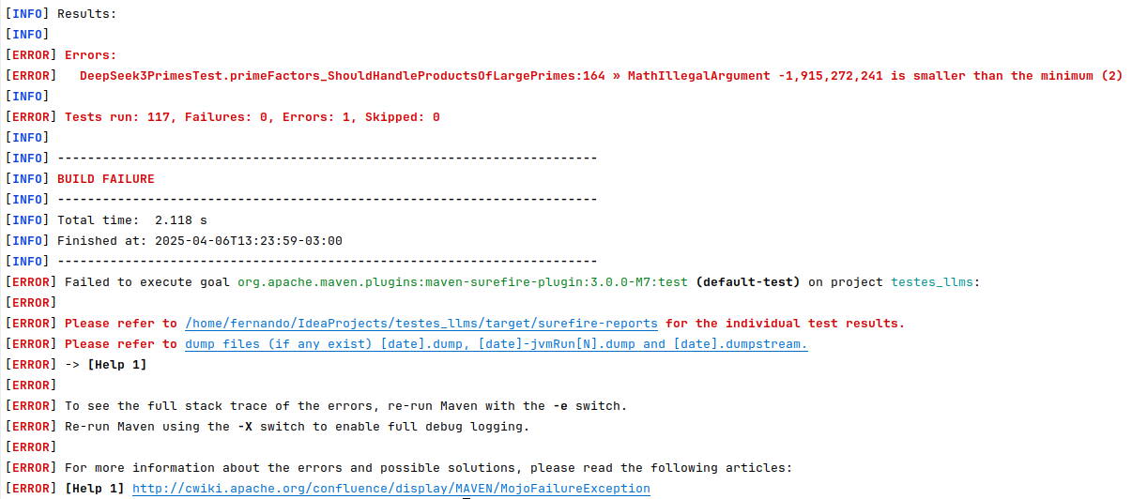
Test: DeepSeek5PrimesTest

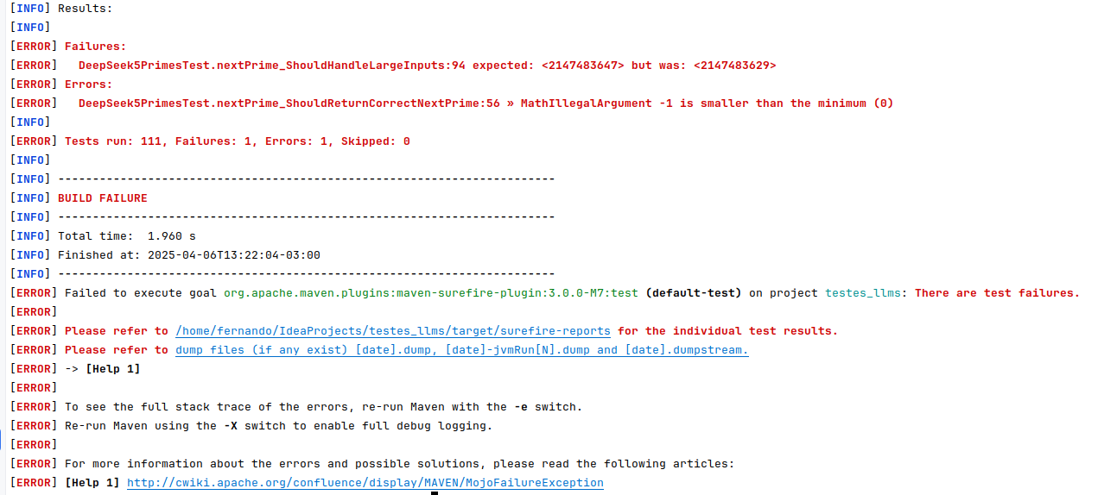
Hex Class

Test: DeepSeek1HexTest
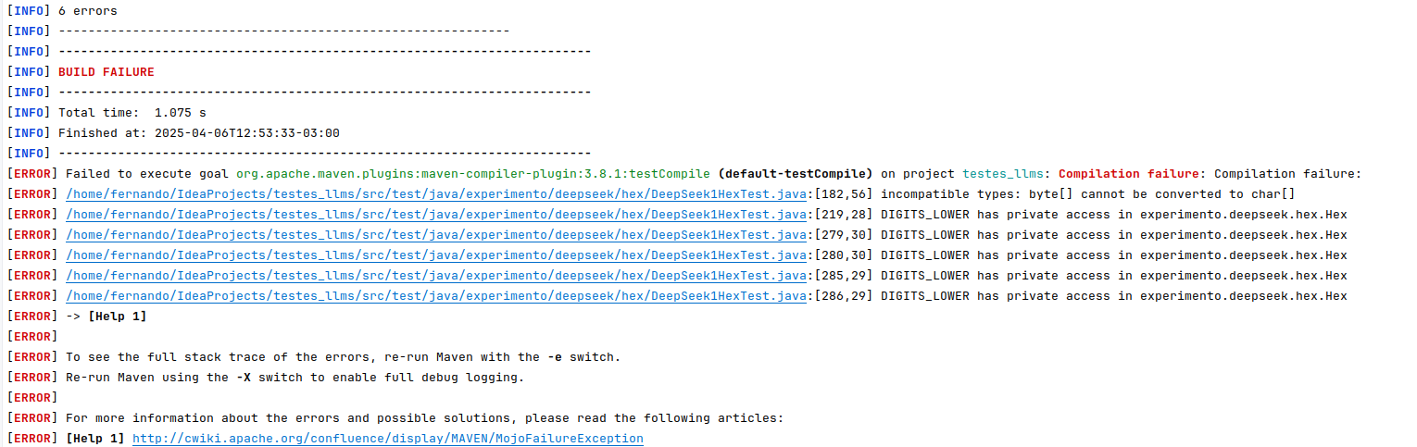
Test: DeepSeek2HexTest

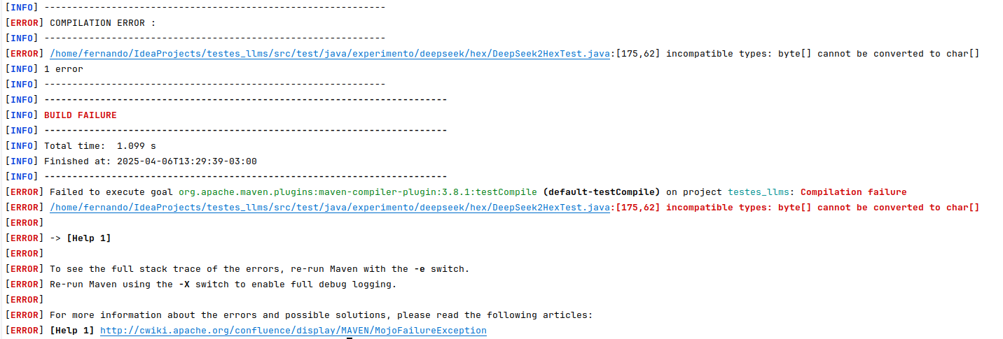
Test: DeepSeek3HexTest

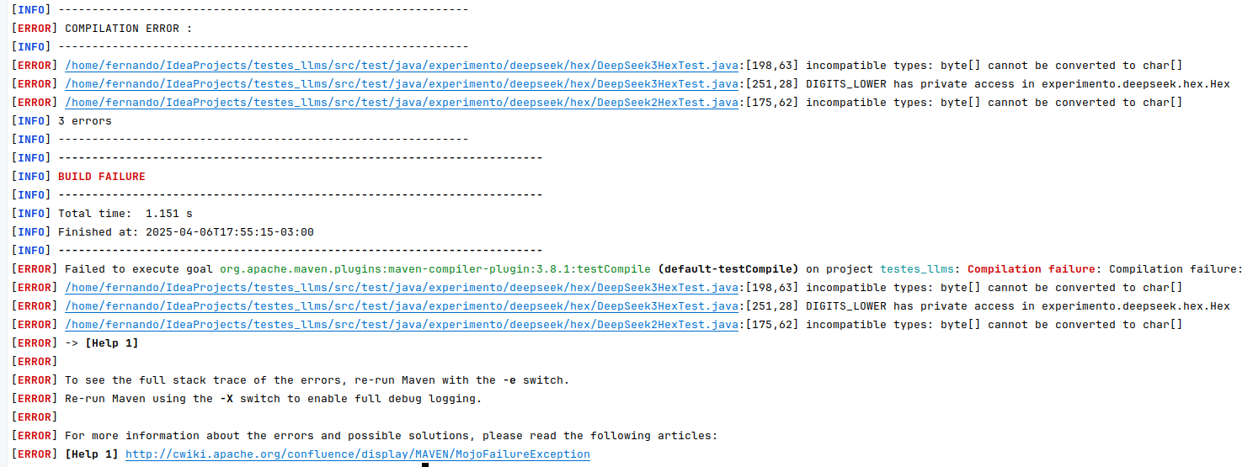

Test: DeepSeek4HexTest

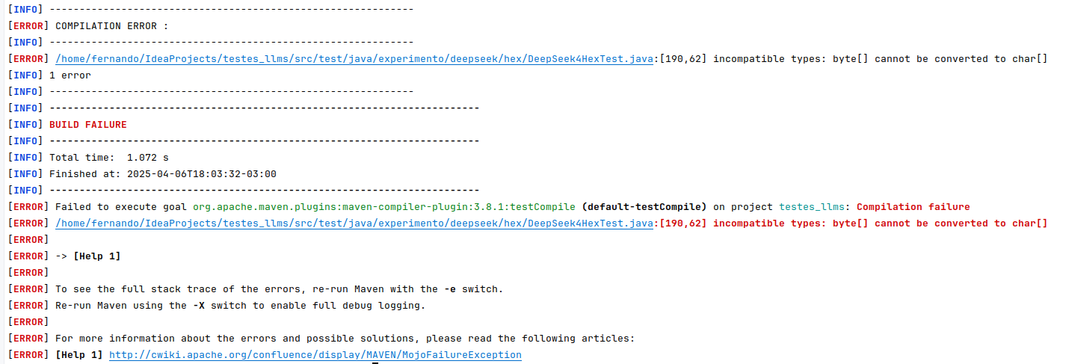
Test: DeepSeek5HexTest

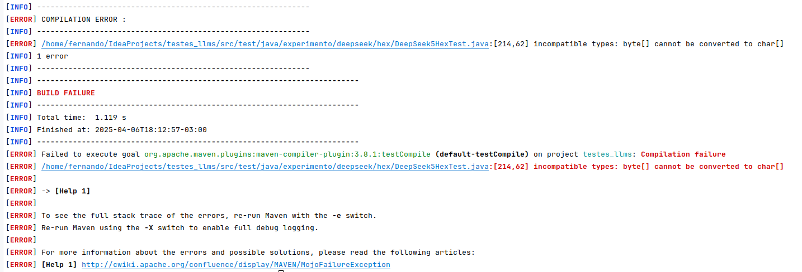

BinaryCodec Class

Test: DeepSeek1BinaryCodecTest

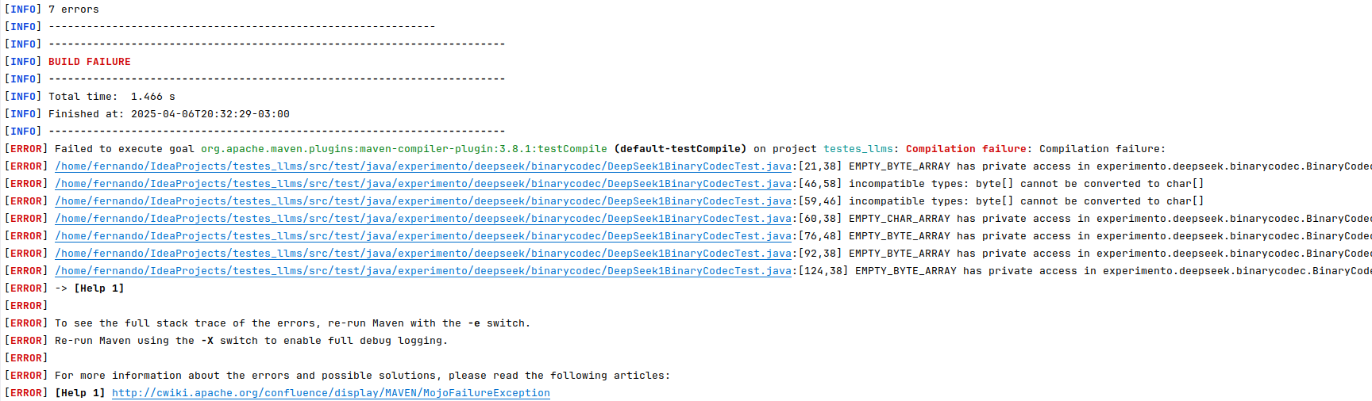

Test: DeepSeek2BinaryCodecTest

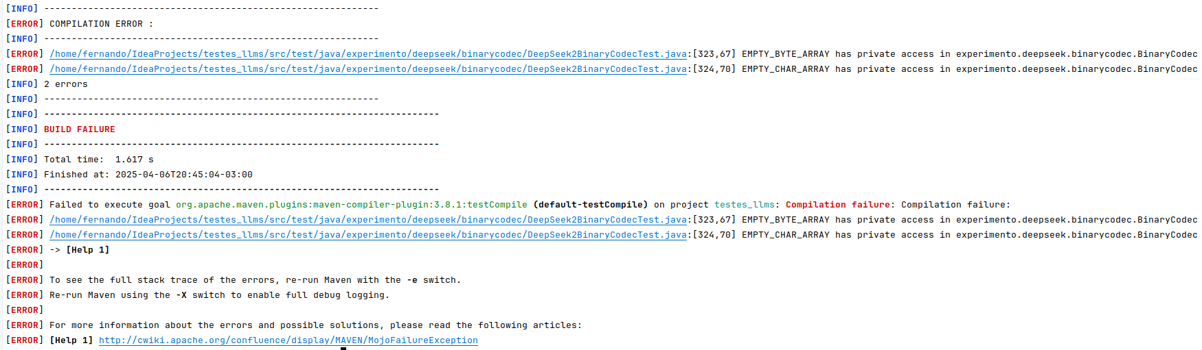
Test: DeepSeek3BinaryCodecTest

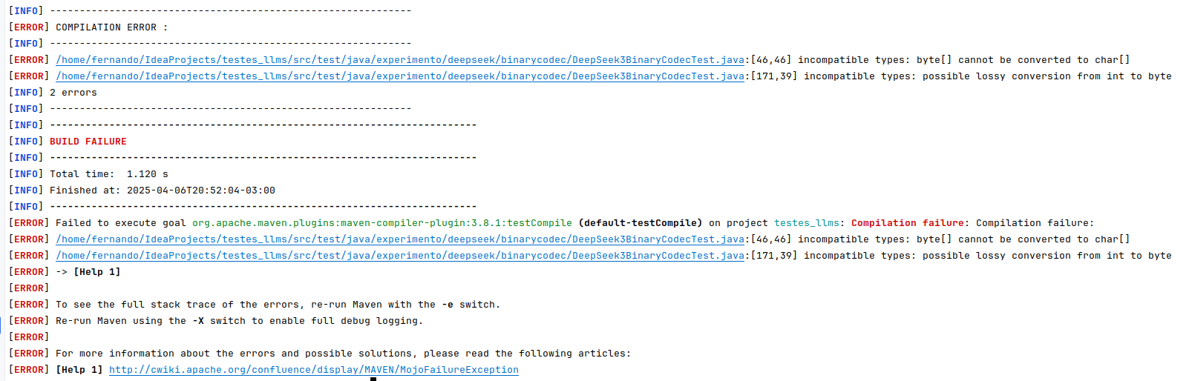
Test: DeepSeek4BinaryCodecTest

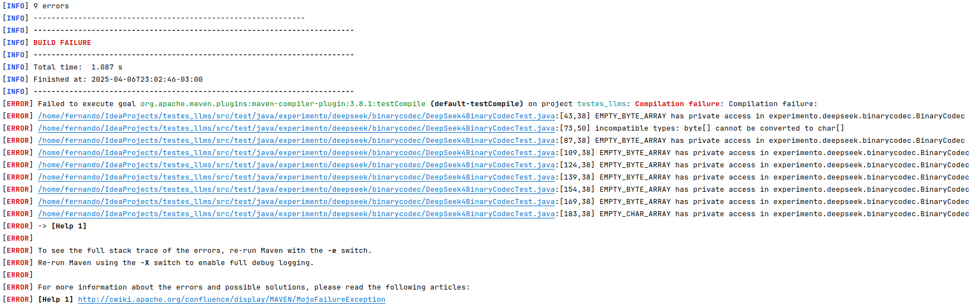

Test: DeepSeek5BinaryCodecTest

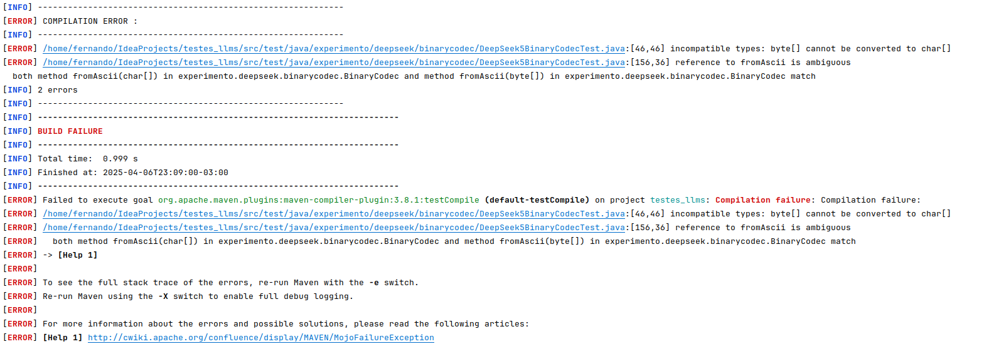

CharRange Class

Test: DeepSeek1CharRangeTest

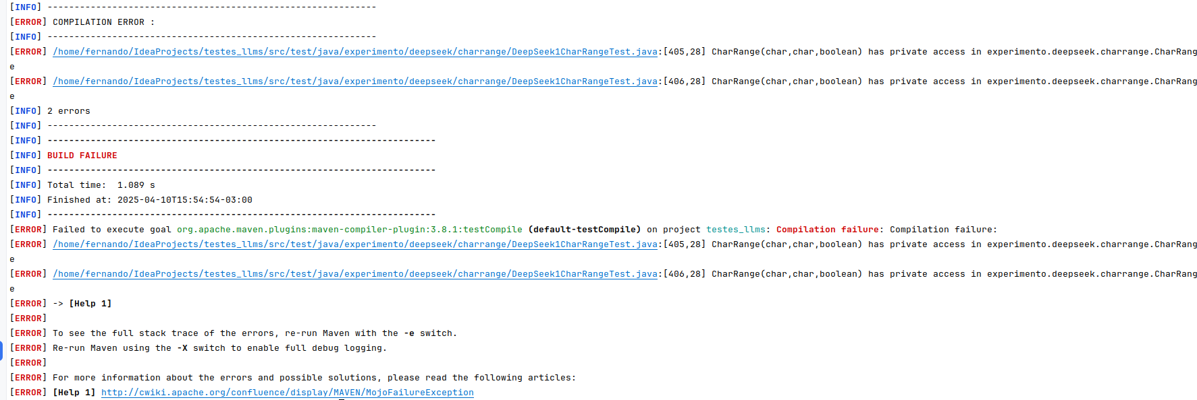

Test: DeepSeek2CharRangeTest

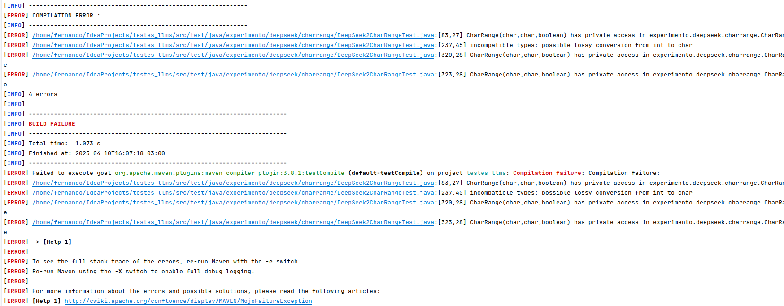

Test: DeepSeek3CharRangeTest

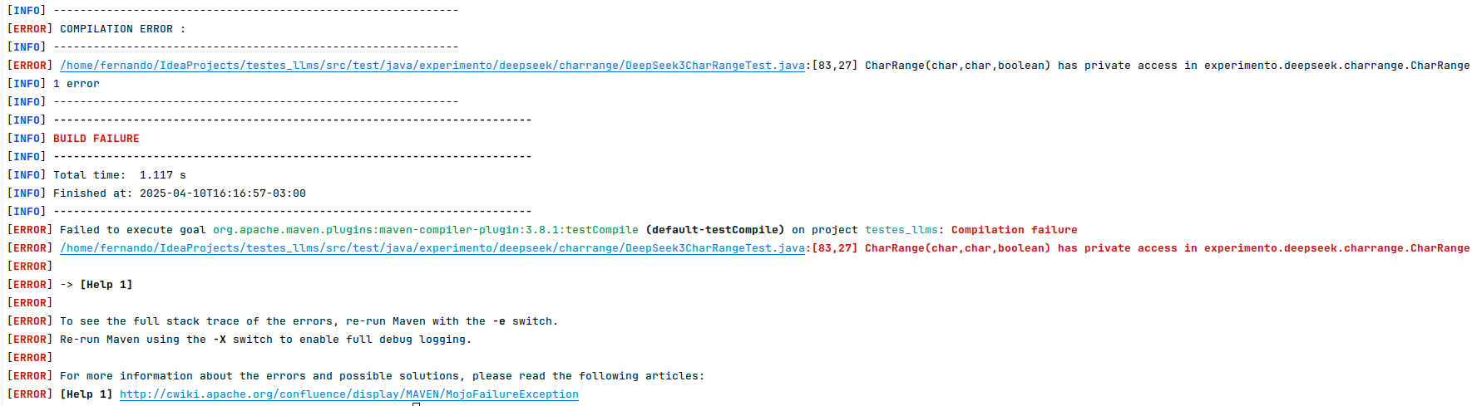

Test: DeepSeek4CharRangeTest

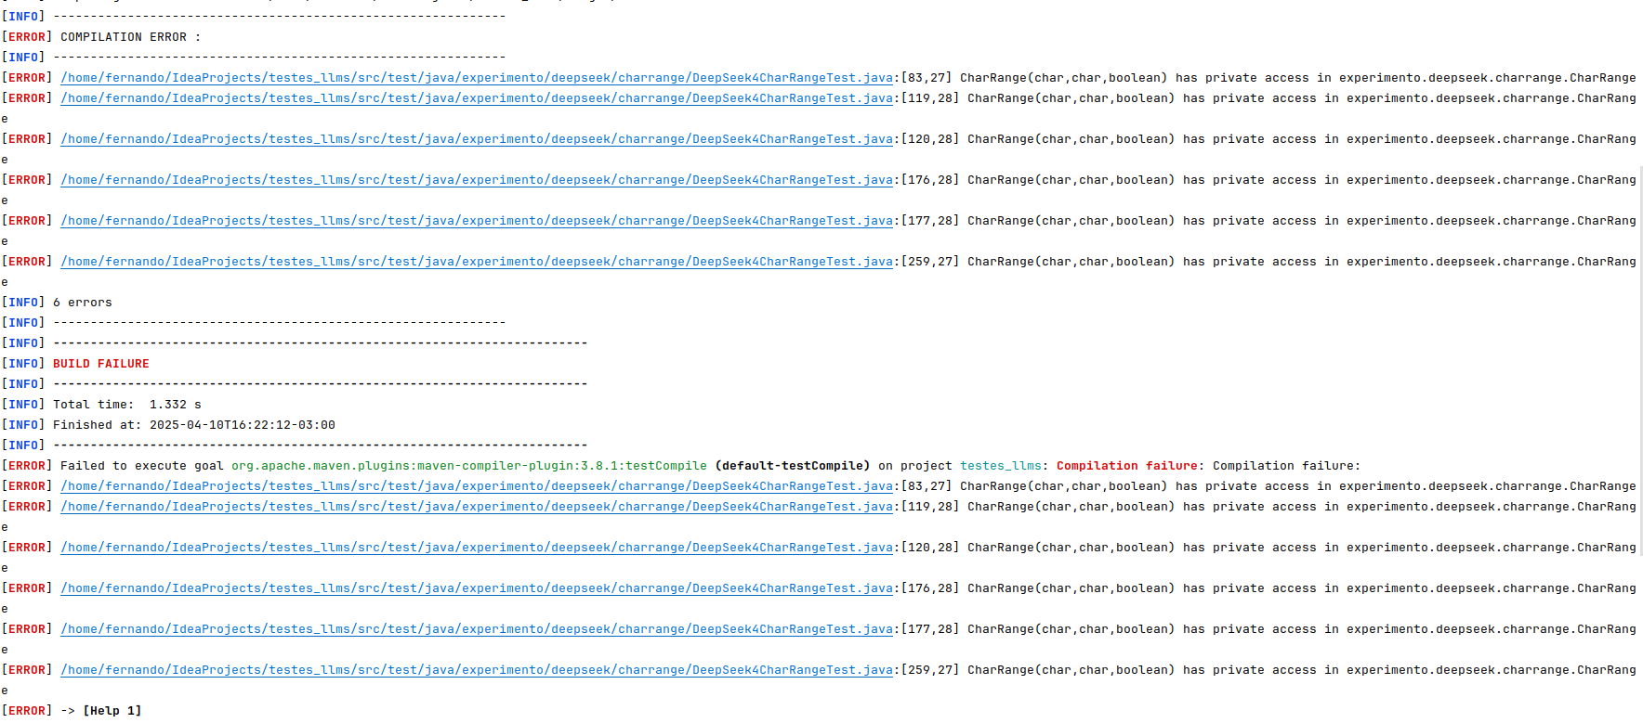

Test: DeepSeek5CharRangeTest

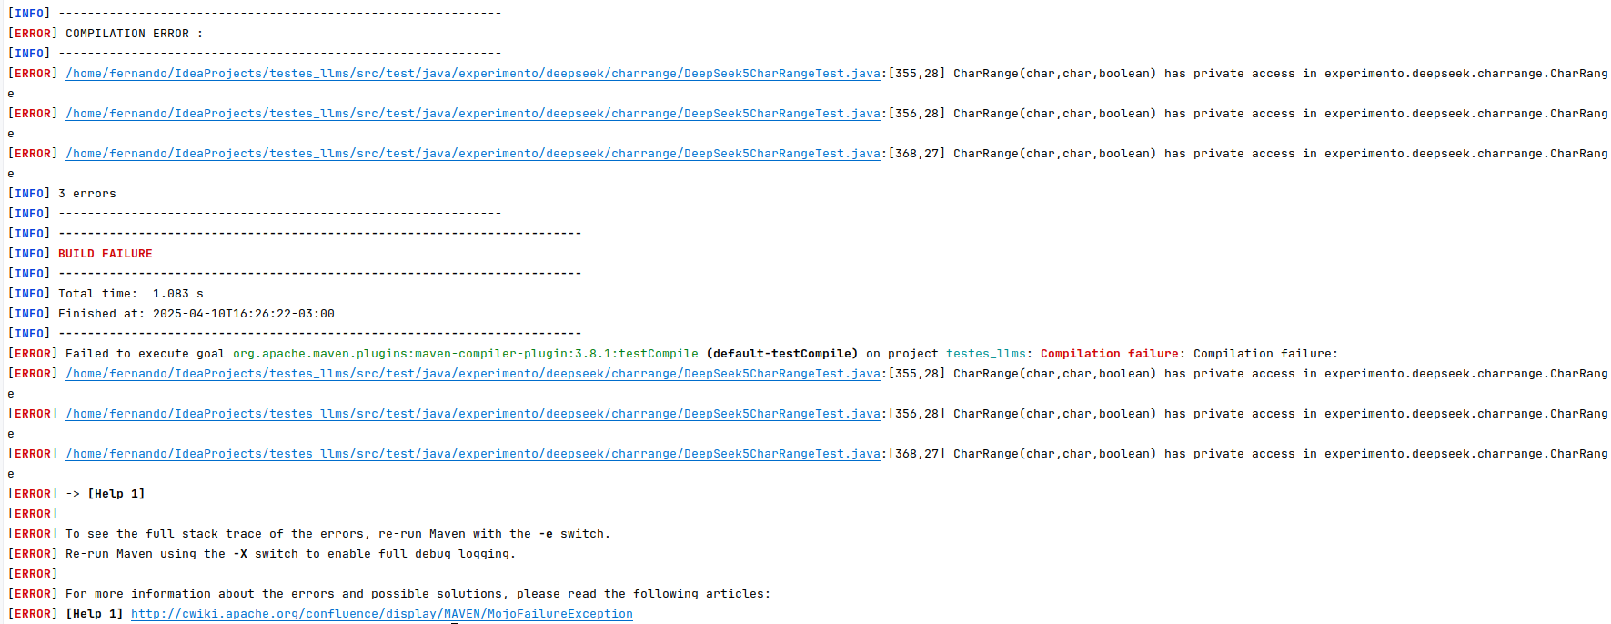

Range Class
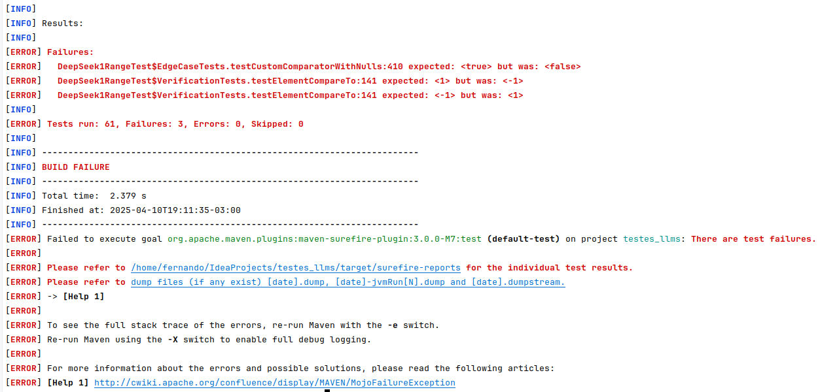
Test: DeepSeek1RangeTest

Test: DeepSeek2RangeTest

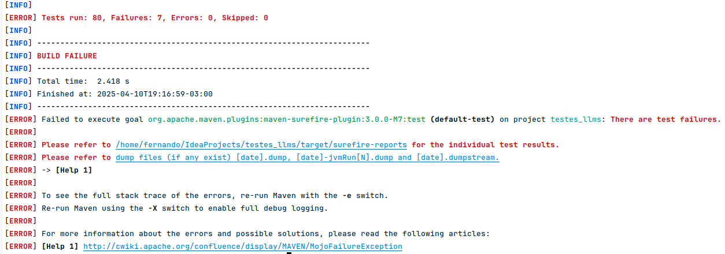
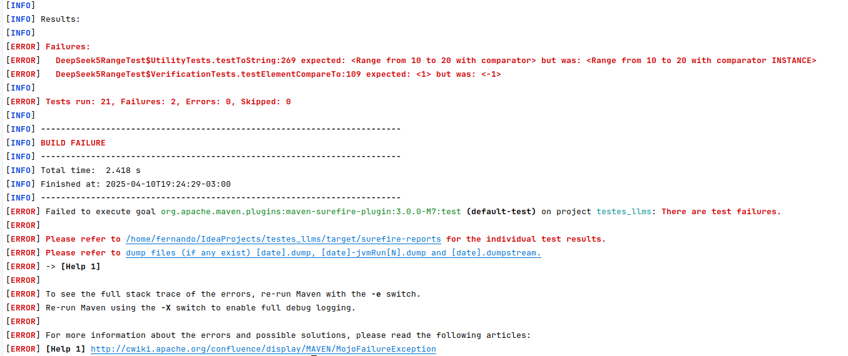
Test: DeepSeek5RangeTest
Fraction Class

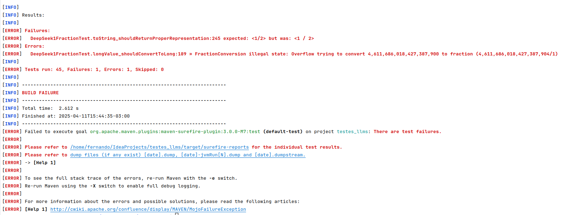
Test: DeepSeek1FractionTest

Test: DeepSeek2FractionTest

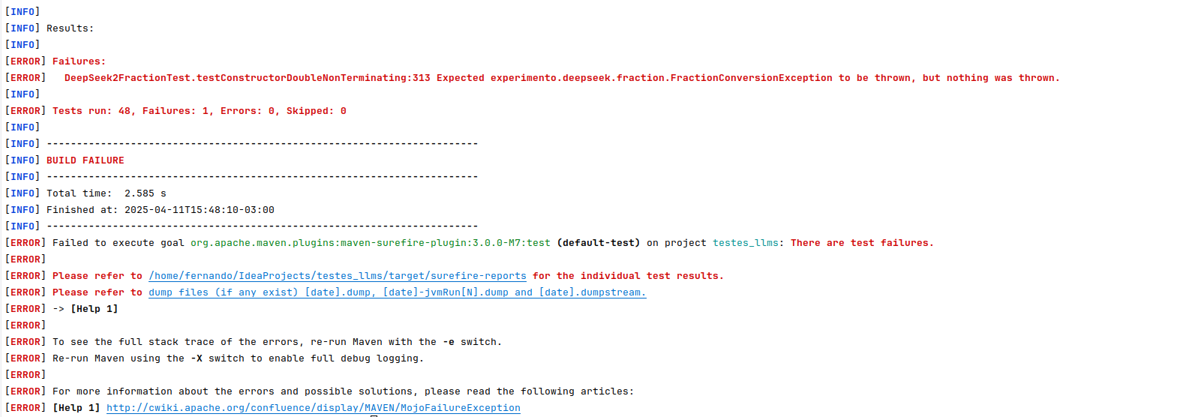

Test: DeepSeek3FractionTest

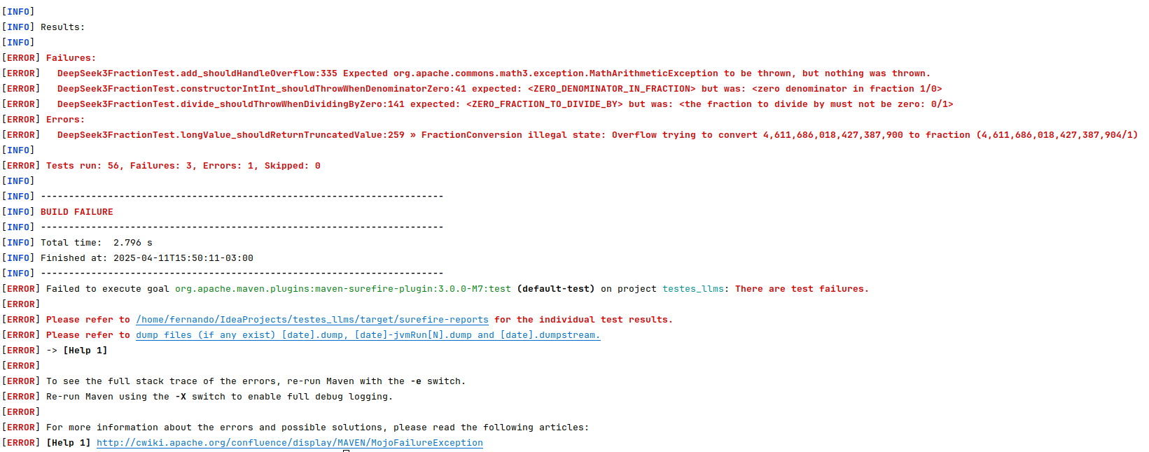

Test: DeepSeek4FractionTest

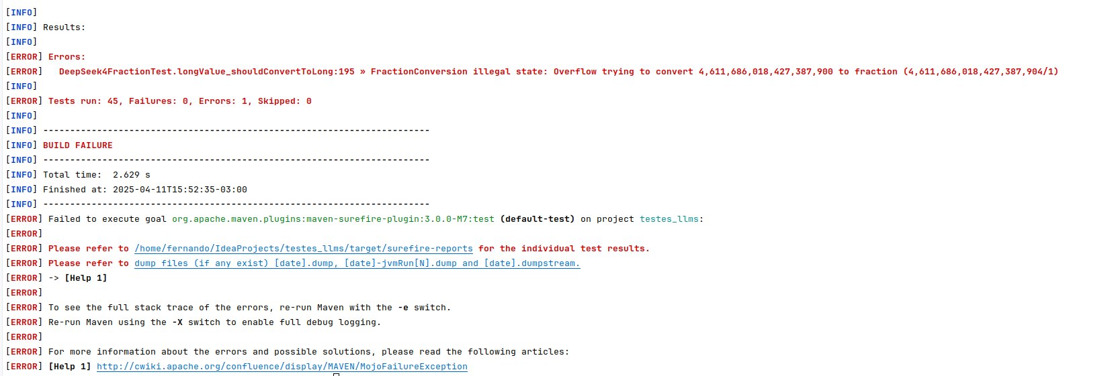

Test: DeepSeek5FractionTest

