

**《High-level Language Programming Project》Report**

Project Name: Zoo Management System

**School:** Computer Science and Engineering

**Major: Computer Science**

**Student Name:**   **蒋怿、杨喆、陈效威、陈星宇**

**Teacher：Professor Xu**

**Submission Date:** 2017.6.13

|  |  |
| --- | --- |
| Teacher comment | signature：  date： |
| Performance evolution |  |
| remark |  |

**1. Requirement Analysis for System**

1.1 The Background and Motivation of System

* With the development of the society, it's quite necessary for a manager to have a management system for a company to make sure that everything of the co-operation is in order and running properly.
* This program can be regarded as a management system of a company and in the program make the company more specific----a zoo.
* In a zoo, it takes a lot of efforts for the staffs and managers to schedule the feeding time for animals and plan for the open days. The information of animals and the salaries management can become a tough burden for the zoo manager. As the amounts and species of animals growing up, the increasingly growing database may descent the zoo into chaos and also annoy the manager.
* We also know that in the zoo, there will be many different kinds of people such as staffs, tourists and managers. Each of them has their own assignments.
* There will be all kinds of animals and each animals has it's own detailed information.

1.2 System Objectives

* If we can make this program successfully, it will be very useful to the manager of a zoo. Besides, it also takes little effort for us to change it into a general and perfect program for **companies’ management** by merely changing the name and adding some other features.

**2. Program Analysis**

2.1 Key Issues for System

Zoo management, communication between staffs and managers, staff, tourist

2.2 Duty Assignments

The description of duty for every student in the group is listed here.

**蒋怿：In charge of the main body of the program and the Qt part.**

**杨喆： Testing, debugging and writing comments.**

**陈效威：Testing, debugging and writing comments.**

**陈星宇：In charge of part of the Qt work and a series of animal class.**

**3. Technical Routine**

3.1 Run time Environment

The platforms of software and hardware for the system are described here.

**Visual Studio 2015, Qt creator,** **Qt Designor**

3.2 General Design

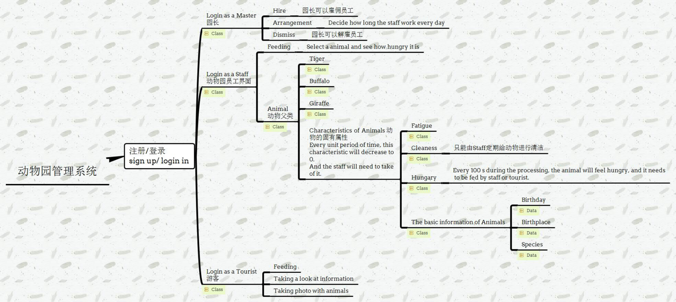The user can log in as a tourist\staff\master, each of who has various features.

3.3 Detailed Design

There are 3 main kinds of characteristics that you may choose as the initial role when you try to log in the system.

* **Tourist**:
  + They will be able to log in to the system, get detailed introduction about the animals they are going to visit and the goods which is sold in the zoo.
  + 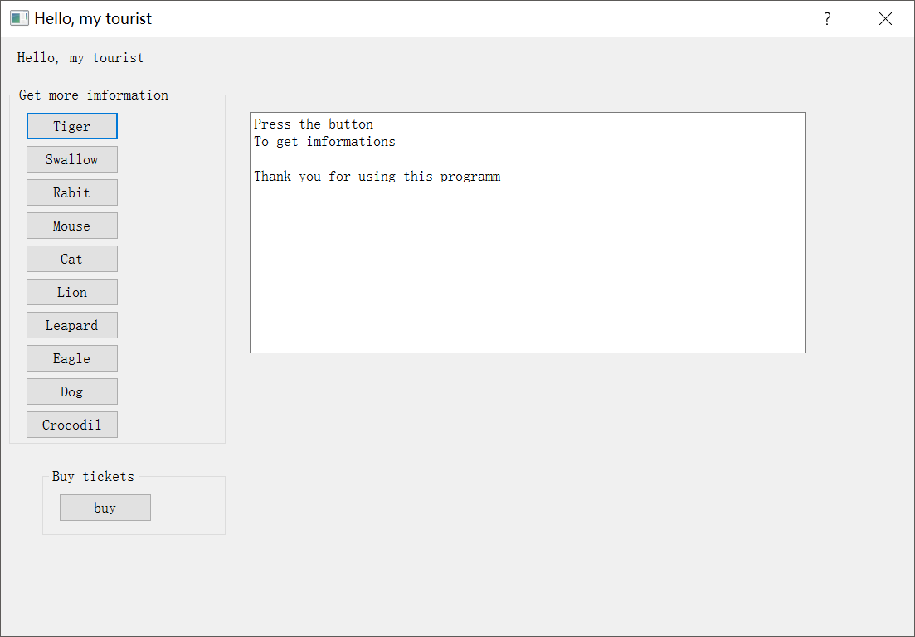
  + 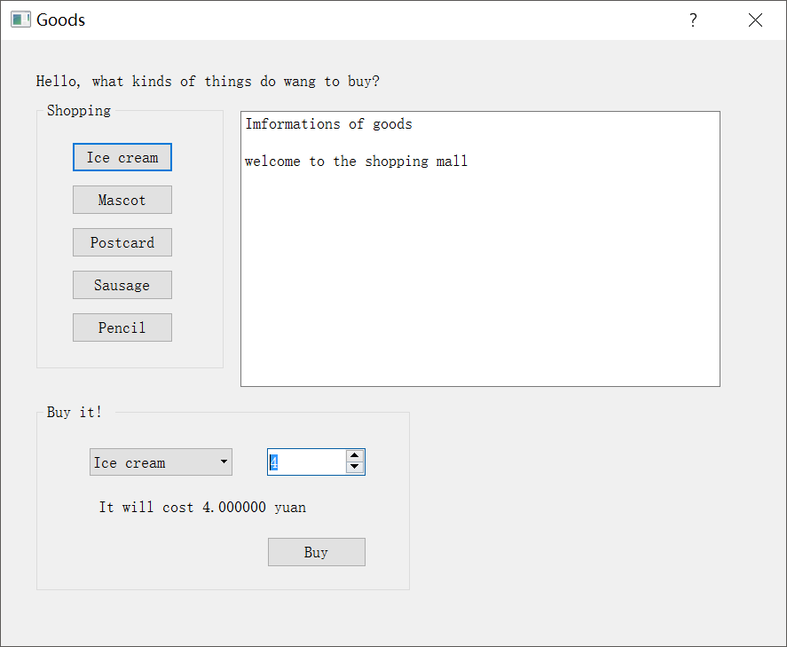
  + They can purchase the goods or the suveniors in the zoo.
  + You can set up a ID as a tourist freely.
  + : .

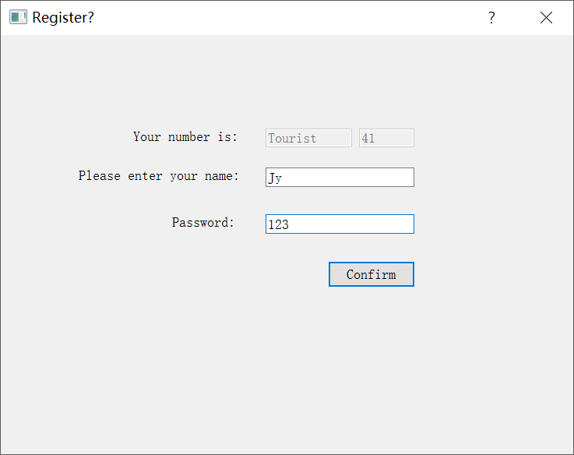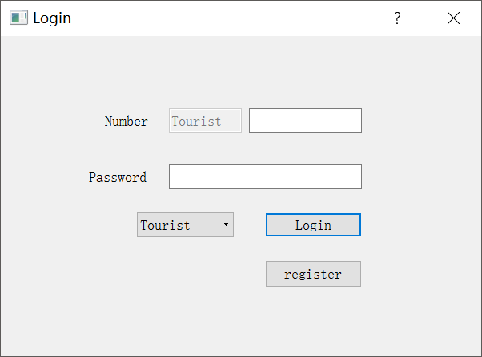

* + You can also buy tickets and some interesting souvenirs in the shopping window:

* **Staff:**
  + They can check the information of any animal such as the weight and age.
  + Also they will be able to receive the orders from the manager.
  + After they finish their assignments, they can log out and their information will not be missing.
  + You may not set up a user ID using the characteristic of staff because there are 4 default staffs constructed by us.

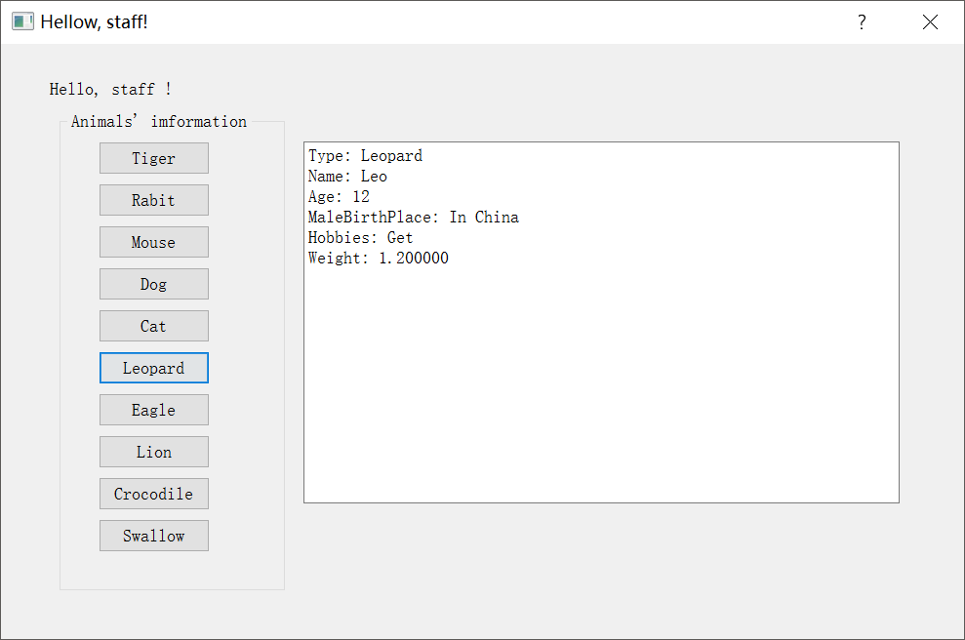

* **Manager**:
  + Deliver orders to the staffs
  + check (get) the information of all the staffs and all the animals in the zoo.
  + You may not set up a user ID using the characteristic of master because there is a default manager constructed by us.
  + You can fill the blank using the ID and password shown in the image down here to log in as a master
  + Also he can log out.
  + 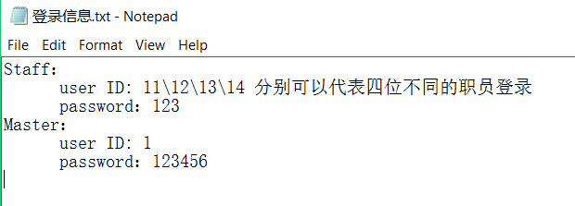

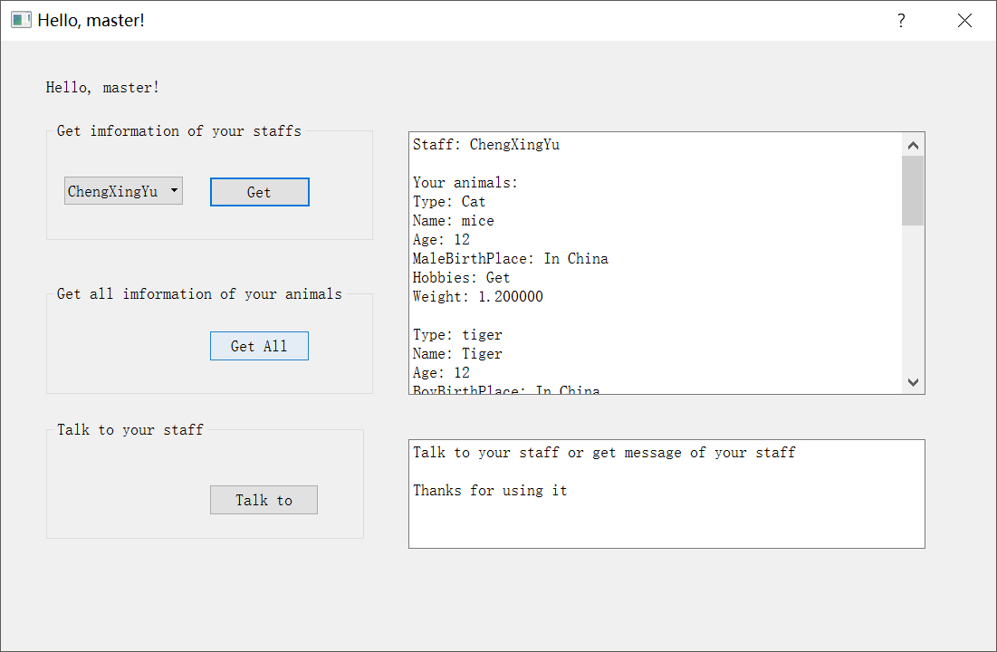

* **Animals** :
  + You can check the information of animals either in master’s, tourists or staff’s window.

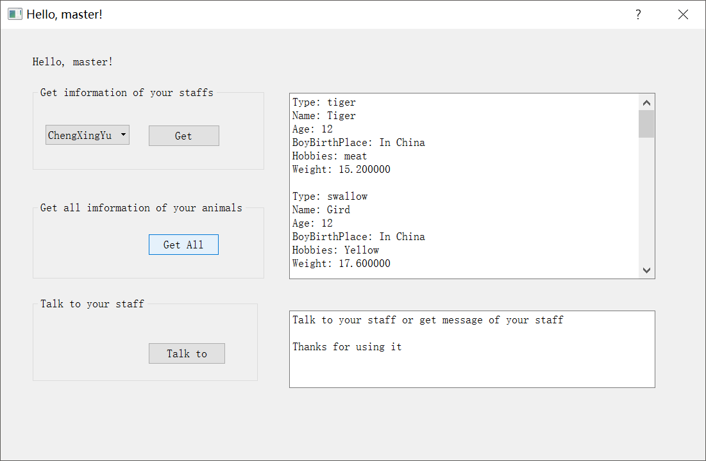

**4. Programming Progress**

|  |  |  |  |
| --- | --- | --- | --- |
| **Phases of Mission** | **Period** | **Planned Completion** | **Actual** **Completion** |
| Determining the topic and submit the proposal | 2017.04.26-2017.05.03 | Survey the interesting topics, and writing the proposal. | We finished designed the |
| Studing QT | 2017.05.03-2017.05.10 | Finish learning QT and start to program | The same as the planned completion. We know how to use QT |
| Writing the basic classes. | 2017.05.10-2017.05.17 | Write the code about animals, staffs and managers. | Finish these three kinds of basic classes. |
| Connect the classes together and add QT parts. | 2017.05.17-2017.05.24 | Add the classes into the project and add QT parts as well. | We get a detailed project with QT parts. |
| Improving. | 2017.05.24-2017.05.6.1 | Add more functions to the project. | We get a better project than before. |
| Testing | 2017.6.1-2017.6.7 | Test the program again and again, try all the functions and find the bugs. | We estimate all the bugs that we found and finally we make a perfect program. |

Note: The progress for each week should be recorded. The project will be started from April 26, 2017 and ended at June 7, 2017.

**5. Testing Report**

5.1 Function testing

There is sth. wrong at the beginning such as we didn’t initialize the static member at first.

5.2 System testing

Perfect and fluently.

The communication among multi-thread is rapid.

**6. Personal Summary**

This is the first functioning project that our group have finished. After we setting down the goal of the program in the first week, we strived to succeed, so that every group member try his utmost to learn new stuffs and at the end, fortunately, we made it.

The program is far from being perfect. Nevertheless, the successful testing and running of the program just inspire us from moving on and it gives a clue that we deserve it.

Undoubtedlly, the program is just a beginning of our CS career, we may face so many difficults in the forseenable future. And when we feel tough and want to give up, this experience that we tackled the problems with teammates can encourage us a lot.

Tough as it is, I think it is a good starting point for Computer Science freshmen.

**7. Reference**

None.