Fernando Davis Rivera

Project: Disaster Site Resource Locator

Report 1.

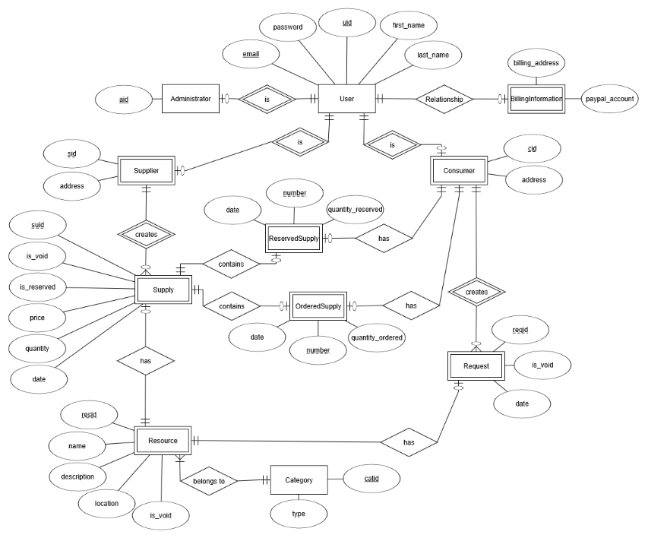Entity Relational Model.

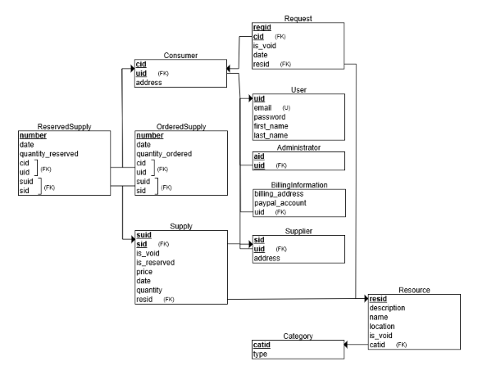

Relational Schema.