AfriLogic MVC Web App

AfriLogic is a web application built on the MVC .NET7 framework. It is designed to provide a platform for Farmers and Employees to manage information related to farmers, products, and user authentication. This README file serves as a guide to understand the application's features and usage.

Contents

AfriLogic MVC Web App 1

Features 3

Usage 3

Technologies 3

Links 4

Login Information 4

Features

1. User Authentication:

- Farmers and Employees can create accounts, log in, and log out.

- Access to the system is restricted based on user roles.

2. Farmer Dashboard:

- Farmers can view a list of all farmers in the system.

- The list displays each farmer's name, surname, and products.

- Farmers can add new products to the system, associated with their own account.

3. Employee Dashboard:

- Employees can view a list of all farmers in the system.

- The list displays each farmer's username, password, name, surname, and products.

- Employees can add new farmers to the system.

Usage

1. Access the AfriLogic application using the following link:

[AfriLogic](https://poe-part2-st10115510-fernandohattingh.azurewebsites.net/)

2. The landing page will be the login page. Enter your credentials or create a new account.

3. After logging in, you will be redirected to either the Farmer Dashboard or the Employee Dashboard based on your user role.

4. Farmer Dashboard:

- View the list of all farmers and their information.

- Add new products associated with your own account.

- Log out.

5. Employee Dashboard:

- View the list of all farmers and their information.

- Add new farmers to the system.

- Log out.

Technologies

The AfriLogic application is built using the following technologies:

- MVC .NET7: A framework for building web applications using the Model-View-Controller architectural pattern.

- Azure: A cloud computing platform used for hosting the application.

- Azure SQL Database: A cloud-based relational database used to store user and application data.

- Authentication: Authentication mechanisms are implemented for user login and access control.

- HTML, CSS, JavaScript: Front-end technologies for building the user interface.

- Ajax: A technique for making asynchronous HTTP requests to the server.

* C#: The programming language used for the application's server-side logic.

Links

Github:

<https://github.com/VCSTDN/prog7311-part2-FernandoHattingh>

Azure Publish :

[- AgriLogic (poe-part2-st10115510-fernandohattingh.azurewebsites.net)](https://poe-part2-st10115510-fernandohattingh.azurewebsites.net/)

Login Information

Employee:

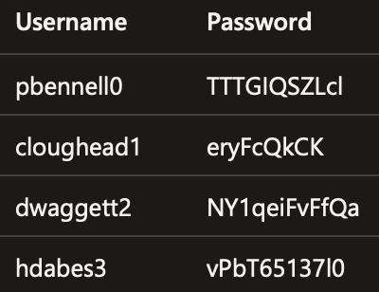

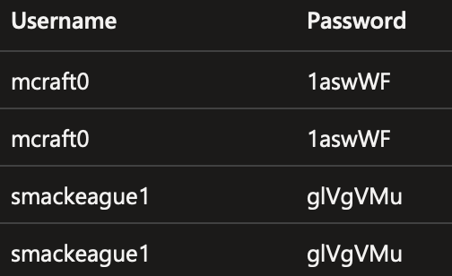Farmer: