Expense Reimbursement System

# Executive Summary

The Expense Reimbursement System (ERS) will manage the process of reimbursing employees for expenses incurred while on company time. All employees in the company can login and submit requests for reimbursement and view their past tickets and pending requests. Finance managers can log in and view all reimbursement requests and past history for all employees in the company. Finance managers are authorized to approve and deny requests for expense reimbursement.

**State-chart Diagram (Reimbursement Statuses)**

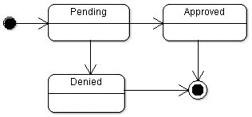

**Reimbursement Types**

Employees must select the type of reimbursement as: LODGING, TRAVEL, FOOD, or OTHER.

**Models**

// user : table

{

username: “name”, // partition key

password: “pass”,

firstName: “fname”,

lastName: “lname”,

email: “email”,

role: “employee” // or maybe “admin”

}

// reimbursement : table

{

username: “name”, // partition key

timeSubmitted: timestamp, // sort key, number

items: [

// array of reimbursement items

],

approver: “username of resolver”,

status: “approved” // or “denied”,

receipts: [

// strings that contain urls to retrieve the receipts from s3 buckets – stretch goal

]

}

// reimbursementItem :not an actual table

{

title: “must be unique to this list”,

amount: 50,

description: “description of what the reimbursement is for”,

timeOfExpense: timestamp // number

}

**Use Case Diagram**

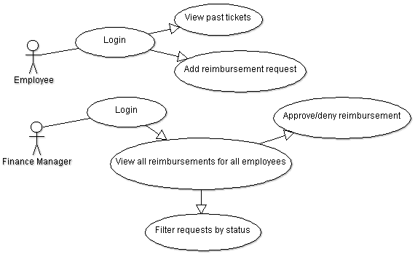

**Activity Diagram**

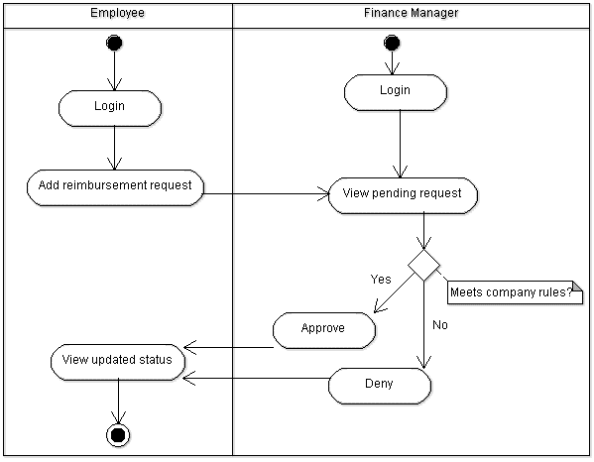

# Technical Requirements

The back-end system shall use the aws-sdk to connect to DynamoDB. The application shall deploy onto Node.js Server. The middle tier shall use express for handling Http requests. The front-end view can use JavaScript or ReactJS to make a single page application that uses AJAX to call server-side components.

Additionally it would be nice to have passwords encrypted by the server and securely stored in the database. As well as the ability for users can upload a document or image of their receipt, into S3 buckets, when submitting reimbursements.