Método Post 🡺

<http://localhost:8081/Cliente-0.0.1/WS/Cliente/Criar>

Json 🡺

{

    "nome": "Katia De Almeida",

    "cpf": "03245878415",

    "telefone": "41988458741"

}

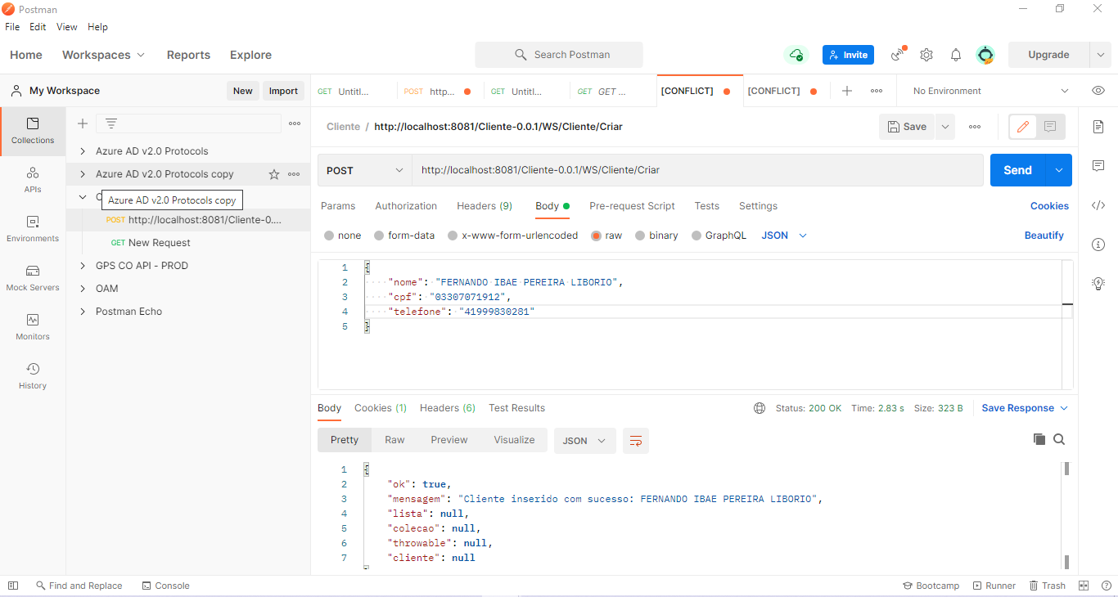

<http://localhost:8081/Cliente-0.0.1/WS/Cliente/Pesquisar>

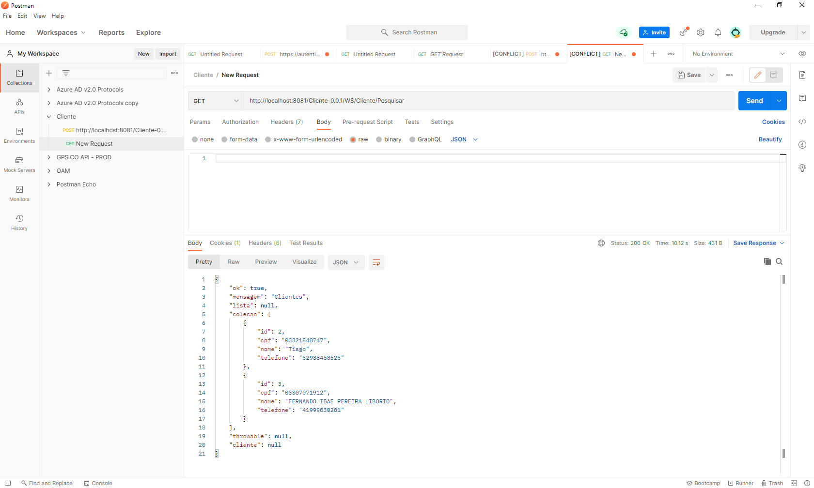

<http://localhost:8081/Cliente-0.0.1/WS/Cliente/BuscarCliente/03307071912>

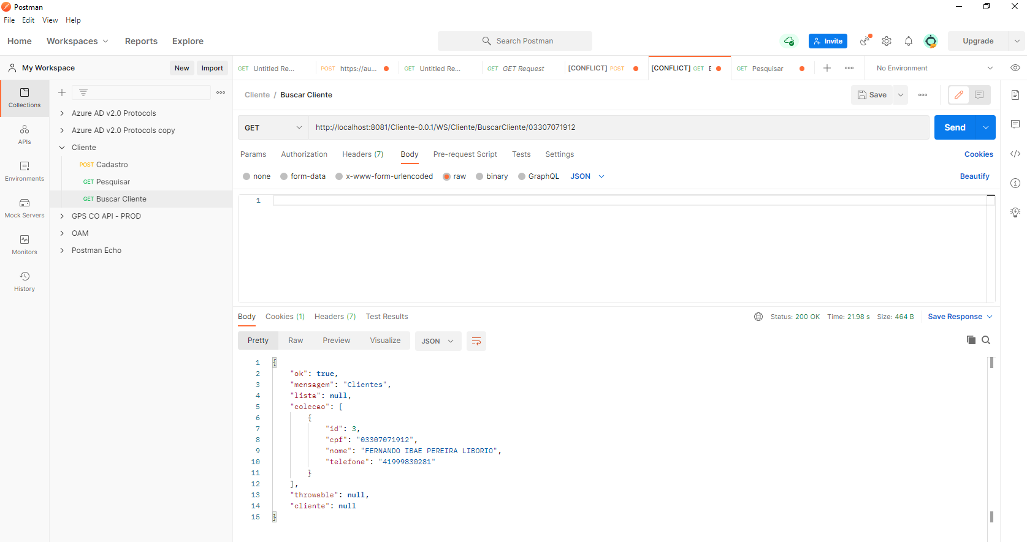

<http://localhost:8081/Cliente-0.0.1/WS/Cliente/deletar/2>

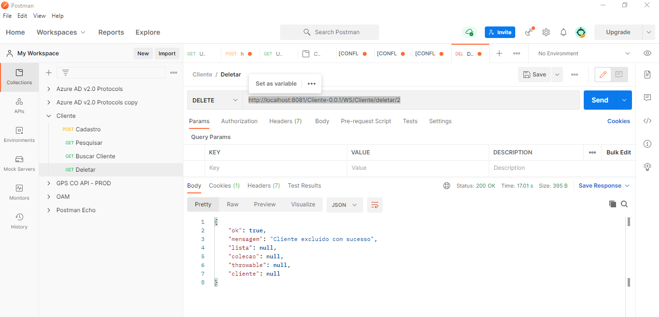

<http://localhost:8081/Cliente-0.0.1/WS/Cliente/Criar>

Exceção 🡺 Limite de caracteres.

{

    "nome": "Katia De Almeida",

    "cpf": "03245878415654",

    "telefone": "41988458741"

}

