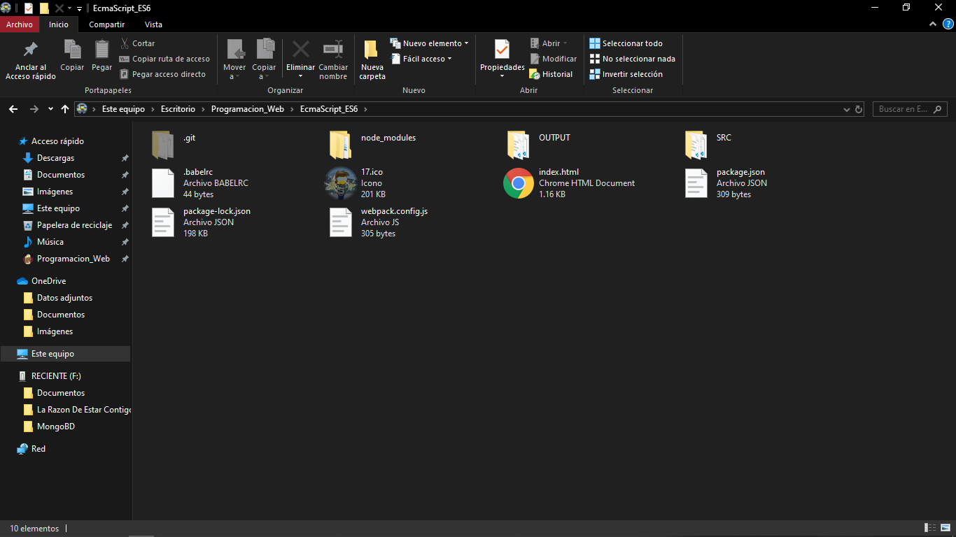

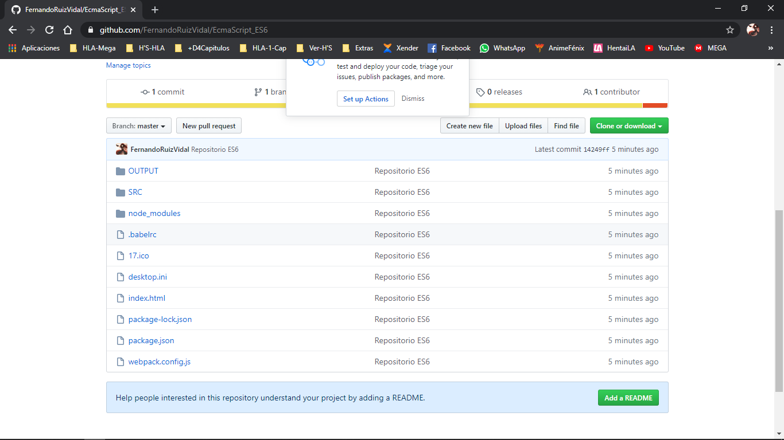

https://github.com/FernandoRuizVidal/EcmaScript_ES6.git